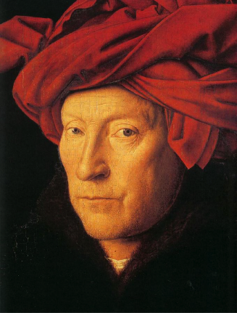

**NAME:**  Jan Van Eyck

**DATES:** c1390-1441

**NATIONALITY:** Flemish

**TRAINING:** Trained as a manuscript illuminator. In the service of Duke John of Bavaria, Count of Holland at The Hague from c1422, then appointed court painter to Philip the Good, Duke of Burgundy and rule of most of Flanders, who also entrusted him with secret missions as far afield as Portugal. Brother to Hubert.

**SELECTED WORKS:**

1. The Ghent Altarpiece, completed 1432, tempera and oil on panel, 3.35x4.57m, St Bavo Cathedral, Ghent
2. Arnolfini Portrait, National Gallery
3. Man in a red turban *(above right: thought to be a self-portrait)*
4. Madonna of Chancellor Rolin, 1433-34, oil on panel 66x61cm, Louvre

[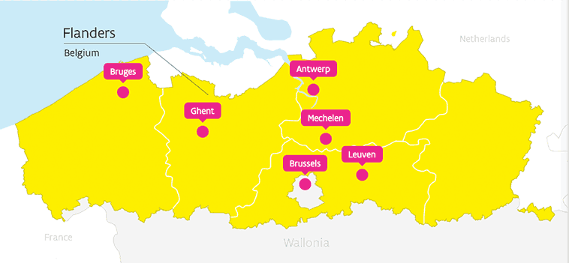](http://www.google.co.uk/url?sa=i&rct=j&q=&esrc=s&source=images&cd=&cad=rja&uact=8&ved=0ahUKEwiji8z6u4vWAhUIGhQKHUFaCuQQjRwIBw&url=http%3A%2F%2Fwww.visitflanders.com%2Fen%2Fdestinations%2F&psig=AFQjCNGpRVG9ORisOtLBeW4yXs_uqGsGpg&ust=1504612357395987)**BACKGROUND**

Ghent, Bruges and Ypres were the three leading FlemIsh cities of the time, and formed part of the duchy of Burgundy.

In Flanders, there had been little, if any, large scale painting before Van Eyck. There were magnificent, richly glowing stained glass windows, but the great contribution Flemish painters were to make to Western art – the development of easel or panel painting – owed more to the tradition of manuscript illumination. And to obtain an effect as bright and lustrous on panel, demanded the development of a new medium: oil paint.

Mixing pigments with oil (usually linseed) and applying translucent films of paint to over opaque colours to give an appearance of depth beneath a hard enamel like surface. Great advantage was that unlike tempera, oil dried slowly and therefore permitted and encouraged great precision of detail.

**KEY QUOTES**

Bartolommedo Fazio (author of *Of Famous Men*, the earliest account of the painter, written at the court of the King of Naples), called him “the leading painter of our time” for his technical accomplishment, truth to nature and the rediscovery of pigments known to Pliny (but the last probably reflects the Renaissance bias of the Italian writer).

Extensive symbolism in Van Eyck’s works illustrates St Thomas Aquinas “corporeal metaphors for things spiritual”.

**KEY TERMS (give definition for each)**

|  |  |
| --- | --- |
| Polyptych |  |
| Tempera |  |
| Oil |  |
| Grisaille |  |
| Predella |  |

**KEY WORKS**

1. [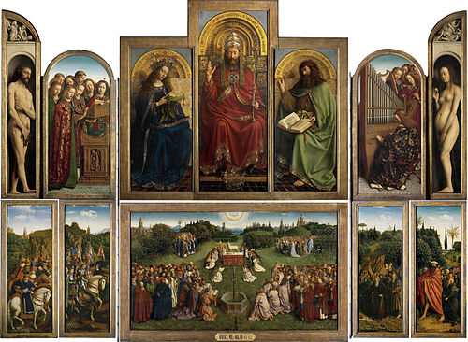](https://www.google.co.uk/url?sa=i&rct=j&q=&esrc=s&source=imgres&cd=&cad=rja&uact=8&ved=0ahUKEwiKjfnKsYvWAhXHXBQKHZ4_BegQjRwIBw&url=https%3A%2F%2Fen.wikipedia.org%2Fwiki%2FGhent_Altarpiece&psig=AFQjCNFMNMKJhG3ZKalzw-O4YvTr8SDj9g&ust=1504609574091287)**The Ghent Altarpiece**

**PATRONS:** Joos Vijd and his wife Elisabeth Borluut. Vijd was a burgher, serving on the Ghent City Council intermittently from 1395, also a member of the minor nobility and a landowner. Elisabeth came from a patrician family of Ghent that had included knights and abbots. Their wealth probably came from wool, on which the prosperity of Ghent was founded and so, for them, the Lamb of God, which had appeared on the city’s seal since the 13th century must have had special significance.

**MOTIVE:** They paid for the construction of the chapel where daily masses were to be said for them and their ancestors in what was then their parish church, dedicated to St John the Baptist, whose emblem is a lamb. The chapel has high windows and a Gothic vault.

**ICONOGRAPHY**: High level of symbolism gives meaning to the doctrine of Redemption.

Overview taken from Honour & Fleming *A World History of Art*:

20 panels, 16 of them mounted on the doors which, when closed, cover the central four. Originally there was a predella beneath, representing the hell or limbo into which Christ descended to redeem the virtuous. On the outside of the doors, the donors are portrayed life size, kneeling before simulated stone statues, painted in grisaille of St John the Baptist and St John the Evangelist. Above them, the archangel Gabriel is shown announcing to the Virgin that she is to give birth to the Redeemer, as foretold by the two prophets and two sibyls who appear in the top register. The windows of the Virgin’s room open on to a townscape of typically Flemish buildings. When the doors are opened a more brilliantly coloured celestial vision is revealed. In the centre of the top register, Christ (sometimes mistaken for God the Father) more than life size, is enthroned as the King of Kings and Lord of Lords (the inscription embroidered on the hem of his robe) wearing the papal crown, raising his right hand in benediction and holding a sceptre in his left, with a jewel encrusted royal crown at his feet. He is flanked by the Virgin and St John the Baptist, with angels singing and making music on either side of them. Adam and Eve, depicted in the end panels in niches beneath simulated stone reliefs of Cain and Abel, seem to have been placed there to record the origin of sin that necessitated redemption. Inscriptions state that ‘Adam thrusts us into death’ and ‘Eve has afflicted us with death’. Lower register has unified background, a panorama of wooded hills surrounding a lush meadow bright with flowers of all seasons. There are trees that grow in different parts of Europe, including the palms, cypresses, stone-pines, pomegranates, olives and oranges of the Mediterranean region. Swallows and other small birds swoop in the clear summer sky. This is a vision of paradise where all the most beautiful plants flourish and they are depicted with such precision that they may be botanically identified. Towers and spires rising above the horizon include those of Utrecht Cathedral and the church of St Nicholas in Ghent; the symbolise the heavenly Jerusalem where the whole community of the redeemed, the ‘ransomed of the Lord’ will be united in worship. The meadow is approached over rough ground in the other panels by Just Judges (stolen in 1934 and replaced by a copy) Christian warriors, hermits and a giant St Christopher leading pilgrims. Patriarchs and prophets (including Virgil); popes, bishops and other clergy are in the foreground of the main panel, as well as confessors who avowed the Christian faith despite persecution, and an endless procession of female saints beyond them. In the centre beneath the dove of the Holy Spirit, the Lamb of God stands on an altar, blood flowing from his breast into a chalice. A fountain in the foreground is inscribed ‘This is the fountain of the water of life proceeding out of the throne of God.” The meaning of the open altarpiece would have been explicit when it was seen above the head of a priest celebrating the Mass and, after the consecration of bread and wine, reciting the Agnus Dei “Lamb of God who takest away the sins of the world, have mercy on us”.

**SAINTS AND SYMBOLS:** *give the pictorial symbol and locate each figure:*

|  |  |  |  |
| --- | --- | --- | --- |
| Saint | Symbol | Who is s/he? | Seen where on the altarpiece? |
| Virgin Mary |  |  |  |
| St John the Baptist |  |  |  |
| St John the Evangelist |  |  |  |
| Cain |  |  |  |
| Abel |  |  |  |
| Angel Gabriel |  |  |  |
| Adam |  |  |  |
| Eve |  |  |  |

* **Problematic identity: Is it God the Father or Jesus Christ in Majesty?**

*Read the following extracts:*

The Ghent altarpiece (1432) by Hubert and Jan van Eyck, contains a striking image, wearing a papal crown and garments, seated upon a throne, with a crown at his feet. The Latin inscriptions arching over him read:

"Here is God, most powerful because of his divine majesty and high over all because of his sweet goodness and most generous in giving because of his measureless bounty."

Other inscriptions read:

"King of kings and lord of lords."

"Youth without old age on his brow, joy without fear at his side."

The inscription on his sash says "Sabaut" (here used as a title, as in "Lord Sabbaoth his name"). (Latin translations provided by Dr. David S. Wilson-Okamura)

The attribution of the central figure here has been controversial. The papal crown usually indicates the Father, but the youthful face is typical of the Son. Moreover, the central figure is in a triptych of the altarpiece between the Virgin Mary on the left and St. John the Baptist on the right pointing to him -- both figures closely related to Jesus in iconography. Normally when God the Father is depicted, along with him are symbols of other members of the Trinity.

For an in-depth discussion of the pros and cons of this, see Erwin Panofsky, "The Friedsam Annunciation and the Problems of the Ghent Altarpiece," Art Bulletin, 17, No. 4 (1935), 419-442.

After a long discussion, **Panofsky** concludes: "To summarize: from the point of view of representational traditions, we may safely continue to refer to the central figure in the 'upper triptych' as God the Father.... From the dogmatic point of view this figure belongs in the same class as its forerunners, its parallels, and its Flemish derivatives: it fuses the three Persons, God the Father, God the Son, and God the Holy Ghost into one image which is dogmatically equivalent to the whole Trinity."

*And:*

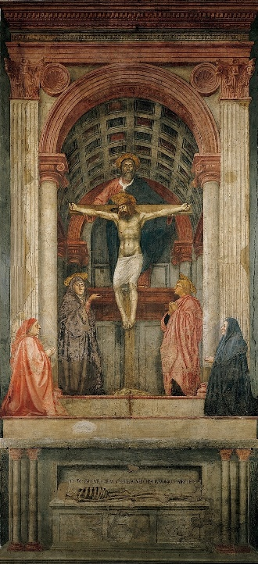Christ in Majesty or Christ in Glory (Latin: Maiestas Domini) is the Western Christian image of Christ seated on a throne as ruler of the world, always seen frontally in the centre of the composition, and often flanked by other sacred figures, whose membership changes over time and according to the context. The image develops from Early Christian art, which directly borrowed the formulae of depictions of the enthroned Roman Emperor. In the Byzantine world, the image developed slightly differently into the half-length Christ Pantocrator, "Christ, Ruler of All", a usually unaccompanied figure, and the Deesis, where a full-length enthroned Christ is entreated by Mary and St. John the Baptist, and often other figures. In the West, the evolving composition remains very consistent within each period until the Renaissance, and then remains important until the end of the Baroque, in which the image is ordinarily transported to the sky.

**Gombrich** extract taken from *A Story of Art (p236):*

“For all their obvious differences there are a number of similarities between Masaccio’s [Holy Trinity – see right} fresco in Florence and this altarpiece painted for a church in distant Flanders. Both show the pious donor and his wife in prayer at the sides and both centre on a large symbolic image – that of the Holy Trinity in the fresco and on the altar the mystic vision of the Adoration of the Lamb, the lamb, of course, symbolising Christ. The composition is mainly based on a passage in the Revelations of St John (vii.9) ‘And I beheld… a great multitude, which no man could number, of all nations and kindred and people and tongues [which] stood before the throne and before the lamb..’ a text that is related by the Church to the Feast of All Saints, to which there are further allusions in the painting. Above, we see God the Father, as majestic as Masaccio’s but enthroned in splendour like a Pope, between the Holy Virgin and St John the Baptist, who first called Jesus the Lamb of God.”

Which opinion seems most convincing to you? Explain why?

*Make a schematic (outline) drawing of the central lower panel: The Adoration of the Lamb.*

Identify each of the four groups of people around the central cluster of lamb and angels:

1. 2

3 4

1.

2.

3.

4.

Why is their identity important and what kind of community is represented by including these figures in this way?

1. **THE ARNOLFINI PORTRAIT**

Date: 1434

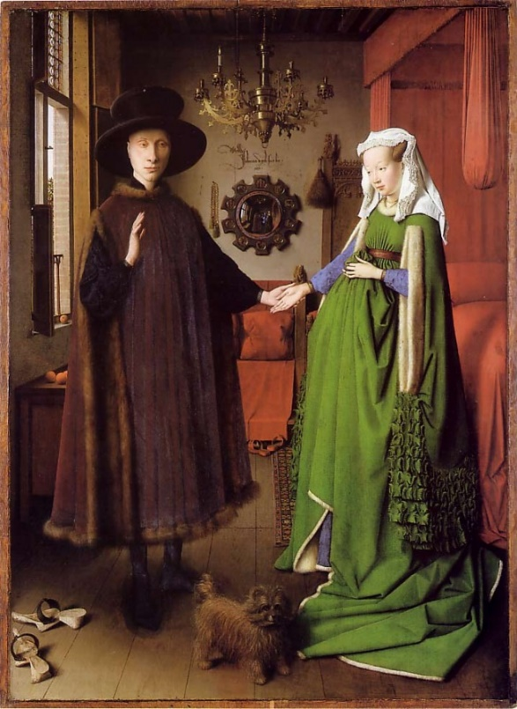Size: 82 x 60 cm

Medium: oil on panel

Style: Northern Renaissance

Genre: Double portrait (full length)

**Questions:**

1. What season is it? Cite the evidence?
2. Describe his clothing? And hers? What does this tell us about their identity?
3. Explain why their shoes are in different places in the room?
4. How many figures are seen reflected in the mirror? And who are they?
5. What is on the window sill? Why?
6. What are the scenes depicted around the mirror in the background?

**SCHOLARLY DEBATE**

In 1934 **Erwin** **Panofsky** published an article entitled Jan van Eyck's 'Arnolfini' Portrait in the Burlington Magazine, arguing that the elaborate signature on the back wall, and other factors, showed that it was painted as a legal record of the occasion of the marriage of the couple, complete with witnesses and a witness signature. Panofsky also argues that the many details of domestic items in the painting each have a disguised symbolism attached to their appearance. While Panofsky's claim that the painting formed a kind of certificate of marriage is not accepted by all art historians, his analysis of the symbolic function of the details is broadly agreed, and has been applied to many other Early Netherlandish paintings, especially a number of depictions of the Annunciation set in richly detailed interiors, a tradition for which the Arnolfini Portrait and the Mérode Altarpiece by Robert Campin represent the start (in terms of surviving works at least).

[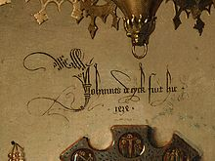](https://en.wikipedia.org/wiki/File:The_Arnolfini_Portrait,_d%C3%A9tail_(6).jpg)Since then, there has been considerable scholarly argument among art historians on the occasion represented. **Edwin Hall** considers that the painting depicts a betrothal, not a marriage. **Margaret D. Carroll** argues that the painting is a portrait of a married couple that alludes also to the husband's grant of legal authority to his wife. Carroll also proposes that the portrait was meant to affirm Giovanni Arnolfini's good character as a merchant and aspiring member of the Burgundian court. She argues that the painting depicts a couple, already married, now formalizing a subsequent legal arrangement, a mandate, by which the husband "hands over" to his wife the legal authority to conduct business on her own or his behalf (similar to a power of attorney). The claim is not that the painting had any legal force, but that van Eyck played upon the imagery of legal contract as a pictorial conceit. While the two figures in the mirror could be thought of as witnesses to the oath-taking, the artist himself provides (witty) authentication with his notarial signature on the wall.

Johannes de eyck fuit hic 1434 (Jan van Eyck was here. 1434).

**Jan Baptist Bedaux** agrees somewhat with Panofsky that this is a marriage contract portrait in his 1986 article "The reality of symbols: the question of disguised symbolism in Jan van Eyck's Arnolfini Portrait." However, he disagrees with Panofsky's idea of items in the portrait having hidden meanings. Bedaux argues, "if the symbols are disguised to such an extent that they do not clash with reality as conceived at the time ... there will be no means of proving that the painter actually intended such symbolism." He also conjectures that if these disguised symbols were normal parts of the marriage ritual, then one could not say for sure whether the items were part of a "disguised symbolism" or just social reality.

**Craig Harbison** takes the middle ground between Panofsky and Bedaux in their debate about "disguised symbolism" and realism. Harbison argues that "Jan van Eyck is there as storyteller ... [who] must have been able to understand that, within the context of people's lives, objects could have multiple associations", and that there are many possible purposes for the portrait and ways it can be interpreted. He maintains that this portrait cannot be fully interpreted until scholars accept the notion that objects can have multiple associations. Harbison urges the notion that one needs to conduct a multivalent reading of the painting that includes references to the secular and sexual context of the Burgundian court, as well as religious and sacramental references to marriage.

**Lorne Campbell** in the National Gallery Catalogue sees no need to find a special meaning in the painting: "... there seems little reason to believe that the portrait has any significant narrative content. Only the unnecessary lighted candle and the strange signature provoke speculation." He suggests that the double portrait was very possibly made to commemorate a marriage, but not a legal record and cites examples of miniatures from manuscripts showing similarly elaborate inscriptions on walls as a normal form of decoration at the time. Another portrait in the National Gallery by van Eyck, Portrait of a Man (Leal Souvenir), has a legalistic form of signature.

**Margaret Koster**'s new suggestion, discussed above and below, that the portrait is a memorial one, of a wife already dead for a year or so, would displace these theories. Art historian **Maximiliaan Martens** has suggested that the painting was meant as a gift for the Arnolfini family in Italy. It had the purpose of showing the prosperity and wealth of the couple depicted. He feels this might explain oddities in the painting, for example why the couple are standing in typical winter clothing while a cherry tree is in fruit outside, and why the phrase "Johannes de eyck fuit hic 1434" is featured so large in the centre of the painting. **Herman Colenbrander** has proposed that the painting may depict an old German custom of a husband promising a gift to his bride on the morning after their wedding night. He has also suggested that the painting may have been a present from the artist to his friend.

In 2016, French physician **Jean-Philippe Postel**, in his book L'Affaire Arnolfini, agreed with Koster that the woman is dead, but he suggested that she is appearing to the man as a spectre, asking him to pray for her soul.

* Is it a marriage portrait, a pictorial witness to a legal ceremony or a memorial to his dead wife?

Which argument do you find the most convincing? Explain why?

*Choose two DIFFERENT critical readings that you find interesting. Look up the era/place in which each critic worked and note down the key text they produced:*

|  |  |  |
| --- | --- | --- |
| Name of critic | Era/location of work | Key text produced |
|  |  |  |
|  |  |  |

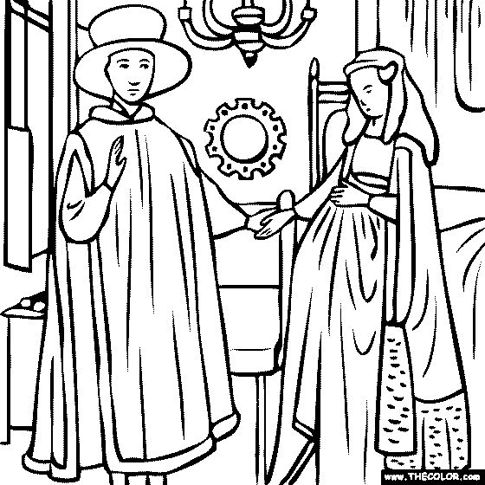

**Further reading/watching**

The Ghent Altarpiece: <https://smarthistory.org/van-eyck-the-ghent-altarpiece/>

Andrew Graham-Dixon BBC Culture <http://www.bbc.co.uk/culture/story/20140905-how-van-eyck-changed-art-forever>

Conservation of the Ghent Altarpiece: <https://smarthistory.org/ghent-altarpiece-project-overview/>

The Arnolfini Porttrait: <https://smarthistory.org/jan-van-eyck-the-arnolfini-portrait/>