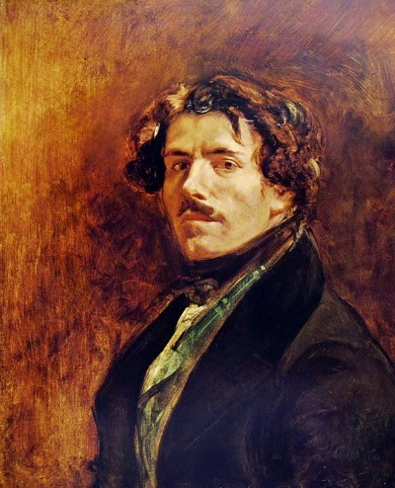**Specified Artist**

**Name**: Eugène Delacroix   
**Life dates**: 1798-1863  
**Nationality**: French  
**Art movement/style**: Romanticism

**Biography:** Eugène Delacroix was considered the leader of the French **Romantic** movement. Born into a well-connected family, he began his art training at the École des Beaux-Arts aged 17 under the painter Pierre-Narcisse Guérin. Despite the training of Guérin, who was a **Neoclassical** artist, Delacroix became strongly influenced by Romanticism and was a great admirer of the Romantic painter **Théodore Géricault**. Delacroix visited the studio of Géricault when he was painting his masterpiece ‘*The Raft of the Medusa’*. “Géricault allowed me to see his Raft of the Medusa while he was still working on it. It made so tremendous an impression on me that when I came out of the studio I started running like a madman and did not stop till I reached my own room”.[1]

By 1822 Delacroix was exhibiting at the **Paris Salon** and achieving great success. His first work to be publicly exhibited at the Salon was ‘*The Barque of Dante’*, 1822 and which was clearly inspired by Géricault’s ‘*Raft of the Medusa’*. His next major work *The Massacre at Chios* dealt with a more contemporary event, the Greek War of Independence.   
  
In 1825 Delacroix visited England where he met with leading painters of the day. His works would continue in a heavily Romantic style and cover subjects from both the past and present and derived from literature, poetry, history and contemporary life.

1830 saw the production of ‘*Liberty Leading the People*’, considered his most famous work. In 1832 he travelled to Spain and North Africa. These trips would have a significant impact on his art. His use of colour became more intense and vibrant as he documented the people and events he witnessed on these trips and the subjects in his works became more ‘exotic’ as a result.

Delacroix received numerous prestigious commissions for the decoration of a variety of public buildings including churches, cathedrals and ceilings at the Louvre etc. These large scale works occupied a significant amount of the later years of his life. When Delacroix died in 1863 he left behind a significant body of work covering all genres and his use of colour and application of paint were to be a major influence on future generations of artists working in all styles.

|  |  |
| --- | --- |
| Give a definition for each of these terms | **Romanticism** |
|  | **Neoclassicism** |
|  | **Paris Salon** |

**Legacy:** “We all paint in Delacroix’s language,” observed Cézanne

From the bold colours and abstract shapes of Matisse and Kandinsky, to the expressiveness of Van Gogh and Gauguin, to the vibrant complementary colours of the Impressionists. All can be traced back to Eugène Delacroix – the last painter of the Grand Style but equally one of the first modern masters, who transformed French painting in the 19th century.

‘Delacroix and the Rise of Modern Art’ is a long-overdue homage to France’s leading exponent of Romanticism – a true original who, at the time of his death in 1863, was the most revered artist among the avant-garde in Paris.

Drawing inspiration from British art and literature, his real and imagined travels to North Africa, and biblical scenes; every chord of human passion can be found in Delacroix’s paintings – stories of love, murder, violence, and war. “The first merit of a painting is to be a feast for the eye,” he emphasised towards 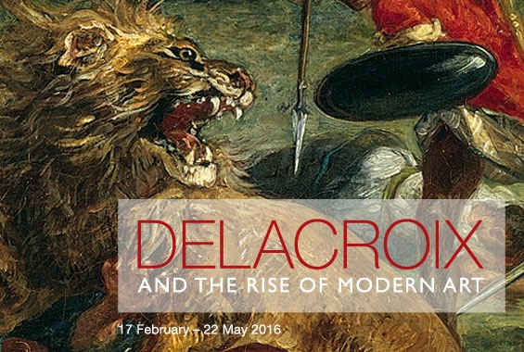the end of his life.

Placing Delacroix alongside contemporaries such as Courbet and Chassériau, this exhibition traces 50 years of Delacroix’s legacy, exploring the profound impact he had on generations of artists to come.

**Read these reviews which outline how influential Delacroix was as a painter.**

<http://www.telegraph.co.uk/art/what-to-see/delacroix-and-the-rise-of-modern-art-national-gallery-review-mon/>

<https://www.theguardian.com/artanddesign/2016/feb/21/delacroix-and-the-rise-of-modern-art-review-national-gallery>

**Major works by Eugène Delacroix:**   
  
*The Barque of Dante*, 1822, Louvre, Paris  
*Massacre at Chios*, 1824, Louvre, Paris  
*Liberty Leading the People*, 1830, Louvre, Paris  
*Women of Algiers*, 1834, Louvre, Paris  
*The Death of Sardanapalus*, 1844, Louvre, Paris

Details of these paintings can be found on the link below

<http://www.louvre.fr/en/routes/eugene-delacroix>

Find details for three public commissions by Delacroix and use to complete the table below

|  |  |  |  |
| --- | --- | --- | --- |
| Title |  |  |  |
| Date |  |  |  |
| Location/venue |  |  |  |
| Patron |  |  |  |
| Subject matter/genre |  |  |  |
| How is this work typical of Romanticism |  |  |  |

1. The Journal of Eugène Delacroix, pxii, <https://monoskop.org/images/8/80/The_Journal_of_Eugene_Delacroix.pdf>