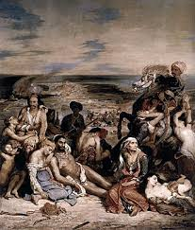 | 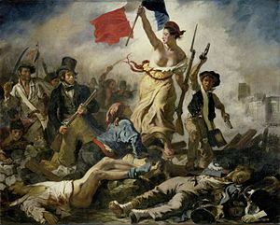
Massacre at Chios, 1824, oil on canvas, 4.1 x 3.5m | Liberty Leading the People, 1830, oil on canvas, 2.6 x 3.2m
In max 50 words, what is the subject of this work? Be specific in your detail: | In max 50 words, what is the subject of this work? Be specific in your detail:
Pick out key characters who aid the narrative within the work. Describe their role, costume, placement in the painting. | Pick out key characters who aid the narrative within the work. Describe their role, costume, placement in the painting. The most prominent figure is a woman who is an allegorical representation of Liberty. Dressed in classical robes, she is elevated above the crowd, placed centrally and shown carrying a French tricolour. She leads the crowd of revolutionaries. To her left is a young student known as Gavroche who represents youthful rebellion and waves a pistol. On her right we see various classes in society including a bourgeois gentleman holding a rifle, factory-workers and kneeling at the feet of Liberty we see a peasant who looks up at her. Collectively they suggest that all members of society are unified in this revolution and are willing to die for their shared beliefs.
How is this work typical of its style? Look at theme, formal features, painting technique: The subject is dramatic and this suits the style of Romanticism. Expressions of human emotion, including love, grief and despair are represented in the faces of the victims. The Ottoman’s twisting, exaggerated pose and the terrified expression of his horse add dynamic energy and drama. The landscape is used symbolically, the vast cloudy sky and clearly defined horizon line on the sea contribute an ominous tone to the painting. They imply an uncertain future for those who will be taken as slaves and shipped off to foreign lands, far away from their home which now lies in ruins and smoke. Red is used to draw our eye across the work. This colour typically suggests passion and bloodshed. We see it on dress of the elderly woman as well as the costume of the Ottoman soldier. Foreground features are clearly defined to allow for detail, however Delacroix has painted the background in soft, cloudy forms to indicate smoke from burning buildings. Movement, shown in the rearing horse and billowing smoke provides action. Pathos is shown in the infant who clutches at its dead mother’s breast as it seeks milk to survive. | How is this work typical of its style? Look at theme, formal features, painting technique:
Which side in the conflict does Delacroix support? How is this shown?: | Which side in the conflict does Delacroix support? How is this shown?:
Why did Delacroix paint a subject so close to the time of the event? : | Why did Delacroix paint a subject so close to the time of the event? :
This work is for the topic Places Affected By War. List three things which suggest the specific location of the event shown: | This work is for the topic War or Revolution in 2D. List three things which suggest revolution in this painting:
What were Delacroix’s motivations for painting this subject? : | What were Delacroix’s motivations for painting this subject? :
Comment on scale: | List three things which link to French identity:
The famous writer Charles Baudelaire described this work as: “A hymn composed in honour of destiny and irremediable anguish”. What does he mean? : | Delacroix wrote of this work: “I may not have fought for my country, at least I shall have painted for her”. What does he mean? :
How does this work compare to Jeremy Deller’s It Is What It Is (your other key work for Places Affected By War)? : | How does this work compare to Picasso’s Guernica (your other key work for War or Revolution in 2D)? :

