The Male and Female Gaze

Who was **John Berger**?

In which highly important text did he describe male and female roles thus: “men act and women appear”?

Watch Episode 2 of his BBC series here: <https://www.bing.com/videos/search?q=john+berger+ways+of+seeing+episode+2&&view=detail&mid=A6135AEA9DFED9718705A6135AEA9DFED9718705&&FORM=VDRVRV>

Who is **Laura Mulvey**?

What was the title of her ground-breaking work?

What three ‘looks’ does she identify in a work?

Watch this video clip: <https://www.slideshare.net/fleckneymike/the-male-gaze-laura-mulvey>

Mulvey discusses the objectification of women, and how in being viewed as objects, female characters are devoid of any agency. While the male characters are active, driving the storyline forward, the women are passive, functioning as objects to be viewed and enjoyed. This active/passive divide of the male characters looking and the female characters being looked at is suggested by Mulvey as a way to depict – and also reinforce – hierarchical power relations, which almost always reflect the patriarchal structures which were as present on film in 1975 as they are now.

Explain what the highlighted phrases mean in your own words:

1. ‘objectification’
2. ‘devoid of any agency’
3. ‘patriarchal’

Another theorist that completes the theory of the oppositional gaze is **Bell Hooks**. Bell Hooks adds another dimension to the oppositional gaze which is race. Media rarely represents women in favourable light but black women have almost never had strong and beautiful characterization of their gender and colour. “They resented the way these screen images could assault black womanhood, could name us bitches, nags.” (Hooks, page 120) here Bell Hooks illustrates how the main stream media particularly has been degrading to black women.

Explain ‘oppositional gaze’ in your own words:

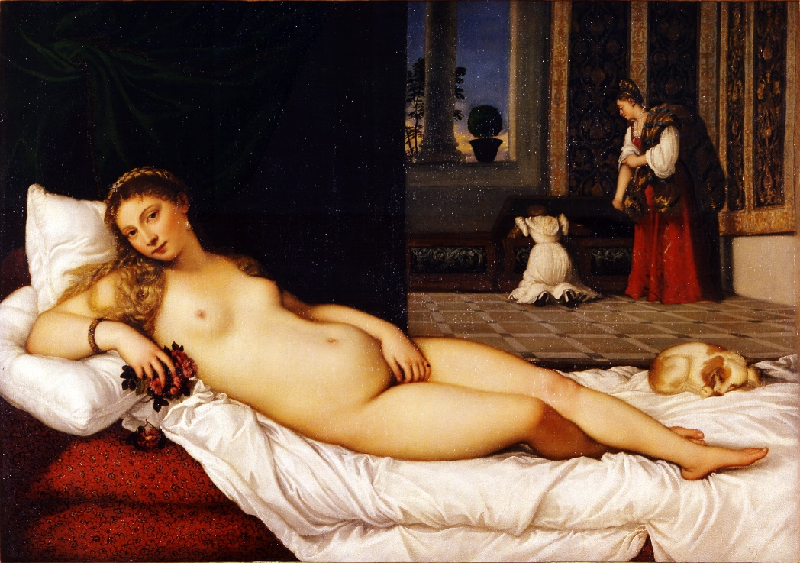

**Fanon** talks about being under examination, stating, “I am being dissected under white eyes, the only real eyes. I am fixed,” (Fanon, 2008)

[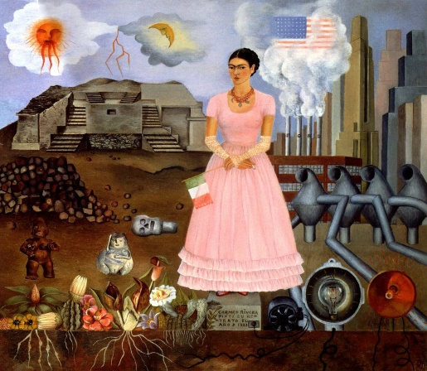](https://www.fridakahlo.org/images/paintings/self-portrait-along-the-boarder-line-between-mexico-and-the-united-states.jpg)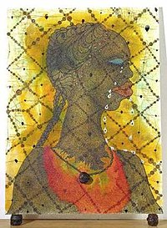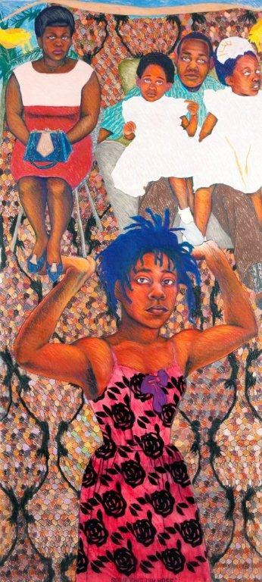**Stuart Hall** argues the movement; “Broke its links with the western humanist celebration of self and became more positional…the black self-image was in a double sense, an exposure, a "coming out". The self is caught in its very emergence,” (Hall, 2006

All three modern works have long titles and use unusal materials, scale and /or form. On a sheet of lined paper, make some notes on why you think this is….

Left: Sonia Boyce ‘She ain’t not holding them up, she’s holding on: Some English Rose’; Frida Kahlo ‘Self Portrait on the Border-line’ and Chris Ofili ‘No Woman No Cry’: all explore/present the female post 1850. Make notes on their techniques and messages.