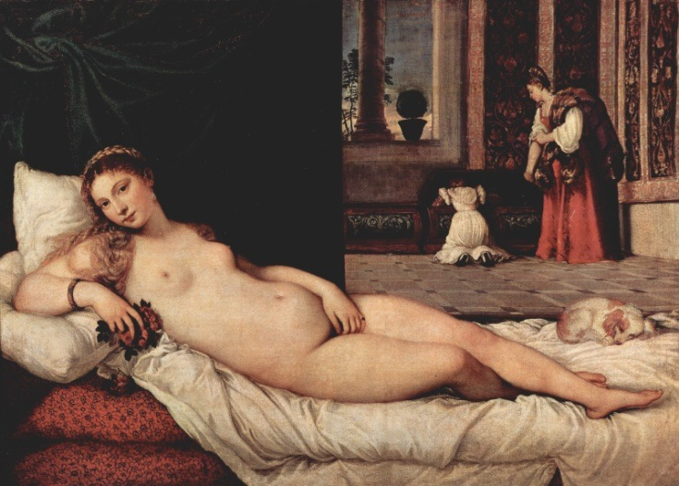 **Key Work:** Titian, *Venus of Urbino*, 1538