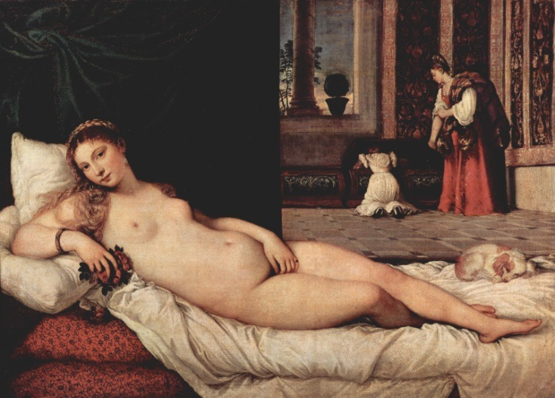Artist: Titian

Title: ‘Venus of Urbino’

Date: 1538

Size: 119 cm × 165 cm (47 in × 65 in)

Location: Florence

Style: High Renaissance

Material: Oil on Canvas

Subject: Nude female figure

Patron**:** Duke of Urbino

1. **Female Identity**

In this painting the woman is shown reclining on the chaise longue in a seductive manner. She looks straight at the viewer, drawing us into the painting. The ‘male gaze’ is adopted, by this we mean we look at the painting as a man would: judging her virtue and beauty – rather than her character and individuality. Her pose is coy but she also makes eye contact with us, the tilt of her head suggests submissiveness. Her pose is relaxed and the paleness of her skin tone imply refinement and also fragility. She is nude except for jewellery; a large pearl earring, a bracelet on her right hand and a jewelled gold ring on the small finger of her left hand, these items indicate prestige and act as decorations to adorn her otherwise nude body. The figure of the female is at once both realistic and also idealised. The proportions of her body are not entirely accurate, her face is idealised and reflects the type of Venetian beauty prevalent at that time. The feminine curves of her body contrast with the straight hard lines and edges of the room. Her hair hangs loose around her, dishevelled like the bedlinen on which she lies which suggests intimacy between man and wife. The setting is one which emphasises a domestic environment or setting, this is evident by presence of Venus and her female attendants but also reminds us that she is awaiting the arrival of a male, most likely her husband.

1. **Style and influences**

This work is painted in the High Renaissance style. The classical column we see in the window is typical of the interest Renaissance artists had in classical motifs and subjects during this period. The women in the background are wearing clothes contemporary to the period in which the painting was completed. Titian based the composition of his painting on a work by fellow Renaissance artist Giorgione. In Giorgione’s painting ‘*Sleeping Venus*’ (1510), we see Venus placed outdoors in a landscape with eyes closed and in a setting more timeless than that in which Titian situates his reclining Venus. In *Venus of Urbino*, the figure occupies the majority of the space, making her the focus of our attention. There are two clear lines dividing the painting. One goes vertically down the middle along the outer edge of the green curtain which directs the viewer’s eyes toward her sex, another clear line is visible running horizontally across the centre of the composition. The painting is split up into four distinct sections, the lower two contain the woman lying seductively on the rumpled cloth, the upper right square might indicate the domestic role she plays during the day with the assistance of her maids. Colours are rich and typical of those used by Titian and other artists working in Venice during the Renaissance. Both the red and greens complement each other. The red repeats itself in the background where we see it in the skirt of the standing female maid. The white sheet and pillows highlights the creamy skin colour of Venus which appeal to the desires of we the viewers. Diagonal lines are shown in the tiled floor in the middle ground, these run towards the horizon line. Titian creates space and depth through the receding tiled floor, the lightly coloured sky outside the window provides atmospheric perspective. Titian connects the foreground of the painting with the background by including the deep red colour of the chaise longue with the dress of the female attendant. He also scales objects and figures accurately to create a realistic scene.

1. **Background of the artist**

Titian learnt his trade as an apprentice to the Bellini brothers who were leading artists in Venice. He eventually became master of his own workshop in Venice with his own assistants and ran a very busy and successful studio. Throughout his career he remained a member of the Painters’ Guild. Artists during this period were required to be part of a guild, this allowed them to run studios and seek commissions and work as professional artists.

Titian worked to order for a range of important patrons. He received commissions from the Church, royalty and nobility alike including the doges of Venice, the Duke of Urbino, the Duke of Mantua, the Holy Roman Emperor Charles V, Pope Paul lll and wealthy merchants across Europe. During his lifetime he produced over 600 paintings, primarily in genres including religious, mythological and portraits. He was in frequent communication with significant individuals including European royalty and this shows evidence of his social standing and status as an artist. He lived until the age of 88 and continued accepting commissions from major patrons up until his death.

Venus of Urbino was commissioned by Guidobaldo ll della Rovere, the Duke of Urbino.

1. **Ways the work might have been used**

A full length female figure fills the foreground as she lies on a chaise longue or day bed. The background is divided into two sections, to the left hand side behind the figure is a heavy rich green velvet curtain and in the right hand side are two female figures giving the scene a more domestic setting with a distant view out of the window.

The red roses which the figure holds connote love and could suggest that she is newly married. The presence of roses and the pot of myrtle on the window sill, traditional emblems of Venus, are shown, however this figure is not actually an image of Venus but rather a symbol of the ‘perfect woman’ intended to act as a role model or example to the Duke of Urbino’s young wife. A sleeping lap dog lies at her feet, this animal represents fidelity and loyalty, two ‘qualities’ a wife is meant to demonstrate.

The maids in the background may be taking clothes from a cassone, this was a richly decorated wooden chest which was often included in the dowries of noble women during this era and typically contained clothing and linens. This shows the duty of a wife to organize her household as well as to entertain her husband and in term become a mother.

The overall setting is one of opulence and elegance, the green velvet curtain, the rich tapestries hanging on the background walls and the tiled floor suggest a wealthy and aristocratic household. These themes of love and marital obligations indicate that this painting was commissioned by the Duke of Urbino as a gift for his young wife Giulia Varano.