AS
Music Technology
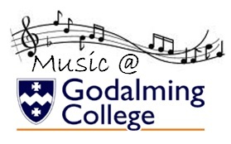

Component 2: technology-based Composition

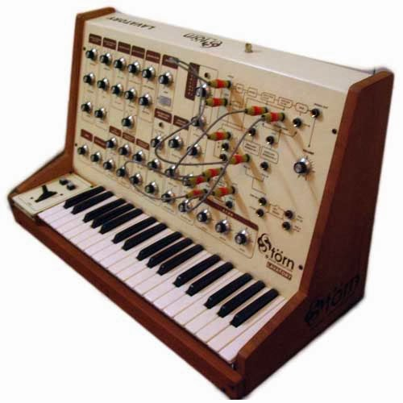
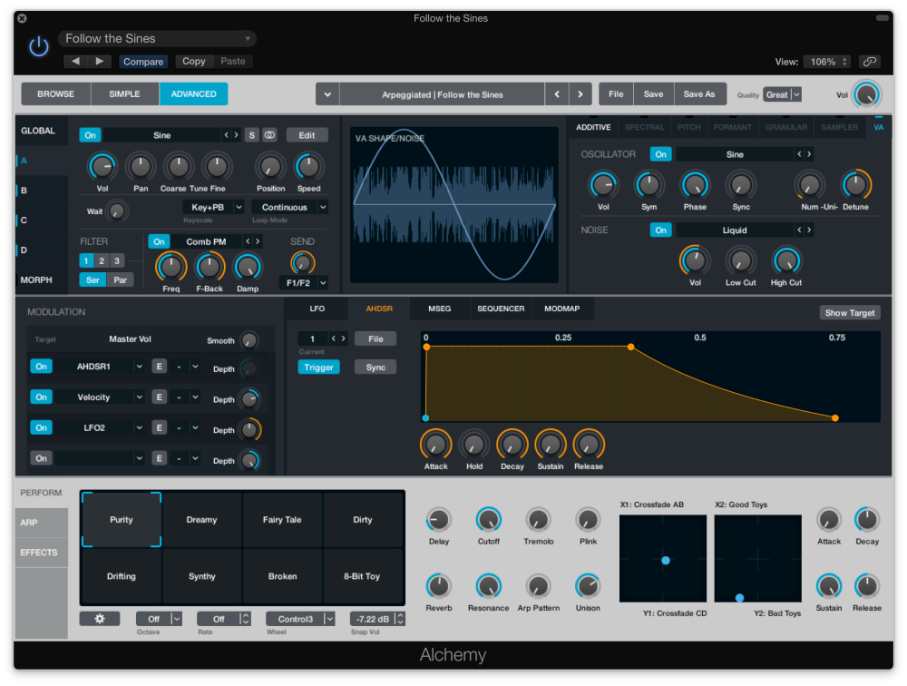

STUDENT WORKBOOK

Name__________________________________

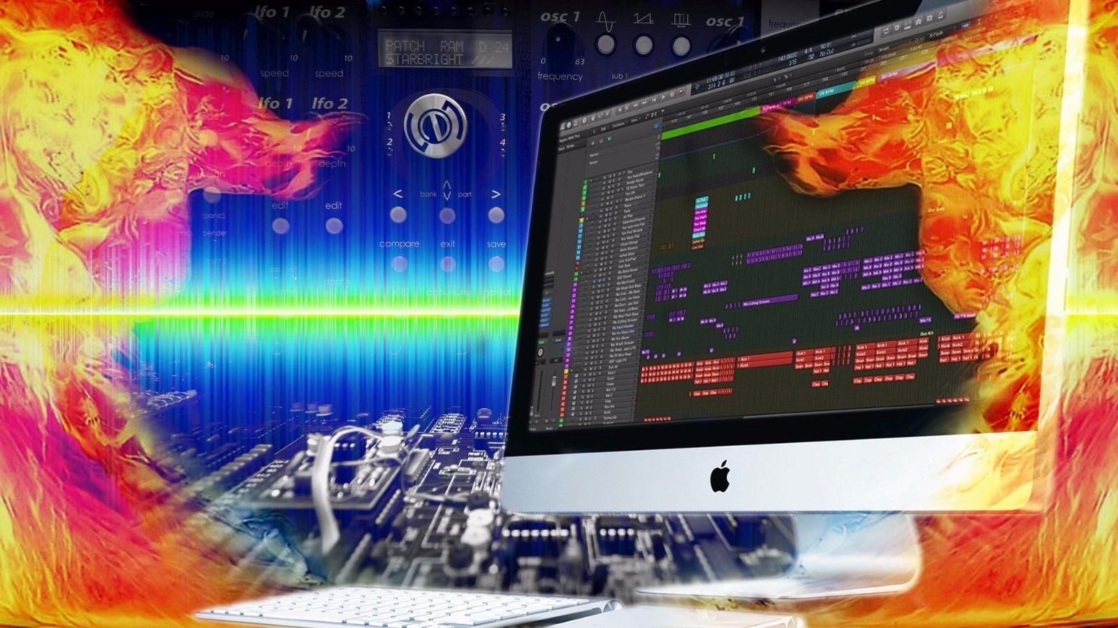
Composition Brief
Technology-based composition
Create a composition based on the following brief.

You have been provided with two samples. Use both of these to develop a composition
in any style.

Both of the samples must appear at least once in their entirety in your composition.
You must manipulate the samples using audio editing techniques, effects and processing.
The technology-based composition must contain at least six parts. Any combination of
vocal, instrumental and sample-based parts is acceptable.

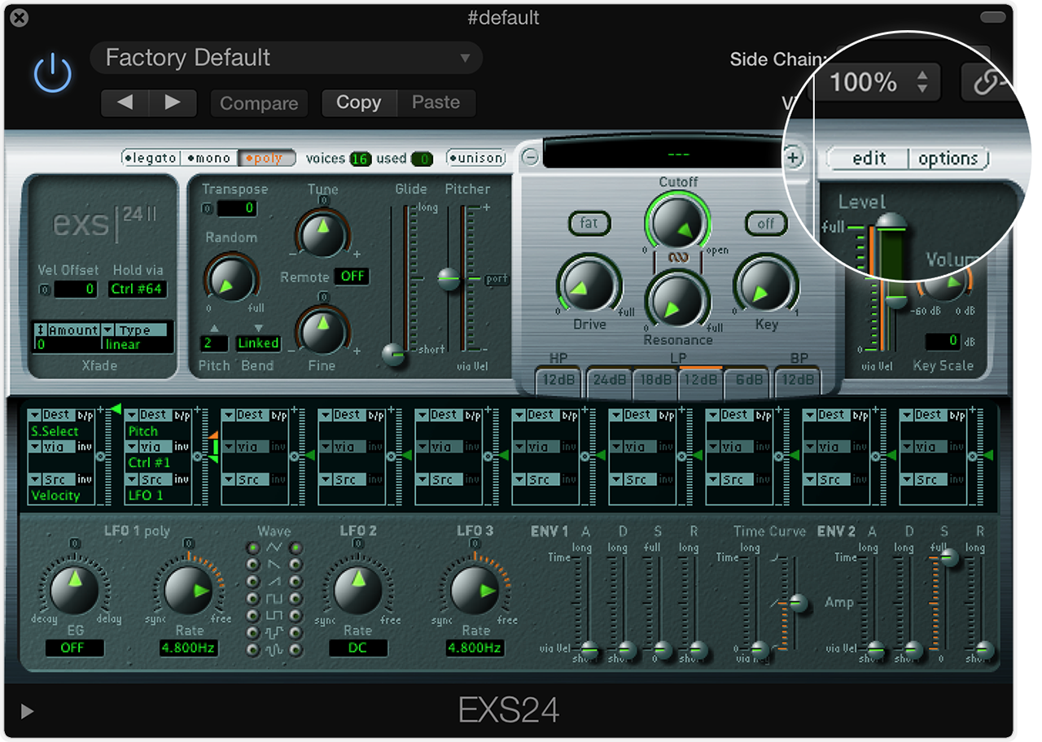
You must use the following sound design methods in creating your instrumental parts:
• synthesis
• sampling/audio manipulation
• creative effects
• automation and real-time control.

You may also use any combination of:
• MIDI-controlled virtual instruments
• live recorded audio.

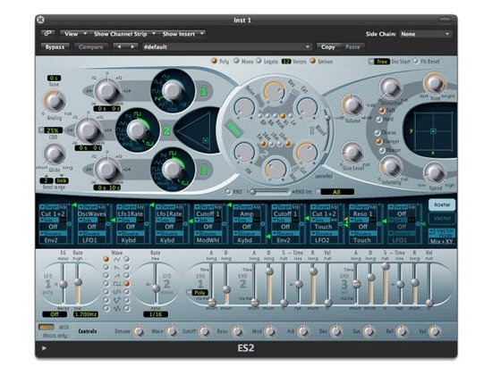
Samples and loops must be manipulated in order to gain credit.
Your logbook must detail all of your original sound design: synthesis, sampling and
creative effects. The source of any additional samples that you have used should be
credited in your logbook.
You must produce a high quality stereo recording of your technology-based composition
that pays attention to all aspects of production – capture, balance, blend, EQ, dynamics,
stereo field and effects.

Your composition must be 2½ minutes long.

1 | Introduction to Component 2
2 | Sequencing Basics: Intro to Logic Pro
3 | Sequencing Basics: Audio editing-Loops and Samples
4 | Sequencing Basics: Inputting Data
5 | Sequencing Basics: Editing MIDI
6 | Practical Assessment: Arrangement Task 20th October
7 | Exploring set briefs and mark scheme
8 | Sound Design Workshops: Synthesis
9 | Sound Design Workshops: Sampling
10 | Composition Techniques: Style/Structure
11 | Composition Techniques: Chord Progressions
12 | Composition Techniques: Developing melodic ideas
13 | Assessment: Composition First Draft 14th December
14 | Exploring the mark scheme and feedback
15 | COMPONENT 1: RECORDING SESSIONS week starting January 8th
16 | Assessment: Composition Second Draft
17 | Exploring the mark scheme and feedback
18 | Coursework workshops/tutorials
19 | Assessment: Component 2 FINAL Draft 9th February
20 | Exploring the mark scheme and feedback
21 | Mastering Workshop
22 | Coursework workshops/tutorials
23 | Logbook
24 | COMPONENT 2 FINAL MIX 2nd March

Task 1: Sequenced Arrangement Deadline: 20th October 2017
Arrangement Task:
Create an original arrangement approximately 2 minutes in length using Seven Nations Army(The White Stripes) as your stimulus.

You must choose one of the following styles:
- Reggae (eg. in the style of Bob Marley and the Wailers, Toots and the Maytals, Burning Spear)
- House (eg. in the style of : MARRS, David Guetta, Duke Dumont)
- A style of your choice-REMEMBER TO COMPLETE STYLISTIC FEATURES SHEET

You will assessed on the following criteria:

- Response to brief – sonic and musical ideas combined to
reflect the requirements of the brief

- Style and coherence – use of stylistic conventions and control of flow and direction of ideas

For the following five criteria will be assessed but only the three
highest marks will be used to calculate the total.

- Melody

- Harmony

- Form and structure

- Rhythm

- Texture

You must submit the following:
- Audio Mixdown 16bit 44.1kHz of your final arrangement
- Logic Project file with production log in the notes section
- Q1 and Q2 of this workbook.

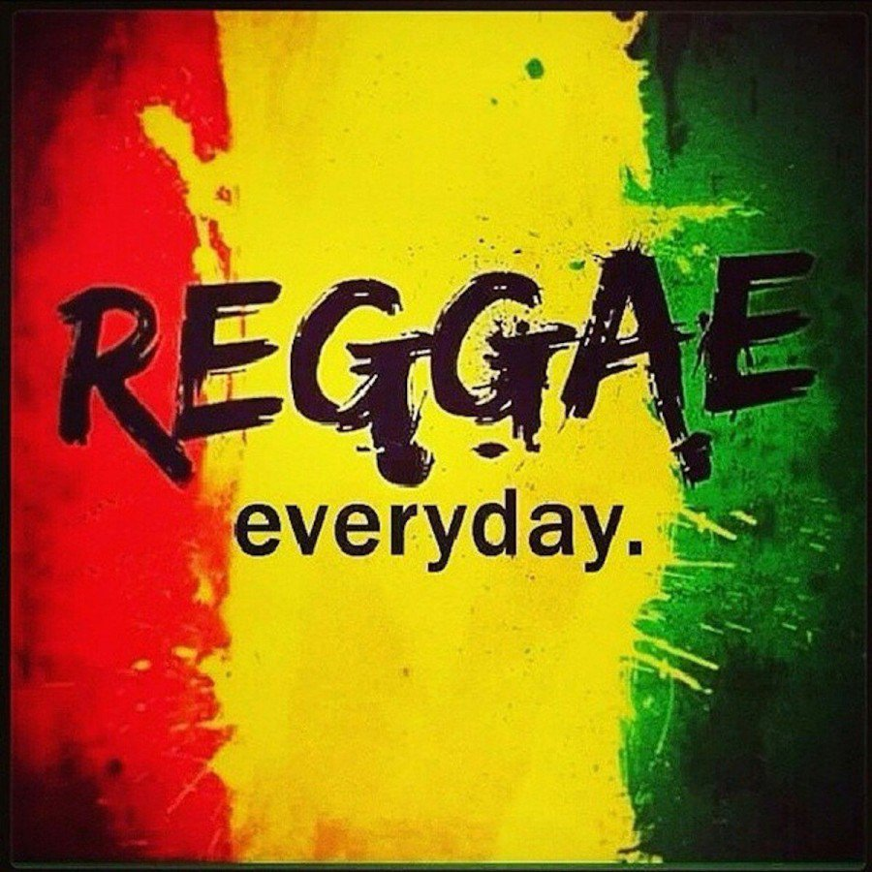
Stylistic Features of Reggae Music:
Instrumentation:
- Main Vocals
- Backing Vocals – 3 or 4 part harmonies
- Guitarists x 2
- Piano, Keyboards, Organ, synthesizers
- Horn section – Saxophone, Trumpet or Trombone
- Bass Guitar
- Drums and Percussion

Performance and Arrangement:
- The vocals of reggae are expressive
- A standard drum kit is generally used in reggae,
- The back beat of reggae music is relaxed but rhythmically tight
- Reggae drumbeats fall into one of three main categories: One drop, Rockers, and Steppers
- Reggae is played in 4/4 time
- Recognisable offbeat rhythms
- Staccato / choppy chords played by a guitar, piano or both on the offbeats of the measure, often referred to as the skanking
- The tempo of reggae is usually slower than ska and rocksteady, approximately 60 to 90 bpm
- Heavy use of syncopation
- A Melodic riff based Bass lines which plays a dominant role in reggae music
- Simple chord progressions
- Vocal call and response phrases
- Horn sections are frequently used in reggae, often playing introductions and counter-melodies
- The toasting vocal style is unique to reggae, originating when DJs improvised spoken introductions to songs
- Reggae is noted for its tradition of social criticism in its lyrics, although many reggae songs discuss lighter, more personal subjects, such as love and socialising
- Side stick on snare beat 3
- Organ shuffle played in the left hand plays off-beat quavers
- A wide variety of percussion is used which includes shaker, tambourine and hand drums

Technology and Production:
- The bass sound is thick and heavy, and equalised so the upper frequencies are removed and the lower frequencies emphasised, heavily compressed and plays a key part in the performance so is mixed relatively high.
- Drums are isolated with the use of gating and compression to achieve a more punchy sound
- The snare drum is often tuned very high to give it a timbales-type sound
- Piano and guitar chops are EQed to sound unnaturally thin
- The horn section is sometimes produced with punchier, louder phrases for a more up-tempo and aggressive sound.
- Extensive use of the Delay and reverb effects to give a sense of space

Suggested listening:
Bob Marley and the Wailers No Woman No Cry
Toots and the Maytals 54-46 Was My Number
Burning Spear African Postman
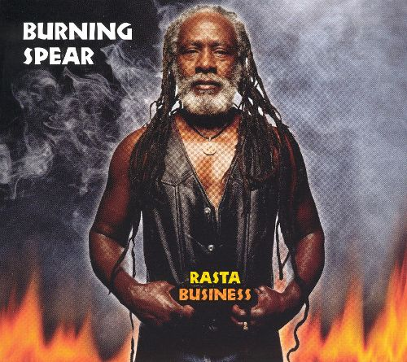
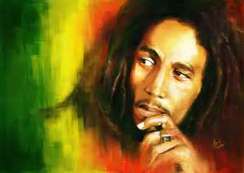

Stylistic Features of House Music:
Performance and Arrangement:
- House has an up-beat tempo in excess of 120bpm and up to 140bpm
- Four-to-the-floor bass drum and hi-hat emphasis on the off-beat quavers (similar to disco)
- Synth stabs or syncopated staccato stabs on piano
- Use of synth for bass lines
- Synth riffs and pad chords
- Samples taken from a range of instrument and vocal recordings
- Anthemic or epic feel
- Rapping used on some songs
- Soul influenced vocals are common
- Structures are built on building up and breaking down textures and rhythmic elements
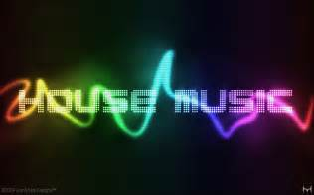
Instrumentation:
- Drum machines
- Drums and percussion
- Synthesizers
- Samplers
- Turntables
- Vocals
Technology and Production:
- Computer-based sequencers to create the music
- Cheaper technology makes music production more accessible
- Electronic instruments used include: Drum machines, samplers and synthesizers
- Use of a wide variety of effects including: reverb, delay, distortion, chorus, side-chain compression, vocoders,
Suggested listening

Duke Dumont I Got U MARRS Pump Up The Volume David Guetta Titanium
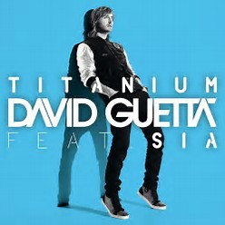
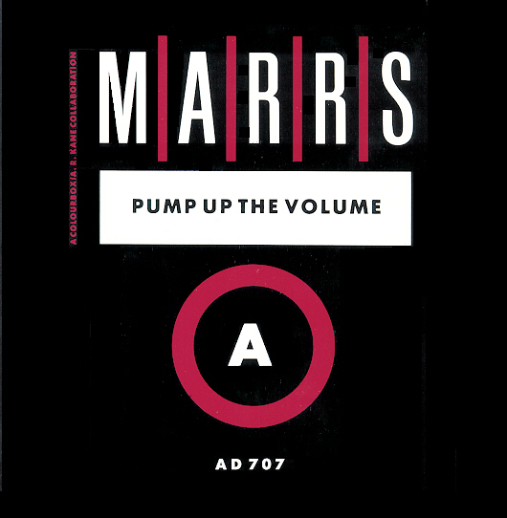

Stylistic Features Sheet
Style of your choice:
Instrumentation:

Performance and Arrangement:

1. Explain how you developed ‘Seven Nation Army’ to create your completed sequenced arrangement. Refer to at least two of the following: melody; harmony; rhythm; texture and instrumentation; form and structure.(10 marks)
Suggested listening
List of reference songs/artists:
1.

2.

3.

4.
Technology and Production:

2. Identify the most important features of your chosen style, and explain how you have
used them in your arrangement. (10 marks)

/20

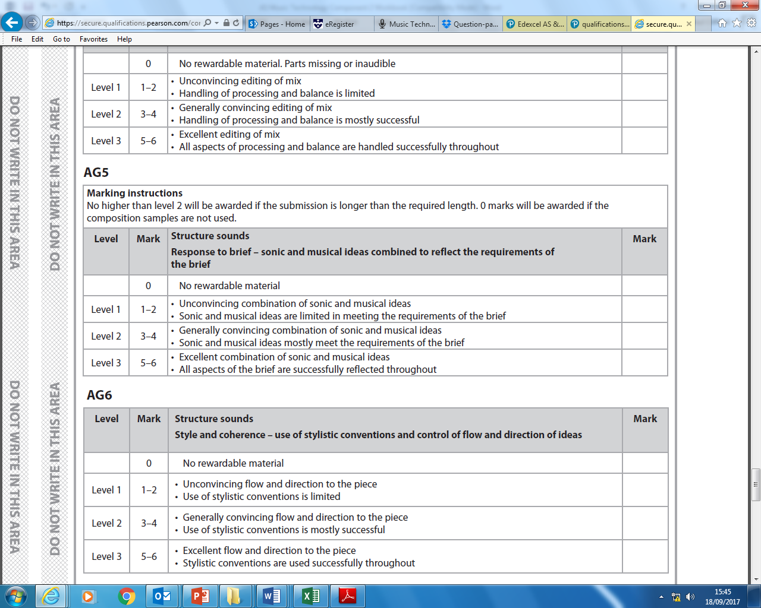

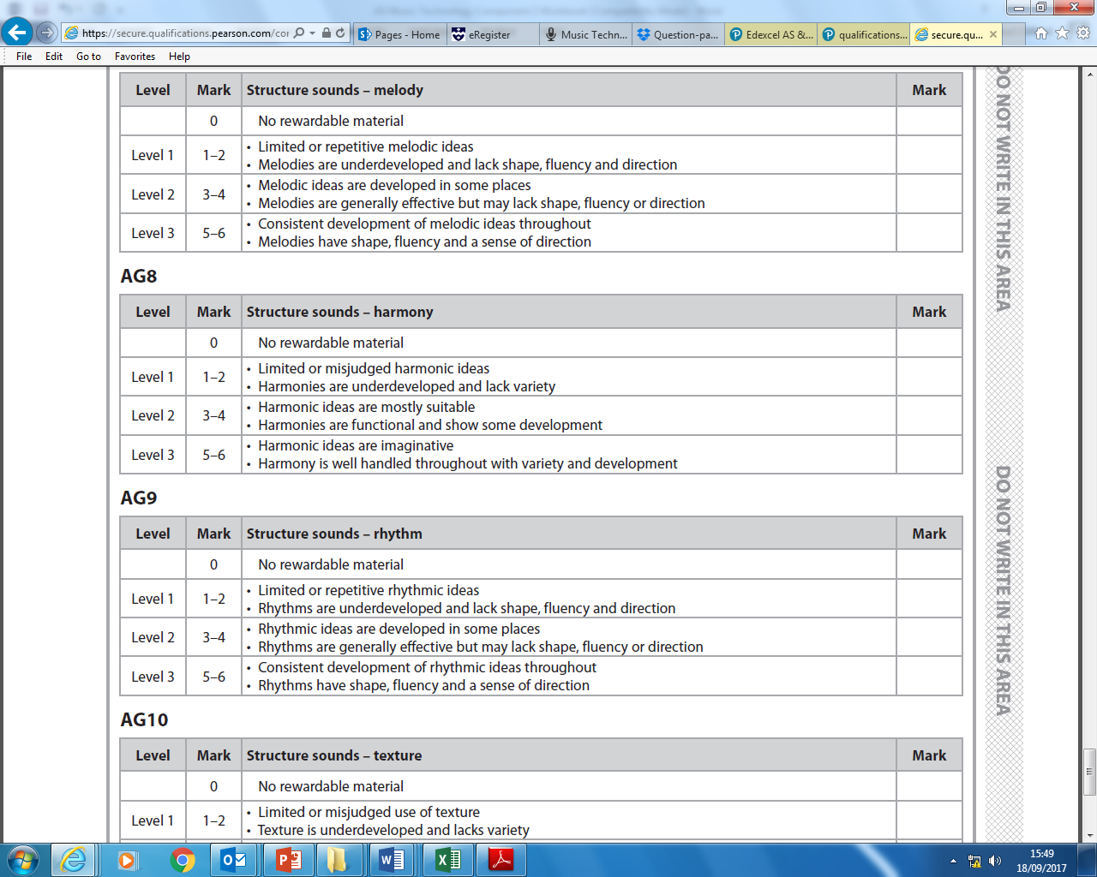

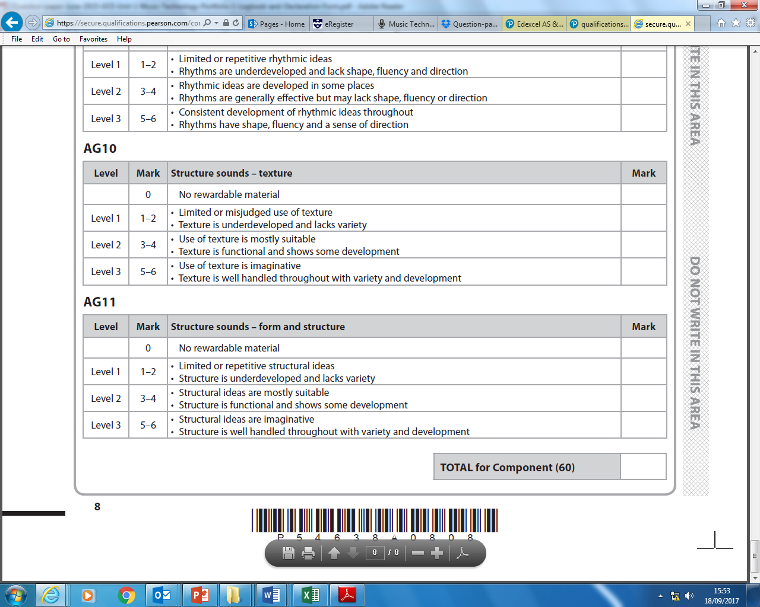

FIRST DRAFT: Composition Deadline 14th December 2017
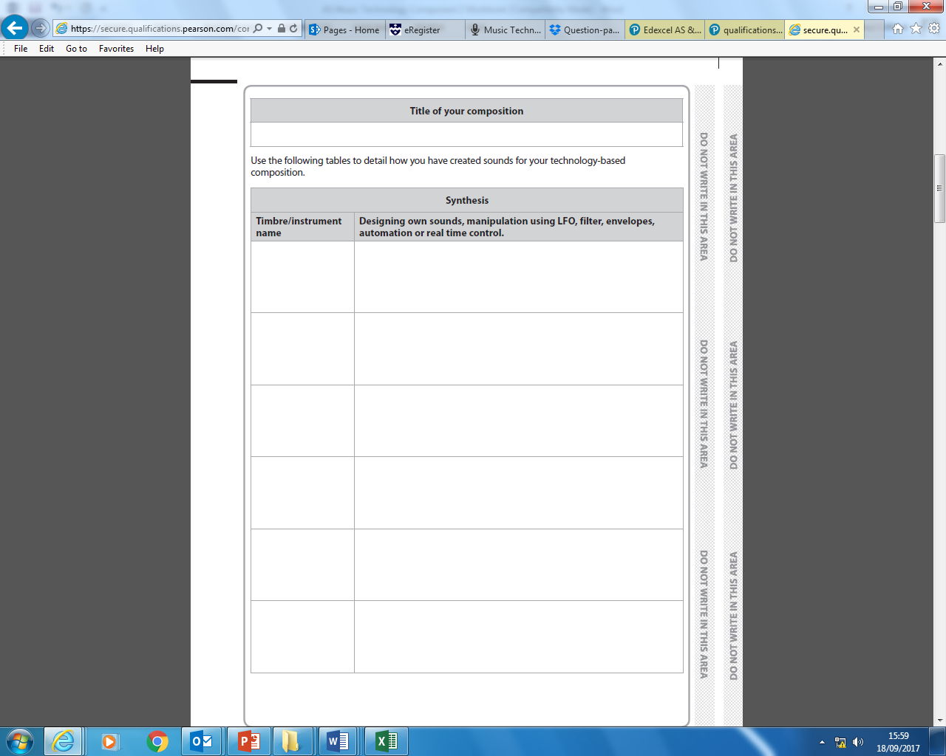
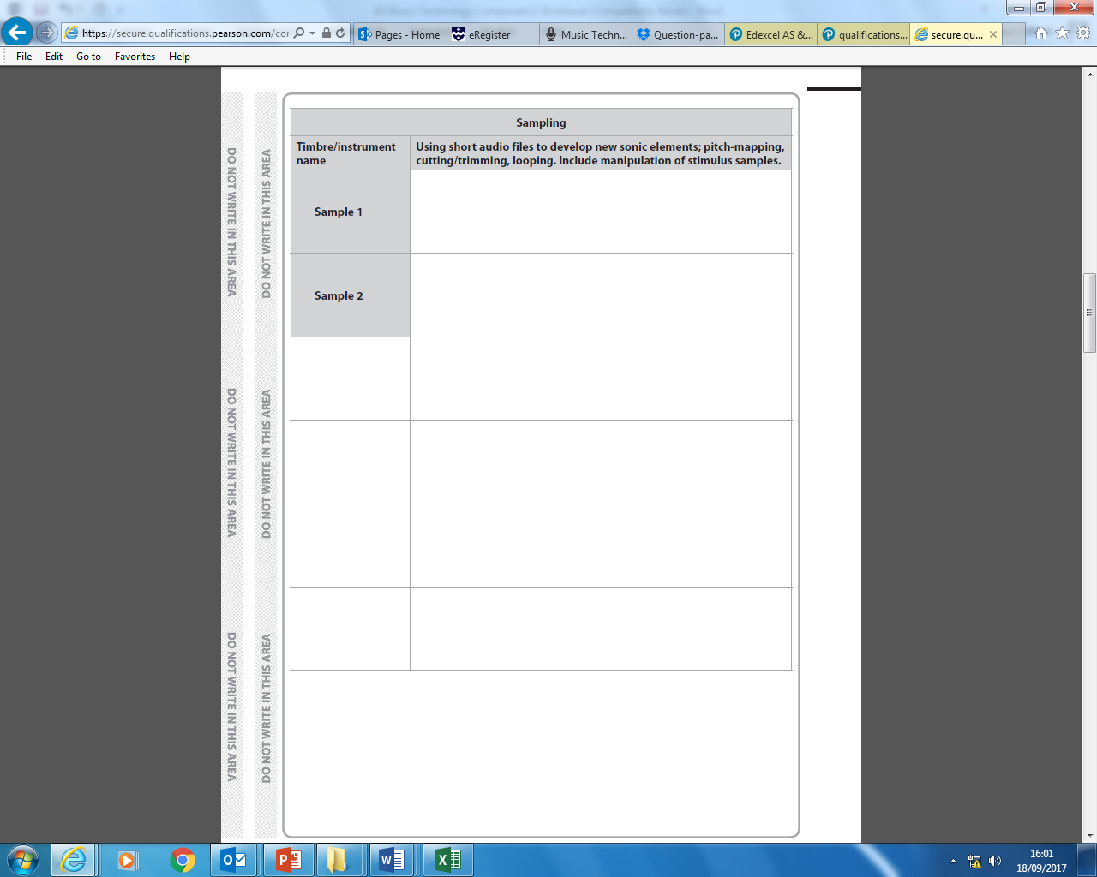

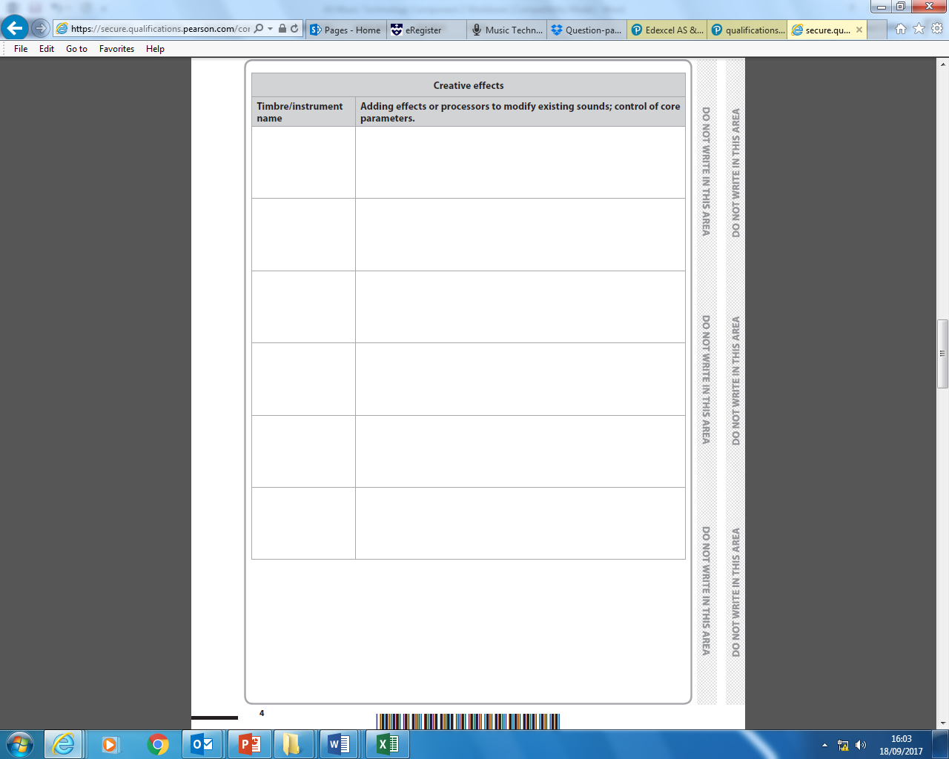

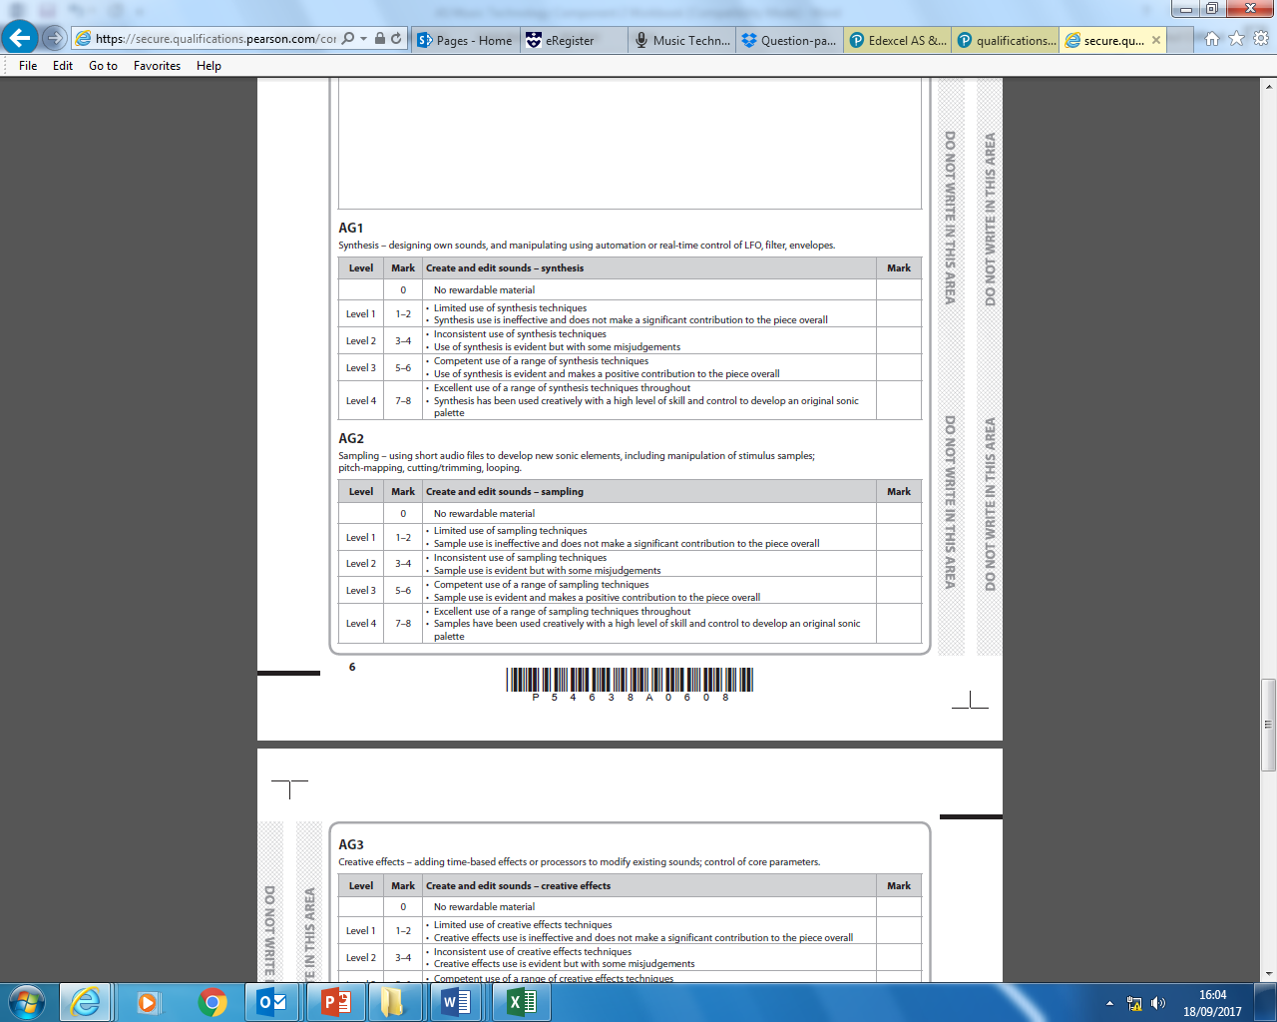

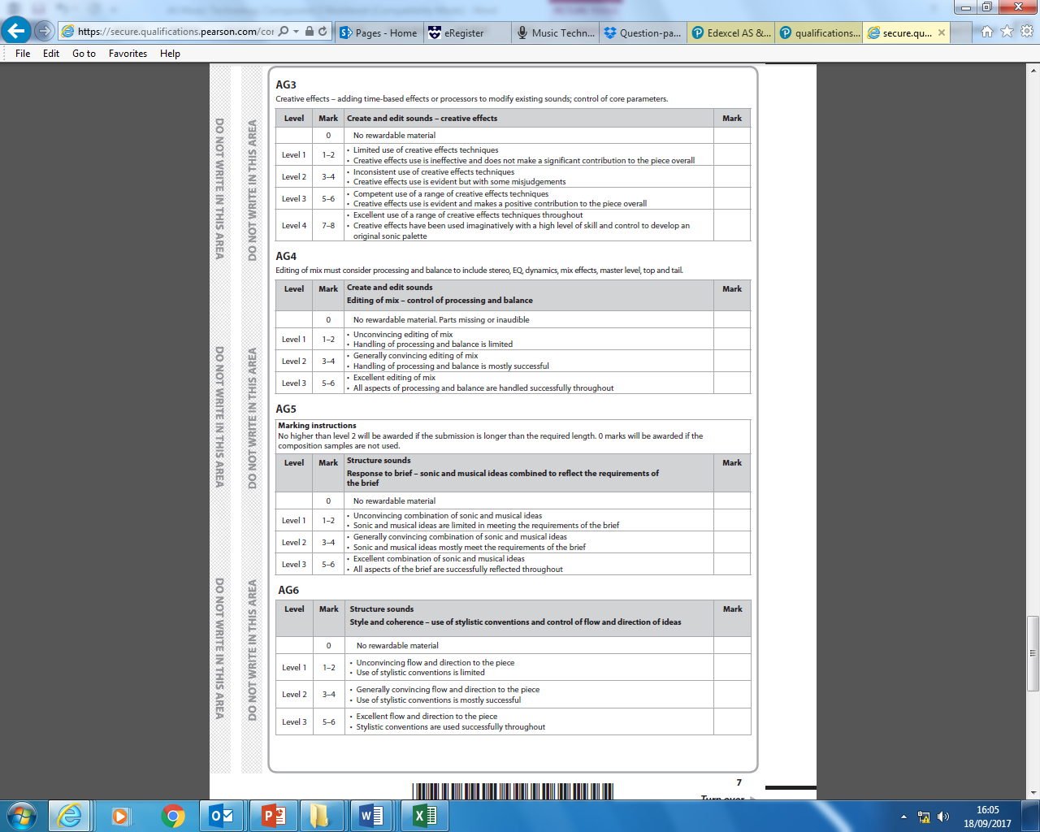
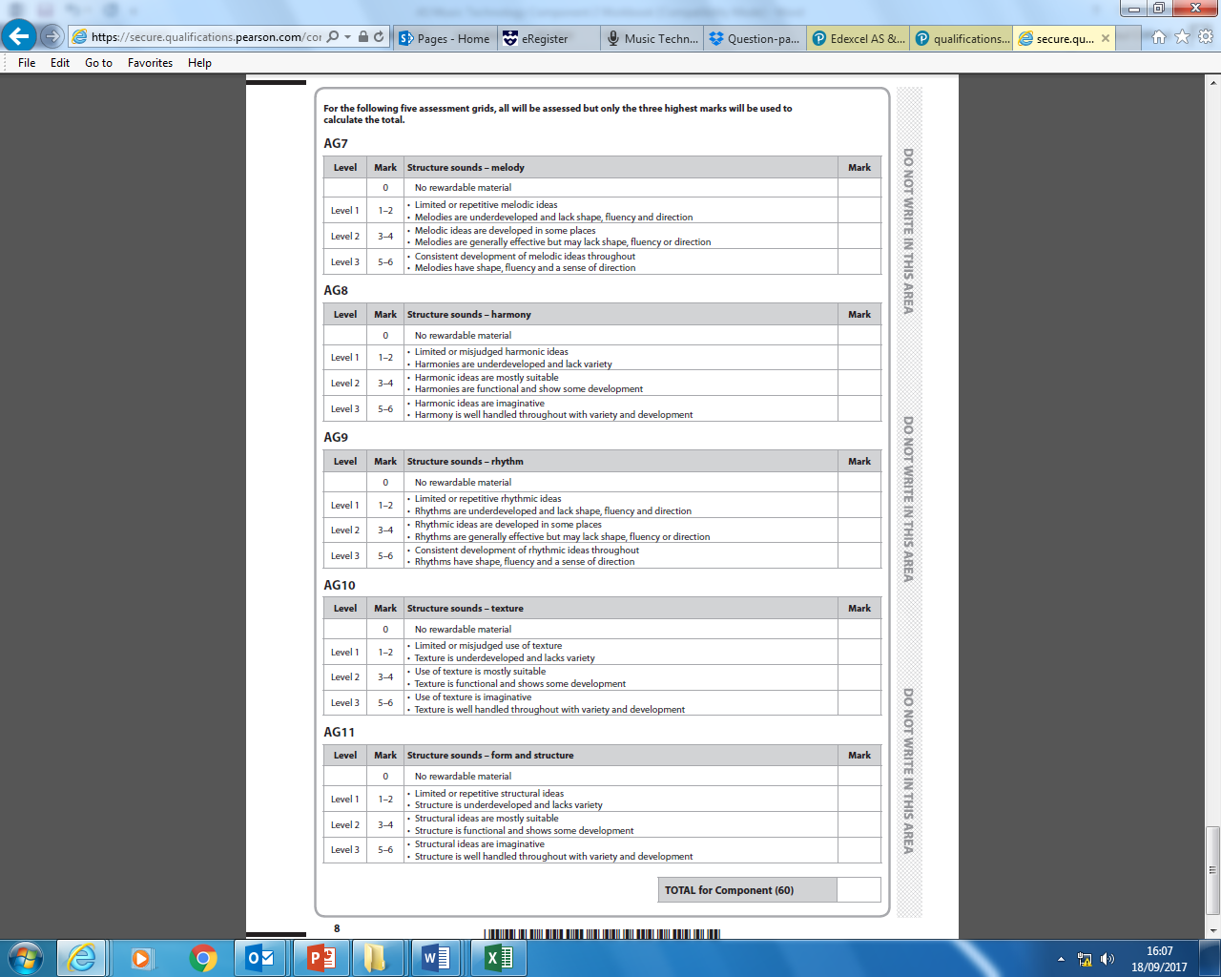 FINAL DRAFT: Composition Deadline 9th February 2018

LOG SHEET: RESEARCH AND PREPARATION
DATE | TIME IN | TIME OUT | DESCRIPTION | TOTAL TIME

LOG SHEET: COURSE WORK( MAX. 20hrs)
DATE | TIME IN | TIME OUT | DESCRIPTION | TOTAL TIME

Key Terminology
ACTIVE SENSING - a method by which a MIDI device detects disconnection. A message is sent to the receiver around three times per second, and if no message is received during this period, the unit assumes the MIDI connection has been broken. It then begins a routine to reestablish normal operation.
ADDITIVE SYNTHESIS - a synthesis method that builds complex waveforms by combining sine waves whose frequencies and amplitudes are independently variable.
ADSR - Attack, Decay, Sustain and Release are the four stages of an envelope that describe the shape of a sound over time. Attack represents the time the sound takes to rise from an initial value of zero to its maximum level. Decay is the time for the initial falling off to the sustain level. Sustain is the time during which it remains at this level. Release is the time it takes to move from the sustain to its final level. Release typically begins when a note is let up. In most sound generators, the time and the value reached are programmable.
AFTER TOUCH - a measurement of the force applied by a performer to the key on a controller after it has been depressed. Either polyphonic, which measures the pressure on each individual key, or monophonic, reflecting the total pressure on all keys.
AIFF - the standard file format for storing audio information on an Apple Macintosh computer.
ALGORITHM - a set of instructions supplied to a computer for the purpose of solving a problem.
ALL NOTES OFF - a three byte MIDI channel message that instructs the receiving device to terminate all notes currently sounding.
ALIASING (FOLD-OVER) - ``false frequencies'' that are created when sampling frequencies greater than one-half the sampling rate.
AMPLIFIER - a device that increases the amplitude, power or current of a signal. The resulting signal is a reproduction of the input signal as well as this increase.
AMPLITUDE - the strength or magnitude of any changing quantity when compared to its \Qat rest' or \Qzero' value.
ANALOG - information which is continuously variable in nature.
ANALOG SYNTHESIS - a method of sound synthesis that relies on predefined waveforms to create sounds that vary over time. The amplitude, frequency and harmonic content of these waveforms can be manipulated to produce a vast number of different results.
ARPEGGIATE - to play the notes of a chord in succession rather than simultaneously.
ATTACK - the initial stage of an envelope. Refers to the time from the beginning of the sound to its highest or maximum level.
BANK - a storage location in a sampler or synthesizer that typically holds a large number of individual program (sounds).
BINARY NUMBERS - a numbering system based on 2 in which 0 and 1 are the only available digits.
BITS (BYTES) - a binary digit. Mode of information used by a computer to store numbers. One bit equals a \Qone' or a \Qzero'. Usually 8 bits equals one byte, however, MIDI uses a 10 bit-byte that includes a start bit, the 8 - bit data message, and a stop bit.
BUFFER - an area of RAM used to temporarily store data.
CENTRAL PROCESSING UNIT (CPU) - a silicon chip that performs calculations and acts as the brain of a computer.
CHANNELS - one of 16 different data paths that are available to carry messages in MIDI.
CHANNEL MESSAGE - a type of MIDI message that carries specific channel information.
CHORUSING - a doubling effect commonly found on a synthesizer or sampler that makes a single sound appear to sound like an entire ensemble. The initial signal is split and appears at a slightly altered pitch from the original, or at a slightly later point in time. This time and pitch level are often controllable by a low frequency oscillator (LFO).
CONTINUOUS CONTROLLER - a type of MIDI message that is generated by the movement of a continuous control.
CONTROLLERS - various sliders, levers, knobs, or wheels typically found on a MIDI controller. Used to send continuous (as opposed to discrete) data to control some aspect of a sound.
DECIBEL -a decibel (or dB ) is 1/10th of a bel, which is a relative measure of two sounds.
DC (DIRECT CURRENT) - an electrical current that flows in one direction.
DECAY - one of the four basic stages of an envelope. Refers to the time the sound takes to settle into its sustain level.
DEFAULT - the "normal" or "startup" state of a hardware device or software application.
DELAY - a common effect in a sampler or synthesizer that mimics the time difference between the arrival of a direct sound and the first reflection to reach the listener's ears.
DIGITAL AUDIO - the numeric representation of sound. Typically used as the means for storing sound information in a computer or sampler.
DIGITAL SYNTHESIS - the use of numbers to create sounds. Method most often used in today's synthesizers for generating sounds, as compared to analog method employed previously.
DIN PLUG - a five-pin connector used by MIDI equipment.
DISTORTION - a process, often found desirable by guitar players, that alters a sound's waveform.
DRUM MACHINE - an electronic device, usually controllable via MIDI commands, that contains samples of acoustic drum sounds. Used to create percussion parts and patterns.
DSP - digital signal processing. Processes used to alter sound in its digital form.
DYNAMICS - the relative loudness or softness of a piece of music.
ECHO - the repetition of a sound delayed in time by at least 50 milliseconds after the original. An effect often found in synthesizers and samplers.
ENVELOPE - changes in a sound over time, including alterations in a sound's amplitude, frequency and timbre.
ENVELOPE GENERATOR - a device or process in a synthesizer or other sound generator that creates a time varying signal used to control some aspect of the sound.
ERROR CORRECTION - a procedure found in digital audio systems that detects and correct inaccurate or missing bits in the data stream.
EQUALIZATION (EQ) - boosting or cutting various frequencies in the spectrum of a sound.
FADE IN/OUT - a feature of most audio editing software that allows the user to apply a gradual amplitude increase or decrease over some segment of the sound.
FADER - also known as a slider or attenuator, this control allows the user to perform a gradual change to the amplitude of a signal. Commonly found as a feature of MIDI software programs.
FILTER - a circuit which permits certain frequencies to pass easily while inhibiting or preventing others. Typical filters include low pass, high pass, band pass, and band reject.
FLANGE - an effect applied to a sound wherein a delayed version of the sound is mixed with the original.
FM SYNTHESIS - a synthesis method that involves the interaction of a signal (carrier) by another (modulator).
FREQUENCY - the rate per second at which an oscillating body vibrates. Usually measured in Hertz (Hz), humans can hear sounds whose frequencies are in the range 20 Hz to 20kHz.
FUNDAMENTAL FREQUENCY - the predominant frequency in a complex waveform. Typically provides the sound with its strongest pitch reference.
GRAPHIC EQUALIZER - a device type that applies a series of bandpass filters to a sound, each of which works on a certain range of the spectrum. The frequencies that fall within the range, typically one-third octave, can be boosted or cut.
HARMONIC - a sine wave component of a complex sound whose frequency is a whole number multiple of the fundamental frequency.
HARMONIC SERIES - also known as the ``overtone'' series, this is the series of frequencies in a sound that are whole number multiples of the fundamental.
HERTZ - a measurement used to represent the number of times per second a waveform repeats its pattern of motion (cycle).
KEYBOARD SPLIT- a setup of a keyboard where different notes trigger different sounds. Also known as zoning.
LCD - Liquid Crystal Display. A small screen found on electronic instruments that displays data.
LFO - a low frequency oscillator that is used to alter a sound's frequency or amplitude.
LIBRARIAN - a category of MIDI software that is used to organize and store a MIDI device's patch (program) data.
LOCAL ON/OFF - a three byte channel message that determines the status of the Local On function of a MIDI device. LOCAL ON allows the instrument to produce sounds from incoming MIDI data and its own keyboard. LOCAL OFF states that only external MIDI data is responded to.
LOOP - to repeat a sequencer pattern or portion of an audio sample repeatedly. The point to which the program returns, whether the beginning or some other point, is usually definable by the user.
METRONOME - a device or software function that produces a discrete pulse. Used to synchronize music with a specific tempo.
MIDI - the Musical Instrument Digital Interface. An international standard for communication between a musical instrument and a computer.
MIDI CLOCK - a system real time message that enables the synchronization of different MIDI devices. The standard rate is 24 divisions per beat.
MIDI INTERFACE - a device that adds a MIDI In, Out and sometimes Thru port to a desktop computer.
MIDI MERGE - used to combine MIDI data from various sources into a single source.
MIDI MESSAGE - the different packets of data that form a MIDI transmission.
MIDI PATCHER - a device that allows the routing of one or more MIDI signals to various MIDI devices. Typically reconfigurable to allow for different routings of the data.
MIDI PORTS - the three connectors that pass MIDI data into (MIDI IN), out of (MIDI OUT) and through (MIDI THRU) a MIDI device.
MIDI TIME CODE (MTC) - a timing system used as a universal reference for all the devices in a MIDI network. Represents the information contained in a SMPTE signal using MIDI messages.
MIXER - a recording device that allows several different audio sources to be combined. Provides independent control over each signal's loudness and stereo position.
MODULATION WHEEL - one of several common continuous controls on a MIDI device. Often used to add a vibrato effect to a sound.
MONOPHONIC - the ability to play only one note at once. A characteristic of some older synthesizers.
MULTITIMBRAL - having the ability to produce many different musical timbres (sounds) at once.
MULTITRACK - in traditional recording technology, the ability to layer multiple different audio signals at once. In MIDI software, the ability to layer numerous MIDI data streams.
NOTE ON COMMANDS - a channel voice message that indicates a note is to begin sounding. Contains two additional data bytes: Note number and Note velocity.
NYQUIST FREQUENCY - the highest frequency that any given digital audio system can capture. Defined as one half the sampling rate of that system.
OCTAVE - a frequency ratio of 2:1. A musical distance (interval) of 12 semitones.
OSCILLATOR - an electronic device capable of generating a recurring waveform, or a digital process used by a synthesizer to generate the same..
OVERDUB - the ability to record one sound on top of another.
PATCH CORD - an audio cable used to connect the output of a device to an amplifier or mixer.
PAN - to move a signal from the left to the right of a stereo field, or vice versa.
PARAMETERS - characteristic elements of a sound that are usually programmable in a synthesizer or other MIDI device.
PARTIAL - a sine wave component of a complex sound.
PATCH EDITOR - a category of MIDI software used to control the sound characteristics of a synthesizer from a computer.
PATCHES - also variously known as programs, timbres, or voices. The name used for the sounds that can be generated by a MIDI device.
PERIOD - the time required for one cycle in a periodic waveform. Period is the inverse of frequency.
PHASE - the relative position of a wave to some reference point.
PITCH - a continuous frequency over time.
PITCH BEND - a MIDI controller that can vary the pitch of a sound.
POLYPHONIC - the ability to play many different notes at once.
POTENTIOMETER (POT) - a variable resistor used to alter voltage.
PRESETS - typically, the sounds permanently stored by the manufacturer in a sound generating device.
PROGRAMS (SEE PATCHES)
PROGRAM CHANGE MESSAGE - a two byte MIDI message used to request that a synthesizer change the currently loaded program.
PUNCH IN/OUT - the ability to start and stop a recording at some point other than the beginning.
QUANTIZATION - rounding or truncating a value to the nearest reference value. In a sequencer, used to adjust recorded material so it will be performed precisely on a selected division of the beat. In digital audio, the range of numbers used for specifying amplitude levels of a recorded signal. (16 bit quantization = 65,536 values; 8-bit = 256, etc.)
RAM - random access memory. The temporary storage area of a computer or sampler.
REAL TIME - a recording or realization of a sound processing procedure as it occurs. (see Step Time).
RECEPTION MODE - one of four basic configurations used by a synthesizer that determines how it will respond to incoming data.
ROM - read only memory. Permanent memory in a computer or MIDI device.
SAMPLER - an electronic device that can record, alter and playback digital audio data under the control of a MIDI data stream.
SAMPLING - digitizing a waveform by measuring its amplitude fluctuations at some precisely timed intervals. The accuracy of the measurements is a function of the bit resolution.
SAMPLING RATE - the rate at which samples of a waveform are made. Must be twice the highest frequency one wishes to capture. Commercial compact discs use a rate of 44,100 samples per second.
SEQUENCER - MIDI software or less commonly, a hardware device that can record, edit and playback a sequence of MIDI data.
SINE WAVE - the most basic waveform, consisting of a single partial. Forms the basis of all complex, periodic sounds.
SMPTE TIME CODE - a timing standard adopted by the Society of Motion Picture and Television Engineers for controlling different audio and video devices. Allows a sequencer and an external device such as a tape recorded to stay synchronized.
STEP TIME - entering notes one by one, as opposed to real time recording in a sequencer.
SONG POSITION POINTER (SPP) - a system-common message that specifies where in a sequencer a device should begin to play.
STANDARD MIDI FILE - a standardized form of data used for exchanging MIDI files between programs.
STATUS BYTE - the first byte of a MIDI message that specifies what type of message it is.
SUSTAIN PEDAL - a pedal on a MIDI controller (or acoustic piano) that keeps all notes sounding even a key is released.
SYSTEM COMMON MESSAGES - MIDI messages used for various functions including tuning an instrument and song selection.
SYSTEM EXCLUSIVE MESSAGE - MIDI message used to communicate with a device made by a specific manufacturer.
SYSTEM REAL TIME MESSAGES - commands used to synchronize one MIDI device with another.
TEMPO - the rate of speed at which a musical composition proceeds. Usually uses a quarter note as the timing reference.
TIMBRE - the property of a sound that distinguishes it from all other. Tone color.
TREMELO -a rapid alternation of two tones. Usually a third apart. On a synthesizer, this effect can usually be controlled by the modulation wheel or modulation amount.
VELOCITY - a measure of the speed with which a key on a controller is pressed. Used to determine volume characteristics of note.
WAVEFORM - the graphical display of a sound pressure wave over time.
WAVETABLE - a storage location that contains data used to generate waveforms digitally.

