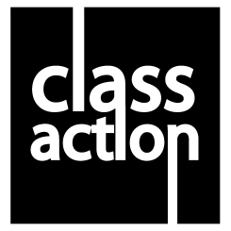

**SELECTION OF MONOLOGUE CHOICES**

**Most of the texts can be found on GoL**

**Code**

**M = male**

**F=Female**

**B = Both**

**N = Gender neutral**

**Monologues**

Posh (M)

Carmen Disruption (B)

Many Moons (B)

After The End (F)

Orca (F)

Monsters (F)

Lela & Co (F)

Revolt. She Said. Revolt Again (F)

Lungs (F)

Widows (F)

Frozen (B)

People, Places and Things (B)

Every Brilliant Thing (N)

About a Goth (M)

Spacewang (F)

Notes for First Time Astronauts (M)

Things I Know To Be True (B)

Blood Wedding (F) under 2 minutes

Chalk Farm (B)

Five Kinds of Silence (B)

Pornography (B)

1984 (M)

The Pitchfork Disney (B)

Grounded (F)

Curious Incident (M)

The Laramie Project (B)