RWS15: Other Market Structures Booklet
OLIGOPOLY, MONOPOLISTIC COMPETITION AND THE THEORY OF CONTESTABLITIY

The theory of contestability
Contestability occurs when there is freedom of entry and exit into the market. Thus in a market which is contestable, there will be low sunk costs.(Costs which can’t be recovered when leaving the market). Factors which determine the contestability of a market.
- Sunk Costs. If Sunk costs are high this makes it difficult for new firms to enter and leave the market. Therefore it will be less contestable. For example, if a new firm had to purchase raw materials, that it wouldn’t be able to resell on leaving the market, this may act as a deterrent.
- Levels of advertising and brand loyalty. If an established firm has significant brand loyalty such as Coca Cola, then it will be difficult for a new firm to enter the market. This is because they would have to spend a lot of money on advertising which is a sunk cost. Even if they spend money on advertising it may not be sufficient to change customer loyalty to very strong brands. It depends on the industry, customer loyalty would be fairly low for a product like petrol because it is quite homogenous. But, for soft drinks people have greater attachment to their ‘brand’
- Vertical Integration If a firm does not have access to the supply of a good then the market will be less contestable. E.g. Oil firms could restrict the supply of petrol to petrol stations, making it difficult for new firms to enter. If you wish to sell electricity to domestic customers, a big issue is whether you can gain access to the electricity grid. The national electric grid is a natural monopoly, but government regulation can make sure firms have a fair access to the grid. Giving access to different stages of production can make the market more contestable. (How vertical barriers can restrict competition)
- Access to technology and skilled labour For some industries like car production it is difficult for new firms to have the right technology. Nuclear power may require skilled labour that is difficult to get. This makes the market less contestable. If you wished to compete with Google, you may find it hard to employ the best software engineers because Google pays its employees a very good wage and is seen as an attractive company to work for.
- See also: other barriers to entry below

As well as looking at barriers to entry, there are other factors that might indicate the competitiveness of a market.
- The level of profit. If the market is highly profitable, this suggests the market is less contestable. In theory, if firms are making supernormal profit, it would attract new firms into the market. The persistence of supernormal profits suggests that hit and run competition is not possible and there are barriers to entry.
- The number of firms. A contestable market could have a low number of firms – as long as there is the threat and possibility of new firms entering. However, if there are only a few firms and it has been many years since any new firms have entered, then it is likely to be less contestable. If there are recent examples of firms entering the market, then it is likely to be more contestable.
- It is important to remember that contestability is not a clear cut issue, there are degrees of contestability, some markets having more capacity for new firms to enter. In practise few industries are perfectly contestable. For example – UK Banking industry
Not contestable | Contestable
- There are high sunk costs in getting a network of banks set up around the country..  - Brand loyalty to existing banks is high. Customers are not so willing to switch. Therefore a new firm may have to spend a lot on advertising to attract new customers, which is a sunk cost, therefore not contestable.  - Existing banks make very high profits, suggesting hit and run competition does not occur. | - The introduction of the internet has reduced set up costs and enabled new firms to enter the market for online banking e.g. EGG, Virgin business.  - The government is trying to introduce regulation to reduce the time and costs of switching to another current account.

More on Barriers to Entry
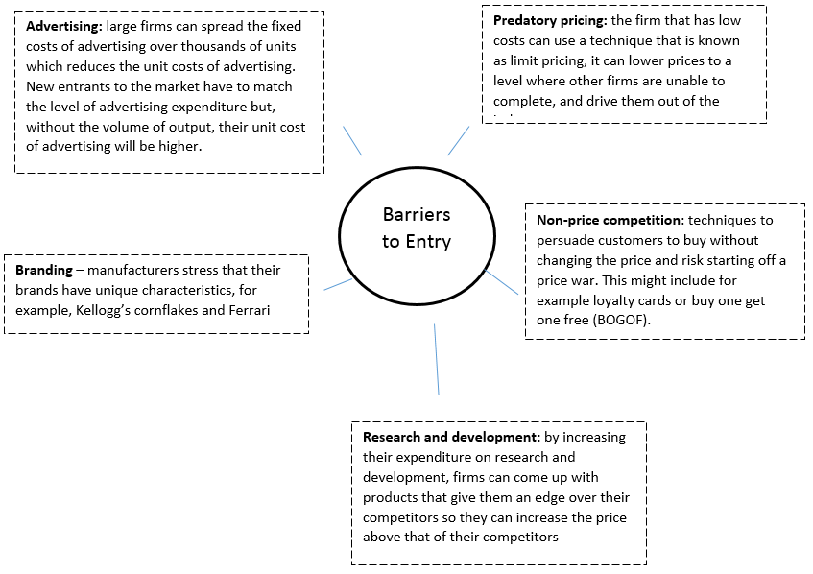 | TASK: Complete these questions  - What other barriers to entry could be added to this diagram?  - Which barriers are natural and which are artificial (place an N or A in each box)  - Explain what barriers to entry firms in the Grocery Market (say Tesco) and in the Energy Market (say EDF) have to protect them?
Monopolistic Competition
A market structure where there are large number of buyers and sellers who are price makers as they sell differentiated products and have low barriers to entry and exit. Firms in monopolistic competition are assumed to profit maximise (MC = MR) and are characterised by:
- Product Differentiation rather than having a homogeneous product. This gives each firm a little bit of market power and the ability to be a price maker, with a downward sloping demand curve.
- Low barriers to entry or exit so firms face potential competition in the long-run
- Large number of buyers and sellers so firms face competition from many similar firms with slightly different products, which limits the firms ability to raise their price significantly (demand will be elastic).

NB. Many students confuse monopolistic competition with monopoly; in fact monopolistic competition is nearer to perfect competition just with differentiated products.

Monopolistic Competition Examples?
TASKS: Which of these markets is the best example of monopolistic competition? Use the assumptions of monopolistic competition to help you.
LOCAL TAXI FIRMS | LOCAL HAIRDRESSERS | LOCAL TAKEAWAY | Your Answer:
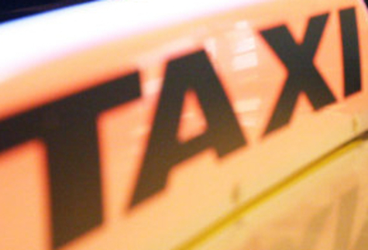 |  | 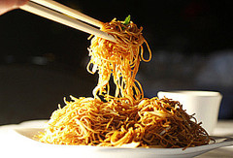

Economic Analysis: Drawing the Monopolistic Competition Model
a) Downward sloping elastic demand
The monopolistic competition diagram resembles the monopoly diagram we studied earlier. Demand slopes downwards due to each firm having some market power due to their differentiated product. However, demand will be relatively elastic as each firm faces competition (there are many substitutes) so firms will lose revenue if they increase their price significantly as consumers will go to competitors. Firms are therefore price makers in the short run due to their product differentiation but do not have as much market power to increase price as a monopoly due to the competition they face.

b) Short-term abnormal profits & deadweight loss
Firms can earn abnormal profits in the short-term (as shown above). However, this is only the short-term equilibrium. We need to look at the long-run situation too where firms can enter and exit the market due to low barriers to entry & exit. Note like in monopoly there is also deadweight loss present.

(c) Long- run Equilibrium: Monopolistic Competition
In the long-run more firms are able to enter the market to take advantage of the supernormal profits, due to low barriers to entry and exit. With new firms entering the industry with their differentiated products there will be two changes to the industry, specifically to a firm’s demand:
- Lower demand: new firms will attract customers away from existing firms, making demand: this will mean demand will fall for the existing firm.
- More elastic demand: more substitutes for original product will now exist, making demand more elastic. Firms are less able to increase price due to the influx of competition.
In the long-term firms will only be making normal profits (AR = AC) and there is no incentive for further incentive for exit or entry. There is also deadweight loss present.

TASK: Using the information above, draw the two diagrams below:
Short- run Equilibrium: Monopolistic Competition | Long-run Equilibrium: Monopolistic Competition
Economic Inefficiency under Monopolistic Competition
Even with only a very minor change to the assumptions from perfect competition (i.e. having differentiated products), the impact on efficiency is dramatic. In fact monopolistic competition is never productively nor allocatively efficient in the short or long-term.

Firms in a monopolistically competitive market will not be allocatively efficient because they are setting their price above marginal cost and are exploiting their market power gained from product differentiation. They are also not producing at the minimum of their AC curve, so will not be productively efficient. You could argue that they still have some market power allowing them to use price to cover some increases in average cost.

Evaluation Points
Monopolistic competition is often characterised by product differentiation and advertising, it is worth considering whether these are desirable characteristics. This is in contrast to perfect competition where firms have no need for advertising (due to perfect information) and do not have differentiated products (they are homogeneous). However, other firms with market power will use both these strategies, such as in an oligopoly.

a) Product Differentiation:
- Impact on Producers: does benefit producers as it gives them some market power to set price above perfectly competitive levels. It also reduces their risk if they have more than one product on offer (e.g. a wide range of options on the takeaway menu). However, it does cost the firm to develop & market these products and there is no guarantee that consumers will have a preference for your differentiated product over your rivals.
- Impact on Consumers: consumers will benefit from having a wider range of choice than when producers all have the same products (product homogeneity). However, it is possible that product differentiation allows firms to have greater market power and the ability to increase their price and exploit consumers.

b) Advertising if done effectively can persuade consumers to buy products and increase firm revenue, hopefully more than it raises costs. It also increases entry barriers which increases market power of current firms. Consumers can also benefit from increased information if advertising is informative, although persuasive advertising may lead to buying products they don’t need and prices may be higher due to market power.

TASK: Using the information above, you should now be able to answer these questions below:
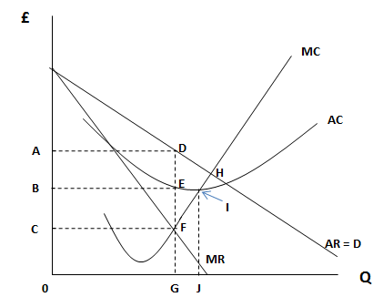 | The diagram to the left shows a local window cleaner in a town, operating under the conditions of monopolistic competition. We are assuming profit maximisation.  1. Why will there be downward sloping demand for the window cleaner?

2. What do the following letters represent?
a) ADEB |  | b) ADGO |  | c) BEGO |  | d) DHF |  | e) Producing at E not I

3. In the long-run what will happen to:
a) Supernormal profits |  | b) Demand

4. In the long-run, will the window-cleaner be economically efficient?\

Oligopoly (and Duopoly)

INTRODUCTION (40m)
Oligopoly is a market structure where a few large firms have a majority of the market share. Oligopolistic industries are dominated by large firms who have the majority of the market share however there might also be quite a large number of smaller firms operating in the same market. A large number of the goods and services which are produced are under oligopolistic conditions in the UK.

Duopoly is a form of oligopoly. In its purest form two firms control all of the market, but in reality the term duopoly is used to describe any market where two firms dominate with a significant market share. There are many examples of duopoly; including Coca-Cola and Pepsi (soft drinks), Unilever and Proctor & Gamble (detergents), Bloomberg and Reuters (Financial information services), Standard and Poor’s and Moody’s (credit rating agencies), and Airbus and Boeing (aircraft manufacturers). In these markets entry barriers are high although there are usually smaller players in the market surviving successfully.

An oligopoly usually exhibits the following features:
- Inter-dependent and uncertain decision-making: Inter-dependence means that firms must take into account the likely reactions of their rivals to any change in price, output or forms of non-price competition. They are independent in being able to make their own decisions but firms in oligopolistic competition display reactive behaviour in determining their price and output decisions. They cannot be sure that their decision will have the desired outcome; there is risk involved. This is a crucial assumption as it means there is no single theory of price and output under conditions of oligopoly unlike the other three market structures. If a price war breaks out, oligopolists may choose to produce and price low like a competitive industry would; whereas at other times they act like a pure monopoly and push prices higher. Equally the price might stabilise.
- Product branding: Each firm in the market is selling a branded product and so goods are heterogenous although there maybe relative close substitutes.
- Non-price competition: Non-price competition is a consistent feature of the competitive strategies of oligopolistic firms.
- Entry barriers: Entry barriers maintain supernormal profits for the dominant firms. It is possible for many smaller firms to operate on the periphery of an oligopolistic market, but none of them is large enough to have any significant effect on prices and output

TASK: Give examples of 3 industries that you believe are operate in an Oligopolistic market
1.
2.
3.

Concentration Ratios
Economists measure the market strength of the larger firms in terms of a concentration ratio so a concentration ratio of 5:80 means 5 firms control 80% of the market. TASK: Answer the questions below:
Supermarkets’ % of market share  Tesco 31  Asda 17  Sainsbury’s 16  Morrisons 12  Somerfield 4  Waitrose 4 | - Calculate the five and 3 firm concentration ratio in the supermarket industry.  - Explain how Tesco may be seen as different from the rest of the firms in the industry.  - What proportion of the market share is left to other firms if there is a 3 firm concentration ratio?

UK Newspaper Market Share
The various newspaper companies below demonstrate the  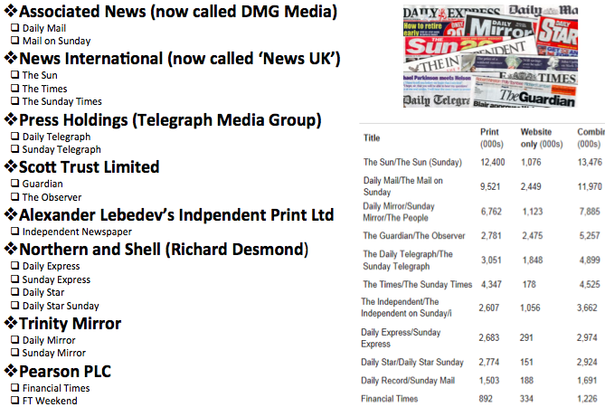 | TASK: If we use the combined circulation of print and website access, what is the concentration ratio of the following companies:  - News International  - Telegraph Media Group  - DMG Media  - Trinity Mirror  - Pearson  - Northern and Shell  Does any of the news companies have a ‘legal monopoly’ in this oligopolistic market?
STRATEGY 1: COMPETITION - PRICING STRATEGIES IN AN OLIGOPOLISTIC MARKET
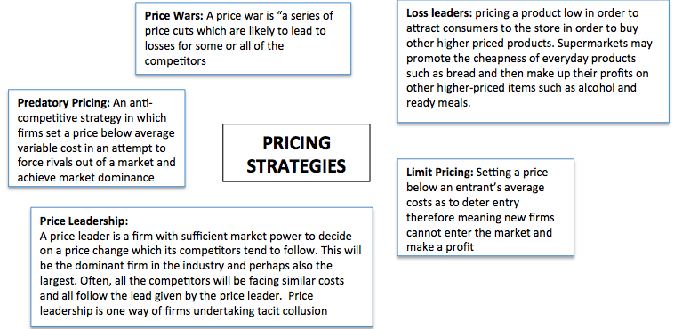

CASE STUDY: London Newspaper Market – TASK: Read the account below and using the info above, complete the questions on the right
1960 - 3 large companies selling papers to London commuters. One of these is the Associated Newspapers famous ‘Evening Standard’ with 2.2 million copies being sold. They are sold in the Evening for commuters as they return home to share the days news.  1980 - Evening Standard becomes a monopoly for a pure London based ‘local’ paper by lowering it’s prices - this pushes out existing firms and deters other firms from entering or if they do enter, from staying too long.  1990’s - Even though it has monopoly power, sales of the Evening Standard fall to just 340,000 copies being sold (things are looking bad for the Evening Standard compared to 1960). However advertising revenues increased by 34 per cent over the same period). Therefore still profitable with 75% of revenue coming from advertising and 25% from the cover price.  2000 - Associated Newspapers launched a second paper, the ‘Metro’, a free newspaper for those travelling on the London underground. Metro costs money to produce but doesn’t raise any revenues from the cover price (because it is free) and only earns money from advertising. The Metro is also much smaller and it’s stories are very short compared to the Evening Standard.  2004 - Associated Newspapers launched a third paper, the ‘London Lite’ which was another free newspaper distributed at lunchtimes from the same central London newsstands that sell the Evening standard  2006 - News International (a rival company) launch ‘thelondonpaper’ which was available for free in the afternoon AND evening. Associated Newspapers responded by making ‘London Lite’ available at the same times.  2007 - by the end of the year both ‘London Lite’ and ‘thelondonpaper were making a loss  2009 - ‘thelondonpaper’ is taken from circulation due to making £12.9m losses; it never made any profit. The ‘London Lite’ is pulled from circulation 3 weeks later.  2009 - The Evening Standard is taken over by a Russian businessman for £1 (takes 75% stake in the business) and The Evening Standard was launched for the first time in it’s 180 year history as a free paper. The Metro continues to be owned by Associated Newspapers and branches out to other urban areas.  2017 - All London newspapers are starting to struggle as advertising revenues fall with the advent of internet based communications. | - What type of pricing strategy did the Evening Standard employ in 1980?  - Associated newspapers launch a second paper in 2000 and then a third in 2004 to complement the Evening Standard but for free? What type of pricing strategy is that?  - From 2006, a new competitor enters the market (News International). What followed is a good example of which pricing strategy?

TASK: Draw a cost/revenue diagram for an oligopolistic firm employing a limit pricing or predatory pricing strategy. HINT: the firm will not be profit maximising but trying to achieve the lowest price possible…can you explain why?
STRATEGY 2: COMPETITION - NON-PRICE
Non-price competition assumes increased importance in oligopolistic markets.
- Branding: This involves advertising and marketing strategies to increase demand and develop brand loyalty among consumers. Businesses will use other policies to increase market share:
- Better quality of product or service including guaranteed delivery times for consumers and low-cost servicing agreements and perhaps longer opening hours for retailers, 24 hour online customer support etc.

The kinked demand curve model
The kinked demand curve model assumes that a business might face a dual demand curve for its product based on the likely reactions of other firms to a change in its price or another variable. The assumption is that firms in an oligopoly are looking to protect and maintain their market share and that rival firms are unlikely to match another's price increase but may match a price fall. I.e. rival firms within an oligopoly react asymmetrically to a change in the price of another firm. If a business raises price and others leave their prices constant, then we can expect quite a large substitution effect making demand relatively price elastic. The business would then lose market share and expect to see a fall in its total revenue. If a business reduces its price but other firms follow suit, the relative price change is smaller and demand would be inelastic. Cutting prices when demand is inelastic leads to a fall in revenue with little or no effect on market share.

The kinked demand curve model makes a prediction that a business might reach a stable profit-maximising equilibrium at price P1 and output Q1 and have little incentive to alter prices and therefore there will be long spells of relative price stability under an oligopoly with businesses focusing on non-price competition as a means of reinforcing their market position and increasing their supernormal profits.

Short-lived price wars between rival firms can still happen under the kinked demand curve model. During a price war, firms in the market are seeking to snatch a short term advantage and win over some extra market share. Recent examples of price wars include the major UK supermarkets, price discounting of computers in China and a price war between cross channel speed ferry services. Price competition is frequently seen in the telecommunications industry.

TASK: Draw the kinked demand curve below based on the explanation above and explain why this means that prices are likely to stay stable at one point? Feel free to research on internet but try and have a go at drawing it yourself first and understanding it before you look up the answer!
STRATEGY 3: COLLUSIVE OLIGOPOLY (30m)

Firms will collude in order to try and increase their profits and in order to face less competition (especially on price). However, collusion is illegal and is punishable under competition law. They can be fined up to 10% of UK turnover and executives could face time in jail. The problem that Competition authorities face is that is often very hard to prove definitively that collusion has taken place as firms may claim that they are not colluding but just competing in an industry with similar costs which means similar prices. There are two types of collusions:  - Tacit Collusion: Firms agree to restrict competition without a formal agreement  - Overt Collusion: Firms agree to restrict competition using a formal agreement | TASK: Draw a diagram to represent what would happen if the 4 largest firms in an oligopolistic market decided to covertly collude to raise prices. Explain why this would NOT be statically efficient?

Examples of Collusive Oligopoly
Extract 1: Top 50 independent schools found guilty of price-fixing to push up fees  Fifty of the country's leading private schools were found guilty yesterday of running an illegal price-fixing cartel which investigators said had allowed them to drive up fees for thousands of parents.  Following one of the biggest inquiries in its history, the Office of Fair Trading published provisional findings showing the schools, which include Eton and Harrow, had exchanged detailed financial information in a regular report known as the Sevenoaks survey.  "This ... systematic exchange of confidential information as to intended fee increases was anti-competitive and resulted in parents being charged higher fees than would otherwise be the case," the OFT stated.  The Guardian, Thursday 10 November 2005 | Extract 2: Banking (August 2012)  Seven banks, including HSBC and Royal Bank of Scotland, are to be questioned in the US for alleged manipulation of the Libor inter-bank lending rate. Barclays, Citigroup, Deutsche Bank, JPMorgan and UBS have also received subpoenas from the attorneys general of New York and Connecticut.  Last month, Barclays was fined £290m by UK and US regulators for rigging Libor. US regulators said they were investigating potential involvement by other banks in the Barclays scandal.  The investigation is predicated on the assumption that at least one other bank must have colluded with Barclays in any attempts to manipulate Libor rates, which are used as a reference to price trillions of dollars of financial products.  Daily Telegraph, August 2012

TASK: Using the notes from your case studies, to what extent have the supermarket and grocery markets been colluding?
Arguments for why they have been colluding | Arguments for why they have not been colluding

DO YOU UNDERSTAND?

TASK: imagine you are the CEO of Tesco’s, what is the best strategy you might employ to grow your market share in the grocery market? | TASK: imagine you are the CEO of British Gas, what is the best strategy you might employ to protect your market share in the retail energy markets

SHORT ANSWER QUESTIONS – TASK: answer one of these questions in full below on a separate piece of paper
- “Firms in Oligopoly markets are likely to take part in non-price competition”. Explain what is meant by non-price competition in the context of oligopoly markets. (10 marks)
- “Prices in Oligopoly markets tend to be stable.” Explain this statement. (10 marks)
- Explain why firms in oligopolistic markets are ‘interdependent’? (10 marks)
- Explain why Oligopolistic firms are affected by both interdependence and uncertainty when selling their product. (15 mark)
- ‘A pharmaceutical company can expect to make supernormal profits on a new drug or medicine in the short run’. Explain why some firms might be able to continue to make supernormal profits in the long run (15 Marks)

ESSAY QUESTIONS – TASK: Plan the main body of your essay roughly below
- Evaluate whether firms in Oligopolistic Markets are good for society (25 marks)

