PRICING AND NON PRICING STRATEGIES

**Introduction**

Although firms generally aim for price stability and non-price competition there are some other pricing strategies open to them as well.

**1. Pricing Strategies**

**a) Predatory Pricing**

“An anti-competitive strategy in which firms set a **price below average variable cost** in an attempt to **force rivals out** of a market and achieve market dominance.”

**AFC =  
  
£2**

**AVC =  
  
£1**

Set predatory price

**Price =  
  
£0.99**

* Predatory pricing is therefore used by firms when they are faced with competition in a market and want to eliminate it.
* They are then free to set higher prices and gain supernormal profits in the long-term.

**Limitations**

1. **Re-entry to the market:** you could argue that firms would have an incentive to enter the market again if price was raised. However, the firm should by now have gained a reputation to fight ‘tough’ with new entrants and so they will be afraid to enter again (by consistently fighting new entrants).
2. **Legality**: predatory pricing is illegal and anti-competitive, firms caught doing this could face fines & other punishments. However, the profits and market dominance (and ability to set higher prices) that result still gives a large incentive for firms to engage in such practises.
3. **Short-term loss:** this strategy does involve making substantial short-term losses and therefore only large dominant firms (with large cash reserves) could employ this strategy

**b) Limit Pricing**

“Setting a **price below an entrant’s average costs** as to **deter entry** therefore meaning new firms cannot enter the market and make a profit”

**Price =  
  
£3.99**

Sets limit price

**AC   
(Incumbent)  
a  
£3**

**AC   
(Entrant)  
a  
£4**

Cannot enter and make a profit

* Limit pricing involves setting a price so that if there was entry the entrant would not be able to make any economic profit.
* It is assumed that the current (or incumbent) firm will have lower AC due its experience in the industry.
* To deter entry into the market the incumbent will **set a price lower** **than the entrant’s average cost.**
* Therefore the entrant cannot enter and set a price of £3.99 and make a profit as their costs are £4.
* The advantage is that although the entrant would only make normal profit, the current firm should make abnormal profits due to having a lower average cost.

**Limitations**

1. **Lower profits:** for the strategy to be successful the firm must keep limiting their price to deter new entry. Therefore, less abnormal profit will be made each year. However, there is of course the advantage of less entrants competing with the firm which would reduce profits
2. **Success depends on cost advantage:** the extent to which you can still make abnormal profits whilst limiting your price depends on how much lower your average cost is compared to potential rivals. If average costs are similar prices will have to be very low and profits limited severely for the incumbent firm
3. **Imperfect Information:** it may be difficult for firms to know what a *potential* entrant’s average cost will be before they set-up. This makes setting the correct price to limit entry very difficult. To some extent the firm would have to either do extensive research about potential average costs of entrants (increasing their cost) or use trial & error which is prone to mistakes.
4. **Consumer Reaction:** although consumers may be in favour of a lower price they may argue that they now have lower and choice. This could have impacts on the firms reputation and future sales.

**c) Price Leadership**

A **price leader** is a firm with sufficient market power to decide on a price change which its competitors tend to follow. This will be the dominant firm in the industry and perhaps also the largest. Often, all the competitors will be facing similar costs and all follow the lead given by the price leader.

Price leadership is one way of firms undertaking **tacit collusion,** meaning that firms in the market observe each other’s behaviour closely and refrain from competing with each other on price, even if they do not actually communicate with each other.

**Barometric price leadership** iswhere one firm tries out a price increase and then waits to see if other firms follow. If they do, a new higher price has been reached without the need for overt discussions between firms. Alternatively, if the other firms do not feel it is time for a change they will keep their price steady and the first firm will drop their price back down.

The advantage of price leadership is that if it successfully initiates a period of collusive behaviour then profits can be higher for all firms involved, including the price leader.

**Limitations**

1. **Legality:** if the price leadership means that collusion takes place and prices are fixed at a higher level then the Competition Commission (CC) may view this as anti-competitive and punish the offending firms (e.g. with fines & prison sentences). However, the CC needs to be able to prove collusion has taken place.
2. **Reputational Effects:** if firms are then caught colluding not only will they be fined but the firm’s reputation could be damaged, impacting on future sales.
3. **Short-term Revenue Loss:** in the short-term firms could lose total revenue as they are pricing above their rivals and other firms may not even follow suit.
4. **Only dominant firms can use it successfully:** this strategy tends to be used by the market leader (i.e. in terms of market share), small firms may not have enough influence to alter pricing decisions of larger firms (e.g. a newsagent couldn’t use price leadership to get Tesco to raise their prices and tacitly collude).

**d) Price Wars**

A **price war** is “a series of price cuts which are likely to lead to losses for some or all of the competitors”.

* Price wars may be started by a dominant firm with a **predatory pricing** strategy and an objective of driving one of the small players out of the market.
* They occur from time to time among newspapers, package holidays & petrol companies with firms trying to gain market share off each other. They also benefit firms as they show customers that the firm cares about pricing which is valuable in some markets.
* Supermarkets have also engaged in price wars as a **loss leader** strategy where the firm makes a loss on certain products but attracts customers to their stores.
* Price wars often do not last long due to the loss of profits for all concerned and are often followed by a long period of price rigidity.

**Limitations**

1. **Loss of profits:** price wars result in lower profits for all firms initially. Although this may be compensated for by higher long-term profits (predatory pricing) or rises in profits elsewhere (when using loss leaders).
2. **Legality & Reputation:** if a price war is used to drive firms out of market in a predatory way (pricing below average variable cost) by a dominant firm then just as before the Competition Commission may punish firms and this may damage future sales & reputation.

**e) Other Pricing Strategies (Extension)**

Here are some other strategies you can bring into your answers in the exam but won’t be specifically required:

* **Premium or Prestige pricing**: pricing high in order to signal high quality. Classic examples of this would be in jewellery where the price is often used by consumers with imperfect information to judge the quality of the product.

**Limitations:** However, if consumers do not judge the product to be high quality then they may be deterred by the high price (i.e. they may just go to cheaper rivals who they perceive to have just as good quality).

* **Penetration pricing:** initiallypricing low in order to introduce a product. The best example of this is with new magazines where an initial price is set for the first issue to allow consumers to try the magazine and they hope that consumers will then bear the higher price as they will become loyal to the product.

**Limitations:** However, setting a low price for the product can be risky as you may be making a loss at a time when there are significant start-up costs to cover. This may work best for a business with several products as they could use other profitable products to cross subsidise the new product.

* **Price skimming:** pricing a product high and then gradually reducing price over time. This is often done with games consoles where the customers who need to have the product brand new and be the first with it will be willing to pay a higher price and then when the price is lowered people with lower willingness to pay will also buy the product.

**Limitations:** However, the high initial price may put people off buying the new product (especially if they are undercut by rivals). There is also an issue that the profit margin earned will decrease over the products lifetime.

* **Loss leaders:** pricing a product low in order to attract consumers to the store in order to buy other higher priced products. Supermarkets may promote the cheapness of everyday products such as bread and then make up their profits on other higher-priced items such as alcohol and ready meals.

**Limitations:** However, you will be making a loss (or reduced profits) on the loss leaders themselves and it assumes that consumers will shop for other products in your store rather than just buying the loss leaders.

**2. Non-Pricing Strategies (i.e. Product, Place, Promotion)**

**a) Advertising**

**Advertising: "**the activity of attracting public attention to a product or business, as by paid announcements in the print, broadcast, or electronic media.**"**

* Advertising is conducted by many oligopolistic industries in order to **boost demand** and profits by informing and persuading customers to buy their goods and services.
* Furthermore, advertising could be a **barrier to entry** (and exit) and therefore could be used to increase market dominance and to preserve a firm’s market power and abnormal profits and inefficiencies.

**Limitations**

1. **Cost:** advertising will increase a firm’s average costs and therefore some firms may not be able to afford this strategy
2. **Effectiveness:** the quality of advertising varies greatly. If it is wrongly targeted, has an unclear message or is not seen by customers then its affect on consumer demand will be limited.
3. **Cost-Effectiveness:** for an advert to be successful (at boosting profit) it must generate more revenue than costs. Therefore firms must be wary of both spending too much money on advertising if the effect is only minimal.
4. **Difficulty judging effectiveness:** it may be difficult to accurately judge the effect of advertising on sales revenue. This is because sometimes the effect of the advert may be longer term or unknown to the consumer who is surveyed. Even if it could be judged it would take costly market research to find this out.

**b) Sales Promotion**

**Sales Promotion:** “activities, usually short-term, designed to attract attention to a particular product and to increase its sales”  
a  
- Loyalty card schemes   
- Point of sale displays  
- Competitions & prizes   
- Gifts with purchase

The main benefit of these schemes is that they should **boost sales** and with the increased use of database marketing, consumer behaviour research & loyalty cards the sales promotions should be well targeted and effective. If sales do rise a firm should also gain **higher market share.** They can also be used to launch (or re-launch) a particular product.

**Limitations**

1. **Often only short-term boost to sales** if consumers get used to or bored of promotions. Long-term success will depend on repeat purchase.
2. **Confusion** for customers if there are a plethora of offers available
3. **Branding & price cutting:** if brands are associated with high quality, a sales promotional offer may damage such a reputation
4. **Postponement effect:** special offers may just mean that people will take advantage of the offer and then put off purchasing the product next time. This is why you often see lots of offers on perishable products to stop this happening.
5. **Who pays for the promotion:** it is often the case that small suppliers rather than dominant supermarkets bear the brunt of promotional offers. Therefore dominant retailers may benefit by getting people into the store and don’t get their profits hit, whereas small suppliers suffer drops in price and not necessarily an increase in revenue.

**c) Product Redesign**

By offering a new or improved brand or a new and improved product the customers may respond by increasing their spending and **boosting your sales, profits & market share**. It is also true that if a brand can be strengthened then customer loyalty should increase and this is a strong **barrier to entry** and allowing greater market power.

**Limitations**

1. **Need for market research:** in order to offer an effective brand and product range market research is needed which is both costly and not always accurate.
2. **Cost:** not only will there be research costs but also the need for product development for new products or advertising/promotion to help branding of the company.

**d) Other non-price strategies**

**i) Customer Service Improvements**

Customer service is the provision of a service to a customer before, during and after a purchase. This can include the experience the customer gets in store (e.g. with sales staff in a mobile phone shop), good service could include attending to and meeting customers requirements, having a helpful attitude and generally exceeding customer expectations. After-sales service is also important (e.g. guarantees, warranties, fixing problems).

The benefits of good customer service is that customers are more likely to become **repeat purchasers** which will **boost sales and profits** in the longer-term. It may also **enhance the reputation** of the firm.

**Limitations:**

**1. Possible training costs for staff** in order to ensure high quality customer service at all times. **2. Good customer service cannot substitute for a bad product:** however good the manner of the sales team, there is only so many sales that can be gained if the product itself is of low quality or doesn’t meet customer requirements.   
 **ii) Mergers and Acquisitions**

Another non-pricing strategies is the use of mergers and acquisitions i.e. external growth. For example, firms could use:

* **Horizontal integration** to improve market share and profitability in an industry.
* **Conglomerate integration** to reduce their risk and increase the overall profits of the company.
* **Vertical integration** to gain the profits from the supply chain and guarantee supply of raw materials / a distribution channel to sell their products.

See **growth of firms** handout for more details and evaluation points.

**iii) Place or Distribution**

Businesses can also consider the place part of the marketing mix and alter their distribution. The better distribution channels the easier it is for customers to buy the product, **boosting revenue**. This could involve setting up an online catalogue (e-commerce) or a manufacturer gaining shelf space in major retailers. Setting up your own shop/distribution channel will **increase costs** & **require expertise** to run effectively. However, using others’ channels may incur other costs.

COLLUSIVE STRATEGIES

**Introduction**

Having considered competitive oligopolies we will now consider what happens when oligopolies collude with each other.

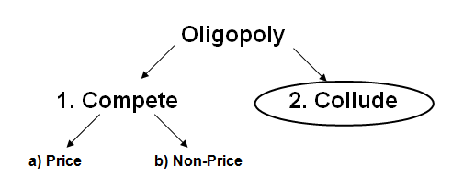

**What is Collusion?**

|  |  |
| --- | --- |
| **Collusion** | “collective agreements between firms not to compete with each other in an attempt to increase industry profits and restrict competition.” |

Firms will collude in order to try and increase their profits and in order to face less competition (especially on price). However, collusion is **illegal** and is punishable under competition law. They can be fined up to 10% of UK turnover and executives could face time in jail. The problem that Competition authorities face is that is often very **hard to prove** definitively that collusion has taken place as firms may claim that they are not colluding but just competing in an industry with similar costs which means similar prices.

There are two types of collusions:

|  |  |
| --- | --- |
| **Tacit Collusion** | Firms agree to restrict competition **without** a formal agreement |
| **Overt Collusion** | Firms agree to restrict competition **using** a formal agreement |

**Overt (or Formal) Collusion**

A formal collusive agreement is called a **cartel**. Firms may agree on prices, market share, advertising, marketing etc. Formal collusion involves formal agreements between firms.

The benefit of formal collusion to a firm is that each firm explicitly knows what to do with prices and when; there is less confusion and it is easier to manage the agreement as a result. However, it is easier for the Competition Commission to prove collusion has taken place if there is a formal agreement found.

**Tacit Collusion**

Tacit collusion is when firms collude without any formal agreements having been reached or without any explicit communication between the firms having taken place. Here firms observe each other’s behaviour closely and unwritten rules are developed which define the ways in which firms compete.

The benefit of tacit collusion is that it helps conceal the firms’ behaviour from authorities but is harder to manage for the firms. It is still illegal to use tacit collusion and so if caught they will still be punished appropriately.

**Factors Favouring Collusion**

In order to collude firms must have:

* **Market Power:** in order to be a price maker and set a higher collusive price
* **High Barriers to Entry:** this prevents new firms coming into the market and undercutting the higher collusive price.

However, it is easier if:

* **High concentration:** if there are only a few firms in the market then it is easier to co-ordinate collusion and there are fewer firms to undermine / break the collusive agreement.
* **Similar firms:** if firms sell the same products then setting the same collusive price is easier as consumers have no reason to go to one firms over another.
* **Competition Policy is ineffective:** if the Competition Commission is not catching firms who are illegally colluding then there is more incentive to collude as they are less likely to be fined.

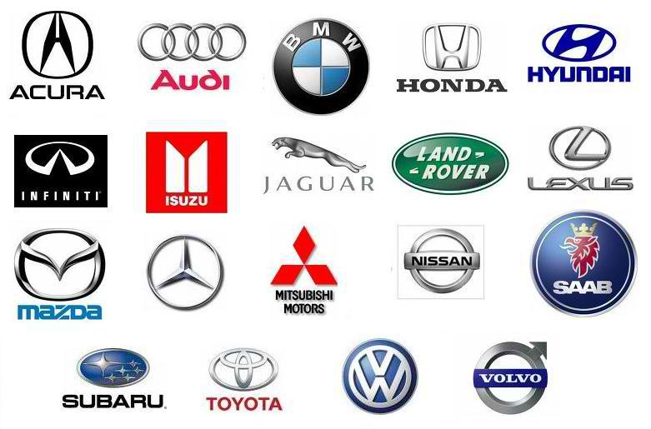

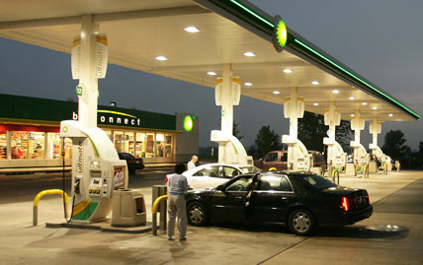

**Cars**

**Petrol**

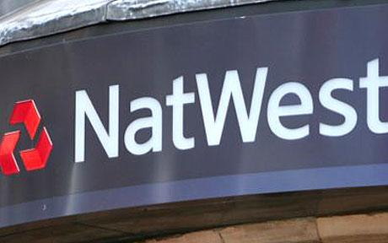

**Supermarkets**

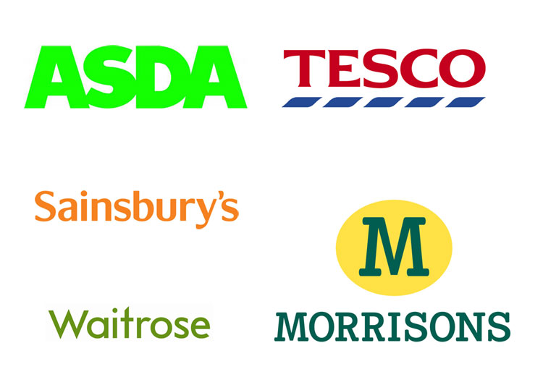

**Banking**

**Examples of Collusion**

**1. Petrol (September 2012)**

The [Office of Fair Trading](http://www.guardian.co.uk/business/office-of-fair-trading) has opened an inquiry into claims of unfair competition at the pumps amid widespread concerns about soaring petrol and diesel prices.

The British examination of a market said to be worth £32bn a year follows similar investigations in Germany and Spain, which both found evidence of a lack of competition in the road fuel sector.

The OFT has asked industry, [motoring](http://www.guardian.co.uk/money/motoring) groups and consumer bodies to submit information over the next six weeks and said it planned to publish its findings in January 2013. Claire Hart, a director at the OFT, said: "We are keenly aware of continuing widespread concern about the pump price of petrol and diesel, and we have heard a number of different claims about how the market is operating.

"We have therefore decided to take a broad-based look at this sector, to provide an opportunity for people to share their concerns and evidence with us. This will help us determine whether claims about competition problems are well-founded and whether any further action is warranted," she said.

The OFT's investigation was welcomed by a variety of groups that have expressed alarm after the petrol price rose 38% since June 2007. Diesel has gone up by 43%.

Stephen Glaister, director of the RAC Foundation motorists' group, said: "We have always argued for pricing transparency and this review promises to provide it. Now at last we should get a definitive answer on how the market works. We also welcome scrutiny of what the rapid decline in the number of petrol stations has meant for fuel supply and price. In 1990, there were some 18,000 forecourts. Now there are fewer than 9,000."

The campaign group FairFuelUK, was also pleased. Quentin Willson, a former Top Gear presenter and FairFuelUK campaigner, said: "There is a widespread feeling that when [oil](http://www.guardian.co.uk/business/oil) goes up, pump prices rocket immediately but when the oil price falls, pump prices don't reflect that fall. This causes a sense of complete exasperation and anger."

Major oil companies and supermarkets are allegedly making it hard for independent road fuel providers to compete and are slow to pass on lower crude costs.

In a separate development, a House of Commons energy committee revealed a survey showing that half of householders blamed profiteering by the Big Six energy suppliers for high domestic fuel costs. The survey of householders showed that 50% blame energy company profits and only 23% attribute it to fossil fuel price rises. Just one in 20 of those questioned blamed high prices on the subsidy for renewable companies.

Tim Yeo, chairman of the energy and climate change committee, said a range of changes were needed to ensure that householders did not feel ripped off. "If consumer trust in energy companies is to increase, there needs to be more competition in the market and more transparency about profits," he said.

**2. Cars (July 1999)**

The British car industry was reeling yesterday as Volvo became the first company in this country to admit involvement in price-rigging with dealers.

The Office of Fair Trading said that the manufacturer had colluded in "a blatant disregard for UK law" and shown an "indifference to exploitation of customers".

John Bridgeman, director general of fair trading, said: "This is a disgraceful case. A major and well-respected car manufacturer colluded with dealers who were fixing prices by penalising distributors who didn't toe the line."

The Competition Commission is about to start public and private hearings into car pricing and dealership arrangements after complaints that British consumers pay higher prices to subsidise smaller profit margins elsewhere in Europe.

**3. Banking (August 2012)**

Seven banks, including HSBC and Royal Bank of Scotland, are to be questioned in the US for alleged manipulation of the Libor inter-bank lending rate. Barclays, Citigroup, Deutsche Bank, JPMorgan and UBS have also received subpoenas from the attorneys general of New York and Connecticut.

Last month, Barclays was fined £290m by UK and US regulators for rigging Libor. US regulators said they were investigating potential involvement by other banks in the Barclays scandal.

The investigation is predicated on the assumption that at least one other bank must have colluded with Barclays in any attempts to manipulate Libor rates, which are used as a reference to price trillions of dollars of financial products.

**4. Supermarkets (August 2011)**

Tesco has threatened legal action after being hit with a £10m fine from the Office of Fair Trading (OFT) following an inquiry into the price fixing of dairy products. The supermarket giant was one of nine firms facing penalties totalling close to £50m for colluding over the price of milk and cheese in 2002 and 2003. But Tesco expressed "surprise and dismay" that it was included in the penalties handed down by the regulator. Tesco denies it colluded with others.

The OFT estimated that the collusion saw shoppers pay 2 pence extra for a litre of milk and 2p extra on 100g of cheese. The regulator originally calculated that an extra £270m was spent by UK consumers as a result of the price fixing, but no total figure has been included in the final report.

**The Impacts of Collusion**

If firms collude they will act like a profit maximising monopoly and with each colluding firm getting a share of those abnormal profits. Therefore a collusive oligopoly can be illustrated as a monopoly diagram:

**£**

**Q**

**MC**

**AC**

**AR = D**

**MR**

There are several impacts of collusion therefore:

**a) Higher prices and lower consumer surplus for consumers:** consumers will now face higher prices than they would have done under a competitive oligopoly and this lowers consumer welfare and consumer surplus.

**b) Price Stability and Guaranteed Supply:** consumers may gain however due to the fact that they will face a market with price stability (reducing uncertainty) and a guaranteed supply.

**c) Higher abnormal profits:** collusive firms will earn higher profits than under competitive oligopoly due to acting like a monopoly by restricting quantity and increasing price. This is what provides the incentive for firms to collude.

**d) Inefficiency:** as the firms are acting like a monopoly firms will be both productively (not producing at minimum AC) and allocatively (pricing above marginal cost) inefficient. There will be deadweight loss present.

**e) Dynamic gains:** as firms have more abnormal profits they may use this to fund innovation and R&D which can provide dynamic efficiency gains in the long-term. For example, by discovering more efficient production techniques or producing more innovative products for consumers, widening their choice. Indeed, firms may collude over R&D spending which would be in the interests of consumers if it makes innovation more likely.

**f) International Competitiveness:** colluding firms may also be a large source of exports for a country and use their abnormal profits to compete abroad.

Evaluating Oligopolies

As we have discussed oligopolies vary dramatically and there are many models to explain them (game theory, kinked-demand etc.). Drawing any firm conclusions on oligopoly in general is therefore difficult. Indeed, oligopolies can be good and can be bad.

However, it is likely that they will be **allocatively and productively inefficient** due to their market power. There are of course exceptions to this (e.g. a price war could force prices down to MC).

**Oligopolies can be ‘bad’ due to inefficiencies (especially when colluding), less economies of scale & problems with advertising & product differentiation**

* If oligopolies act collusively then they act like monopolies with the usual inefficiencies (both productive and allocative).
* Even competing oligopolies are likely to have some market power which is likely to lead to some inefficiency, although not as much as collusive oligopolies.
* There may also be less scope for economies of scale to offset market power, as can be the case in monopoly.
* Advertising could be an entry barrier discouraging new firms to enter, increase firms costs (which may lead to higher prices) and may persuade customers with imperfect information to desire inferior products (allocative efficiency issues).
* Product differentiation may form a barrier of entry to the industry making the market less competitive.

**Oligopolies can be ‘good’ if there is price competition, possible dynamic benefits and the benefits of advertising and product differentiation**

* Problems are less if markets have low entry and exit barrier and there is price competition. Firms are then more likely to be allocatively efficient.
* Oligopolies could reinvest profits into new product development. They have the incentive to do so because new products may be used to gain market share. This should aid dynamic efficiency.
* Advertising may increase customer information, encourage price competition (e.g. Asda Price, recent Tesco ads) and encourage product differentiation (as adverts show unique selling points).
* Technical improvements may occur in an attempt to ‘win’ during any price competition that does occur. This should improve the productive efficiency of the firm.
* Product differentiation may also give consumers more choice.

**Conclusions**

As with most areas of oligopoly there are no clear-cut general arguments. Oligopoly could be good for society or bad for society, it **depends on the industry**. Many questions on oligopoly will be asked using real-life industries which need to be assessed on their merits. Are they collusive? Are they producing new products? Are they advertising excessively? Is price competition fierce?

The work of the Competition Commission and Competition Policy is primarily involved in large oligopoly firms and trying to make judgements on individual cases, deciding whether firms are actively competitively and efficiently. We will look more closely at some of these issues when we focus on Competition Policy later in the unit.