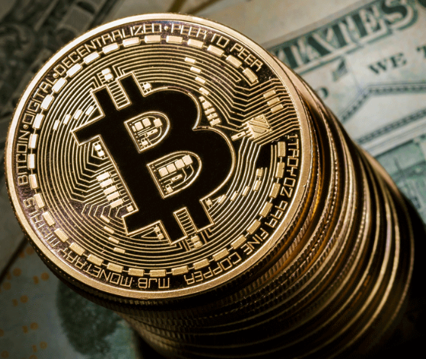**Bitcoin price soars above $5,000 to record high**

Adapted from an article by Julia Kollewe, Thursday 12 October 2017 in the Guardian

**Rising price of the cryptocurrency, now worth four times as much as an ounce of gold, has led to warnings of a bubble**

The price of bitcoin has smashed through $5,000 to an all-time high. Bitcoin has soared by more than 750% in the past year and is worth four times as much as an ounce of gold. But the price has been volatile. The digital currency plunged below $3,000 in mid-September after the Chinese authorities announced a crackdown. Beijing ordered cryptocurrency exchanges to stop trading and block new registrations, due to fears that increasing numbers of consumers piling into the bitcoin market could prompt wider financial problems

Bitcoins are unusual in that they are not issued by a central bank or Government but instead are ‘mined’ and recorded through computer code. Bitcoins each have a unique code which has an ‘access point’ or passcode to encrypt the coin. If the Bitcoin is passed from one person to another, the code is changed to a new password and the transaction is registered onto a public ledger (similar to one a bank might have) that records all Bitcoin transactions in something called a ‘blockchain’. The maintenance of the block chain is performed by a network running bitcoin software on people’s computers. Mining is therefore a record-keeping service done through the use of computer processing power. Miners keep the block chain consistent, complete, and unalterable by repeatedly verifying and collecting newly broadcast transactions into a new group of transactions called a block. Each block contains a cryptographic hash (or record) of the previous block (hence the word chain). The miners reward is to receive Bitcoins. However there are only a finite amount of Bitcoins that can be mined (roughly 21 million) and the computer programming becomes more complex and takes a longer amount of time the more Bitcoins are mined. Using bitcoin allows people to bypass banks and traditional payment processes to pay for goods and services directly. Banks and other financial institutions have been concerned about bitcoin’s associations with money laundering and online crime because transactions take place anonymously.

Vladimir Putin, the Russian president, called this week for regulation of cryptocurrencies such as Bitcoins, saying their use “bears serious risks” such as money laundering, tax evasion and funding for terrorism. But he also warned against imposing “too many barriers,” which appears to have given bitcoin a boost. Despite warnings over a bubble, bitcoin is gaining in acceptance. Last month, a London property developer, The Collective, said it would allow its tenants to pay their deposits in bitcoin and accept rent payments in the cryptocurrency by the end of the year. Two weeks ago, Japan’s government implemented rules that recognise bitcoin as a payment method. Celebrities have also got involved, with the boxer Floyd Mayweather, the socialite Paris Hilton and the actor Jamie Foxx promoting coin offerings.

The soaring value of bitcoin and other cryptocurrencies comes despite growing warnings over a price bubble. The starkest warning came from one of the biggest banks in the world, JP Morgan, who said bitcoin was a fraud that would ultimately blow up. Speaking last month, they said there was a limited market for the digital currency, arguing that it was only fit for use by drug dealers, murderers and people living in countries such as North Korea. JP Morgan pledged to sack any trader investing in Bitcoin, but the CEO of JP Morgan also admitted he had not been able to dissuade his daughter from investing!

Kenneth Rogoff, a professor of economics and public policy at Harvard University and a former IMF chief economist, has predicted that the technology behind cryptocurrencies will thrive, but the price of bitcoin will collapse. “It is folly to think that bitcoin will ever be allowed to supplant central bank-issued money,” he wrote in the Guardian this week. “It is one thing for governments to allow small anonymous transactions with virtual currencies; indeed, this would be desirable. But it is an entirely different matter for governments to allow large-scale anonymous payments, which would make it extremely difficult to collect taxes or counter criminal activity.”

Daniel Murray, global head of research at EFG Asset Management, noted that in 2013, bitcoin soared twelvefold in just four months but within a month had lost a third of its value and four months after its peak had lost 60% of its value. “Investors buy [an] asset because they are seduced by the prospect of further rapid gains without necessarily thinking about intrinsic value,” he said. He noted that historically currencies were backed by precious metals, and these days most currencies were based on macroeconomic fundamentals such as inflation, interest rates and growth, and were backed by a central bank and government. None of this applied to bitcoin, although the supply is carefully controlled. “It is hard to argue that bitcoin does anything better than existing currency arrangements whilst it does some things to a lower standard,” Murray added. “Individuals are already able to transact electronically using a plastic card, why do they need Bitcoin?”