**AS Component 1: Investigating the Media**

Subject Content: Media Industries, Focus Area: Media Contexts

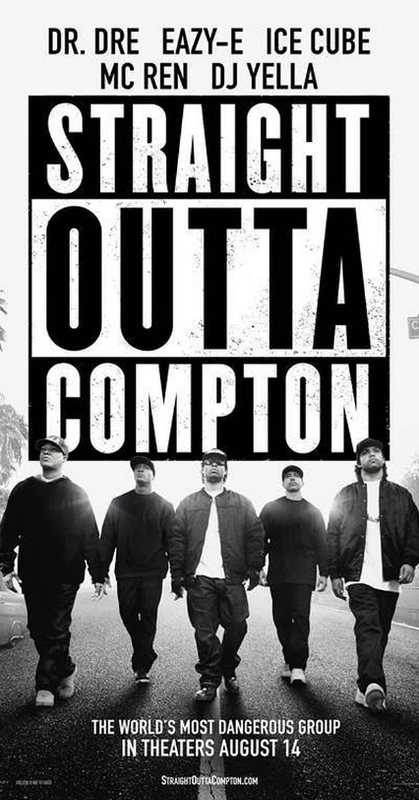

*Straight Outta Compton*

(2015)

**CONTEXT**

*Straight Outta Compton* is a biopic, produced by Legendary Pictures, distributed by Universal Pictures and directed by F. Gary Gray.

The film follows the story of hip hop band N.W.A. in 1980s America. Members of the band (Ice Cube and Dr. Dre) were co-producers.

The film was a huge commercial and critical success, became the highest grossing music biopic of all time, and was nominated for the Academy Award for Best Original Screenplay.

The film portrays events set predominantly in mid-1980’s California, USA. The depiction of this period in a contemporary film may have been impacted by the social upheaval caused by the racial tension and the LA Riots in 1992 (the portrayal of 1980’s California, and the possible glorification of N.W.A. as agents of social change, may have been revised or influenced by subsequent events).

The film was a **major commercial success**, making over $200 million – it had a $50 million total budget ($28 million production budget). Awards nominations (including for the Academy Award for Best Original Screenplay) also contributed to its success.

**ROLE OF PRODUCER**

**While watching the programme, fill in the answers to the following questions:**

**Define the various roles the producer has on a film production?**

**Which elements of a script make it easier for a producer to sell the idea to a director**

**and /or studio?**

**What are the important ingredients for a successful production?**

**How do producers attract finance for their production? What revenue avenues are**

**open for producers?**

**What considerations have to be made when shooting a film?**

**Who are the key personnel on a film set?**

**How do producers work out the budget for a film (i.e. above and below the line costs)**

**PRODUCTION COMPANY**

*Straight Outta Compton* was **produced** by Legendary Pictures who entered into partnership with Universal Pictures (the film’s **distributor**) in 2014. Universal is owned by NBC Universal, a Comcast company. The fact that the film was produced and distributed by a **major, vertically integrated film studio** that is part of a **media conglomerate** is significant in terms of funding, possibilities for cross-promotion and reaching a global audience.

1. What other films have been released by **Universal/ Legendary?**
2. What are they famous for?
3. Might audiences have a perceived sense of quality/expectation?
4. The film was produced by a **major studio** and co-produced by two members of the band – consider how this is significant in terms of the film and its marketing.

**DISTRIBUTION**

***While watching, please answer the following questions:***

**What is the main role of a distributor?**

**Name several mainstream distributors**

**How do distributors acquire films?**

**How do distributors use USPs to sell a film?**

**Why is scheduling an important part of the distribution chain?**

**How are research audiences recruited to help with a campaign? Why is this** **important?**

**How is a marketing budget devised?**

**THE TRAILER**

The film was **scheduled for release** in August 2015. The first **trailer** was released by Universal on 8 February 2015, with a ‘red band’ card to reflect the ‘restricted’ nature of the content; the trailer included an introduction by Ice Cube and Dr. Dre.

**Look at the trailer** <https://www.youtube.com/watch?v=oyoew4T74_w>

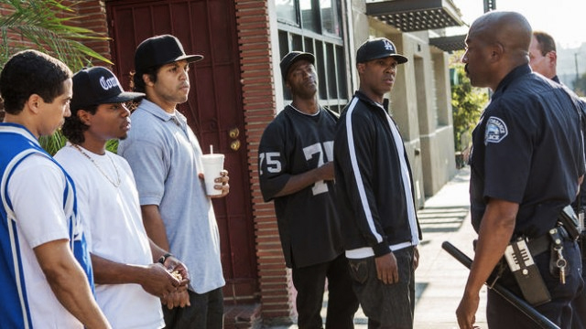

1. Key characters are introduced in the trailer. Consider what you think will be the main roles in the film? What would you expect to see of the relationships between various characters?
2. Where do you anticipate conflicts to arise? Try to identify at least one main plotline and a sub-plot.
3. How would you describe the principal characters? Explore the effects of their costume, make-up, dialogue and physical presence in helping the audience identify with them in the trailer.
4. From watching the trailer, what genre conventions (biopic) can you identify? Comment on how the trailer's use of colour, titles, fonts, costumes and music contribute to creating the genre.
5. Is there anything in the trailer to suggest serious themes? Does it seem distinctly American? If so, how?
6. California in the 1980s is the principle setting for the film. In what ways is this location represented in the trailer? Are you able to identify the period in which it is set based on what you've seen? Explain your answer.
7. Discuss the narrative structure. It is not linear. How has the trailer been constructed and why?
8. What is the film’s USP? How is it being used to sell the film?
9. Discuss the extent to which the trailer, has been constructed to make a **profit** for the producers.
10. What do you make of the following marketing strategy?

*https://www.theverge.com/2016/3/17/11257984/facebook-straight-outta-compton-race-specific-trailer*

**OTHER DISTRIBUTION METHODS/MARKETING STRATEGIES**

Look at the following links and comment on how you think the audience is being targeted.

**Viral marketing** – On 7 August 2015 Beats by Dre launched an **app** that allowed users to upload their own photograph to the *StraightOuttaSomewhere.com* website, completing the ‘Straight Outta’ logo with a location of their choice. Over 6 million downloads of ‘Straight Outta’ images were generated on social media before the film’s opening day. <http://uk.businessinsider.com/straight-outta-comptons-successful-viral-marketing-2015-8?r=US&IR=T>

*Straight Outta Compton* was **released** in Britain on 28 August 2015 and released in the USA on 11 August 2015 (premiere in Los Angeles); see other global release dates: <http://www.imdb.com/title/tt1398426/releaseinfo?ref_=tt_dt_dt>

Economic factors might also consider **synergy** - both the **soundtrack** for the film, featuring music by N.W.A. and a Dr Dre album inspired by the film, *Compton*, were released in conjunction with the film. The commercial success of these albums (e.g. the soundtrack entered the US Billboard 200 album chart at number two a week prior to the film’s release) arguably contributed to the film’s success.

Look at some of the following links. How did this publicity raise audience interest in the film?

<http://www.rollingstone.com/music/news/dr-dre-details-his-long-awaited-compton-the-soundtrack-20150801>

<http://www.rollingstone.com/music/news/dr-dre-talks-nwa-biopic-eazy-e-death-eminem-making-new-music-20150326>

<http://www.telegraph.co.uk/music/what-to-listen-to/compton-a-sountrack-dr-dre-review/>

Narrati

**TARGET AUDIENCE**

**Consider the ways in which the marketing attempts to both appeal to these existing (and possibly pre-sold) audiences and also transcend the music genre to appeal to a wider film audience.**

**There are a number of specific and distinct potential audiences that the film is attempting to target.**

1. Who are the primary/secondary/tertiary audiences for this film? Explain fully why you think this and how they have been targeted?

**REGULATION**

Explore the following pages from the British Board of Film Classification Guidelines – these are the standards by which the examining team decide on an age category for a film. What are the significant differences between rating a 15 and an 18-certificate film?

<http://www.bbfc.co.uk/sites/default/files/attachments/BBFC%20Classification%20Guidelines%202014_0.pdf>

What age rating did the film receive in the US and the UK? Why is this significant? Have a look at the BBFC Insight link into why the rating was given. <http://www.bbfc.co.uk/releases/straight-outta-compton-film#bbfcinsight>

The DVD of the Director’s cut of the film was awarded an 18 rating by the BBFC for an additional scene of sexual content**.** Do you think was a commercialor creative decision by Universal?

**DISCUSSION POINTS**

N.W.A. were significant in terms of social change as advocates for free speech, producers of protest songs and as highly successful black men from disenfranchised American urban communities. **Do you think the film taps in to the rise in black protest movements in the US, such as Black Lives Matter? Explain your view.**

N.W.A. were also heavily criticised for their misogynistic lyrics and their promotion of a lifestyle that objectified and marginalised women. **Do you think it is acceptable in the second decade of the 21st century to be promoting such negative views of women? Briefly outline your view.**

Two members of the original band N.W.A. co-produced the film, so consider the possible significance of this in relation to funding and to the portrayal of historical events (could this be considered a sanitised attempt to “cash in” by band members?). What is your view?