AS Music Technology Assessment Test: **Microphones**

Mark Scheme

Put a cross in the correct box

*1. What does a microphone do?*

It converts acoustic energy(sound) into electrical signals(1)

*2. Which of the following is NOT a type of microphone?*

Compressor(1)

*3. The diagram represents which of the following polar patterns:*

Cardiod(1)

*4. The diagram is the frequency response of which microphone*

Shure SM57(1)

*5. When recording a drum kit, which microphone would you use on a kick drum?*

AKG D112 (1)

*6. To record vocals effectively, you have to have an understanding of the following terms. Complete the chart by explaining what the term is and provide solutions to reduce or eliminate the problem.*

|  |  |  |
| --- | --- | --- |
|  | Explain what it is | Solutions to the problem |
| Example:  Sibilance | High frequency whistling or lisping sound, due to poor mic technique or excessive EQ | * Use a de-esser * Use a pop filter to reduce the effect |
| Popping | -over emphasis of plosive sounds(1), P’s and B’s(1)  -causes a blast of air towards the microphone which results in unwanted noise or audio spike(1) | -use a pop-filter(1)  -position microphone so that vocalist sings above or below the microphone (1) |
| Proximity Effect | Lower frequencies are enhanced(1) the closer the sound source is to a directional microphone(cardiod)(1) | -use an omni directional microphone(1)  -move the sound source further away from the microphone for an even frequency response(1) |

7. Which of the following microphones does NOT require 48V phantom power?

AKG D112

AKG Solidtube(1)

8. A bass guitar can be recorded using a DI box, what does the abbreviation DI stand for?

Direct Inject(1)

9. What is the function of a DI box?

Used to match the signal-level impedance of a source to the mixer input(1)

10. Describe how you would close mic a lead vocal.

Refer to microphone choice and placement

Large Diaphragm condenser microphone(1) e.g. Neumann TLM 102(1)

Microphone Placement

-microphone in shock mount and on a stand with a pop-filter

-reflection filter to reduce the ambience of the room

-singer between 6-12 inches away from the microphone(close mic)

11. Give the make, model and transducer type of the following microphones.

|  |  |  |  |
| --- | --- | --- | --- |
|  | Make | Model | Type |
| Example | AKG | D112 | Large Diaphragm Dynamic |
|  | AKG(1) | C414(1) | Large Diaphragm Condenser(1) |
|  | Neumann (1) | TLM102(1) | Large Diaphragm Condenser(1) |
|  | AKG (1) | C1000s (1) | Small Diaphragm Condenser (1) |
|  | SHURE(1) | SM57(1) | Dynamic(1) |

12. Describe how you would mic a drum kit.

Refer to microphone choice and placement

|  |  |  |
| --- | --- | --- |
|  | Mic Choice | Mic Placement |
| Kick | Large diaphragm dynamic(1)  D112(1) | -Tune(1)  - Remove reflector head if it does not have a microphone cut out(1)  -Place microphone in drum shell for the best separation(1)  -point microphone towards the beater or just of axis depending on how much attack you want(1)  -Dampen using pillows/blankets if drum is too resonant |
| Snare | Dynamic(1)  SM57(1) | -Place microphone approx.2 inches above beater head(1)  - approx. 2inches from the edge of the drum(1)  -dampen use moon gel or tape(and tissues) if the drum is too resonant(1)  -tune(1) |
| Hi-hat | Small diaphragm condenser(1)  C1000s(1)  M3(1) | -place a 3-6 inches above the top cymbal  -a 2 inches from the edge |
| Tom-Toms | Dynamic/Condenser  Dedicated Tom mic(1)  SM57(1)  M3(1)  C1000s(1) | -Place microphone approx.2 inches above beater head(1)  - approx. 2inches from the edge of the drum(1) |
| Crash Cymbal | Condenser  Stereo pair(1)  SE1-A(1)  M3(1)  C1000s(1) | -2 to 5 feet above the cymbals(1)  -angled to get the best coverage of cymbal and kit(1)  -placed as stereo overheads left and right(1)  -AB spaced pair(1) |
| Ride Cymbal | Condenser  Stereo pair(1)  SE1-A(1)  M3(1)  C1000s(1) | -2 to 5 feet above the cymbals(1)  -angled to get the best coverage of cymbal and kit(1)  -placed as stereo overheads left and right(1)  -AB spaced pair(1) |

13. Describe how you would DI a bass guitar.

Refer to the cables and connectors being used. Use a diagram if necessary. (4)

Connect the output of the bass guitar into the input of the DI(1), using an unbalanced jack/guitar cable(1). Connect the output of the DI to the input of the mixing desk(1), using a balanced XLR/mic cable(1). DI boxes require power either phantom power from the mixer or a battery(1)

14. The AKG C414 uses the switches shown on the table below. Identify the switches and describe what they do.

|  |  |  |
| --- | --- | --- |
| Switch | Identify the switch | Describe what this switch does |
|  | Polar/Pick-Up Pattern  (1) | * Selectable polar patterns(1) * Omni, Figure of 8, Cardiod(1)   (2) |
|  | Pad/Attenuator Switch  (1) | * Reduces the output level of the microphone * Used for high SPLs * 4 settings 0dB(no attenuation), -6dB,-12dB, -18dB level reduction   (2) |
|  | Lo Cut/High Pass Filter  (1) | * Reduces low frequency rumble * 4 settings 0(flat response), 40Hz, 80Hz, 160Hz cut off frequencies.   (2) |

15. The AKG C414 comes with a shock mount. What is a shock mount and what is it used for?

A shock mount is the cradle/holder in which the microphone is placed(1). It suspends/isolates the microphone from the microphone stands(1) to eliminate any structural noise/movement e.g. foot tapping, rumble from outside traffic(1).

16. Identify the polar pattern and label X where the microphone is most sensitive and Y where the microphone is least sensitive on the diagram.(4)

Figure of 8

X

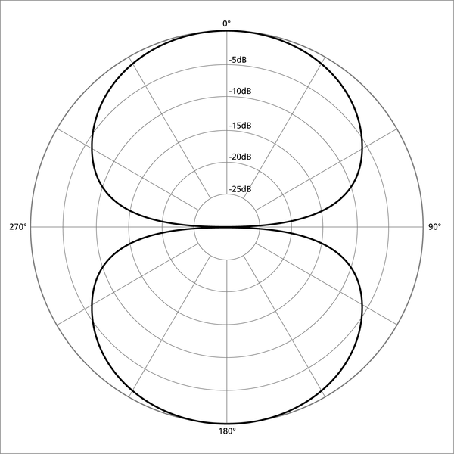

Y

X

Y

17. Explain the differences between the following microphone techniques:

Close mic’ing

-close to the sound source to reduce the effects of room ambience

-up to 30 inches away from sound source

-good separation in a multi-microphone set up

Ambient mic’ing

-stereo microphone techniques

-AB spaced par, XY coincident, MS, Decca Tree

-far from sound source to pick up room ambience, usually bigger spaces such as church and halls

18. Describe how you would close mic an acoustic guitar.

Refer to microphone choice and placement

Condenser microphone(1)

AKG C414, SE1-A, M3, C1000s

Microphone Placement

-place microphone where the neck and body meets(1), at the bridge(1), both(1)

-place the microphone over the guitarist shoulder to get the guitarist perspective(1)

-avoid placing microphone directly in front of the sound hole, it is unnaturally boomy(low frequency boost)(1)

-15 to 30 inches away(1)

-cardiod/omni polar pattern(1)

19. Describe how you would record an electric guitar. Use a diagram to illustrate you answer.

-tune the electric guitar(1)

-connect output of electric guitar in a guitar amp(1)

-use a dynamic(SM57) microphone to mic up the amp(1)

-place the microphone 2-10inches away from the amp of axis from the center of the speaker cone(1)

20.Explain the differences between a dynamic microphone and a condenser microphone.

**Description of a microphone**

A microphone is a transducer (1) that converts sound energy into electrical energy (1). The sensitive transducer element of a microphone is called its *element* or *capsule* (1).

The signal needs a pre-amp (1) to convert it to a workable (line) level/impedance (1).

Any discussion of polar response, e.g. omni / cardioids. Credit accurate diagrams. Max 1.

**Dynamic microphone**

Dynamic microphones are sometimes called moving coil microphones (1). Dynamic microphones function in the same way as a loud speaker, only reversed (1).

A movable coil (1) which is positioned in a magnetic field (1) is attached to the diaphragm (1). When sound enters the microphone the membrane / diaphragm vibrates (1). Consequently, the coil moves in the magnetic field and a varying (1) electrical current is induced (1) in the coil, in line with the rising/falling air pressure (1). This process is called electromagnetic induction (1).

**Benefits of dynamic microphones**

Generally inexpensive (1) Robust (1) Can withstand high SPL (allow volume) (1) Resistant to moisture (1) Lack of sensitivity reduces feedback (1) Good for live use (1) Does not require (phantom) power (1). Limited HF response makes them suitable for bass instruments (1) Slow transient response introduces a form of acoustic compression (1)

**Condenser microphone**

The diaphragm (1) (don’t award diaphragm buzzword twice if mentioned for dynamic microphone) forms one (1) plate (1) of a capacitor (1). When the diaphragm vibrates, the distance of the plates changes (1) thus changing the capacitance (1). From this a varying voltage (1) is produced.

Phantom power (1) 48V (1) is required to charge the capacitor (1).

Some condenser microphones can be powered by a battery (1).

Polar response / pick-up pattern switch (1) that selects between different / combinations of capsules (1). Some microphones have interchangeable capsules (1).

Power switch (1). Pad switch (1) usually -10 dB (1)

High pass filter (1) to eliminate rumble/low frequencies (1) Usually has cradle/shock mount (1)

**Benefits of condenser microphones**

Sensitive / pick up quiet sounds (1) Flat frequency response (1) Good high frequency response / wide frequency range / brighter than dynamics (1) Good signal to noise ratio / low noise / wide dynamic range (1) Fast transient response (1)

Total Marks: 100