Music Technology Assessment Test: **Microphones**

Name:

Total Marks

Put a cross in the correct box

1. What does a microphone do?

* It converts electrical signals into digital information
* It balances the acoustic energy(sound) for recording purposes
* It converts acoustic energy(sound) into electrical signals
* It balances the electrical signals for recording purposes

(1)

2. Which of the following is NOT a type of microphone?

* Condenser
* Dynamic
* Ribbon
* Compressor

(1)

3. The diagram represents which of the following polar patterns:

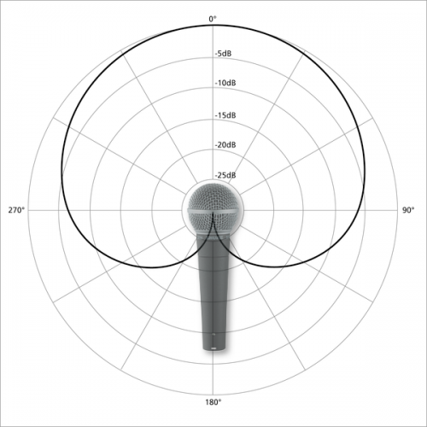

* Omni-directional
* Figure of 8
* SM58
* Cardiod

(1)

4. The diagram is the frequency response of which microphone

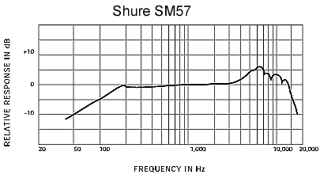

* Neumann U87
* AKG C414
* Shure SM57
* Rode NTK

(1)

5. When recording a drum kit, which microphone would you use on a kick drum?

* AKG C1000s
* AKG C414
* AKG D112
* AKG C430

(1)

6. To record vocals effectively, you have to have an understanding of the following terms. Complete the chart by explaining what the term is and provide solutions to reduce or eliminate the problem.

|  |  |  |
| --- | --- | --- |
|  | Explain what it is | Solutions to the problem |
| Example:  Sibilance | High frequency whistling or lisping sound, due to poor mic technique or excessive EQ | * Use a de-esser * Use a pop filter to reduce the effect |
| Popping | (2) | (2) |
| Proximity Effect | (2) | (2) |

7. Which of the following microphones do NOT require 48V phantom power?

* AKG C1000s
* AKG C414
* AKG D112
* AKG C430

(1)

8. A bass guitar can be recorded using a DI box, what does the abbreviation DI stand for?

* Direct Inject
* Digital Input
* Decibel Incorrect
* Dolby Input

(1)

9. What is the function of a DI box?

* Used to convert an audio signal to a digital signal to record to the DAW
* Used to match the signal-level impedance of a source to the mixer input
* Used to convert sound waves to electrical signals to record to the DAW
* Used to DI the input signal to a low-level mixing desk in the digital domain

(1)

10. Describe how you would close mic a lead vocal.

Refer to microphone choice and placement

Choice of mic

…………………………………………………………………………………………………………………(1)

Microphone Placement

……………………………………………………………………………………………………………………

…………………………………………………………………………………………………………………....

……………………………………………………………………………………………………………………(3)

11. Give the make, model and transducer type of the following microphones.

|  |  |  |  |
| --- | --- | --- | --- |
|  | Make | Model | Type |
| Example | AKG | D112 | Large Diaphragm Dynamic |
|  | (1) | (1) | (1) |
|  | (1) | (1) | (1) |
|  | (1) | (1) | (1) |
|  | (1) | (1) | (1) |

12. Describe how you would mic a drum kit.

Refer to microphone choice and placement

|  |  |  |
| --- | --- | --- |
|  | Mic Choice | Mic Placement |
| Kick | (1) | (2) |
| Snare | (1) | (2) |
| Hi-hat | (1) | (2) |
| Tom-Toms | (1) | (2) |
| Crash Cymbal | (1) | (2) |
| Ride Cymbal | (1) | (2) |

13. Describe how you would DI a bass guitar.

Refer to the cables and connectors being used. Use a diagram if necessary. (4)

14. The AKG C414 has switches shown on the table below. Identify the switches and describe what they do.

|  |  |  |
| --- | --- | --- |
| Switch | Identify the switch | Describe what this switch does |
|  | (1) | (2) |
|  | (1) | (2) |
|  | (1) | (2) |

15. The AKG C414 comes with a shock mount. What is a shock mount and what is it used for?

……………………………………………………………………………………………………………………..

…………………………………………………………………………………………………………………….

…………………………………………………………………………………………………………………..(3)

16. Identify the polar pattern and label X where the microphone is most sensitive and Y where the microphone is least sensitive on the diagram.(4)

Polar Pattern…………………………………………………………………..

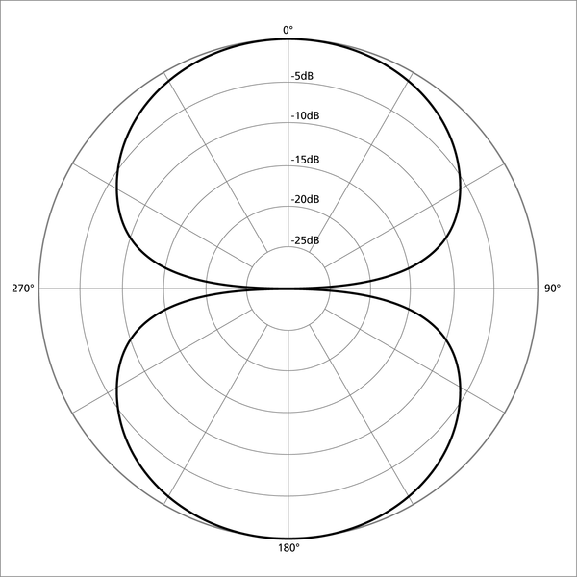

17. Explain the differences between the following microphone techniques:

Close mic’ing

………………………………………………………………………………………………………………………

……………………………………………………………………………………………………………………….

……………………………………………………………………………………………………………………(3)

Ambient mic’ing

………………………………………………………………………………………………………………………

……………………………………………………………………………………………………………………….

……………………………………………………………………………………………………………………(3)

18. Describe how you would close mic an acoustic guitar.

Refer to microphone choice and placement

Choice of mic

…………………………………………………………………………………………………………………(1)

Microphone Placement

……………………………………………………………………………………………………………………

…………………………………………………………………………………………………………………....

……………………………………………………………………………………………………………………(3)

19. Describe how you would record an electric guitar. Use a diagram to illustrate your answer.

………………………………………………………………………………………………………………………...

………………………………………………………………………………………………………………………...

………………………………………………………………………………………………………………………..

………………………………………………………………………………………………………………………..

……………………………………………………………………………………………………………………(4)

Explain the differences between a dynamic microphone and a condenser microphone. (16)

Total Marks: 100