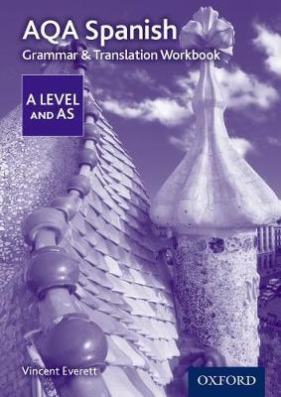

**AQA A Level Spanish: Grammar & Translation Workbook**

* Paperback
* [AQA A Level Spanish](https://www.bookdepository.com/search/advanced?seriesId=743858)

ISBN13 9780198415558 Written especially for students transitioning from GCSE to AS and those working towards the A Level exam, the AQA AS and A Level Spanish Grammar & Translation Workbook can be used for homework, revision and independent study. It includes thorough revision of key grammar points and embedded translation practice, giving students confidence in language manipulation skills when meeting the rigorous demands of the 2016 specification.show more

* Paperback
* [AQA A Level Spanish](https://www.bookdepository.com/search/advanced?seriesId=743858)

By (author)  [Vincent Everett](https://www.bookdepository.com/author/Vincent-Everett)

£7.99

Available. Dispatched from the UK in 2 business days

£

**Description**

Written especially for students transitioning from GCSE to AS and those working towards the A Level exam, the AQA AS and A Level Spanish Grammar & Translation Workbook can be used for homework, revision and independent study. It includes thorough revision of key grammar points and embedded translation practice, giving students confidence in language manipulation skills when meeting the rigorous demands of the 2016