

NAME:

**Ancient History**

**Period Study: Relations Between Greek States and Between Greek and Non-Greek States, 492-404 BC**

**TOPIC 4:**

**The Archidamian War**

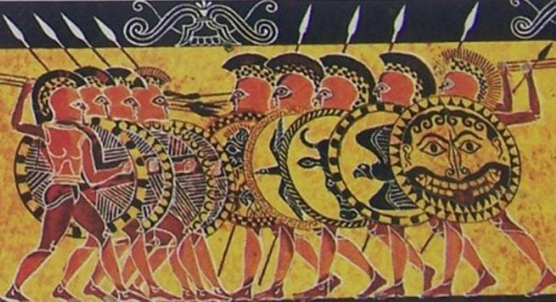**431-420 BC**

***Aims of this Booklet:***

* Examine the Athenian and Spartan strategies in the Archidamian War 431-421 BC
* Cover the course of the Archidamian War - the invasion of Attica, Plague in Athens, Pylos, Sphacteria
* Analyse the Peace of Nicias – the attitude of Athens and Sparta and of their allies to the peace

**Suggested Reading**

**History Today Articles (go to** [www.historytoday.com](http://www.historytoday.com) **username= Godalming; password= history)**

# Thucydides: the Compassionate Scientist

By [P.A. Brunt](http://www.historytoday.com/author/pa-brunt)

Published in [History Today](http://www.historytoday.com/archive/history-today/latest) [Volume 7 Issue 12 December 1957](http://www.historytoday.com/archive/history-today/volume-7-issue-12-december-1957)

# Thucydides, Chance and the Dilemma of Imperialism

By [Irene Brown](http://www.historytoday.com/author/irene-brown)

Published in [History Today](http://www.historytoday.com/archive/history-today/latest) [Volume 31 Issue 3 March 1981](http://www.historytoday.com/archive/history-today/volume-31-issue-3-march-1981)

# Architects of the Athenian Empire, Part II: Pericles

By [Stephen Usher](http://www.historytoday.com/author/stephen-usher)

Published in [History Today](http://www.historytoday.com/archive/history-today/latest) [Volume 17 Issue 6 June 1967](http://www.historytoday.com/archive/history-today/volume-17-issue-6-june-1967)

**Textbooks**

* C. Cottam, D. Hodgkinson *et al*, *OCR Ancient History, Component 1: Greece*, Bloomsbury, 2017

**Books in the ILC**

* J. T. Roberts, *The Plague of War: Athens, Sparta and the struggle for Ancient Greece,* Oxford, 2017
* J. Ober, *The Rise and fall of Classical Greece*, Princeton, 2016
* R. Garland, *Ancient Greece: everyday life in the birthplace of western civilisation,* New York, 2013
* R. L. Fox, The Classical World: an Epic History of Greece and Rome, Penguin, 2006
* P. Cartledge, *Ancient Greece: A very Short Introduction*, Oxford, 2011
* J. Boardman, *The Oxford History of Greece & the Hellenistic World*, Oxford, 1986

**eBooks on** [**www.dawsonera.co.uk**](http://www.dawsonera.co.uk)

* G. Cawkwell, *The Greek Wars: The Failure of Persia*, Oxford, 2005
* P. Rhodes, *A History of the Classical Greek World 478-323 BC*, Wiley-Blackwell, 2009
* P. Cartledge, *After Thermopylae,* Oxford, 2013
* Powell, *Athens and Sparta,* Routledge, 2016
* P. De Souza, *The Greek and Persian Wars 499-386 BC*

**Useful Websites**

* <https://www.bloomsbury.com/cw/ocr-as-and-a-level-ancient-history/?pid=330294> (A companion website for the OCR Ancient History textbook – good selection of wider reading and revision quizzes)
* <http://www.ancient.eu/>
* <http://ancient-greece.org/index.html>
* <http://www.livius.org/>
* [www.ocr.org.uk](http://www.ocr.org.uk)

 **Podcasts**

Sparta **-** <http://www.bbc.co.uk/programmes/b00nvz72>

The Battle of Themopylae - <http://www.bbc.co.uk/programmes/p004y278>

The Battle of Salamis - <http://www.bbc.co.uk/programmes/b08j99jl>

Thucydides - <http://www.bbc.co.uk/programmes/b050bcf1>



*For help in accessing the ebook catalogue on dawsonera, go to the ILC’s page on Godalming Online and read their guide to accessing ebooks.*

*Ebooks can be read using your college log on details whilst in college or at home.*

**ANCIENT HISTORY LUNCHTIME SUPPORT**

**If you need any help in Ancient History going over content, completing homework, attempting assessed questions or preparing for exams, there will be a lunchtime support session each Wednesday between 1 and 2 pm in room 211.**

**TASK:** summarise how each of the ‘complaints’ below contributed to the outbreak of war in 431 BC

**Athenian and Spartan Strategy 431-421 BC**

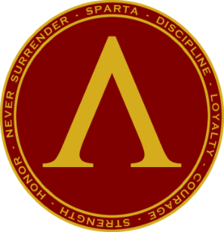The first decade of the Peloponnesian War is referred to today by historians as the **Archidamian War** after the Spartan King at the start of the conflict **Archidamus II**.

***Spartan Strategy***

***Athenian Strategy***

***TASK 1:*** Label each of the following as an Athenian or Spartan advantage going into the Archidamian War

Stable leadership

Well-established alliance

Stable supply of food

Powerful Navy

Dominance on land

Access to manpower

Overseas empire

Well-defended city

Powerful infantry

Wealth

Large army

Vulnerable enemy homeland

***TASK 3:*** Do you think that Athens or Sparta was in the stronger position in 431 BC?

***TASK 2:*** Using the above ideas as a starting point, summarise how you think Athens and Sparta should fight the Archidamian War – what strategy should they adopt and why?

**Athenian and Spartan Strategy 431-421 BC**

In 431 the Spartans sent a final offer/ultimatum to Athens saying that they could avoid war if Athens would ‘free the Greeks’. In reality this meant giving up their empire and for Pericles and most in Athens this was unthinkable; their empire was their source of trade, wealth and power. In 431, therefore, the Spartan King Archidamus II led a Spartan and Peloponnesian invasion of Attica.

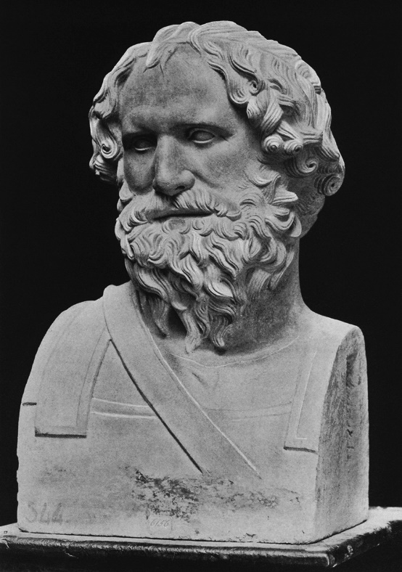**Spartan Strategy**

**Prescribed Source – Thucydides 2.8**

Nothing in their designs was on a small or mean scale: both sides put everything into their war effort. This was natural enough. At the beginning of an undertaking the enthusiasm is always greatest and at that time both in the Peloponnese and in Athens there were great numbers of young men who had never been in a war and were consequently far from unwilling to join in this one. Meanwhile all the rest of Hellas hung poised on the event, as the two leading cities came together in conflict. There were all kinds of prophecies and all kinds of oracular utterances being made both in the cities that were about to go to war and in other places as well. Then, too there was an earthquake in Delos just before this time – a thing that had never happened before in the memory of the Hellenes. This was said and thought to be a sign of impending events; and if anything else of the same kind happened to occur, its meaning was always carefully examined.

People’s feelings were generally very much on the side of the Spartans, especially as they proclaimed that their aim was the liberation of Hellas. States and individuals were enthusiastic to support them in every possible way, both in speech and action, and everyone thought that unless he took a personal share in things the whole effort was being handicapped. So bitter was the general feeling against Athens, whether from those who wished to escape from her rule or from those who feared that they would come under it.

1. What is the tone of Thucydides in the first paragraph of this source and does the provenance of the source explain this?
2. What does Thucydides state was the Spartan aim at the start of the Archidamian War?

The Spartans started the war assuming that the traditional strategy and tactics of hoplite warfare would bring them victory. It was believed that the most effective way to defeat another Greek power was by attacking their crops and farms, forcing the inhabitants of the city, most of whom would be farmers, out of the city to engage in direct battle. The Spartans knew that they had the superior infantry (hoplites) so were confident that if they could lure the Athenians out of their city in this way, they would defeat them in Attica and win the war.

***Recap:***briefly summarise how hoplites were thought to have fought. Give any information you can remember on their tactics or weapons or the nature of hoplite warfare.

Under this strategy, the Spartans would launch **annual invasions** of Attica in 431, 430, 428, 427 and 425 BC in which they would destroy crops in Attica and try to force the Athenians out into open battle.

**Prescribed Source - Thucydides, 2.11**

‘Peloponnesians and allies, our fathers have engaged in many campaigns both in and outside the Peloponnese and the elder men in this army of ours are not inexperienced in war. Yet we have never marched out in greater strength than now. And, just as we are in greater numbers and in better spirit than ever before, do the city against which we are moving is at the height of her power. We must not, then, fall short of our fathers’ standards, nor fail to live up to our own reputations. For the whole of Hellas is eagerly watching this action of ours, and, because of the general hatred against Athens, wishing us success in our undertakings. Therefore, even though it may seem that we are invading in tremendous force and that there is little risk of our enemy coming out to meet us in battle, this must not be made an excuse for relaxing our precautions while we are on the march: officers and soldiers of every individual state should constantly be prepared to find their own particular positions threatened. There is much that is unpredictable in war, and attacks are usually made as the result of a sudden impulse. Very often, too, a numerically inferior force, fearing for its own safety, has beaten off the superior numbers of an enemy who, through over-confidence, has relaxed his precautions. Certainly one ought to march forward confidently in an enemy country but one should also take practical measures based on the idea of security. In this way armies are likely to be most courageous in attack and most reliable in defence.

‘And the city against which we are marching is very far from being incapable of defending herself. She is extraordinarily well equipped in every respect, so that we ought to consider it very likely that they will come and meet us in battle; and that, if they have not yet set out against us before we are there, they will do so when they see us in their own country laying waste and destroying their property. People grow angry when they suffer things that they are quite unused to suffer and when these things go on actually in front of their own eyes. They do not wait to think, but plunge into action on the spur of their impulse. And the Athenians are especially likely to act in this way, since they think that they have a right to supremacy and are much more used to invading and destroying other people’s land than seeing this happening to their own land. Remember, then, that you are marching against a very great city. Think, too, of the glory, or, if events turn out differently, the shame which you will bring to your ancestors and to yourselves, and, with all this in mind, follow your leaders, paying strictest attention to discipline and to security, giving prompt obedience to the orders which you receive. The best and safest thing of all is when a large force is so well disciplined that it seems to be acting like one man.’

1. From the source what are the Spartan forces planning to do?
2. Why does Archidamus fear over-confidence on the part of the Spartans?

**Prescribed Source - Thucydides, 5.14**

Indeed, what now took place was that, after the battle of Amphipolis and the withdrawal of Ramphias from Thessaly, neither side went on with the war. Instead they began to think how to make peace. The Athenians had suffered a serious blow at Delium and another one soon afterwards at Amphipolis; they no longer possessed the same confidence in their strength which had induced them to reject previous offers of peace, in the belief that their good fortune at that time would carry them through to final victory. They were also apprehensive about the allies, fearing that they might be encouraged by these defeats to revolt on a more serious scale, and they regretted that they had not seized upon the excellent opportunity of making peace after Pylos. The Spartans on their side had found that the war had gone very differently from what they had imagined when they believed that they could destroy the power of Athens in a few years simply by laying waste to her land. The disaster suffered on the island was something which had never been known before in Sparta; her territory was being raided from Pylos and from Cythera; the helots were deserting, and there was always the fear that even those who remained loyal might gain confidence from the others and take advantage of the situation to make revolution, as they had done in the past. It happened, too, that the thirty years’ truce between Sparta and Argos was on the point of expiring; the Argives refused to renew it unless Cynuria was given back to them, and it seemed impossible to fight Athens and Argos at once. They also suspected that some of the states in the Peloponnese had the intention of going over to Argos, as indeed they did.

**Prescribed Source - Thucydides, 7.28**

Then the supplies of food from Euboea, which previously had been brought in by the quicker route overland from Oropus through Decelea, now, at great expense, had to go by sea round Sunium. Every single thing that the city needed had to be imported, so that instead of a city it became a fortress. By day detachments took it in turn to mount guard on the battlements, by night all except the cavalry were on duty, some at the various armed posts and others on the walls. So, summer and winter, there was no end to their hardships. What wore them down more than anything else was the fact that they had two wars on their hands at once, and indeed they had got themselves into such a state of obstinate resolution that no one would have believed it possible if he had been told of it before it actually happened. For it was incredible that, besieged by the Peloponnesians who were based on a fortress in Attica, they should not only leave Sicily, but actually stay on and lay siege in just the same way to Syracuse, a city which was in itself as big as Athens, and should give the Hellenic world such an astonishing demonstration of their power and of their daring; how astonishing can be seen from the fact that at the beginning of the war some thought that, if the Peloponnesians invaded Attica, Athens might survive for a year, and while others put the figure at two or three years, no one imagined she could last for more than that; yet now, in the seventeenth year after the first invasion, having suffered every kind of hardship already in the war, here were the Athenians going out to Sicily and taking upon themselves another war on the same scale as that which they had been waging all this time with the Peloponnesians.

For all these reasons – the great damage done by the occupation of Decelea and the other heavy expenses which fell upon them – the Athenians were becoming embarrassed financially, and it was about this time that they imposed upon their subjects, a tax of five per cent on all imports and exports by sea, thinking that this would bring in more money. Expenditure was not the same as it had been, but had grown bigger as the war grew bigger, while revenue was declining.

1. What do these two sources (5.14 & 7.28) reveal about Sparta’s strategy at the start of the war and how successful it would prove? (paragraph needed)

**Athenian Strategy**

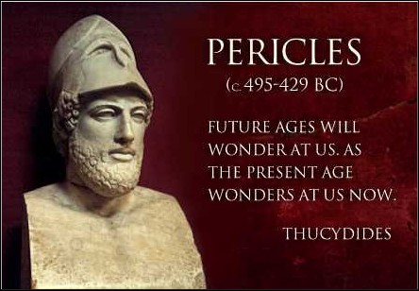Athens’s strength was its navy and its empire. Pericles called for a strategy in which Athens would ***not*** fight an open, hoplite battle with Sparta but would instead retreat within the wall of Athens and live off the resources that could be shipped into Athens from its empire via **Piraeus** This was possible because the **Long Walls** had been completed in 457 BC and guaranteed Athens’ access to its main port. Pericles’ strategy was largely defensive but it had an offensive side which was that Athens’ navy could be used to attack Sparta and its allies from the sea. Fundamentally, however, Pericles was hoping to out-last Sparta and its allies forcing them to admit defeat.

**Prescribed Source - Thucydides, 2.65**

In this way Pericles attempted to stop the Athenians from being angry with him and to guide their thoughts in a direction away from their immediate sufferings. So far as public policy was concerned, they accepted his arguments, sending no more embassies to Sparta and showing an increased energy in carrying on the war; yet as private individuals they still felt the weight of their misfortunes. The mass of the people had had little enough to start with and had now been deprived of even that; the richer classes had lost their fine estates with their rich ad well-equipped houses in the country, and, which was the worst thing of all, they were at war instead of living in peace. In fact, the general ill feeling against Pericles persisted, and was not satisfied until they had condemned him to pay a fine. Not long afterwards, however, as is the way with crowds, they re-elected him to the generalship and put all their affairs into his hands. By that time people felt their own private sufferings rather less acutely and, so far as the general needs to the state were concerned, they regarded Pericles as the best man they had. Indeed, during the whole period of peace-time when Pericles was the head of affairs the state was wisely led and firmly guarded, and it was under him that Athens was at her greatest. And when the war broke out, here, too, he appears to have accurately estimated what the power of Athens was. He survived the outbreak of war by two years and six months, and after his death, his foresight with regard to the war became even more evident. For Pericles had said that Athens would be victorious if she bided her time and took care of her navy, if she avoided trying to add to the empire during the course of the war, and if she did nothing to risk the safety of the city itself. But his successors did the exact opposite, and in other matters which apparently had no connection with the war private ambition and private profit led to policies which were bad both for the Athenians themselves and for their allies. Such policies, when successful, only brought credit and advantage to individuals, and when they failed, the whole war potential of the state was impaired. The reason for this was that Pericles, because of his position, his intelligence, and his known integrity, could respect the liberty of the people and at the same time hold them in check. It was he who led them, rather than they who led him, and, since he never sought power from any wrong motive, he was under no necessity of flattering them: in fact he was so highly respected that he was able to speak angrily to them and to contradict them. Certainly when he saw that they were going too far in a mood of over-confidence, he would bring back to them a sense of their dangers; and when they were discouraged for no good reason he would restore their confidence. So, in what was nominally a democracy, power was really in the hands of the first citizen. But his successors, who were more on a level with each other and each of whom aimed at occupying the first place, adopted methods of demagogy which resulted in their losing control over the actual conduct of affairs. Such a policy, in a great city with an empire to govern, naturally led to a number of mistakes, amongst which was the Sicilian expedition, though in this case the mistake was not so much an error of judgement with regard to the opposition to be expected as a failure on the part of those who were at home to give proper support to their forces overseas. Because they were so busy with their own personal intrigues for securing the leadership of the people, they allowed this expedition to lose its impetus, and by quarrelling among themselves began to bring confusion into the policy of the state. And yet, after losing most of their fleet and all the other forces in Sicily, with revolutions already breaking out in Athens, they nonetheless held out for eight years against their original enemies, who were no reinforced by the Sicilians, against their own allies, most of which had revolted, and against Cyrus, son of the King of Persia, who later joined the other side and provided the Peloponnesians with money for their fleet. And in the end it was only because they had destroyed themselves by their own internal strife that finally they were forced to surrender. So overwhelmingly great were the resources which Pericles had in mind at the time when he prophesied and easy victory for Athens over the Peloponnesians alone.

1. What three objectives did Pericles, according to Thucydides, set out at the start of the war?



1. What image of Pericles does Thucydides present in this source and how reliable do you find this?

**Prescribed Source - Thucydides, 2.13**

While the Peloponnesians were either still mustering at the isthmus or on their march before the invasion of Attica, Pericles, the son of Xanthippus, one of the ten Athenian generals, realizing that the invasion was coming, suspected that Archidamus, who happened to be a friend of his, might possibly pass by his estates and leave them undamaged. This might be either from a personal wish to do him a favour, or as the result of instructions given by the Spartans in order to stir up prejudice against him, just as it had been because of him that they had previously made the proclamation about driving out the curse. He therefore came forward first and made a statement to the Athenians in the assembly, saying that, though Archidamus was his friend, this fact was certainly not going to be harmful to Athenian interests, and, in case the enemy should not lay waste his estates and houses, like those of other people, he proposed to give them up and make them public property, so that no one should have any suspicion against him on their account. Then, with regard to the present situation, he gave just the same advice as he had given before. This was that they were to prepare for war and bring into the city their property in the country. They were not to go out and offer battle, but were to come inside the city and guard it. Their navy, in which their strength lay, was to be brought to the highest state of efficiency, and their allies were to be handled firmly, since, he said, the strength of Athens came from the money paid in tribute by her allies, and victory in war depended on a combination of intelligent resolution and financial resources. Here Pericles encouraged confidence, pointing out that, apart from all other sources of revenue, the average yearly contribution from the allies to Athens amounted to 600 talents, then there still remained in the Acropolis a sum of 6,000 talents of coined silver. This reserve fund at its maximum, had been 9,700 talents. It had been drawn on to pay for the Propylaea and other public buildings, and for Potidaea. In addition to this there was the uncoined gold and silver in offerings made either by individuals or by the state; there were the sacred vessels and furniture used in the precessions and in the games; there were the spoils taken from the Persians and other resources of one kind or another, all of which would amount to no less than 500 talents. To this he added the money in the other temples which might be used and which came to a considerable sum, and said that, if they were ever really reduced to absolute extremities, they could even use the gold on the statue of Athene herself. There was, he informed them, a weight of forty talents of pure gold on this statue, all of which was removable. But he pointed out that if they did use this gold for their own preservation they must restore it again afterwards in the same or in a greater quantity.

Thus he reassured them about their financial positions. As for their army, they had 13,000 hoplites in addition to the 16,000 others who were in various garrisons and those engaged in the actual defence of the city. This was the number originally detailed for defence in case of invasion, and the force was drawn from the eldest and the youngest of the citizens in the army together with the resident aliens who were qualified as hoplites. The wall of Phalerum ran for four miles from the sea to the city circuit; and nearly five miles of the wall surrounding the city was guarded, though part of it (the section between the Long Walls and the wall of Phalerum) was left without a guard. Then there were the four and a half miles of the Long Walls to Piraeus, the outer one of which was garrisoned. Then, too, there were seven and a half miles of fortifications surrounding Piraeus and Munychia, half of which distance was guarded. There were also 1,200 cavalry, including mounted bowmen; 1,600 unmounted bowmen, and 300 triremes ready for active service. This was an accurate, or perhaps a conservative, estimate of the resources in each department available to Athens at the time when the Peloponnesian invasion was expected and at the beginning of the war. Pericles also used his usual arguments to show that they should feel confident of final victory.

TASK: use this source from Thucydides to summarise what Pericles thought were Athens’ strengths at the start of the war.

Athenian Strengths in 431

Retreating from the countryside around Athens and allowing the Spartans to destroy the crops was a controversial policy. Many Athenians would see their livelihoods destroyed and would want leave the city to defend them. However the impact of the Spartans on the land around Attica was in fact limited. The Spartans and their allies only occupied the land for brief periods of time during each invasion before they themselves needed to return home. The longest Spartan invasion of Attica was in **430 BC** but lasted for only **40 days**. The Peloponnesian allies of Sparta tended to be farmers so needed to return home to look after their own crops.

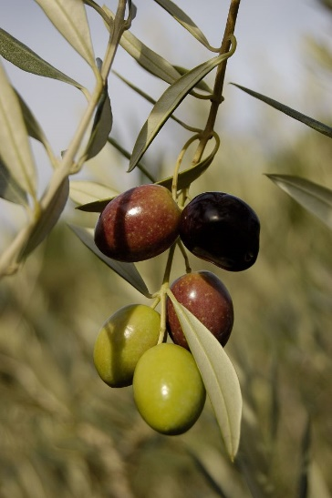It has also been debated by historians how easy it is in fact to destroy crops. To do this effectively, crops needed to be **‘fired’** just before they were due to be harvested otherwise they would re-grow and the impact would be limited. In addition to this, much of the land in Attica was used to grow **olives**, not for direct consumption but for sale and export. The loss of these had less of an impact on the food supplies of the city and olive plants themselves are almost impossible to destroy.

This meant that Pericles’ strategy of holding out in Athens had the potential to work and whilst the Athenians were doing this they could use their formidable navy, estimated to have **250 triremes** to defend its empire and attack the Peloponnesians in a more limited and safe way. Of the Peloponnesians, only Corinth had a significant fleet and Sparta would not build one until later in the war, despite the advice of King Archidamus II.

**Athenian and Spartan Strategy 431-421 BC**

***TASK:*** Using the understanding you have gained from the previous pages, annotate the map below to summarise how Athens and Sparta intended to fight the Archidamian War.

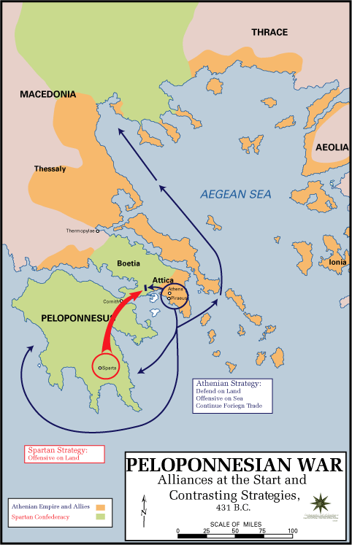

**The Course of the Archidamian War**

***As you study the events of the Archidamian War, keep adding detail to the timeline below.***

|  |  |  |
| --- | --- | --- |
| ***Event(s)*** | ***Details*** | ***Significance*** |
| **431** |  |  |
| **430** |  |  |
| **429** |  |  |
| **428** |  |  |
| **427** |  |  |
| **426** |  |  |
| **425** |  |  |
| **424** |  |  |
| **423** |  |  |
| **422** |  |  |
| **421** |  |  |
| **420** |  |  |

**Summary Questions**

1. How significant do you think the death of Pericles was in shaping the Archidamian War?
2. What do you think was the most decisive military encounter of the period and why?
3. Did Athens or Sparta appear to be in the better position by 421?
4. How sustainable does the Peace of Nicias appear to be?

**The Course of the Archidamian War**

**Thebes and Plataea**

The fighting of the Archidamian War did not begin between Athens and Sparta but between two of their allies – Plataea and Thebes.

***Recap:***Can you remember why Plataea and Thebes had poor relations with one another (you will need to think back to Herodotus).

In 431 BC Thebes, without a formal declaration of war launched a night-time attack on Plataea hoping to capture the city and link up with its Peloponnesian allies. An attack like this was in violation of the ‘Thirty-Years’ peace, something, which according to Thucydides, the Spartans later admitted:

**Prescribed Source – Thucydides 7.18**

The Spartans also prepared to invade Attica, as they had already decided to do and as they had been asked to do by the Syracusans and Corinthians, who, when they heard that Athens was sending reinforcements to Sicily, hoped that this would be stopped by an invasion. Alcibiades, too, was constantly urging them to fortify Decelea and to carry on the war with vigour. But what chiefly encouraged the Spartans to act with energy was their belief that Athens, with two wars on her hands – one against them and one against the Sicilians – would be now easier to crush. There was also the fact the Spartans considered that Athens had been the first to break the peace treaty. In the first war they thought that the fault had been more on their side, partly because the Thebans had entered Plataea in peace time and partly because, in spite of the provisions in the previous treaty that there should be no recourse to arms if arbitration was offered, they themselves had not accepted the Athenian offer of arbitration. They therefore thought that there was some justice in the misfortunes they had suffered and took to heart the disaster of Pylos and their other defeats. But now, in addition to the constant raids from Pylos, the Athenians had come out with thirty ships from Argos and laid waste part of Epidaurus and Prasiae and other places; also whenever any dispute arose on doubtful points in the treaty, it was Sparta who had offered to submit to arbitration and Athens who had refused the offer. It was now Athens therefore, the Spartans thought, who was in in the wrong through having committed exactly the same fault as theirs had been before, and they went into the war with enthusiasm. This winter they sent round to their allies for supplies of iron and got ready all the other materials for building fortifications. At the same time they organized a force of their own and conscripted other forces from the rest of the Peloponnese to be sent out in merchant ships to the help of their allies in Sicily. So the winter ended, and the eighteenth year of this war recorded by Thucydides.

The Thebans managed to briefly capture Plataea before being defeated by the Plataeans. The Athenians, keen to keep their ally, sent soldiers to garrison the city and a three-year siege followed as Sparta attacked the city in 429. Plataea eventually fell to the Spartans in 427 and they killed almost all of those in the city who had opposed them. Most Plataeans, however, had been evacuated to Athens before the final defeat.

**The impact of the War on Athens**

From 430 BC onwards the Spartans would launch almost annual invasions and occupations of Attica in an attempt to destroy the countryside around Athens and to force the Athenians out into open battle where they could be defeated.

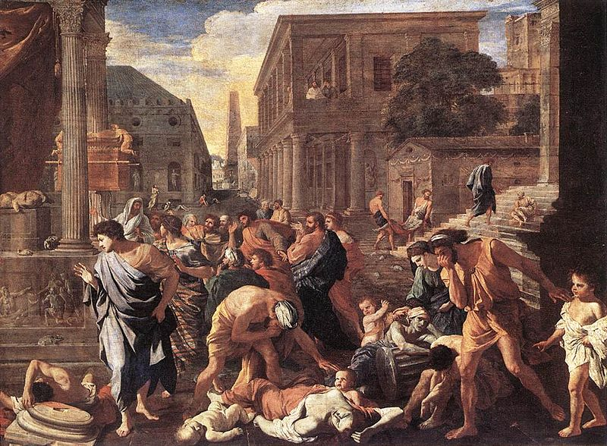However, what had the most damaging impact on Athens and its population during this period was not the actions of the Spartans but was the **plague** that hit the city in 430 and lasted for two years before returning again in 426 BC

TASK: Do some quick research into the Plague in Athens in 430. Try to find any details on the following points.

**Thucydides** himself contracted the plague although he survived. In his ‘History of the Peloponnesian War’ Thucydides argued that the plague did more than anything else to damage Athens:

**Prescribed Source - Thucydides, 1.23**

The greatest war in the past was the Persian War; yet in this war the decision was reached quickly as a result of two naval battles and two battles on land. The Peloponnesian War, on the other hand, not only lasted for a long time, but throughout its course brought with it unprecedented suffering for Hellas. Never before had so many cities been captured and devastated, whether be foreign armies or by Hellenic powers themselves (some of these cities after capture, were resettled with new inhabitants); never had there been so many exiles; never such loss of life – both in the actual warfare and in internal revolutions. Old stories of past prodigies, which had not found much confirmation in recent experience, now became credible. Wide areas, for instance, were affected by violent earthquakes; there were more frequent eclipses of the sun than had ever been recorded before; in various parts of the country there were extensive droughts followed by famine; and there was the plague which did more harm and destroyed more life than almost any other single factor. All these calamities fell together upon the Hellenes after the outbreak of war.

The estimated death toll of the plague supports Thucydides’ claim. The size of Attica’s population may have been between 250,000 to 350,000 people before the war and the plague may have had a 30% mortality rate meaning that around 100,000 people in Attica may have died from the plague.

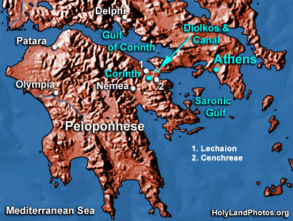The war did not stop during the plague, although the Spartans did not invade Attica in 429 possibly to avoid catching it themselves. In 430 the Peloponnesians sent out an embassy to **Persia** in an attempt to form an alliance. Nothing came of this at this stage as the Persian representatives failed to reach the Peloponnese. The Athenians, meanwhile, continued the war by attempting to use their naval power to attack the Spartans and their allies from the sea. **Phormio**, the Athenian general took a force of ships to block the Gulf of Corinth. The Corinthian-led Peloponnesian fleet came out to meet the Athenians where they were beaten decisively at the battle of **Naupactus in 429 BC**. Early on in the war, therefore, Athens had asserted its naval dominance and there would not be any further significant naval battles during the Archidamian War.

As the war continued it also started to change the way Athens saw and related to its allies (or its empire). Athens’ allies across the Aegean were vital to its war effort and to Pericles’ strategy as it was their resources and manpower that would allow the city to hold out even when Attica was occupied by the Spartans. In 428, therefore, when a revolt against Athens broke out at **Mytilene** on the island of Lesbos, the Athenians responded aggressively. Mytilene was by this point one of only two allies who were still contributing ships to Athens (the other was Chios) and was too important for the Athenians to lose. The Athenian **Cleon** put forward a motion to the Assembly that the entire population of Mytilene should be put to death once the revolt was supressed. The Assembly voted in favour of this motion before a second debate the next day where the decision was reversed. Cleon is depicted by Thucydides as the leading **demagogue** in Athens – a politician who exploited the support of ordinary Athenians by offering them popular language and measures.

Further evidence of the changing nature of Athens’ relationship with its allies came from the **Cleonymous Decree** of 426 and the **Thoudippos Decree** of 425. Both of these tightened up the collection of **tribute** from Athens’ allies and imposed penalties on those officials who failed to collect the correct tribute. The Thoudippos Decree went further by significantly increasing the amount of tribute Athens demanded from its allies. This had been set at **460 talents** when it was first set by Aristeides and then increased at the start of the Archidamian War to **600 talents**. The new decree increased it to **1,460 talents** to be paid by a total of 400 states. There is no way of confirming this final figure but the usually reliable Plutarch does mention in his book *Aristeides* that the tribute increased to 1,300 talents.

**Extension Task**

**Read the original text of the Thoudippos Decree at:**

[**https://www.atticinscriptions.com/inscription/IGI3/71**](https://www.atticinscriptions.com/inscription/IGI3/71)

**Record quotations from the source which support the points made in the paragraph above.**

1. What does the Thoudippos Decree reveal about the impact of the Peloponnesian War on Athens and on Pericles’ strategy?

**The Impact of the War on Sparta**

In 492 BC Pericles died from the Plague. Pericles was one of ten generals who had been elected to lead Athens at the start of the Archidamian War but in reality, it was his strategy that the city had been following. With his death, a new generation of leaders started to emerge who wanted to challenge this strategy.

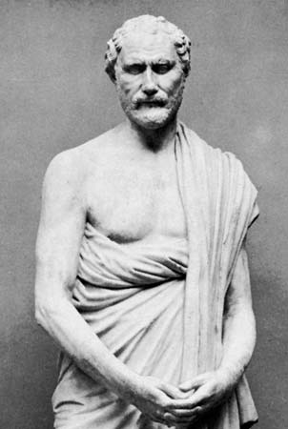One of these figures was **Demosthenes** who wanted to pursue a more aggressive policy that would take the war to the enemy rather than just trying to hold out in Athens.

**TASK:** what options were open to Demosthenes? How could the Athenians take the war to the enemy?

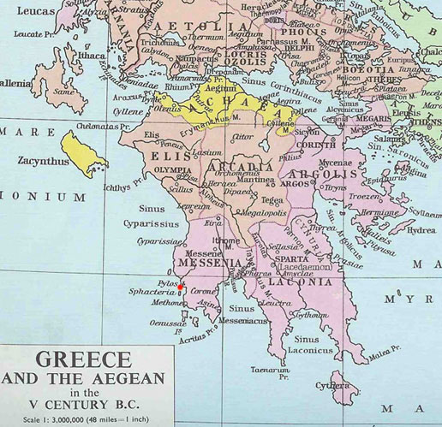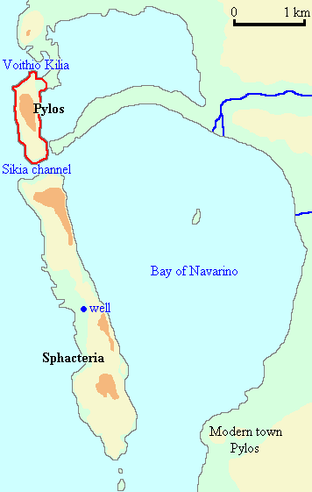Demosthenes began his new policy by fortifying a position on the island of **Pylos** off the south-west coast of the Peloponnese (see maps below) in 425 BC. This tactic of building a fort within enemy territory was known as **epiteichismos** and in this case was designed to stir up another helot revolt against the Spartans.

The Spartans responded by immediately ending their annual invasion of Attica after only 15 days and by counter-attacking against the Athenians at Pylos on land and sea. Spartans occupied the island of Sphacteria to the south of Pylos hoping to take control of the harbour below Pylos and the promontory that stuck out form the mainland giving the Athenians on Pylos nowhere to shelter. The Athenians, however, repelled these attacks and were themselves able to take control of the harbour. This meant that the Spartan forces on Shacteria were now cut off.

**Prescribed Source - Thucydides, 4.19-20**

‘Sparta calls upon you to make a treaty to end the war. She offers you peace, alliance, friendly and neighbourly relations. In return she asks for the men on the island, thinking it better for both sides that the affair should not proceed to the bitter end – whether, by some stroke of luck, the men should manage to force an escape, or else be subdued by your blockade and fall still further into your power. In our view, where great hatreds exist, no lasting settlement can be made in a spirit of revenge, when one side gets the better of things in war and forces its opponents to swear to carry out the terms of an unequal treaty; what will make the settlement lasting is when the party that has it is in his power to act like this takes instead a more reasonable point of view, overcomes his adversary in generosity, and makes peace on more moderate terms than his enemy expected. In such a case, so far from wanting to get his own back for the violence that has been done to him, the enemy is already under an obligation to pay back good for good, and so is the more ready, from a sense of honour, to abide by the terms that have been made. And men are more inclined to act in this way towards their greatest enemies than towards people with whom they have only minor differences. Then, too, when others are willing to make concessions it is natural for one to give way gladly oneself, just as it is natural, if one meets with an attitude of arrogance, to face things out to the end, even against one’s better judgement.

‘As for Sparta and Athens, if ever there was a good time for making peace it is now, before some irredeemable event overtakes us, something that would force us into an unending hatred of you, personal as well as political, and would deprive you of the hope of what we are offering you at this moment. Now is the time for us to be reconciled, while the final issue is still undecided, while you have won glory and can have our friendship as well, and we, before any shameful thing has taken place, can, in our present distress, accept a reasonable statement. Let us choose for ourselves peace instead of war, and give to the Hellenes a respite from their sufferings. For this they will think that it is you rather than we whom they have to thank. As for the war in which they are engaged, they are not certain who began it; but peace now depends chiefly upon you, and if peace is made, it is to you that their gratitude will go. By accepting our proposal you can have the firm friendship of Sparta, a friendship which is not extorted from her but which is offered to you freely and which you will oblige her by accepting. Think also of the advantages which can reasonably be expected to follow. For if we, Athens and Sparta, stand together, you can be sure that the rest of Hellas, in its inferior position, will show us every possible mark of honour.’

1. According to this source from Thucydides, how did the Spartans react to the situation on Sphacteria?
2. How did the Spartans try to persuade the Athenians to accept their offer and how likely do you think this is to happen?
3. What does this source and the Spartan actions described within it suggest about the situation on Sphacteria?

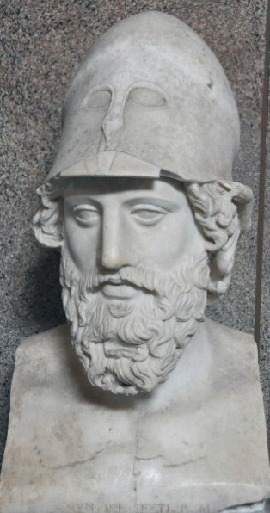The sources on this period (mainly Thucydides and Aristophanes) present the Athenian politician and general **Cleon** as the key figure in calling for the Athenians ***not*** to accept the Spartan offer of peace. According to these sources Cleon mustered popular support to call for the Spartans to offer better terms including the return of all of the territory which Athens had had to give up in the Thirty-Years Peace.

*Recap:* What territory had the Athenians given up in 446 BC?

The Spartan representative who had been sent to Athens could not accept these terms and so returned home without an agreement. The portrayal of Cleon in this episode, and more generally, appears negative (i.e. a rabble-rousing demagogue) but it is worth understanding that Cleon was not an aristocrat, as Aristophanes and Thucydides were, but was instead from a commercial/trading background. The sources therefore are perhaps naturally prejudiced against him and his views which were certainly popular with the people.

Following the rejection of the Spartan offer of a truce, Cleon clashed with other Athenian generals about how to proceed. It became clear that the Athenians could not continue their blockade of the Spartans on Sphacteria indefinitely; the Athenian commander **Nicias** offered to give up his command if Cleon thought he could do better. Cleon took him up on this offer (despite having no military experience) and declared that he could take the island in 20 days. He landed on Sphacteria with a force of 800 hoplites, 1,600 archers and javelin throwers, and the crews of 70 ships. The Spartans were forced back to the north end of the islands where they dug in. Cleon and Demosthenes promised the Spartans that they would not attack if the Spartans **surrendered** and to the amazement of both sides, and the whole of Hellas, they did.

**Prescribed Source - Thucydides, 4.40-41**

This event caused much more surprise among the Hellenes than anything else that happened in the war. The general impression had been that the Spartans would never surrender their arms whether because of hunger or any other form of compulsion; instead they would keep them to the last and die fighting best they could. It was hard to believe that those who had surrendered were the same sort of people as those who had fallen. Indeed, there was an occasion afterwards when an Athenian ally in order to insult one of the prisoners from the island asked him whether it was the ones who had fallen who were the real Spartans. The reply was that ‘spindles (by which he meant arrows) would be worth a great deal if they could pick out brave men from cowards’, a remark which was intended to show that the ones who died were simply the ones who came in the way of the stones and the arrows.

When the prisoners had been brought to Athens, the Athenians decided to keep them in prison until a settlement was arrived at, but that, if the Peloponnesians invaded Attica before then, they would take the men out and kill them. Pylos was firmly garrisoned, and the Messenians from Naupactus sent some of their best troops back there to what was in fact their old country, since Pylos was in what used to be Messenia. The troops carried out raids into Laconia and, helped by the fact that they spoke the same dialect as the inhabitants, did a lot of damage. The Spartans had had no previous experience of this type of guerrilla warfare and, as the helots began to desert, they feared the spread of revolution in their country and became exceedingly uneasy about it. Though they did not want to reveal this to the Athenians, they still sent representatives to Athens and tried to get back Pylos and the prisoners. The Athenians, however, were aiming at gaining still more and, though frequent representations were made to them, they sent every Spartan representative back empty-handed. This completes the account of what happened at Pylos.

1. Why, according to Thucydides was the Spartan surrender at Pylos so surprising?

1. In what way did the Athenians use the Spartan prisoners they took back to Athens?
2. Does the Spartan surrender at Pylos reveal anything else about the Spartan attitude to the Archidamian War?

**Brasidas**

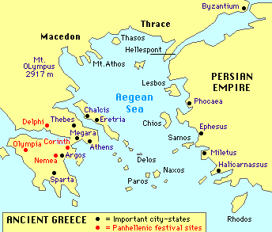After the defeat at Sphacteria and Pylos, the Athenians continued to attack the Spartans in the Peloponnese and it became increasingly clear that the Spartan tactic of annual invasions of Attica was not working. Further direct attacks against Attica also risked the lives of the Spartan prisoners being held in Athens.

A new Spartan commander emerged with new tactics to try and win the war – **Brasidas**. Brasidas’ plan was to invade territory of Athens’s allies to cut of the supply of materials to Athens and to stir up revolts. To do this Brasidas led a force of mercenaries and freed helots, known as **neodamēdeis**, to **Thrace** in 424 BC. This was a key ally for Athens as it was an important supplier of timber for the navy.

**Prescribed Source - Thucydides, 4.80-81**

For now that the Athenians were making their attacks on the Peloponnese, and particularly on the actual territory of Sparta, the Spartans thought that the best way of diverting these attacks would be to give Athens, too, the same kind of trouble by sending an army to her allies, particularly as these allies were prepared to supply the army and were asking for it in order to be able to revolt. The Spartans were also glad to have a good excuse for sending some of their helots out of the country, since in the present state of affairs, with Pylos in enemy hands, they feared a revolution. In fact they were so frightened of their unyielding character and of their numbers that they had had recourse to the following plan. (Spartan policy with regard to the helots had always been based almost entirely on the idea of security.) They made a proclamation to the effect that the helots should choose out of their own number those who claimed to have done the best service to Sparta on the battlefield, implying that they would be given their freedom. This was, however, a test conducted in the belief that the ones who showed the most spirit and came forward first to claim their freedom would be the ones most likely to turn against Sparta. So about 2,000 were selected, who put garlands on their heads and went round the temples under the impression that they were being made free men. Soon afterwards, however, did away with them, and no one ever knew exactly how each one of them was killed.

Now, on this present occasion, the Spartans were glad to send out 700 as hoplites to serve with Brasidas. The rest of his army were mercenaries whom he had raised from the Peloponnese. Brasidas himself was sent out by the Spartans largely because it was his own wish, though the Chalcidians were also eager to have him, a man who in Sparta itself had a great reputation for energy in every direction and who on his foreign service had shown himself to be so valuable to his country. And on this occasion it was his upright and moderate conduct towards the cities which caused most of them to revolt and enabled him to take others by treachery, so that when Sparta wanted to make peace (as she did in the end) she was in the position of having places to offer in exchange for those held by Athens, and in the meantime the Peloponnese was relieved of much of the burden of the war. Then, too, in the later period of the war, after the Sicilian expedition, the chief factor in creating a pro-Spartan feeling among the allies of Athens was the gallantry of Brasidas and the wisdom which he showed at this time – qualities which some knew from experience of them and others assumed because they had been told of them. He was the first to be sent out in this way, and by the excellent reputation which he won for himself on all sides he left behind a rooted conviction that the rest also were like him.

1. 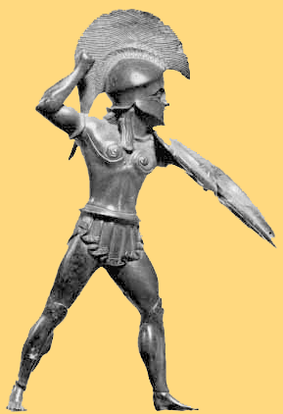Make a list of the qualities of Brasidas that Thucydides gives:

**Prescribed Source - Aristophanes, *Peace* 619–622**

HERMES. Then, when the cities that you ruled realised that you [the people of Athens] were at each other’s throats and showing your teeth as you grinned, they plotted against you in every way that they could because of their fear of the tribute, and they used bribes to persuade the most powerful men in Sparta.

Aristophanes’ play ***Peace***was performed in 421 BC and showed a clear desire from some in Athens to achieve peace. The section above also shows an awareness that many of Athens’ allies (like cities in the region of Thrace) were ripe for revolt.

Brasidas’ aim was to exploit this and he first marched to the city of **Acanthus** whose population eventually allowed him to enter the city and address the people. The Athenians at this time were focused on central Greece as the Generals Demosthenes and Hippocrates tried to win the support of several Boeotian cities to rebuild the Athenian land empire here. They were opposed here by members of the **Boeotian confederacy** led by Thebes who defeated the Athenians at the **battle of Delium** in 424 BC

After Acanthus, Brasidas next moved against the city of **Amphipolis.** Thucydides (a general in Athens at this time) was dispatched from Thasos to secure the city but Brasidas was allowed in by the inhabitants before he arrived. His *History of the Peloponnesian War* explained these events and the actions of the people Amphipolis:

**Prescribed Source - Thucydides, 4.108**

The capture of Amphipolis caused great alarm at Athens. The place was not only useful because it supplied timber for ship building and brought in revenue; there was also the fact that, although the Spartans, provided they got an escort from the Thessalians, could reach the allies of Athens up to the line of the Strymon, they could not go any further so long as they did not control the bridge, since there was a great lake formed by the river above the town and in the direction of Eion they were exposed to the blockade of Athenian triremes. Now, however, these difficulties appeared to have been removed. The Athenians also feared that their allies would revolt, since Brasidas was behaving with great moderation and was constantly declaring wherever he went that his mission was the liberation of Hellas. The cities subject to Athens, when they heard of the capture of Amphipolis, of the terms being offered, and of the considerate behaviour of Brasidas himself, eagerly embraced the idea of change, made overtures to him, begging him to march into their territory, and vied with each other in being the first to revolt. Indeed, they fancied that this was a perfectly safe thing to do, though, as was proved later on, the power of Athens was as great as had been their mistake in underestimating it. As it was, their judgement was based more on wishful thinking than on a sound calculation of probabilities; for the usual thing among men is that when they want something they will, without any reflection, leave that to hope, while they will employ the full force of reason in rejecting what they find unpalatable. Then too there was the fact that the Athenians had just been defeated in Boeotia, and there was the untrue, but attractive, statement of Brasidas that at Nisaea the Athenians had not dared to engage even the army that he had there himself. All this produced a feeling of confidence and a belief that no steps would be taken by Athens to secure her interests. But what most of all made them ready to undertake all kinds of risks was the pleasurable excitement of the moment, and the fact that it looked for the first time as though they were going to find the Spartans acting with real energy.

All this did not escape the notice of the Athenians, who, so far as was possible at such short notice and in winter, sent garrisons to the various cities. Brasidas sent messengers to Sparta asking for another army to be sent out to him, and meanwhile began to arrange for the building of triremes on the Strymon. The Spartans, however, did nothing for him, partly because their leading men were jealous of him, partly because what they really wanted was to recover the prisoners made on the island and to end the war.

1. Why according to Thucydides was the defeat at Amphopolis so damaging?

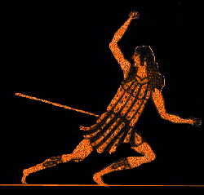**The Peace of Nicias**

Brasidas did not receive the extra troops he asked for but he continued to ‘liberate’ Athenian allies with the cities of **Torone**, **Scione** and **Mende** falling to him.

In the spring of 423 an armistice was signed between the two sides – both Athens and Sparta had peace parties and the Spartans had hoped that by now the Athenians would be tired of war. However, the armistice did not stop the fighting – the Athenian general Nicias sailed to re-take Mende and Sicone, whilst back in Athens Cleon called for all of the Athenian losses to be reclaimed. In 422 Cleon led an Athenian force which re-took Torone and then fought a major battle with Brasidas at **Amphipolis**. According to Thucydides, Cleon was killed in the battle when he was hit in the back with a javelin whilst retreating. Brasidas was also wounded and died later. **The battle of Amphipolis was a decisive Spartan victory**.

**Prescribed Source - Aristophanes, *Peace* 639–648**

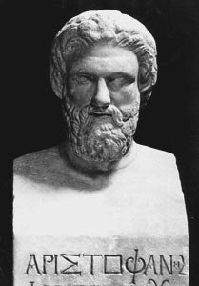

HERMES. [The speakers in the Assembly] used to shake down the wealthy and prosperous among the allies, laying accusations that they were Brasidean sympathisers. And then you tore at them like hounds – the city, sitting there pale and frightened, gobbled up with pleasure whatever slanders anyone told it. The foreigners, seeing the blows that were being struck, bunged up the mouths of those who made these accusations with gold, making them rich, while you were never going to notice that Greece was on its way to desolation. And the man who did this was the tanner [i.e. Kleon].

***TASK:*** what is Aristophanes saying about Cleon in this source and how reliable is his portrayal?

With the death of **Brasidas** and **Cleon**, the two figures on each side most eager to continue the war had gone opening up the door to peace between Athens and Sparta.

**Prescribed Source - Thucydides, 5.16**

Now Athens had suffered another defeat at Amphipolis, and Cleon and Brasidas were dead – the two people who on each side had been most opposed to peace, Brasidas because of the success and honour which had come to him through war, Cleon because he thought that in time of peace and quiet people would be more likely to notice his evil doings and less likely to believe his slander of others.

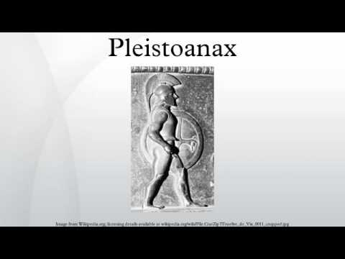The Athenians appeared ready for peace having suffered serious defeats at **Delium** and **Amphipolis** and the new strategy of ‘**expeditionary warfare**’ (i.e. taking the war to the enemy) did not appear to be working. The Spartans were also eager to have the prisoners taken at Sphacteria returned, whilst the loss and surrender at Pylos and Sphacteria had dented Spartan military confidence. Added to this, the helots were also continuing to desert. Finally, the Spartans were also aware that their thirty year truce with **Argos** was due to run out soon and this raised the possibility of having to fight Athens and Argos at the same time.

The Spartan King **Pleistoanax** had been restored after having been banished (at some point between 446-444 BC) and was a moderate who had already shown in 446 that he was keen to avoid war. Negotiating a successful peace treaty with Athens would also be a quick victory for Pleistoanax and help to silence his critics in Sparta.

***Recap****:* Why do you think that Pleistoanax had originally been exiled?

**Prescribed Source - Thucydides, 5.13-17**

At the very beginning of winter, Ramphias and his forced advanced to Pierium in Thessaly. The Thessalians, however, were unwilling to let them go farther; Brasidas, for whom they were bringing reinforcements, was dead; so they turned back home, thinking that the time for action had passed now that the Athenians had been defeated and had gone away, and that they themselves were not capable of carrying out the plans which Brasidas had had in mind. But their main reason for returning was that they knew at the time when they set out that Spartan opinion was, in fact, in favour of peace.

Indeed, what now took place was that, after the battle of Amphipolis and the withdrawal of Ramphias from Thessaly, neither side went on with the war. Instead they began to think how to make peace. The Athenians had suffered a serious blow at Delium and another one soon afterwards at Amphipolis; they no longer possessed the same confidence in their strength which had induced them to reject previous offers of peace, in the belief that their good fortune at that time would carry them through to final victory. They were also apprehensive about the allies, fearing that they might be encouraged by these defeats to revolt on a more serious scale, and they regretted that they had not seized upon the excellent opportunity of making peace after Pylos. The Spartans on their side had found that the war had gone very differently from what they had imagined when they believed that they could destroy the power of Athens in a few years simply by laying waste to her land. The disaster suffered on the island was something which had never been known before in Sparta; her territory was being raided from Pylos and from Cythera; the helots were deserting, and there was always the fear that even those who remained loyal might gain confidence from the others and take advantage of the situation to make revolution, as they had done in the past. It happened, too, that the thirty years’ truce between Sparta and Argos was on the point of expiring; the Argives refused to renew it unless Cynuria was given back to them, and it seemed impossible to fight Athens and Argos at once. They also suspected that some of the states in the Peloponnese had the intention of going over to Argos, as indeed they did.

Both sides, therefore, had cogent reasons for making peace, the Spartans, perhaps, most of all, since they were extremely anxious to get back the men who had been captured on the island. Among these men were Spartans of the officer class, important people themselves and related to members of the government. Sparta had begun to negotiate directly after their capture, but the Athenians were doing so well that they would not listen to any reasonable proposals. After the defeat of Delium, however, the Spartans, realizing that Athens would now be more inclined to come to terms, immediately concluded the armistice for one year, in which it was provided that meetings should take place to see whether this period could be extended. Now Athens had suffered another defeat at Amphipolis, and Cleon and Brasidas were dead – the two people who on each side had been most opposed to peace, Brasidas because of the success and honour which had come to him through war, Cleon because he thought that in time of peace and quiet people would be more likely to notice his evil doings and less likely to believe his slander of others. This was the moment, then, when even greater efforts to secure peace were made by the two statesmen who had the best claims to influence in each city, the Spartan King Pleistoanax, the son of Pausanias, and Nicias, the son of Niceratus, who had done better in his military commands than anyone else of his time. So now, while still untouched by misfortune and still held in honour, Nicias wished to rest upon his laurels, to find an immediate release from toil and trouble both for himself and for his fellow citizens, and to leave behind him the name of one whose service to the state had been successful from the start to finish. He thought that these ends were to be achieved by avoiding all risks and by trusting oneself as little as possible to fortune, and that risks could be avoided only in peace. As for Pleistoanax, he was being attacked by his enemies in connection with his restoration; whenever anything went wrong, they invariably brought his name forward in an attempt to convince the Spartans that what had happened was due to this illegal restoration of his. The charge made against him was that he and his brother Aristocles had bribed the priestess at Delphi to give oracles to the Spartan delegations which had come on various official visits, commanding them to bring home from abroad the seed of the demigod son of Zeus, or else they would have to plough with a ploughshare of silver. He was exiled beacause he was supposed to have been bribed to retreat from Attica, and, because of his fear of the Spartans, he had built half of his house inside the grounds of the temple of Zeus. So in the end, according to his accusers, he had induced the Spartans in the nineteenth year of his exile to Lycaeum to bring him back with the same dances and sacrifices as they had used originally in the institution of their kings at the time of the foundation of Sparta. He was naturally distressed by these accusations and he thought that in peacetime disasters would not occur; also that, once the Spartans got back their prisoners, his enemies would have no bases from which to attack him, whereas during a state of war those in the highest position must necessarily get blamed for every misfortune that took place. He was therefore extremely anxious to come to terms with Athens.

1. What reasons does Thucydides give to explain why the Spartans were eager for peace in 422-421 BC?
2. What, according to Thucydides, are the specific reasons Pleistoanax wanted to conclude a peace treaty with Athens?

By 422-21, therefore both sides appeared ready for peace and both had leaders who wanted this: **Pleistoanax** in the case of Sparta and **Nicias** in Athens. Nicias was a well-known aristocrat, politician and general who had traditionally favoured peaceful relations with Sparta (the Athenian and Spartan aristocracies shared much in common, many knew each other, meaning they tended to be the strongest supporters of peace).

The peace treaty was agreed in 421 and is today known as the **Peace of Nicias**. Thucydides records the terms of the treaty:

***(TASK: there are nine main terms of the treaty each of which is numbered. Explain each term clearly in your own words)***

**Prescribed Source - Thucydides, 5.18**

‘The Athenians, the Spartans and their allies made a treaty and swore to it, city by city, as follows:

‘With regard to the Panhellenic temple, everyone who wishes, according to the customs of his country, to sacrifice in them, to travel to them, to consult the oracles, or to attend the games shall be guaranteed security in doing so, both by sea and by land. At Delphi the consecrated ground and the temple of Apollo and the Delphians themselves shall be governed by their own laws, taxed by their own state, and judged by their own judges, both the people and the territory, according to the custom of the place.

➋

➊

‘The treaty is to be in force between the Athenians, with their allies, and the Spartans, with their allies, for fifty years without fraud or damage by land or sea.

‘It shall not be lawful to take up arms with intent to do injury either for the Spartans and their allies against the Athenians and their allies, or for the Athenians and their allies against the Spartans and their allies, in any way or by any means whatever. If any dispute should arise between them, they are to deal with it by law and by oath, as may be agreed between them.

➍

➌

‘The Spartans and their allies are to give back Amphipolis to the Athenians. In the case of all cities given back by the Spartans to the Athenians, the inhabitants shall have the right to go where they please taking their property with them.

‘These cities are to pay the tribute fixed by Aristides and are to be independent. So long as they pay the tribute, it shall not be lawful for the Athenians or their allies to take up arms against these cities, once the treaty has been made. The cities referred to are Argilus, Stagirus, Acanthus, Scolus, Olynthus, and Spartolus. These cities are to be allied neither to Sparta nor to Athens. If, however, the Athenians persuade the cities to do so, it shall be lawful for the Athenians to make them their allies, provided that the cities themselves are willing.

‘The Mecybernaeans, the Sanaeans, and Singaeans shall inhabit their own cities, as shall the Olynthians and Acanthians. The Spartans and their allies shall give back Panactum to the Athenians. The Athenians shall give back Coryphasium, Cythera, Methana, Ptelium, and Atalanta to the Spartans; also all Spartans who are in prison in Athens or in any other prison in the Athenian dominions.

➏

➎

➐

The Athenians shall let go the Peloponnesians besieged in Scione and all others in Scione who are allies of Sparta, and those whom Brasidas sent in there, and any other allies of Sparta who are in prison in Athens or in any other prison in the Athenian dominions. The Spartans and their allies shall in the same way give back all Athenians or allies of Athens whom they have in their hands. With regard to Scione, Torone, Sermyle and any other cities in Athenian hands, the Athenians may act as they think fit.

‘The Athenians shall take an oath to the Spartans and their allies, city by city. The oath taken shall be the most binding one that exists in each city, and seventeen representatives on each side are to swear it. The words of the oath shall be these: “ I shall abide by the terms of this treaty honestly and sincerely.” In the same way the Spartans and their allies shall take an oath to the Athenians. This oath is to be renewed annually by both sides. Pillars are to be set up at Olympia, Pythia, the Isthmus, in the Acropolis at Athens, and in the temple at Amyclae in Lacedaemon.

➒

➑

‘If any point connected with any subject at all has been overlooked, alterations may be made, without any breach of oath, by mutual agreement and on due consideration by the two parties, the Athenians and the Spartans.

It was agreed that Athens could the treat the cities returned to it by Sparta in two ways –

* Those that had clearly resisted Athenian authority (Amphipolis, Scione and Torone), Athens could treat or punish how it wanted
* Those cities who had gone along with Sparta in breaking away from Athens were allowed to keep their independence as long as they continued to pay yearly tribute to Athens set at the level originally agreed by Aristeides back when the Delian League was formed

|  |  |
| --- | --- |
| **Terms that appear realistic and sustainable** | **Terms that appear unrealistic and unsustainable** |
|  |  |

**The Peace of Nicias** had a number of immediate problems:

* The inhabitants of Amphipolis did not return to Athens and the Spartan commander on the ground did not force them to do so (Athens was meant to be able to treat the city as it wanted)
* Argos did not renew its treaty with Sparta meaning that Sparta still felt threatened by the possibility of a war with Athens and Argos at the same time.

The biggest problem, however, was the fact that the treaty was essentially an agreement between Athens and Sparta and was not fully supported by their allies

**Prescribed Source - Thucydides, 5.17**

Discussions went on throughout the winter, and as spring drew near there were threats from Sparta of another invasion; orders were sent round to the cities to prepare for building permanent fortifications in Attica – all this in order to make the Athenians more inclined to accept the terms offered. During the discussions various claims were put forward by each side, and in the end it was agreed that peace should be made on the basis of each party’s giving back what it had acquired during the war, except that Athens was to retain Nisaea. (When Athens had put in a claim for Plataea, the Thebans replied that they had not taken the place by force, but held it as the result of an agreement reached freely, and with no element of treachery, with the citizens. The Athenians pointed out that the same held good of their occupation of Nisaea.) Once this point was reached the Spartans called a meeting of their allies, all of whom voted in favour of peace except for the Boeotians, the Corinthians, the Eleans, and the Megarians, who were opposed to what was being done. The treaty was then concluded and peace was made between Athens and Sparta, each side swearing to the following provisions:

**Prescribed Source - Thucydides, 5.25**

After the peace treaty and the alliance between Sparta and Athens, made after the ten years’ war, when Pleistolas was ephor in Sparta and Alcaeus archon in Athens, there was peace so far as those who had accepted the terms were concerned. But Corinth and various other cities in the Peloponnese were trying to upset the agreement, and Sparta found herself immediately in fresh trouble with her allies. Then, too, as time went on the Spartans also lost confidence of the Athenians because they failed to carry out some of the terms of the treaty. It is true that for six years and ten months they refrained from invading each other’s territory; abroad, however, the truce was never properly in force, and each side did the other a great deal of harm, until finally they were forced to break the treaty made after ten years, and once more declare war openly upon each other.

1. Write a list of those city-states mentioned by Thucydides who did not support the Peace of Nicias?
2. Why was it so potentially damaging that these smaller states did not support the peace treaty?

**GLOSSARY**

|  |  |
| --- | --- |
| **Term** | **Description** |
| **Archidamian War** |  |
| **Demagogue** |  |
| **Cleonymous Decree** |  |
| **Thoudippos Decree** |  |
| **Epiteichismos** |  |
| **The Peace of Nicias** |  |
| **Neodamēdeis** |  |
| **Acanthus** |  |
|  |  |
|  |  |
|  |  |
|  |  |
|  |  |
|  |  |
|  |  |
|  |  |
|  |  |
|  |  |

**KEY FIGURES**

|  |  |
| --- | --- |
| **nAME** | **Description** |
| **King Archidamus II** |  |
| **Phormio** |  |
| **Cleon** |  |
| **Brasidas** |  |
| **Demosthenes** |  |
| **Nicias** |  |
| **Styphon** |  |
|  |  |
|  |  |
|  |  |
|  |  |
|  |  |
|  |  |
|  |  |
|  |  |
|  |  |
|  |  |
|  |  |

|  |  |  |  |
| --- | --- | --- | --- |
| ***Date set*** | ***Details*** | ***Date Due*** | ***Done?*** |
|  |  |  |  |
|  |  |  |  |
|  |  |  |  |
|  |  |  |  |
|  |  |  |  |
|  |  |  |  |
|  |  |  |  |
|  |  |  |  |
|  |  |  |  |
|  |  |  |  |



HOMEWORK RECORD