***“To what extent do you think rail transport in the UK should be nationalised?” 25 Marks***

**INSTRUCTIONS:** I want you to produce an essay plan to this title above using the guidance below and the reading in this booklet. Make sure you answer the questions below; I am not expecting a fully written answer but I am expecting detail to the plan. Please do not produce more than 1-2 sides of A4 paper and make sure the plan is word processed.

**TIME TAKEN:** Should take you between 2.to 3 hours to complete this including all the reading, thinking and writing.

**ASSESSMENT:** Will be done in groups as part of a class debate where you will be expected to contribute your points, arguments and evidence in a group and class setting.

**GUIDE TO THE ESSAY – Hints and Tips**

INTRODUCTION

* Definition – What is nationalization?
* Context – How does the rail system work in the UK? Who is in charge of what? What has the history of nationalization looked like in the UK? What has Jeremy Corbyn’s recent pledge been and has it been popular?
* Route through the essay? – What are the main arguments for and against nationalization?

MAIN POINTS

Use the articles and data below to construct 3-4 points. Remember each point must be supported with arguments containing economic analysis and/or real life examples and then evaluated using arguments with analysis and/or examples. The trick is to ensure that your arguments do not overlap with different points.

Also remember that you may not be able to find data, facts for every argument you make; do not worry! Economic analysis (the use of relevant diagrams and or/ logical explanations using economic concepts) is a good replacement.

*Arguments to consider:*

* **Monopoly exploitation (and allocative efficiency) –** look at price rises over the past few years? Do privatized train companies restrict provision so they are able to raise prices and earn abnormal profit? Bear in mind that there is the distribution of the tracks (currently run by a non-profit organization called Network Rail after the collapse of Railtrack in 2002) and then the individual train companies that bid every 5-10 years for the rights to run a rail service on certain lines.
* **Dynamic/Productive efficiency –** what have nationalized companies been accused of in the past? Has privatization led to improvements in the ‘rolling stock’ (i.e. trains)?
* **Government intervention/failure –** to what extent is the ORR (the regulator doing a good job and how much is it costing the exchequer? Equally, if we nationalized what would be the costs involved? How much is privatization costing the tax payer compared to nationalization?
* **Impact on workers –** What is the impact on workers (vital stakeholders in any business) of privatization and how was it before with nationalization?
* **Safety worries –** What have been the worries (if any) over privatization of rail? Hatfield and Paddington crashes perhaps evidence of what?
* **Externalities –** What are the positive externalities of having a rail service? Danger of certain areas of the country not being represented as it would be considered loss making for a private firm?

CONCLUSION

* What is your position – yes or no?
* Justify your position – what are the key arguments that support this position?
* Defend your position – what are the key arguments that defend this position?

**DATA SHEET**

|  |
| --- |
|  |
|  |

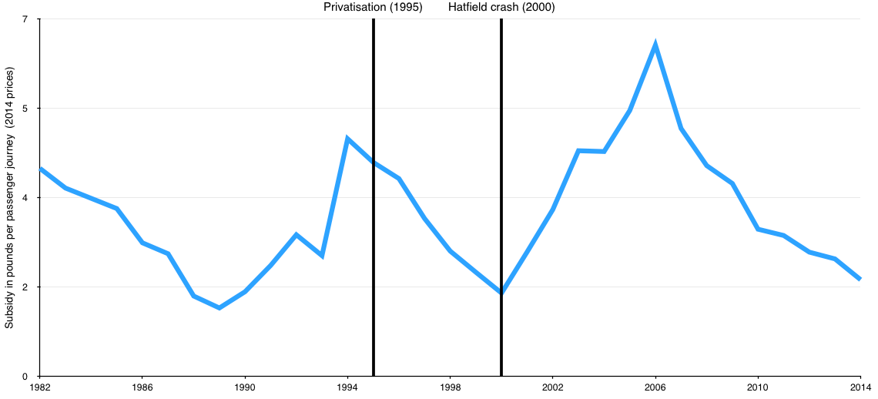

**READING**

Compulsory Reading (you must read these articles to complete the essay plan)

* Article on introduction below
* BBC News 2013 – Why not….nationalise the railways? <http://www.bbc.co.uk/news/uk-politics-22700805>
* BBC News 2016 – The trouble with our trains <http://www.bbc.co.uk/news/uk-37835087>
* Channel 4 News 2017 – Details on Labour’s plans to nationalize rail <https://www.channel4.com/news/factcheck/factcheck-qa-should-we-nationalise-the-railways> and <http://www.bbc.co.uk/news/uk-politics-39886998>
* 2012 – Economics Help: <https://www.economicshelp.org/macroeconomics/privatisation/rail-privatisation/>
* 2015 – Telegraph: <http://www.telegraph.co.uk/news/uknews/road-and-rail-transport/11787426/Should-the-railway-be-in-private-or-public-hands.html>

**ARTICLE: An Introduction to Industrial Policy in the UK**

Key utilities and heavy industry have had a chequered history in the UK

**Period of nationalization from 1945 to 1951 (lasting until 1979) – why?**

The main motive for nationalisation during the post-war period was to ensure a co-ordinated approach to production and supply to ensure economic survival and efficiency in the face of war, and post-war reconstruction. For example, the advantage of a nationalised rail network, as with other natural monopolies, was that central planning could help create a more organised and co-ordinated service. This argument was applied widely to the so-called commanding heights of the economy.

It can also be argued that much infrastructure provides a considerable external benefit to individuals and firms. For example, a nationally and centrally funded and efficient rail network helps keep road traffic down and hence reduces pollution and congestion. It may also help reduce business costs, which may be passed on to other businesses.

Another advantage of national ownership is that economies of large scale can be gained that would not be available to smaller, privately owned enterprises. For example, a nationalised rail service could purchase materials, rail track, and rolling stock on a large scale, thereby reducing average costs and supplying more efficiently than smaller operators.

In more recent times, the failure of major banks has highlighted the fact that, under national ownership and control, failing banks can be funded more quickly and for larger amounts than under private ownership. This enables the banking infrastructure to be rebuilt, as well as ensure the closer regulation of banks in the future.

**Period of privatization from 1979-1997 – why?**

By the late 1970s it became increasingly apparent that many of the industries nationalised between 1945 and 1951 were running into difficulties. The major problems that the industries faced were:

They were being managed ineffectively and inefficiently. The principal-agent problem is highly relevant to public sector activities given that the managers of the utilities were generally not required to meet any efficiency objectives set by the state. There was growing criticism that, because these industries were protected from competition, they had become increasingly inefficient.

Nationalised industries were also prone to suffer from moral hazard, which occurs whenever individuals or organisations are insured against the negative consequences of their own inefficient behaviour. For example, if a particular nationalised industry made operating losses, the government would simply cover those loses with subsidies. Knowing that the taxpayer would come to the rescue meant that the inefficient behaviour could continue. This is, perhaps, the most significant criticism of the recent 'bail out' of failing banks. Given that they know the taxpayer will bail them out this may be an encouragement to continue with their inefficient and highly risky lending activities.

In addition, the nationalised industries had limited scope to raise capital for long term investment and modernisation because they would have to compete with other government spending departments, like education, health and defence. The result was a prolonged period of under-investment in these industries.

By the late 1970s, and throughout the 1980s, most UK's major State owned industries were sold off to the private sector through privatisation. The intention was that, back in the free market, these industries would become more efficient and would be able to modernise by having greater access to the capital markets, and by employing more modern and dynamic management. Privatisation also generated huge revenues for the UK Treasury as well as allowing tax cuts and creating an environment where other supply-side reforms could be implemented.

**Period of ‘semi-privatisation’ (and the odd nationalisation) 1997-2015**

Under New Labour, Tony Blair kept with the previous Thatcherite policies of privatization to some extent by attempting to privatize elements of the NHS and encouraging more ‘Academies’ in education. He also did not renationalize any industries. However from 2007-8, Gordon Brown (the then Prime Minister) effectively nationalized Lloyds Banking Group and the Royal Bank of Scotland to ‘bail out the banks’ in the wake of the Financial Crash. But this was only done because of the emergency at the time.

**Back to the Future 2015-17**

The defeat of Ed Miliband in the 2015 election provoked a sea-change in the New Labour party which elected Jeremy Corbyn as leader, an outspoken critic of New Labour who had originated in the more left-wing ‘Old Labour’ section of the party. Corbyn, faced a difficult time as leader but ultimately had something of a comeback in the recent 2017 general election where Theresa May the current Conservative Prime Minister lost her commons majority and formed a minority Government backed by the DUP. Jeremy Corbyn’s platform for the 2017 election was a pledge to ‘renationalise’ the railways in the light of rising prices, suggesting exploitation of monopoly power by the various Rail providers. It touched a nerve with the public and proved to be reasonably popular but is it the right policy?