It's a sticky wicket all right and suddenly the game is baseball
By David Wighton, Business and City Editor, in the Times, Monday 2nd March 2009

The Bank of England's Monetary Policy Committee is a bit like the England cricket team. The recent results may not have been great, but at least its members know roughly how the game works.  Thanks to years of experience, they understand how changing interest rates affect the economy, just as Test players understand that the ball tends to swing more when it is cloudy and spin when the pitch is worn.  Suddenly, with no chance to practise whatsoever, the team are being forced to play baseball. No wonder the crowd's a tad nervous.  Indeed, it is worse than that. There are, at least, some people around the world who understand baseball. Nobody has much experience of quantitative easing at all, including the Americans, who have also just taken up the sport for the first time. (The one place that it has been played is Japan and the rest of us didn't take much interest, a bit like sumo wrestling.)  Looking back at the MPC's record over the past decade, it appeared pretty good, until recently. Inflation was kept fairly close to the 2 per cent target with the economy growing at a smart pace without the usual booms and busts.  This was widely seen as a vindication of the Government's decision to hand over monetary policy and a credit to the MPC's skill in setting interest rates.  The critics now claim that it was a fluke. The results were good. But the conditions were extremely benign. The MPC was put in to bat on a perfect wicket against feeble opposition.  As Andrew Sentance, a member of the MPC, admitted last week, the record was partly “a product of the circumstances of the time - or what is sometimes characterised as 'luck'”. | 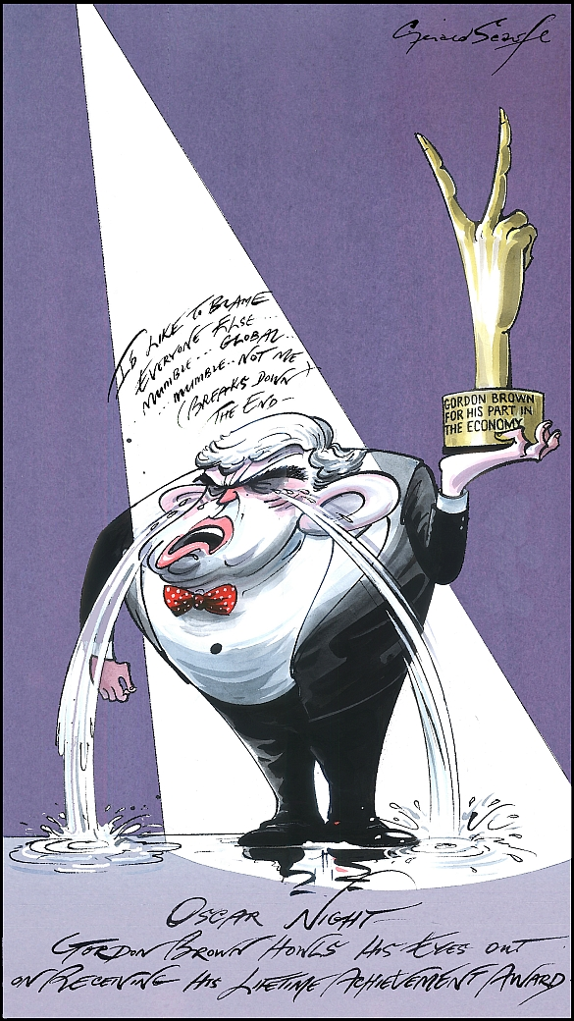

 | With hindsight, the MPC made mistakes, both on the way up and the way down. In 2005, it should have been raising rates, not cutting them, as the credit bubble started to inflate. And last year, it should have cut rates more quickly, as the bubble burst.  How much more difficult will it be now, when the members have to learn a new game in the middle of a crisis? They don't yet know the rules or even how to keep score.  If they get it right, there is every reason to believe that quantitative easing will help, though it remains to be seen how much and how quickly. Perhaps the biggest challenge for the MPC will be judging when to stop. Stop too early, and it risks sending the economy into a “double dip” recession. Stop too late, and it could replace recession with inflation.  With so little experience to base it on, this judgment will be more art than science. A bit like cricket.

