As capitalism stares into the abyss, was Marx right all along?
By Stephen King, in The Independent, Monday 2nd March 2009

We may avoid a 1930s Depression but the best we can hope for may be a 1990s Japan

"Modern bourgeois society ... a society that has conjured up such gigantic means of production and of exchange, is like the sorcerer who is no longer able to control the powers of the nether world whom he has called up by his spells."  Those of you with revolutionary zeal will immediately recognise these words. Penned by Karl Marx in 1848, they form part of the Communist Manifesto. Marx, like Adam Smith before him, had a historical view of society's development. Capitalism, with its bourgeoisie, had replaced feudalism, but capitalism, according to Marx, would be replaced by communism. Capitalism was inherently unstable, as Marx noted later in the same paragraph:  ".....the commercial crises... by their periodical return, put the existence of the entire bourgeois society on its trial, each time more threateningly. In these crises, a great part not only of the existing products, but also of the previously created productive forces, are periodically destroyed. In these crises, there breaks out an epidemic that, in all earlier epochs, would have seemed an absurdity – the epidemic of over-production." | 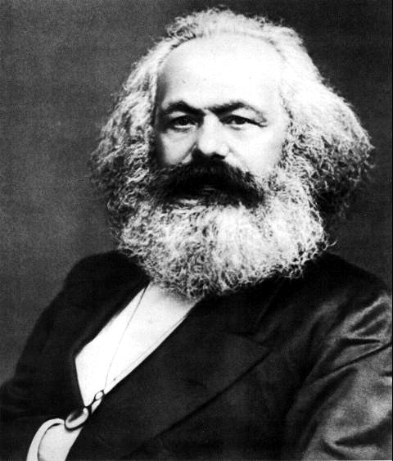

Whatever else one thinks of Marx, he certainly knew a thing or two about the business cycle. Were he alive now, he would surely claim his theories were being vindicated. We are, after all, witnessing the most remarkable collapse in economic activity around the world. Take Japan. In November, industrial production fell 8 per cent. That was bad enough. In December, production dropped another 9 per cent. That was even more remarkable. January's production figures, though, are simply eye-wateringly awful, showing a further 10 per cent decline. Production, then, is down almost 30 per cent in just three months, a pace of decline unprecedented in Japanese post-war economic history.

Or how about the US, where we discovered last week that national income contracted in the final quarter of last year at an annual rate of more than 6 per cent, the biggest drop since the early 1980s. Then there's Taiwan, where exports have been in freefall in recent months. Not to mention dear old Blighty, where the economy might end up shrinking by approaching 4 per cent this year.

The pace of decline in global economic output is extraordinary. On virtually any metric, we are seeing the worst global downturn in decades: worse than the aftermath of the first oil shock in the mid-1970s and worse than the early-1980s downswing, when the world economy had to cope with a doubling of the oil price, the tough love of monetarism and the onset of the Latin American debt crisis. Moreover, this time we cannot use the resurgence of inflation as an excuse for lost output: the credit crunch in all its many guises has seen to that. Instead, we have a world of collapsing output combined with falling prices: a world, then, of depression.

For many years, Marxist ideas appeared to be totally irrelevant. The collapse of the Berlin Wall in 1989 brought to an end the era of Marxist-Leninist Communism, while China's decision to join the modern world at the beginning of the 1980s drew a line under its earlier Maoist ideology. In western economies, Marxist ideas were at their most potent after the First Word War when the likes of Rosa Luxemburg could smell revolution in the air and as the Roaring Twenties gave way to the Great Depression of the 1930s. I'm not suggesting we're entering revolutionary times. However, it seems increasingly likely that the economic landscape in the years ahead will be fundamentally different from the landscape that has dominated the working lives of people like me who entered the workforce in the 1980s. We've lived through decades of plenty, where incomes have risen rapidly, where credit has been all too easily available and where recessions have been mostly modest affairs. Suddenly, we're facing a collapse in activity on a truly Marxist scale. It's difficult to imagine the world's love affair with free markets being sustained under this onslaught. The extreme nature of this downswing will change our lives for decades to come.

The first change relates to the allocation of capital. Increasingly, policymakers are accepting that market forces, left to their own devices, will lead to a race to the bottom. The dangers are becoming greater by the day. Interest rates are close to zero while prices and wages are in danger of declining. If deflation takes hold, real interest rates on cash will start to rise, creating perverse incentives in capital markets. Why bother to buy equities or corporate bonds if you are nicely rewarded for hanging on to an entirely risk-free piece of paper?

The efforts to stop this vicious circle are increasingly focused on bypassing the banking and financial system. As central banks widen the assets they are prepared to purchase to maintain the flow of credit to the economy at large, they are increasingly getting into the capital allocation game. They, and not the market, will at the margin decide whether companies and households are creditworthy. And as governments increase their spending plans to ward off a catastrophic loss of demand, they, rather than companies, will decide on how our savings should be allocated.

The second change relates to an increased national bias in the allocation of capital. As Nicolas Sarkozy, the French President, pushes to offer government funding to French car companies on condition they don't outsource French jobs abroad, as US Congress signs off a stimulus package with more than a hint of a "Buy American" policy, and as the UK Government pushes to encourage bailed-out banks to lend domestically as opposed to internationally, we appear to be turning our backs on the previous world of heightened cross-border trade and capital flows. While these flows have undoubtedly been volatile, they have nevertheless allowed emerging economies, in particular, to gain a foothold on the development ladder. Are we about to cast these countries asunder in our desperate attempt to fix our domestic problems?

The third change relates to interference in the price mechanism. When it comes to Sir Fred Goodwin's pension, this isn't so surprising, but the price mechanism extends far and wide. At the microeconomic level, we'll enter a world of subsidised loans with murky political undertones. At the macroeconomic level, countries may take the opportunity to manipulate their exchange rates in an attempt either to gain a competitive advantage or to "default" to foreign creditors.

Some of these changes may be absolutely necessary to prevent an outright collapse in global economic activity (although the rise in protect-ionist pressures is surely a retrograde step). They also suggest, though, that there will be no return to "business as usual" for market forces. The cost of avoiding depression is a heightened level of state intervention on a scale unimaginable for those who believe in the virtues of free markets. While such intervention may help prevent the worst ravages of economic collapse, it will ultimately do little to foster the entrepreneurial spirit and risk-taking behaviour which have, in the past, contributed so much to rising living standards. We may avoid a 1930s Depression but, increasingly, we may find the best we can hope for is a 1990s Japan. Not quite a Marxist revolution, then, but certainly a lasting sea-change in economic performance.

