Government’s should have a ‘competition policy’ because of the negative effects of firms with monopoly power on society. Monopoly firms profit maximise (point A where MR=MC) which means they can restrict output in a market to raise prices and earn abnormal profit (blue area on figure 1). This means that monopolies are not statically efficient; they are both allocatively inefficient at the quantity of production by withholding supply to the market (Qmon instead of Qsoc). The price is greater than the marginal cost at this quantity suggesting further possible production to benefit society and avoid the deadweight welfare loss to society (triangle ACD in fig.1). Monopolies are also | 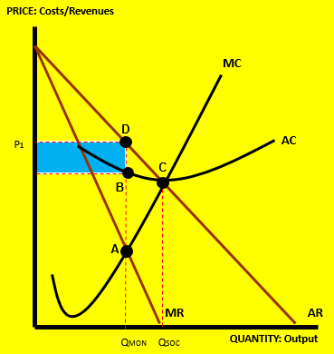  FIGURE 1
productively inefficient (not producing at the bottom of the AC curve at C); this might be because of x-inefficiency where the incentive to cut costs is not there because of a lack of competition. For example, energy markets have been accused of colluding to raise prices artificially and thus are creating poverty for vulnerable groups. All this points to the need for a policy to prevent these effects or to manage them if large firms with monopoly power are already established.

However larger firms do benefit from economies of scale because of their size meaning a lower LRAC (see figure 2 and a move from A to B). Indeed many products (such as electricity) could not be provided without the economies of scale from large firms. Also, the abnormal profit earned from excessive prices can be reinvested into the firm to provide better service and quality to customers. For example, the growth of online shopping in the grocery | 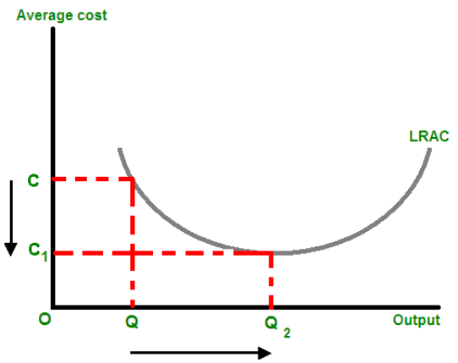  B  A  FIGURE 2
market has made shopping easier for the average consumer. Lastly, perhaps the bad effects of monopoly can be ignored because of ‘creative destruction’. The advent of new technologies often means barriers to entry for monopolies can be broken down in the longer run. For example, Apple have challenged the dominance of Microsoft in recent years and Amazon have broken the retail market stranglehold of well-established High Street stores such as Waterstones etc. Therefore large firms with monopoly power can be useful for society and the need for competition policy becomes less convincing.

