**COMPONENT 1**

**MEDIA PRODUCTS, INDUSTRIES AND AUDIENCES – NEWSPAPERS**

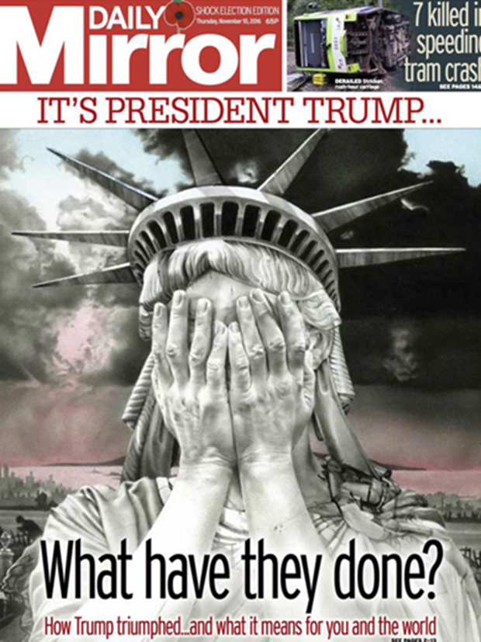

***DAILY MIRROR***

**AMERICAN ELECTION (2016)**

Newspapers offer plentiful opportunities for consideration of political contexts in terms of the political landscape in which news stories are constructed and the political leaning of particular newspapers – the ways in which this influences representations and messages that they construct.

**INDUSTRY – BACKGROUND**

The *Daily Mirror* was first published in 1903 as a newspaper for women ‘to act as a mirror on feminine life’. However, the newspaper was quickly redesigned to appeal to a broader audience.

Owned by the Trinity Mirror Group, the *Daily Mirror* was once the most popular tabloidin the UK. However, it has had the largest year-on-year fall in sales of any national print newspaper in recent years.

1. What can you find out about Trinity Mirror Group? What other publications do they own?
2. What key events in the paper’s history have occurred? What’s its political allegiance?
3. What is its current circulation (Audit Bureau of Circulation)? What is its daily readership (National Readership Survey)? What were the figures two years ago?
4. What has contributed to the decline in the paper’s in circulation?
5. In response to the decline in circulation, the *Daily Mirror* launched *Mirror Online*. What does the website offer readers? Go online and look at *Mirror Online*. Look at the feedback following Trump’s win. What comments can you see? Are readers pro or anti Trump?
6. What other social media platforms does it use?
7. What other market sectors has Trinity Group diversified into? What are the advantages of this?

**REGULATION**

The *Daily Mirror* is part of **Independent Press Standards Organisation (Ipso)** - the independent body which is not backed by the Government and is fully funded by the industry itself.

This is a **regulatory body** that maintains press standards but is anti-Leveson in its approach.

**Political Context in the Newspaper Industry, look at the charts below…**

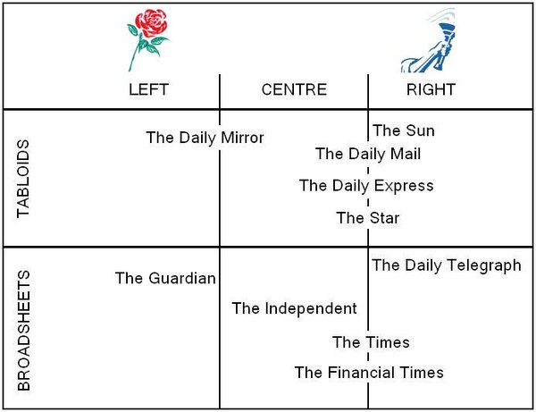  
*Figure 1*

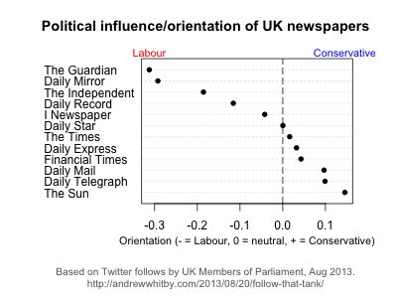

*Figure 2*

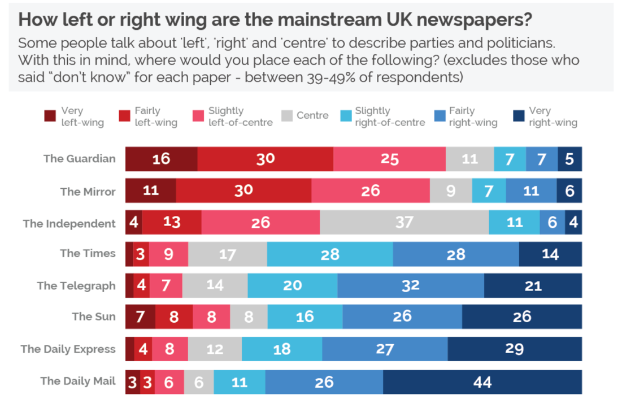

*Figure 3*

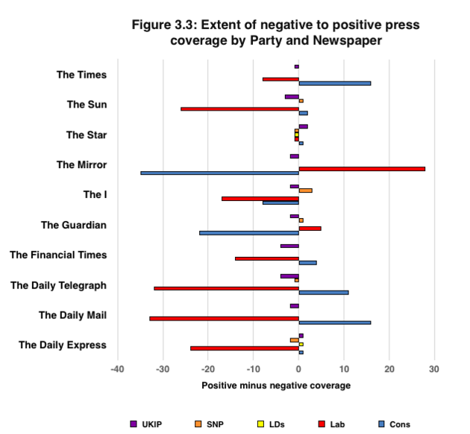

*Figure 4*

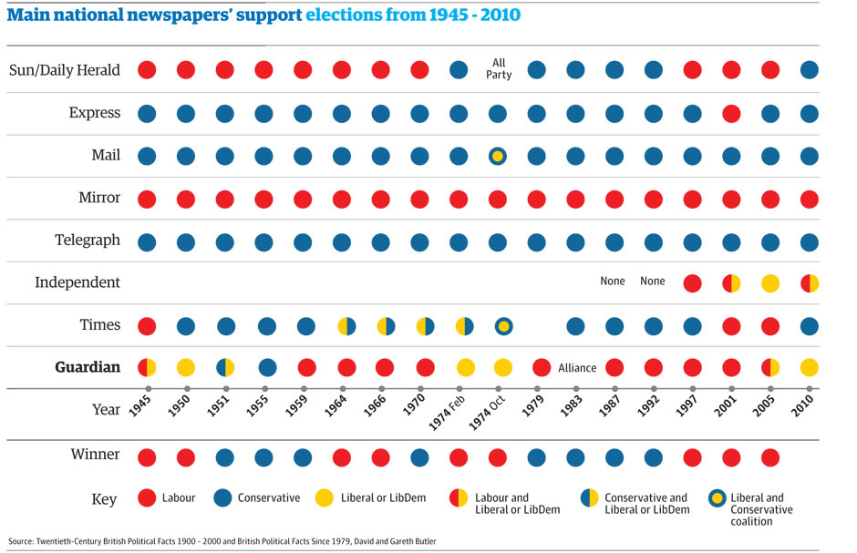

*Figure 5*

1. **What do the above charts and graphs tell you about the politics of the UK newspaper Industry? Refer specifically to Figure 1-5 in your written response**
2. **How could this affect the readers? And the political landscape of the UK?**

**MEDIA LANGUAGE – FRONT COVER**

**Analyse the front cover in terms of media language, considering the connotations of:**

Lighting/colours:

Editing:

Mise-en-scene (colours/iconography/setting):

Written codes:

What does the Statue of Liberty represent? Why is this image, therefore, so powerful?

**Theoretical perspectives**

**MEDIA LANGUAGE**

**DOUBLE-PAGE SPREAD**

**Analyse the double-page spread in terms of media language, considering the connotations of:**

Colours:

Editing:

Mise-en-scene (colours/iconography/setting):

Written codes:

**Theoretical perspectives:**

**Semiotics:**

**REPRESENTATION**

**Consider how the event is being represented**:

What world has been constructed?

Who is in control of this representation?

How is the event represented (consider codes of dress/body language)?

Who is being represented? What’s the ideology of this representation?

How are Clinton and Trump represented? What’s the ideology of these representations?

Reading the article, highlight some key words/sentences? How is the event being represented through written codes?

**THEORETICAL PERSPECTIVE: Discussion point**

**Stuart Hall**:

**AUDIENCE**

1. Who is the paper’s target audience? (demographics)

Primary

Secondary

1. How will the audience interpret the messages on the pages?
2. How will the audiences’ social, cultural or historical circumstances influence their reading of the text?

**Theoretical approaches:**

**Discussion points:**

**Cultivation Theory – Gerbner**

**Reception Theory - Stuart Hall**