

NAME:

**Ancient History**

**Period Study: Relations Between Greek States and Between Greek and Non-Greek States, 492-404 BC**

**TOPIC 3:**

**Peace and Conflict**

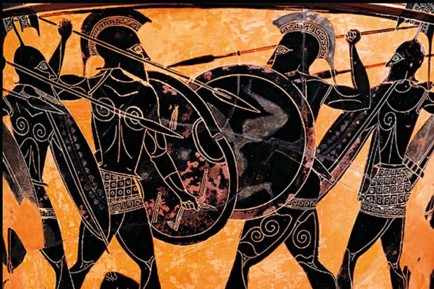**446-431 BC**

***Aims of this Booklet:***

* Examine the Peace Treaty of 446 BC
* Understand the balance of power between Athens and Sparta, and their allies in 446 BC
* Investigate the role of Corinth and Athens in the revolt of Samos
* Analyse the causes of the war between Athens and Sparta in 431 BC

**Suggested Reading**

**History Today Articles (go to** [www.historytoday.com](http://www.historytoday.com) **username= Godalming; password= history)**

# Thucydides: the Compassionate Scientist

By [P.A. Brunt](http://www.historytoday.com/author/pa-brunt)

Published in [History Today](http://www.historytoday.com/archive/history-today/latest) [Volume 7 Issue 12 December 1957](http://www.historytoday.com/archive/history-today/volume-7-issue-12-december-1957)

# Thucydides, Chance and the Dilemma of Imperialism

By [Irene Brown](http://www.historytoday.com/author/irene-brown)

Published in [History Today](http://www.historytoday.com/archive/history-today/latest) [Volume 31 Issue 3 March 1981](http://www.historytoday.com/archive/history-today/volume-31-issue-3-march-1981)

# Architects of the Athenian Empire, Part II: Pericles

By [Stephen Usher](http://www.historytoday.com/author/stephen-usher)

Published in [History Today](http://www.historytoday.com/archive/history-today/latest) [Volume 17 Issue 6 June 1967](http://www.historytoday.com/archive/history-today/volume-17-issue-6-june-1967)

**Textbooks**

* C. Cottam, D. Hodgkinson *et al*, *OCR Ancient History, Component 1: Greece*, Bloomsbury, 2017

**Books in the ILC**

* J. T. Roberts, *The Plague of War: Athens, Sparta and the struggle for Ancient Greece,* Oxford, 2017
* J. Ober, *The Rise and fall of Classical Greece*, Princeton, 2016
* R. Garland, *Ancient Greece: everyday life in the birthplace of western civilisation,* New York, 2013
* R. L. Fox, The Classical World, Penguin, 2006
* P. Cartledge, *Ancient Greece: A very Short Introduction*, Oxford, 2011
* J. Boardman, *The Oxford History of Greece & the Hellenistic World*, Oxford, 1986

**eBooks on** [**www.dawsonera.co.uk**](http://www.dawsonera.co.uk)

* G. Cawkwell, *The Greek Wars: The Failure of Persia*, Oxford, 2005
* P. Rhodes, *A History of the Classical Greek World 478-323 BC*, Wiley-Blackwell, 2009
* P. Cartledge, *After Thermopylae,* Oxford, 2013
* Powell, *Athens and Sparta,* Routledge, 2016
* P. De Souza, *The Greek and Persian Wars 499-386 BC*

**Useful Websites**

* <https://www.bloomsbury.com/cw/ocr-as-and-a-level-ancient-history/?pid=330294> (A companion website for the OCR Ancient History textbook – good selection of wider reading and revision quizzes)
* <http://www.ancient.eu/>
* <http://ancient-greece.org/index.html>
* <http://www.livius.org/>
* [www.ocr.org.uk](http://www.ocr.org.uk)

 **Podcasts**

Sparta **-** <http://www.bbc.co.uk/programmes/b00nvz72>

The Battle of Themopylae - <http://www.bbc.co.uk/programmes/p004y278>

The Battle of Salamis - <http://www.bbc.co.uk/programmes/b08j99jl>

Thucydides - <http://www.bbc.co.uk/programmes/b050bcf1>



*For help in accessing the ebook catalogue on dawsonera, go to the ILC’s page on Godalming Online and read their guide to accessing ebooks.*

*Ebooks can be read using your college log on details whilst in college or at home.*

**ANCIENT HISTORY LUNCHTIME SUPPORT**

**If you need any help in Ancient History going over content, completing homework, attempting assessed questions or preparing for exams, there will be a lunchtime support session each Wednesday between 1 and 2 pm in room 211.**

**The Peace of 446 BC**

Before looking at the terms of the ‘**Thirty Years Peace**’ agreed between Athens and Sparta, recap why 446 had been a year of such tension between the two.

(Clues: *Megara, Euboea, Pleistoanax, Pericles*)­

The Peace of 446BC would become known as the ‘Thirty Years Peace’. It marked the end of period where tension between Athens and Sparta had increased but where they had only fought directly once - at Tanagra in 457 BC. Instead the period from 479-446 BC had seen the Athenian ‘empire’ expand and conflicts erupt between the allies of Athens and Sparta (e.g. Corinth and Megara) leading some historians to refer to it as the ‘First Peloponnesian’ War, whilst others view it as the background to this conflict.

The end of the ‘Thirty Years Peace’ would in fact come in 431 BC as direct war between Athens and Sparta would break out (known as the Archidamian War).

Thucydides gives us an understanding of what was agreed in the Thirty Years Peace through a series of sources.

**TASK:** use the **seven** sources below to complete the table on p. 8 of your lesson materials by finding terms of the Thirty Years Peace that were ***balanced/fair*, *benefitted Sparta*** or ***benefitted Athens.***

Complete this in pairs by splitting the sources and then feeding back to your partner. Make sure you include brief quotes from the sources and that you include the number of the source next to your point.

**Prescribed Source – Thucydides 1.115**

Soon after they had returned from Euboea the Athenians made a thirty years’ truce with Sparta and her allies: Athens gave up Nisaea, Pegae, Troezen, and Achaea – all places which they had seized from the Peloponnesians.

In the sixth year of the truce war broke out between Samos and Miletus over the question of Priene. After having the worst of the fighting the Milesians came to Athens and lodged violent protests against the Samians. Their cause was supported by various private individuals from Samos itself who wished to set up there a different from of government. So the Athenians sailed to Samos with forty ships and established a democracy there. They took fifty boys and fifty men as hostage and kept them in Lemnos. Then, leaving a garrison behind in Samos, they returned home. However, some of the Samians, instead of staying on the island, had fled to the mainland. These entered into communications with the leading oligarchs still in the city and also made an alliance with Pissuthnes, the son of Hystaspes, who at the time was the Persian Governor at Sardis. They raised a force of about 700 mercenaries, and passed over into Samos under cover of night. First they made an attack on the democratic party and imprisoned most of the leaders; then they rescued their hostages from Lemnos and declared themselves independent. They handed over to Pissuthnes the troops in the Athenian garrison and the Athenian officials who had been left in Samos, and at once made preparations for an attack on Miletus. At the same time Byzantium joined them in revolting from Athens.

**Prescribed Source – Thucydides 1.140**

‘Athenians,’ he said, ‘my views are the same as ever: I am against making any concessions to the Peloponnesians, even though I am aware that the enthusiastic state of mind in which people are persuaded to enter upon a war is not retained when it comes to action, and that peoples’ minds are altered by the course of events. Nevertheless I see that on this occasion I must give you exactly the same advice as I have given in the past, and I call upon those of you who are persuaded by my words to give your full support to these resolutions which we are making altogether, and to abide by them even if in some respect or other we find ourselves in difficulty; for, unless you do, you will be able to claim no credit for intelligence when things go well with us. There is often no more logic in the course of events than there is in the plans of men, and this is usually why we blame our luck when things happen in ways that we did not expect.

‘It was evident before that Sparta was plotting against us, and now it is even more evident. It is laid down in the treaty that differences between us should be settled by arbitration, and that, pending arbitration, each side should keep what it has. The Spartans have never once asked for arbitration, nor have they accepted our offers to submit to it. They prefer to settle their complaints by war rather than by peaceful negotiations, and now they come her not even making protests, but trying to give us orders. They tell us to abandon our siege of Potidaea, to give Aegina her independence and to revoke the Megarian decree. And finally they come to us with a proclamation that we must give the Hellenes their freedom.

‘Let none of you think that we should be going to war for a trifle if we refuse to revoke the Megarian decree. It is a point they make much of, and say that war need not take place if we revoke this decree; but, if we do go to war, let there be no kind of suspicion in your hearts that the war was over a small matter. For you this trifle is both the assurance and the proof of your determination. If you give in, you will immediately be confronted with some greater demand, since they will think that you only gave way on this point through fear. But if you take a firm stand you will make it clear to them that they have to treat you properly as equals.

**Prescribed Source – Thucydides 1.35**

‘It is not a breach of your treaty with Sparta if you receive us [Corcyrans] into your alliance. We are neutrals, and it is expressly written down in your treaty that any Hellenic state which is in this condition is free to ally itself with whichever side it chooses. What is really monstrous is a situation where Corinth can find sailors for her ships both from her own allies and from the rest of Hellas, including in particular your own subjects, while we are shut off from a perfectly legitimate alliance, and indeed from getting help from anywhere: and then, on top of that, they will actually accuse you of behaving illegally if you grant our request. In fact it is we who shall have fare greater reasons to complain of you if you are not willing to help us; you will be rejecting us, who are no enemies of yours, in the hour of our peril, and as for the others, who are enemies of yours and are also the aggressors, you will not only be doing nothing to stop them, but will actually be allowing them to build up their strength from the resources of your own empire. Is this right? Surely if you ought either to stop them from engaging troops from your own subjects, or else to give us, too, whatever assistance you think proper. Best of all would be for you to receive us in open alliance and help us in that way.

‘We have already suggested that such a course would be very much in your own interests. Perhaps the greatest advantage to you is that you can entirely depend on us because your enemies are the same as ours, and strong ones, too, quite capable of doing damage to those who revolt from them. And then it is quite a different matter for you if you reject alliance with a naval power than if you do the same thing with a land power. Your aim, no doubt, should be, if it were possible, to prevent anyone else having a navy at all: the next best thing is to have on your side the strongest navy that there is.

**Prescribed Source – Thucydides 1.40**

‘We have shown, I think, that we have good reason for complaint, and that the conduct of Corcyra has been both violent and grasping. Next we should like you to understand that it would not be right or just for you to receive them as allies. Though there may be a clause in the treaty stating that any city not included in the original agreement is free to join whichever side it likes, this cannot refer to cases where the object of joining an alliance is to injure other powers; it cannot refer to a case where a city is only looking for security because it is in revolt, and where the result of accepting its alliance, if one looks at the matter dispassionately, will be, not peace, but war. And this is what may well happen to you, if you will not take our advice. You would not only be helping them, but making war on us, who are bound to you by treaty. If you join them in attacking us, we shall be forced to defend ourselves against you as well as against them.

‘The right course, surely, is either for you to preserve a strict neutrality or else to join us against them. At least you have treaty obligations towards Corinth, whereas you have never even had a peace treaty with Corcyra. What you ought not to do is to establish a precedent by which a power may receive into its alliance the revolted subjects of another power. At the time when Samos revolted from you and when the Peloponnesian states were divided on the question whether to help them or not, we were not one of those who voted against you; on the contrary, we openly opposed the others and said that every power should have the right to control its own allies. Now, if you are going to welcome and assist people who have done wrong to us, you will find just as many of your own people coming over to our side and you will be establishing a precedent that is likely to harm you even more than us.

**Prescribed Source – Thucydides 5.14**

Indeed, what now took place was that, after the battle of Amphipolis and the withdrawal of Ramphias from Thessaly, neither side went on with the war. Instead they began to think how to make peace. The Athenians had suffered a serious blow at Delium and another one soon afterwards at Amphipolis; they no longer possessed the same confidence in their strength which had induced them to reject previous offers of peace, in the belief that their good fortune at that time would carry them through to final victory. They were also apprehensive about the allies, fearing that they might be encouraged by these defeats to revolt on a more serious scale, and they regretted that they had not seized upon the excellent opportunity of making peace after Pylos. The Spartans on their side had found that the war had gone very differently from what they had imagined when they believed that they could destroy the power of Athens in a few years simply by laying waste to her land. The disaster suffered on the island was something which had never been known before in Sparta; her territory was being raided from Pylos and from Cythera; the helots were deserting, and there was always the fear that even those who remained loyal might gain confidence from the others and take advantage of the situation to make revolution, as they had done in the past. It happened, too, that the thirty years’ truce between Sparta and Argos was on the point of expiring; the Argives refused to renew it unless Cynuria was given back to them, and it seemed impossible to fight Athens and Argos at once. They also suspected that some of the states in the Peloponnese had the intention of going over to Argos, as indeed they did.

**Prescribed Source – Thucydides 7.18**

The Spartans also prepared to invade Attica, as they had already decided to do and as they had been asked to do by the Syracusans and Corinthians, who, when they heard that Athens was sending reinforcements to Sicily, hoped that this would be stopped by an invasion. Alcibiades, too, was constantly urging them to fortify Decelea and to carry on the war with vigour. But what chiefly encouraged the Spartans to act with energy was their belief that Athens, with two wars on her hands – one against them and one against the Sicilians – would be now easier to crush. There was also the fact the Spartans considered that Athens had been the first to break the peace treaty. In the first war they thought that the fault had been more on their side, partly because the Thebans had entered Plataea in peace time and partly because, in spite of the provisions in the previous treaty that there should be no recourse to arms if arbitration was offered, they themselves had not accepted the Athenian offer of arbitration. They therefore thought that there was some justice in the misfortunes they had suffered and took to heart the disaster of Pylos and their other defeats. But now, in addition to the constant raids from Pylos, the Athenians had come out with thirty ships from Argos and laid waste part of Epidaurus and Prasiae and other places; also whenever any dispute arose on doubtful points in the treaty, it was Sparta who had offered to submit to arbitration and Athens who had refused the offer. It was now Athens therefore, the Spartans thought, who was in in the wrong through having committed exactly the same fault as theirs had been before, and they went into the war with enthusiasm. This winter they sent round to their allies for supplies of iron and got ready all the other materials for building fortifications. At the same time they organized a force of their own and conscripted other forces from the rest of the Peloponnese to be sent out in merchant ships to the help of their allies in Sicily. So the winter ended, and the eighteenth year of this war recorded by Thucydides.

**Prescribed Source – Thucydides 1.67**

Now, however, Corinth brought matters into the open. Potidaea was under blockade, some of her own citizens were inside, and she feared that the place might be lost. She therefore immediately urged the allies to send delegates to Sparta. There her own delegates violently attacked the Athenians for having broken the truce and committed acts of aggression against the Peloponnese. The people of Aegina were on her side. Out of fear of Athens they had not sent a formal delegation, but behind the scenes they played a considerable part in fomenting war, saying that they had not been given the independence promised to them by treaty. The Spartans also issued an invitation to their own allies and to anyone else who claimed to have suffered from Athenian aggression. They then held their usual assembly, and gave an opportunity there for delegates to express their views. Many came forward with various complaints. In particular the delegates from Megara, after mentioning a number of other grievances, pointed out that, contrary to the terms of the treaty, they were excluded from al ports in the Athenian empire and from the market of Athens itself. The Corinthians were the last to come forward to speak, having allowed the previous speakers to do their part in hardening Spartan opinion against Athens. The Corinthian speech was as follows:

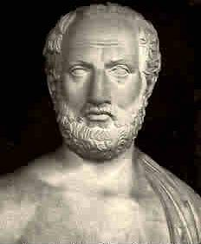**Thucydides**

Thucydides is our main source of evidence when looking at this period and at the Peloponnesian War generally.

Using the understanding you gained in your last topic (and doing any other research that is necessary) make notes below to summarise what kind of historian he was.

***Personal Background/Information:***

***Context in which he was writing:***

***Methods and Research:***

***Problems or Criticisms:***

**The ‘Thirty Years Peace’**

|  |  |  |
| --- | --- | --- |
| **Terms that benefitted Sparta more** | **Balanced/Fair Terms** | **Terms that benefitted Athens more** |
|  |  |  |

***On the balance of the evidence above, how sustainable do you think the ‘Thirty Years Peace’ was?***

The **Thirty Years Peace** was intended to be **compromise** between Athens and their allies, and Sparta and their allies. The peace clearly separated out an Athenian and Spartan area of interest. Athens recognised Sparta’s interests and leadership in the Peloponnese whilst, and perhaps more significantly, the Spartans accepted that the Athenians would be the dominant power in the Aegean and that the members of the Delian League were under the control of Athens. The Peace prevented states from changing allegiances which meant that members of the Delian League would not now be allowed to break away (as Megara had done in 460).

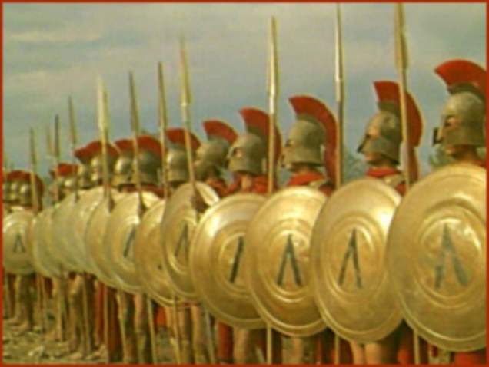The Thirty Years Peace was also ambitious as it attempted to prevent conflict between the two sides in the long term. One clear example of this was the clause of the Peace that required states to submit their disputes to **arbitration** rather than ending up at war.

Some would argue that the Thirty Years Peace was too ambitious to be successful and that the fundamental differences and tensions between Sparta and Athens remained. The Peace, however, would come under pressure from divisions within Sparta and from her allies in the Peloponnese, Corinth in particular.

**The Build-Up to War**

**Prescribed Source – Thucydides 1.23**

The greatest war in the past was the Persian War; yet in this war the decision was reached quickly as a result of two naval battles and two battles on land. The Peloponnesian War, on the other hand, not only lasted for a long time, but throughout its course brought with it unprecedented suffering for Hellas. Never before had so many cities been captured and devastated, whether be foreign armies or by Hellenic powers themselves (some of these cities after capture, were resettled with new inhabitants); never had there been so many exiles; never such loss of life – both in the actual warfare and in internal revolutions. Old stories of past prodigies, which had not found much confirmation in recent experience, now became credible. Wide areas, for instance, were affected by violent earthquakes; there were more frequent eclipses of the sun than had ever been recorded before; in various parts of the country there were extensive droughts followed by famine; and there was the plague which did more harm and destroyed more life than almost any other single factor. All these calamities fell together upon the Hellenes after the outbreak of war.

War began when the Athenians and the Peloponnesians broke the Thirty Years Truce which had been made after the capture of Euboea. As to the reasons why they broke the truce, I propose first to give an account of the cause of complaint which they had against each other and of the specific instances where their interests clashed: this is in order that there should be no doubt in anyone’s mind about what led to this great war falling upon the Hellenes. But the real reason for the war in, in my opinion, most likely to be disguised by such an argument. What made war inevitable was the growth of Athenian power and the fear which this caused in Sparta. As for the reasons for breaking the truce and declaring war which were openly expressed by each side, they are as follows.

1. List three consequences of the Peloponnesian War given by Thucydides
2. What, according to Thucydides was the cause of the conflict?

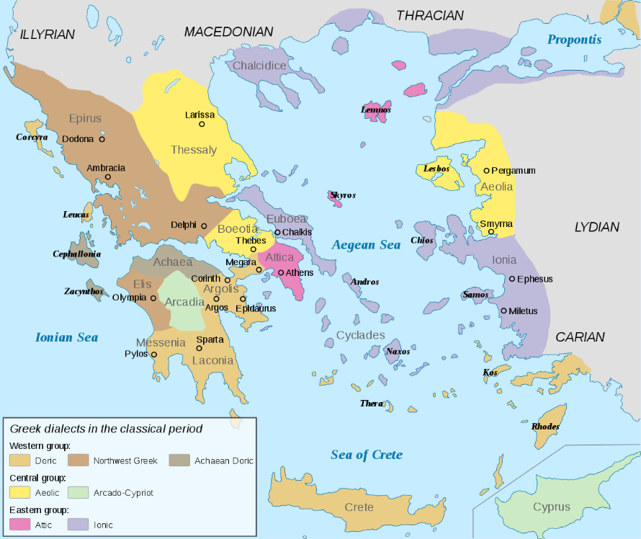**Samos and Miletus**

In 440 BC two of Athens’ allies (members of the Hellenic League) – **Samos** and **Miletus** – went to war. Miletus appealed to Athens for help which they provided by overthrowing Samos’ oligarchy and replacing it with a democracy. The deposed Samian leaders appealed to the Persian Satrap of Lydia (see map) Pissuthnes for support and together they pushed the Athenian garrison out of Samos. Athens fought back and following a battle at sea, two sieges and nine months the Samians surrendered. They were forced to hand over their navy to Athens and to pay tribute to Athens from that point. This effectively disarmed Samos.

**Prescribed Source – Thucydides 1.115-1.117**

Soon after they had returned from Euboea the Athenians made a thirty years’ truce with Sparta and her allies: Athens gave up Nisaea, Pegae, Troezen, and Achaea – all places which they had seized from the Peloponnesians.

In the sixth year of the truce war broke out between Samos and Miletus over the question of Priene. After having the worst of the fighting the Milesians came to Athens and lodged violent protests against the Samians. Their cause was supported by various private individuals from Samos itself who wished to set up there a different from of government. So the Athenians sailed to Samos with forty ships and established a democracy there. They took fifty boys and fifty men as hostage and kept them in Lemnos. Then, leaving a garrison behind in Samos, they returned home. However, some of the Samians, instead of staying on the island, had fled to the mainland. These entered into communications with the leading oligarchs still in the city and also made an alliance with Pissuthnes, the son of Hystaspes, who at the time was the Persian Governor at Sardis. They raised a force of about 700 mercenaries, and passed over into Samos under cover of night. First they made an attack on the democratic party and imprisoned most of the leaders; then they rescued their hostages from Lemnos and declared themselves independent. They handed over to Pissuthnes the troops in the Athenian garrison and the Athenian officials who had been left in Samos, and at once made preparations for an attack on Miletus. At the same time Byzantium joined them in revolting from Athens.

[116] When the Athenians heard of this they sailed against Samos with a fleet of sixty ships. Sixteen of these were not brought into action: some had been sent to Caria to watch the movements of the Phoenician fleet; others had gone to Chios and Lesbos with orders to send reinforcements. The remaining forty-four, under the command of Pericles and nine other commanders, fought, off the island of Tragia, with a Samian fleet of seventy ships which was returning from Miletus and included twenty transports. The result was a victory for the Athenians.

Later they were reinforced by forty ships from Athens and twenty-five from Chios and Lesbos. Having landed on the island and established their superiority with their ground forces, they built three walls to blockade the city, which was already blockaded from the sea. Pericles then took sixty ships from the fleet anchored off Samos and sailed away at full speed for Caunus and Caria, since news had arrived that the Phoenician fleet was on its way against them. Stesagoras and others, with five ships, had actually left Samos and gone to enlist the aid of the Phoenicians. [117] During Pericles’ absence the Samians put out to sea in a surprise attack; they set upon the Athenian camp, which had not been fortified, destroyed the ships that were posted to keep a look-out, and defeated in battle the other ships that were launched to meet them. So for about fourteen days they controlled the sea round their island and were free to bring in or take out what they wanted. But when Pericles returned they were once more under naval blockade. Later the Athenian fleet was reinforced from Athens with forty ships under the command of Thucydides, Hagnon, and Phormio, and twenty more under the command of Tlepolemus and Anticles; also thirty ships from Chios and Lesbos. The Samians made a brief effort at resistance by sea, but were unable to hold their own and were forced to accept terms of surrender after a nine months’ siege: they pulled down their walls, gave hostages, handed over their fleet, and agreed to pay reparations in instalments at regular intervals. Byzantium also agreed to return to its status of a subject city.

**Prescribed Source – Plutarch *Pericles* 28.1-3 (89)**

In the ninth month the Samians surrendered and Perikles pulled down the walls, took away the ships and inflicted a large fine, part of which the Samians paid immediately, part they were assessed to pay at a stated time, giving hostages as security. Douris of Samos writes about this in tragic terms, accusing the Athenians and Perikles of much cruelty not recorded by Thucydides, Ephoros, or Aristotle. But it seems unlikely to be true that Perikles brought the Samian trierarchs (i.e. trireme captains) and marines to the marketplace in Miletos, tied them to boards for ten days and when they were already in a bad way ordered the Milesians to execute them by bludgeoning their heads and then to throw out the bodies without burial. Even when he has no personal links, Douris does not usually control his narrative by reference to truth, and he is very likely here to magnify the misfortunes of his own homeland to slander the Athenians.

1. Why does Plutarch not believe the story that Pericles had ordered the execution of the captains of a number of Samian triremes?
2. What do you learn from this source about the type of historian Plutarch was?

What was particularly significant about the conflict between Samos and Miletus, and Athens’ intervention, was the reaction to it of Sparta, Corinth and the Peloponnesians generally. Thucydides gives us an account of a discussion later on in Athens about whether or not to form an alliance with Corcyra (modern-day Corfu) (see **Thucydides 1.40** on p. 5). The Corinthians had sent a delegation to Athens to argue against this and it became clear that during the time of Athens’ conflict with Samos, the Peloponnesian League had debated intervening against Athens. Corinth voted against this believing that Athens had the right to control its own allies. Sparta, however, must have already voted in favour of war (if they hadn’t then the rest of the League would not be debating it). The significance of this is that as little as six years after the end of the Persian Wars, tension between Athens and Sparta was already great enough for Sparta to try to go to war with Athens, only being stopped by the other members of the Hellenic League.

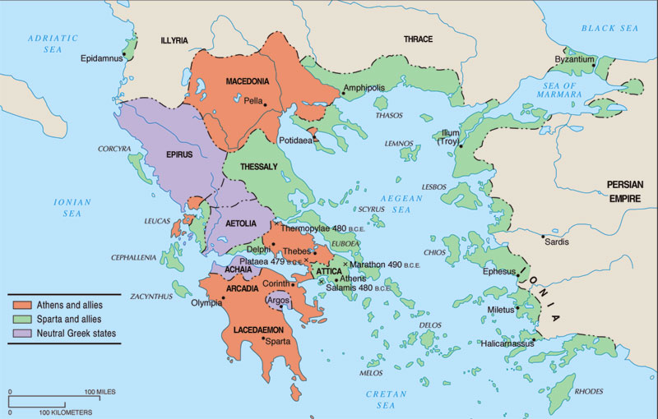**Epidamnus-Corcyra**

This would be the first major complaint made against Athensand would involve the two major powers of **Athens** and **Corinth** being pulled into conflict over the island of **Corcyra** (modern-day Corfu). **Epidamnus** (see map) was originally a colony of Corcyra which was itself originally a colony of Corinth. In **435** a local conflict in Epidamnus resulted in a pro-democracy group appealing to Corcyra for help. When Corcyra refused, Epidamnus asked Corinth for help who accepted. Corinth believed that Corcyra, as a former colony, did not show Corinth enough respect and so looked to interfere to gain influence in Corcyra.

Corinth sent military forces to Corcyra leading to a siege and a naval battle at Leucimme. The Corinthians, however, were defeated and prepared to send a further force in **433,** at which point Corcyra appealed to Athens for support.

Corcyra was an attractive potential ally for Athens at it had a powerful navy of **120 ships** that could be added to Athens’. It was also a neutral state so according to the terms of the Thirty Years Peace, Athens was allowed to form an alliance. The Corcyraeans argued to Athens that their navy would assist them in what looked to be an inevitable war against Sparta, but that if they failed to help, their ships would be taken by Corinth and the Peloponnesian League.

**Prescribed Source - Thucydides, 1.40-141**

‘We [the Corinthian delegation to Athens] have shown, I think, that we have good reason for complaint, and that the conduct of Corcyra has been both violent and grasping. Next we should like you to understand that it would not be right or just for you to receive them as allies. Though there may be a clause in the treaty stating that any city not included in the original agreement is free to join whichever side it likes, this cannot refer to cases where the object of joining an alliance is to injure other powers; it cannot refer to a case where a city is only looking for security because it is in revolt, and where the result of accepting its alliance, if one looks at the matter dispassionately, will be, not peace, but war. And this is what may well happen to you, if you will not take our advice. You would not only be helping them, but making war on us, who are bound to you by treaty. If you join them in attacking us, we shall be forced to defend ourselves against you as well as against them.

‘The right course, surely, is either for you to preserve a strict neutrality or else to join us against them. At least you have treaty obligations towards Corinth, whereas you have never even had a peace treaty with Corcyra. What you ought not to do is to establish a precedent by which a power may receive into its alliance the revolted subjects of another power. At the time when Samos revolted from you and when the Peloponnesian states were divided on the question whether to help them or not, we were not one of those who voted against you; on the contrary, we openly opposed the others and said that every power should have the right to control its own allies. Now, if you are going to welcome and assist people who have done wrong to us, you will find just as many of your own people coming over to our side and you will be establishing a precedent that is likely to harm you even more than us. All this we have a perfect right to claim from you by Hellenic law and custom. We should like also to give you some advice and to mention that we have some title to your gratitude. We are not enemies who are going to attack you, and we are not on such friendly terms that such services are quite normal. We say, therefore, that the time has come for you to repay us for what we did for you in the past.

‘You were short of warships when you were fighting Aegina, just before the Persian invasion. Corinth then gave you twenty ships. As a result of this act of kindness you were able to conquer Aegina, and as a result of our other good turn to you, when we prevented the Peloponnesian states from helping Samos, you were able to punish that island. And these acts of ours were done at critical periods, periods when people are very apt to turn upon their enemies and disregard every other consideration except victory. At such times people regard even former enemies as their friends, so long as they are on their side, and even genuine friends as their enemies, if they stand in their way; in fact their over-mastering desire for victory makes them neglect their own best interests.

1. Why did Corinth argue that although Corcyra was a neutral state, it was still wrong for Athens to make an alliance with it?
2. What two ‘good turns’ did the Corinthians do for Athens?

In the end, Athens decided to ally itself with Corcyra, against the advice of Corinth. In 433 the Corinthians attacked the Corcyraeans and the Athenians intervened turning back the Corinthian ships.

**Prescribed Source - Thucydides, 1.44**

This was the speech of the Corinthian delegation. The Athenians, after listening to both sides, discussed the matter at two assemblies. At the first of these, opinion seemed to incline in favour of the Corinthian arguments, but at the second there was a change, and they decided on entering into some kind of alliance with Corcyra. This was not to be a total alliance involving the two parties in any war which either of them might have on hand; for the Athenians realized that if Corcyra required them to join in an attack on Corinth, that would constitute a breach of their treaty with the Peloponnese. Instead the alliance was to be of a defensive character and would only operate if Athens or Corcyra or any of their allies were attached from outside.

*What type of alliance did Athens form with Corcyra (in your own words)?*

*Why did they do this?*

The general belief was that, whatever happened, war with the Peloponnese was bound to come. Athens had no wish to see the strong navy of Corcyra pass into the hands of Corinth. At the same time she was not averse from letting the two Powers weaken each other by fighting together; since in this way, if war did come, Athens herself would be stronger in relation to Corinth and to the other naval powers. Then, too, it was a fact that Corcyra lay very conveniently on the coastal route to Italy and Sicily.

**Prescribed Source - Thucydides, 1.55**

*How would summarise Corinth’s feelings towards Athens at this point (433 BC)?*

On their voyage home the Corinthians took Anactorium, at the mouth of the Ambracian Gulf. It was a place in which both Corinth and Corcyra had rights and it was given up to the Corinthians by treachery. Before sailing home the Corinthians put settlers of their own into Anactorium. They sold 800 of the Corcyraean prisoners who were slaves, and they kept in captivity 250 whom they treated with great consideration, hoping that a time would come when they would return and win over the island to Corinth. Most of them were in fact people of great power and influence in Corcyra.

So Corcyra remained undefeated in her war with Corinth and the Athenian fleet left the island. But this gave Corinth her first cause for war against Athens, the reason being that Athens had fought against her with Corcyra although peace treaty was still in force.

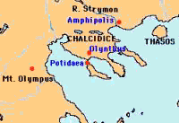

**Potidaea**

The next event to escalate tension between Athens and Corinth (and consequently the Peloponnesian League came at the city of **Potidaea,** located on three-pronged peninsula of **Chalcidice** on the north Aegean coast. Potidaea was in an awkward position as it was a ‘subject state of Athens’ but was also a Corinthian colony (i.e. its original settlers had come from Corinth) to which Corinth still sent governors, known as magistrates. Corinth saw it therefore, as an excellent place to get revenge against Athens for Corcyra.

**Prescribed Source – Thucydides 1.56-58**

Almost immediately afterwards it happened that there was another dispute between Athens and the Peloponnese. This also contributed to the breaking out of war. It concerned the people of Potidaea who live on the Isthmus of Pallene, and who, though colonists of Corinth, were allies of Athens in the tribute-paying class. Corinth was searching for means of retaliation against Athens, and Athens has no illusions about the hatred felt for her by Corinth. She therefore made the following demands of Potidaea: they were to pull down the fortifications looking towards Pallene, to send hostages to Athens, to banish their Corinthian magistrates, and in future not to receive those who were sent out annually from Corinth to replace them. These demands were made because Athens feared that, under the influence of Perdiccas and of the Corinthians, Potidaea might be induced to revolt and might draw into their revolt the other allied cities in the Thracian area. It was directly after the sea battle off Corcyra that the Athenians took these precautions with regard to Potidaea. Corinth was now quite openly hostile, and though Perdiccas, the son of Alexander and King of Macedonia, had in the past been a friend and an ally, he had now been made into an enemy. This had come about because the Athenians had entered into an alliance with his brother Philip and with Derdas, who had joined forces together against Perdiccas. Perdiccas was alarmed by these moves and not only sent his agents to Sparta in order to try to involve Athens in a war with the Peloponnese, but also was approaching Corinth in order to get support for a revolt in Potidaea. He was also in communication with the Chalcidians in Thrace and with the Bottiaeans, and was urging them to revolt at the same time. All these places bordered on his own country, and his idea was that if he had them as his allies, their support would make his own military position easier.

The Athenians knew what he was doing and wished to anticipate the revolt of these cities. They were just on the point of sending out to Macedonia a force of thirty ships and 1,000 hoplites under the command of Archestratus, the son of Lycomedes, with other commanders. Now, these officers were instructed to take hostages from the Potidaeans, to destroy the fortification, and to keep a close watch on the neighbouring cities so as to prevent any movement of revolt.

Meanwhile the Potidaeans had sent representatives to Athens in the hope of persuading the Athenians not to make any alterations in the existing state of affairs. They also sent representatives with the Corinthians to Sparta in order to win support there in case it should be necessary. After long negotiations at Athens nothing valuable was achieved; in spite of all their efforts, the fleet for Macedonia was ordered to sail against them too. The Spartan authorities, however, promised to invade Attica if the Athenians attacked Potidaea. This, then, seemed to the Potidaeans to be the moment: they made common cause with the Chalcidians and the Bottiaeans and revolted from Athens.

Perdiccas, at this point, persuaded the Chalcidians to pull down and abandon their cities on the coast and to settle inland at Olynthus, making that into one big city. To those who left their homes in this way he offered the use for the duration of the war with Athens of some of his own territory in Mygdonia round lake Bolbe. The Chalcidians therefore, after destroying their cities, settled inland and prepared for war.

1. What four demands did the Athenians make of Potidaea?
2. Why did Athens make these demands?

In response to these demands, the Potidaeans sent representatives to Sparta whose **ephors** agreed to invade Attica if Potidaea was attacked by Athens. Sparta would not, however, enact this promise as clearly the Spartan Assembly opposed war with Athens and the city was too divided to act. The Potidaeans did revolt and the Corinthians sent an army to support them. Athens sent forces and began a three year siege of Potidaea.

**Prescribed Source - Thucydides, 1.60-61**

Now that Potidaea had revolted and the thirty Athenian ships were off the coast of Macedonia, the Corinthians feared that the place might be lost and regarded its safety as their own responsibility. They therefore sent out a force of volunteers from Corinth itself and of mercenaries from the rest of the Peloponnese. Altogether this force amounted to 1,600 hoplites and 400 light troops. It was under the command of Aristeus, the son of Adeimantus, who had always been a staunch friend to the people of Poitidaea. And it was largely because of his personal popularity that most of the Corinthian volunteers joined the expedition. This expedition reached Thrace forty days after the revolt of Potidaea.

The Athenians had also received the news immediately after the revolt of the cities. They heard, too, of the reinforcements under Aristeus, and they sent out against the places in revolt an army of 2,000 citizen hoplites and a fleet of forty ships. This force was commanded by Callias, the son of Calliades , with four other commanders. First they arrived in Macedonia, where they found that the original force of 1,000 had just captured Therme and were now besieging Pydna. They therefore joined in the operation against Pydna. The siege lasted for a time, but finally they came to an agreement with Perdiccas and made an alliance with him. They were forced into doing this by the need to hurry on with the campaign at Potidaea and by the arrival there of Aristeus.

Leaving Macedonia, then, they came to Beroea and from there went on to Strepsa. After making an unsuccessful attempt at capturing the place, they marched on by land to Potidaea. They had 3,000 hoplites of their own, apart from a large force of allies and 600 Macedonian cavalry from the army of Philip and Pausanias. The seventy ships sailed with them along the coast. Proceeding by short marches, they reached Gigonus on the third day and camped there.

**Prescribed Source - Thucydides, 1.66**

Both the Athenians and the Peloponnesians had already grounds of complaint against each other. The grievance of Corinth was that the Athenians were besieging her own colony of Potidaea with Corinthians and other Peloponnesians in the place: Athens on the other hand, had her own grievances against the Peloponnesians; that had supported the revolt of a city which was in alliance with her and which paid her tribute, and they had openly joined the Potidaeans in fighting against her. In spite of this, the truce was still in force and war had not yet broken out. What had been done so far had been done on the private initiative of Corinth.

**Megara**

**Recap:** summarise when and how Megara had already contributed to the build-up of tension between Athens and its allies and Sparta and its allies

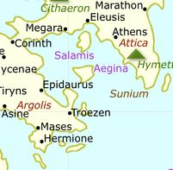

Thucydides gives detailed coverage of the complaints at Poitdaea and Epidamnus-Corcyra but says very little about the complaint from **Megara** and how this may also have contributed to the outbreak of the Peloponnesian War.

The issue revolved around the **Megarian decree**. This was an Athenian law (religious in nature) that banned Megarians from using Athenian-controlled ports or *agora* (market places). The decree did significant damage to Megara’s economy as the city, despite now being a member of the Peloponnesian League, relied on trade with Athens and the different parts of its empire.

The reason behind the decree is unclear but there are a number of possible explanations as to why it was created:

1. 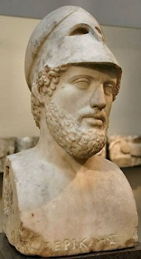Megara had sent eight ships to support the Corinthians against the Athenians at the battle of Leucimme and decree may have been designed to deter other states from helping Athens’ enemies
2. A theory passed on by Plutarch was that the Megarians had profaned a religious land and then killed an envoy who was sent to complain about this. Killing an envoy was a serious religious offence
3. Pericles may have created the decree to distract Athenian attention away from the trial of his friend Pheidias for embezzlement
4. Some blamed Pericles’ mistress Aspasia for passing the decree (see Aristophanes Source)

**Prescribed Source- Aristophanes *Acharnians***

**TASK** – do some quick research into Aristophanes:

*Who was he?*

*When was he alive?*

*What was the style of his writing?*

*What was his play ‘Acharnians’ about?*

DIKAIOPOLIS. Some drunken young men from a party went off to Megara and kidnapped a prostitute named Simaitha. Then the Megarians, their anger fuelled with garlic, came and kidnapped two prostitutes belonging to Aspasia in return. It was a result of that that war broke out for the whole of Greece – over three prostitutes. It was that that caused angry Olympian Perikles to thunder and lighten and stir Greece up: he made laws that were written like drinking songs and said that the Megarians should be banned from earth, from the Agora, from the sea and from heaven. It was this that made the Megarians, who were dying by inches, ask the Spartans to get the decree repealed – the decree over the prostitutes. But we were not willing, even when they often begged us. And it was that that brought about this din of shields.

***TASK – rank the reasons above in order, 1 being the most convincing explanation***

Thucydides suggests that tension over the Megarian decree may have been a significant cause of the Peloponnesian War:

**Prescribed Source - Thucydides, 1.66**

In particular the delegates from Megara, after mentioning a number of other grievances, pointed out that, contrary to the terms of the treaty, they were excluded from al ports in the Athenian empire and from the market of Athens itself.

Thucydides also claims that the Megarian decree was a major source of conflict with Sparta and reports that later on when a Spartan embassy came to Athens to try to avoid war, he singled out Megara:

**Prescribed Source - Thucydides, 1.139**

Later they sent another embassy to demand that Athens should abandon the siege of Potidaea and should give Aegina her independence. But the chief point and the one that they made most clear, was that war could be avoided if Athens would revoke the Megarian decree which excluded the Megarians from all ports in the Athenian Empire and from the market in Attica itself.

The **aim** of the Megarian decree is also disputed by historians. Some argue that it was designed to provoke a war by economically attacking a member of the Peloponnesian League whilst other think that its was meant to put pressure of Megara but stay within the terms of the Thirty Years Peace Treaty. Some have also argued that the impact of the decree would be much less serious as much of Megara’s trade was done by its **metics** (non-citizen Greeks living in the city) who were still able to trade with Athenian ports. Instead, the ‘damage’ of the Megarian decree may have been exaggerated by the Spartan envoys as they complained about Athens’ behaviour.

***TASK*** – which of the aims, explained above do the following two sources best support and why?

**Prescribed Source – Plutarch *Pericles* 23.1-2**

When Perikles included an entry of 10 talents ‘as we needed’ in his account of expenditures from his generalship [in 446/5] the people did not quibble with this or look further into the secret. But some, including the philosopher Theophrastos, have stated that Perikles had ten talents sent annually to Sparta, and that by looking after the authorities in Sparta in this way he deferred the war, not purchasing peace but time during which he could make preparations quietly and ensure that the Athenians fought better.

**Prescribed Source - Thucydides, 1.139**

The Athenians would not give in on the first points, nor would they revoke the decree. They accused Megara of cultivating land that did not belong to them, and of giving shelter to slaves who had escaped from Athens.

**Questions**

1. Summarise in your own words what the Megarian decree was
2. What in your opinion was the main purpose of the decree?
3. How convincing do you find the idea that the Megarian decree was a major cause of the Peloponnesian War?

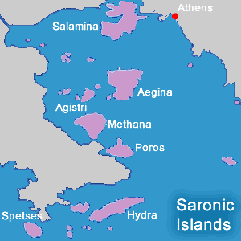**Aegina**

**Recap:** summarise anything you can remember about Athens’ relationship with Aegina and what happened to it during the First Peloponnesian War.

Thucydides gives very little detail on why Aegina was a complaint raised against Athens and it appears from his account to have been a minor cause of the Peloponnesian War. All he states is:

**Prescribed Source - Thucydides, 1.67**

Now, however, Corinth brought matters into the open. Potidaea was under blockade, some of her own citizens were inside, and she feared that the place might be lost. She therefore immediately urged the allies to send delegates to Sparta. There her own delegates violently attacked the Athenians for having broken the truce and committed acts of aggression against the Peloponnese. The people of Aegina were on her side. Out of fear of Athens they had not sent a formal delegation, but behind the scenes they played a considerable part in fomenting war, saying that they had not been given the independence promised to them by treaty.

**Ambracian Gulf**

A final complaint raised against Athens by the Corinthians but appearing directly in Thucydides referred to the Ambracian Gulf in the West of Greece where in the 430s a local conflict was taking place between three groups:

* The Ambracians (connected to Corinth)
* The Amphilochians
* The Acarnanians

The Amphilochians and Acarnanians appealed to Athens for help which they agreed to send meaning that Athens was again interfering in Corinthian affairs.

***TASK*** *–* what previous complaint does this seem very similar too?

**The Outbreak of War**

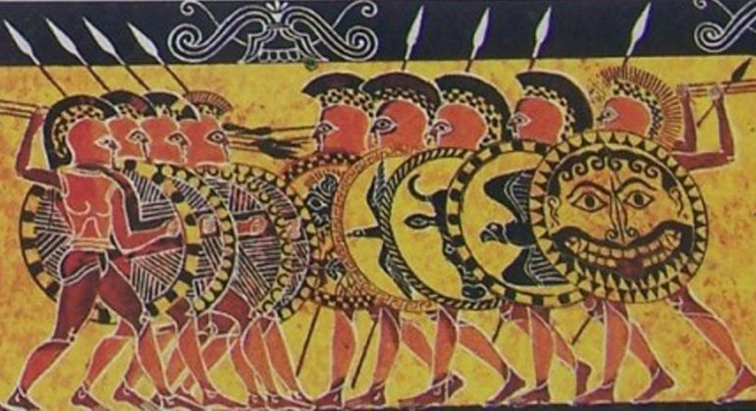The decision to go to war would be made in Sparta as the Kings and ephors heard the complaints against Athens and then listened to the Athenians’ response to this. Thucydides recorded these discussions and debates and in the source below recounts the Corinthian speech to the Spartans. This is known as the **Corinthian Complaint.**

**Prescribed Source - Thucydides, 1.66-69**

Both the Athenians and the Peloponnesians had already grounds of complaint against each other. The grievance of Corinth was that the Athenians were besieging her own colony of Potidaea with Corinthians and other Peloponnesians in the place: Athens on the other hand, had her own grievances against the Peloponnesians; that had supported the revolt of a city which was in alliance with her and which paid her tribute, and they had openly joined the Potidaeans in fighting against her. In spite of this, the truce was still in force and war had not yet broken out. What had been done so far had been done on the private initiative of Corinth.

Who if anyone does Thucydides seem to blame for the increase in tensions?

Now, however, Corinth brought matters into the open. Potidaea was under blockade, some of her own citizens were inside, and she feared that the place might be lost. She therefore immediately urged the allies to send delegates to Sparta. There her own delegates violently attacked the Athenians for having broken the truce and committed acts of aggression against the Peloponnese. The people of Aegina were on her side. Out of fear of Athens they had not sent a formal delegation, but behind the scenes they played a considerable part in fomenting war, saying that they had not been given the independence promised to them by treaty. The Spartans also issued an invitation to their own allies and to anyone else who claimed to have suffered from Athenian aggression. They then held their usual assembly, and gave an opportunity there for delegates to express their views. Many came forward with various complaints. In particular the delegates from Megara, after mentioning a number of other grievances, pointed out that, contrary to the terms of the treaty, they were excluded from all ports in the Athenian empire and from the market of Athens itself. The Corinthians were the last to come forward to speak, having allowed the previous speakers to do their part in hardening Spartan opinion against Athens. The Corinthian speech was as follows:

‘Spartans, what makes you somewhat reluctant to listen to us others, if we have ideas to put forward, is the great trust and confidence which you have in your own constitution and in your own way of life. This is a quality which certainly makes you moderate in your judgements; it is also, perhaps, responsible for a kind of ignorance which you show when you are dealing with foreign affairs. Many times before now we have told you what we were likely to suffer from Athens, and on each occasion, instead of taking to heart what we were telling you, you chose instead to suspect our motives and to consider that we were speaking only about our own grievances. The result has been that you did not call together this meeting of our allies before the damage was done; you waited until now, when we are actually suffering from it. And of all these allies, we have perhaps the best right to speak now, since we have the most serious complaints to make. We have to complain of Athens for her insolent aggression and of Sparta for her neglect of our advice.

What are the Corinthians accusing Sparta of here and why do you think this is?

‘If there were anything doubtful or obscure about this aggression on the whole of Hellas, our task would have been to try to put the fact before you and show you something that you did not know. As it is, long speeches are unnecessary. You can see yourselves how Athens has deprived some states of their freedom and is scheming to do the same for others, especially among our own allies, and that she herself has for a long time been preparing for the eventuality of war. Why otherwise should she have forcibly taken over from us the control of Corcyra? Why is she besieging Potidaea? Potidaea is the best possible base for any campaign in Thrace, and Corcyra might have contributed a very large fleet to the Peloponnesian League.

‘And it is you who are responsible for all this. It was you who in the first place allowed the Athenians to fortify their city and build the Long Walls after the Persian War. Since then and up to the present day you have withheld freedom not only from those who have been enslaved by Athens but even from your own allies. When one is deprived of one’s liberty one is right in blaming not so much the man who put the fetters on as the one who had the power to prevent him, but did not use it – especially when such a one rejoices in the glorious reputation of having been the liberator of Hellas.

‘Even at this stage it has not been easy to arrange this meeting, and even at this meeting there are no definite proposals. Why are we still considering whether aggression has taken place instead of how we can resist it? Men who are capable of real action first make their plans and then go forward without hesitation while their enemies have still not made up their minds. As for the Athenians, we know their methods and how they gradually encroach upon their neighbours. Now they are proceeding slowly because they think that your insensitiveness to the situation enables them to go on their way unnoticed; you will find that they will develop their full strength once they realize that you do see what is happening and are still doing nothing to prevent it.

‘You Spartans are the only people in Hellas who wait calmly on events, relying for your defence not on action but on making people think that you will act. You alone do nothing in the early stages to prevent an enemy’s expansion; you wait until your enemy has doubled his strength. Certainly you used to have the reputation of being safe and sure enough: now one wonders whether this reputation is deserved. The Persians, as we know ourselves, came from the ends of the earth and got as far as the Peloponnese before you were able to put a proper force into the field to meet them. The Athenians, unlike the Persians, live close to you, yet still you do not appear to notice them; instead of going out to meet them, you prefer to stand still and wait till you are attacked, thus hazarding everything by fighting with opponents who have grown far stronger than they were originally.

What warning do the Corinthians give the Spartans here?

‘In fact you know that the chief reason for the failure of the Persian invasion was the mistaken policy of the Persians themselves; and you know, too, that there have been many occasions when, if we managed to stand up to Athenian aggression, it was more because of Athenian mistakes than because of any help we got from you. Indeed, we can think of instances already where those who have relied on you and remained unprepared have been ruined by the confidence they placed in you.

‘We should not like any of you to think that we are thinking in an unfriendly spirit. We are only remonstrating with you, as is natural when one’s friends are making mistakes. Real accusations must be kept for one’s enemies who have actually done one harm.

Is the tone of this speech from the Corinthians to the Spartans surprising? What do you think the Corinthians are trying to do?

Following the ‘Corinthian Complaint’, the Spartans then heard the response of the Athenians who had come to represent their city at the meeting:

**Prescribed Source - Thucydides, 1.75-77**

‘Surely, Spartans, the courage, the resolution, and the ability which we showed then ought not to be repaid by such immoderate hostility from the Hellenes – especially so far as our empire is concerned. We did not gain this empire by force. It came to us at a time when you were unwilling to fight on to the end against the Persians. At this time our allies came to us of their own accord and begged to lead them. It was the actual course of events which first compelled us to increase our power to its present extent: fear of Persia was its chief motive, though afterwards we thought, too, of our own honour and our own interest. Finally there came a time when we were surrounded by enemies, when we had already crushed some revolts, when you had lost the friendly feelings that you used to have for us and had turned against us and begun to arouse our suspicion: at this point it was clearly no longer safe for us to risk letting our empire go, especially as any allies that left us would go over to you. And when tremendous dangers are involved no one can be blamed for looking to his own interest.

‘Certainly you Spartans, in your leadership of the Peloponnese, have arranged the affairs of the various states so as to suit yourselves. And if, in the years of which we were speaking, you had gone on taking an active part in the war and had become unpopular, as we did, in the course of exercising your leadership; we have little doubt that you would have been just as hard upon your allies as we were, and that you would have been forced either to govern strongly or to endanger your own security.

‘So it is with us. We have done nothing extraordinary, nothing to contrary to human nature in accepting an empire when it was offered to us and then in refusing to give it up. Three very powerful motives prevent us from doing so – security, honour, and self-interest. And we were not the first to act in this way. Far from it. It has always been a rule that the weak should be subject to the strong; and besides, we consider that we are worthy of our power. Up till the present moment you, too, used to think that we were; but now, after calculating your own interest, you are beginning to talk in terms of right and wrong. Considerations of this kind have never yet turned people aside from the opportunities of aggrandizement offered by superior strength. Those who really deserve praise are the people who, while human enough to enjoy power, nevertheless pay more attention to justice than they are compelled to do by their situation. Certainly we think that if anyone else was in our position it would soon be evident whether we act with moderation or not. Yet, unreasonably enough, our very consideration for others has brought us more blame than praise. For example, in law-suits with our allies arising out of contracts we have put ourselves at a disadvantage, and when we arrange to have such cases tried by impartial courts in Athens, people merely say that we are overfond of going to law. No one bothers to inquire why this reproach is not made against other imperial Powers, who treat their subjects much more harshly than we do: the fact being, of course, that where force can be used there is no need to bring in the law. Our subjects, on the other hand, are used to being treated as equals; consequently, when they are disappointed in what they think right and suffer even the smallest disadvantage because of a judgement in our courts or because of the power that our empire gives us, they cease to feel grateful to us for all the advantages which we have left to them: indeed, they feel more bitterly over this slight disparity than they would feel if we from the first, had set the law aside and had openly enriched ourselves at their expense. Under those conditions they would certainly not have disputed the fact that the weak must give in to the strong. People, in fact, seem to feel more strongly about their legal wrongs than about the wrongs inflicted on them by violence. In the first case they think that they are being outdone by an equal, in the second case that they are being compelled by a superior. Certainly they put up with much worse sufferings than these when they were under the Persians, but now they think that our government is oppressive. That is natural enough, perhaps, since subject peoples always find the present time most hard to bear. But on one point we are quite certain: if you were to destroy us and to take over our empire, you would soon lose all the goodwill which you have gained because of others being afraid of us – that is, if you are going to stick to those principles of behaviour which you showed before, in the short time when you led Hellas against the Persians. Your own regulated ways of life do not mix well with the ways of others. Also it is a fact that when one of you goes abroad he follows neither his own rules nor those of the rest of Hellas.

***TASK* –** Create a bullet point list of the ways in which the Athenian delegation at Sparta defended its imperialism

*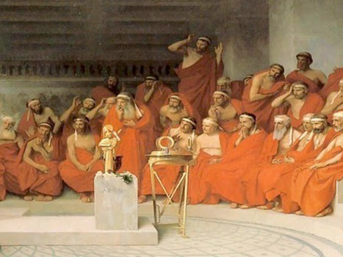****Should Sparta go to war?***

With the person next to you or working in small groups, prepare a brief speech arguing either for or against war. This will need to include a range of arguments and any counter-arguments to what you think the opposing side will say. It will also need to be persuasive.

Use the table below to help plan your speech and then record notes as you listen to the opposing side.

|  |  |
| --- | --- |
| **Arguments for Sparta going to war** | **Arguments against Sparta going to War** |
|  |  |

**Decision of the Class:**

**Your overall Conclusion:**

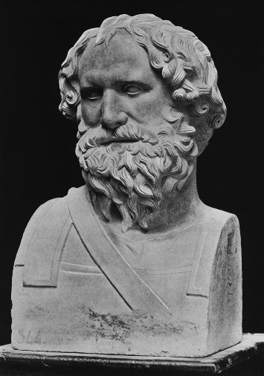The debate in Sparta over whether to go to war or not was split between two figures: **King Archidamus II** and the ephor **Sthenelaias**. Archidamus argued against war by saying that Sparta lacked the necessary resources to win – it had no navy, no money and did not have the allies that Athens had to raise resources. He instead advised that Sparta should seek new allies, possible Persia (he in fact predicted the very things that would bring Sparta victory twenty years later).

Sthenelaidas did not so much challenge any of the King’s concerns but made a fiery, nationalistic speech that called for immediate action and war:

**Prescribed Source - Thucydides, 1.86-88**

‘I do not understand these long speeches which the Athenians make. Thought they said a great deal in praise of themselves, they made no attempt to contradict the fact that they are acting aggressively against our allies and against the Peloponnese. And surely, if it is the fact that they had a good record in the past against the Persians and now have a bad record as regards us, then they deserve to pay double for it, since, though they were once good, they have now turned out bad. We are the same then and now, and if we are sensible, we shall not allow any aggression against our allies and shall not wait before coming to their help. They are no longer waiting before being ill treated. Others may have a lot of money and ships and horses, but we have good allies, and we ought not to betray them to the Athenians. And this is not a matter to be settled by law-suits and by words: it is not because of words that our own interests are suffering. Instead we should come the help of our allies quickly and with all our might. And let no one try to tell us that when we are being attacked we should sit down and discuss matters; these long discussions are rather for those who are meditating aggression themselves. Therefore, Spartans, cast your votes for the honour of Sparta and for war! Do not allow the Athenians to grow still stronger! Do not entirely betray your allies! Instead let us, with the help of heaven, go forward to meet the aggressor!’

After this speech he himself, in his capacity as ephor, put the question to the Spartan assembly. They make their decision by acclamation, not by voting, and Sthenelaidas said at first that he could not decide on which side the acclamations were the louder. This was because he wanted to make them show their opinions openly and so make them all the more enthusiastic for war. He therefore said: ‘Spartans, those of you who think that the treaty has been broken and that the Athenians are aggressors, get up and stand on one side. Those who do not think so, stand on the other side,’ and he pointed out to them where they were to stand. They then rose to their feet and separated into two divisions. The great majority were of the opinion that the treaty had been broken.

They then summoned their allies to the assembly and told them that they had decided that the Athens was acting aggressively, but that they wanted to have all their allies with them when then put the vote, so that, if they decided to make war, it should be done on the basis of a unanimous decision.

Afterwards the allied delegates, having got their own way, returned home. Later the Athenian representatives, when they had finished the business for which they had come, also returned. This decision of the assembly that the treaty had been broken took place in the fourteenth year of the thirty years’ truce which was made after the affair of Euboea. The Spartans voted that the treaty had been broken and that war should be declared not so much because they were influenced by the speeches of their allies as because they were afraid of the further growth of Athenian power, seeing as they did, that already the greater part of Hellas was under the control of Athens.

Once the Spartan assembly had voted for war it still needed its Peloponnesian allies to do the same (this is how decisions in the Peloponnesian League were made).

At the meeting of the Peloponnesian League members in 432 BC, the Corinthians again led the way in persuading other states to support war against Athens.

**Prescribed Source - Thucydides, 1.121-122**

‘Now, on this present occasion it is because we are the victims of aggression and because we have adequate reason that we are going to war; and once we have made ourselves secure from the Athenians we shall at the proper time return to peace. There are many reasons why victory should be ours. First, we are superior in numbers and in military experience; secondly, one and all and all together we obey the orders we receive. As for sea-power, in which they are strong, we shall build ours up both from the existing resources of our alliance and also form the funds in Olympia and in Delphi. If we borrow money from there we shall be able to attract the foreign sailors in the Athenian navy by offering higher rates of pay. For the power of Athens rests on mercenaries rather than on her own citizens; we, on the other hand, are less likely to be affected in this way, since our strength is in men rather in money. The chances are that, if they once lose a battle at sea, it will be all over with them. And supposing they do manage to hold out, then that will give us more time in which to improve our own naval tactics, and once our skill is on level with theirs, there can be little doubt our superiority so far as courage is concerned. They cannot acquire by education the good qualities that are ours by nature; we, on the other hand, by taking pains can abolish the advantage they hold over us in point of skill. It will require money to carry out these projects, and we will contribute money. What an appalling thing to imagine that, while their allies never stop bringing in contributions to maintain their own slavery, we, whose aims are vengeance and survival, should hesitate to incur expense in order to prevent this very money that we are saving from being taken from us by the Athenians and then used to make us suffer!

‘There are also other ways open to us for carrying on the war. We can foster revolts among their allies – and this is the best means of depriving them of the revenues on which their strength depends. Or we can build fortified positions in their country. And there will be other ways and means which no one can foresee at the present, since war is certainly not one of those things which follow a fixed pattern; instead it usually makes its own conditions in which one has to adapt oneself to changing situations. So, when one enters upon a war, one will be all the safer for keeping one’s self-possession: the side that gets over-excited about it is the most likely side to make mistakes.

‘And here is another point to consider. If this was merely a question of boundary disputes between equals and affecting individual states separately, the situation would not be so serious; as it is, we have Athens to fight, and Athens is so much stronger than any single state in our alliance that she is capable of standing up to all of us together. So unless we go to war with her not only in full force but also with every city and every nationality inspired by the same purpose, she will find us divided and will easily subdue us. And let us be sure that defeat, terrible as it may sound, could mean nothing else but total slavery. To the Peloponnese the very mention of such a possibility is shameful, or that so many cities should suffer the oppression of one. If that were to happen, people would say either that we deserved our sufferings or that we were putting up with them through cowardice and showing ourselves inferior to our fathers; for they brought freedom to the whole of Hellas, while we not only failed to safeguard our own freedom, but also allowed a dictator state to be set up in Hellas, although in individual states we made it a principle to put down despots. Such a policy, in our view, cannot be held to be exempt from three of the greatest mistakes that can be made – lack of intelligence, lack of resolution, or lack of responsibility. Nor do we imagine that you can escape these imputations by claiming that you feel superior to your enemies. This feeling of superiority has done much harm before now; indeed, from the number of cases where it proved disastrous it has come to be known as something quite different – not superiority, but plain stupidity.

***TASK*** *–* List four reasons given why the Corinthians believed the Peloponnesian League could defeat Athens

There was one final attempt to avoid war as a Sparta sent representatives to Athens offering not to go to war if the Athenians ‘gave the Greeks their freedom’. What this would have meant would be Athens giving up it empire which was its source of trade and wealth. It would have also gone against the terms of the original Thirty-Years Peace which had recognised the Athenians’ right to rule their empire.

The Athenians, acting under the advice and persuasion of Pericles, rejected the final Spartan offer making war inevitable.

**Prescribed Source - Thucydides, 1.139-140**

The first embassy of the Spartans was as I have described: they demanded that those under the curse should be driven out, and they received a counter demand from Athens in the same terms. Later they sent another embassy to demand that Athens should abandon the siege of Potidaea and should give Aegina her independence. But the chief point and the one that they made most clear, was that war could be avoided if Athens would revoke the Megarian decree which excluded the Megarians from all ports in the Athenian Empire and from the market in Attica itself.

The Athenians would not give in on the first points, nor would they revoke the decree. They accused Megara of cultivating land that did not belong to them, and of giving shelter to slaves who had escaped from Athens.

Finally an embassy arrived with the Spartan ultimatum. The Spartan representatives were Ramphias, Melesippus, and Agesander. They made no reference to any of the usual subjects that had been spoken of before, but simply said: ‘Sparta wants peace. Peace is still possible if you will give the Hellenes their freedom.’

The Athenians then held an assembly in order to debate the matter, and decided to look into the hole question once and for all and then to give Sparta her answer. Many speakers came forward and opinions were expressed on both sides, some maintaining that war was necessary and others saying that the Megarian decree should be revoked and should not be allowed to stand in the way of peace. Among the speakers was Pericles, the son of Xanthippus, the leading man of his time among the Athenians and the most powerful both in action and in debate. His advice was as follows:

‘Athenians,’ he said, ‘my views are the same as ever: I am against making any concessions to the Peloponnesians, even though I am aware that the enthusiastic state of mind in which people are persuaded to enter upon a war is not retained when it comes to action, and that peoples’ minds are altered by the course of events. Nevertheless I see that on this occasion I must give you exactly the same advice as I have given in the past, and I call upon those of you who are persuaded by my words to give your full support to these resolutions which we are making altogether, and to abide by them even if in some respect or other we find ourselves in difficulty; for, unless you do, you will be able to claim no credit for intelligence when things go well with us. There is often no more logic in the course of events than there is in the plans of men, and this is usually why we blame our luck when things happen in ways that we did not expect.

‘It was evident before that Sparta was plotting against us, and now it is even more evident. It is laid down in the treaty that differences between us should be settled by arbitration, and that, pending arbitration, each side should keep what it has. The Spartans have never once asked for arbitration, nor have they accepted our offers to submit to it. They prefer to settle their complaints by war rather than by peaceful negotiations, and now they come her not even making protests, but trying to give us orders. They tell us to abandon our siege of Potidaea, to give Aegina her independence and to revoke the Megarian decree. And finally they come to us with a proclamation that we must give the Hellenes their freedom.

‘Let none of you think that we should be going to war for a trifle if we refuse to revoke the Megarian decree. It is a point they make much of, and say that war need not take place if we revoke this decree; but, if we do go to war, let there be no kind of suspicion in your hearts that the war was over a small matter. For you this trifle is both the assurance and the proof of your determination. If you give in, you will immediately be confronted with some greater demand, since they will think that you only gave way on this point through fear. But if you take a firm stand you will make it clear to them that they have to treat you properly as equals.

**Tension between Athens, Corinth and Sparta**



***Athens and Corinth***

***Athens and Sparta***

**KEY DEBATE: What caused the Peloponnesian War in 431 BC?**

*Use the understanding you have gained of the period 446-431 to add as much detail as you can to the two spider-diagrams below. Make sure you also give the names of any primary sources that support the point you are making*

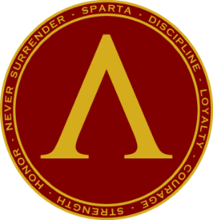

**SPARTA**



**ATHENS**

**GLOSSARY**

|  |  |
| --- | --- |
| **Term** | **Description** |
| **Thirty Years Peace** |  |
| **Corinthian Complaint** |  |
| **Metics** |  |
|  |  |
|  |  |
|  |  |
|  |  |
|  |  |
|  |  |
|  |  |
|  |  |
|  |  |
|  |  |
|  |  |
|  |  |
|  |  |
|  |  |
|  |  |

**KEY FIGURES**

|  |  |
| --- | --- |
| **nAME** | **Description** |
| **Aspasia** |  |
| **Archidamus** |  |
| **Sthenelaidas** |  |
| **Pericles** |  |
|  |  |
|  |  |
|  |  |
|  |  |
|  |  |
|  |  |
|  |  |
|  |  |
|  |  |
|  |  |
|  |  |
|  |  |
|  |  |
|  |  |