**The Build Up To the Peloponnesian War**

As you study the events which led up to the outbreak of the Peloponnesian War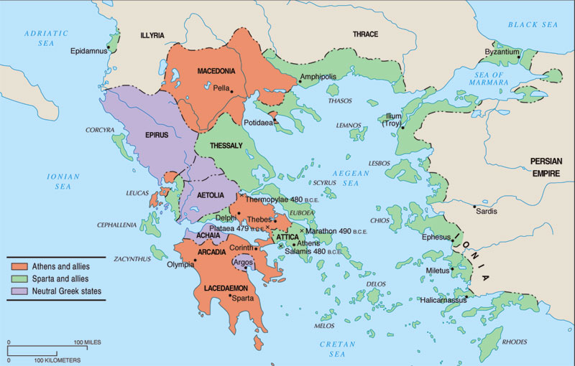 in 431, update this summary sheet.

**Aegina**

**Epidamnus & Corcyra**

**The Ambracian Gulf**

**Megara**

**Potidaea**