**AS Component 1: Investigating the Media**

**PATTERNS OF CONSUMPTION IN THE NEWSPAPER INDUSTRY**

* Print readership is steadily declining, newspapers are closing, and journalists with decades of experience are being laid off.
* Newspapers rely heavily upon advertisements, but print readership has been declining so new digital focus seems to be the only option
* Electronic news, as it is currently consumed, is a disaster for newspapers, because the industry hasn't figured out how to monetise it. According to an industry report released this month, the newspaper industry gains £1 of electronic news revenue for every £10 it loses on the print side.

**There are advantages to electronic news. It can be timelier, more relevant and less expensive**

**Look at the charts below, what do they tell you about how people consume news?**

The different ways UK respondents receives their news in %

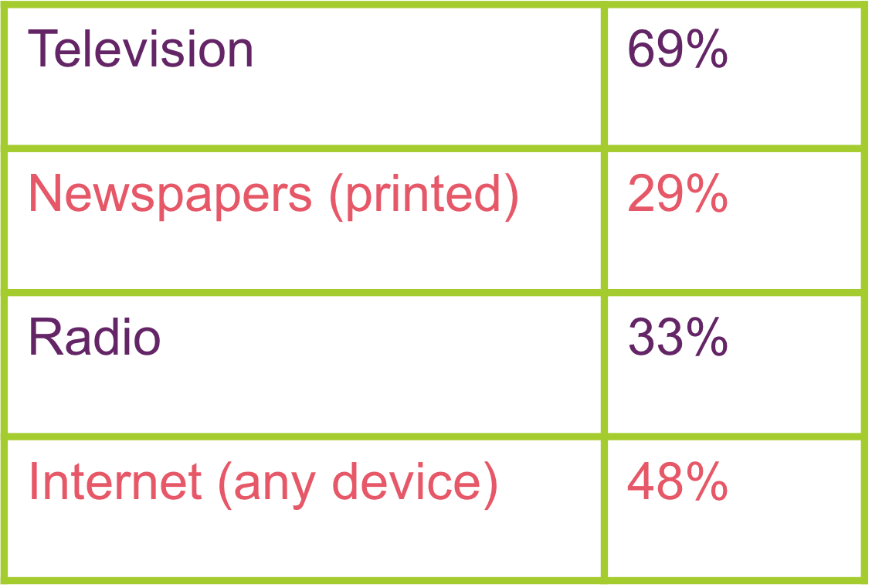

Combined print and digital monthly readership

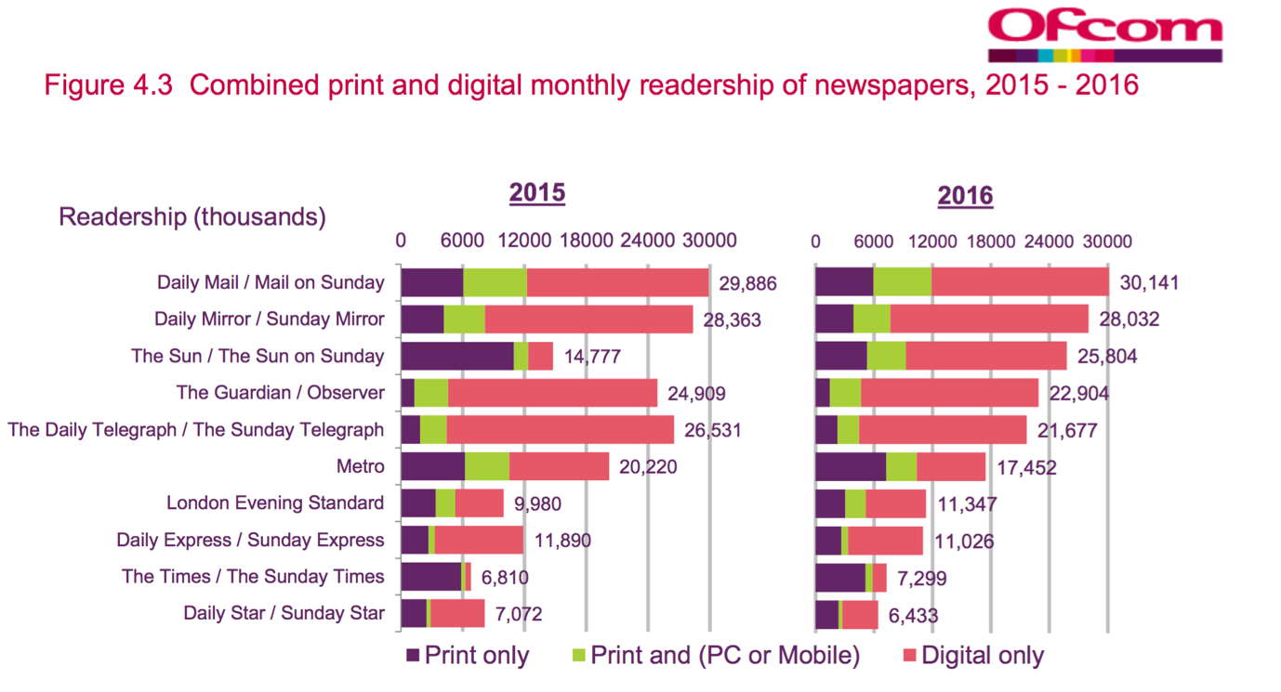

**Paywall**

***Definition:*** *An arrangement whereby access is restricted to users who have paid to subscribe to the site*

* Digital versions of The Times and The Sunday Times were put behind paywalls in 2010.
* The Sun's website was put behind a paywall in 2013, and lost more than a third of its market share of internet visits in the first 10 days, it made a U-turn in 2015 and removed the paywall.
* The Telegraph is also behind a paywall, but with the exception that you can get 20 free articles a month.
* Guardian haven’t put up a paywall but are asking for voluntary contributions.
* The majority of UK news media brands continue to operate a free-content model.

With so much news content available for free, it's perhaps unsurprising that attitudes toward paywalls in the UK remain largely negative. According to a recent study, 80% of UK internet users considered newspaper paywalls either "a bad idea" or "pointless."

1. **What do you think? Are Paywalls a good idea?**
2. **How do you consume your news? Is it in line with the data in the charts?**
3. **What does the future of the newspaper industry look like?**