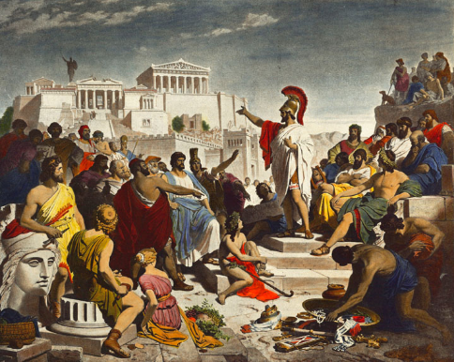**Topic 4 the Archidamian War 431-421 BC**

**Thucydides’ Portrayal of Pericles**

Read the two selected sources below and then answer the questions that follow. Include relevant quotations from the sources to support your answers.

**Prescribed Source - Thucydides, 2.63**

‘Then it is right and proper for you to support the imperial dignity of Athens. This is something in which you all take pride, and you cannot continue to enjoy the privileges unless you also shoulder the burdens of empire. And do not imagine that what we are fighting for is simply the question of freedom or slavery: there is also involved the loss of our empire and the dangers arising from the hatred which we have incurred in administering it. Nor is it any longer possible for you to give up this empire, though there may be some people who in a mood of sudden panic and in a spirit of political apathy actually think that this would be a fine and noble thing to do. Your empire is now like a tyranny: it may have been wrong to take it; it is certainly dangerous to let it go. And the kind of people who talk of doing so and persuade other to adopt their point of view would very soon bring a state to ruin, and would still do so even if they lived by themselves in isolation. For those who are politically apathetic can only survive if they are supported by people who are capable of taking action. They are quite valueless in a city which control an empire, though they would be safe slaves in a city that was controlled by others.

**Prescribed Source - Thucydides, 2.65**

In this way Pericles attempted to stop the Athenians from being angry with him and to guide their thoughts in a direction away from their immediate sufferings. So far as public policy was concerned, they accepted his arguments, sending no more embassies to Sparta and showing an increased energy in carrying on the war; yet as private individuals they still felt the weight of their misfortunes. The mass of the people had had little enough to start with and had now been deprived of even that; the richer classes had lost their fine estates with their rich ad well-equipped houses in the country, and, which was the worst thing of all, they were at war instead of living in peace. In fact, the general ill feeling against Pericles persisted, and was not satisfied until they had condemned him to pay a fine. Not long afterwards, however, as is the way with crowds, they re-elected him to the generalship and put all their affairs into his hands. By that time people felt their own private sufferings rather less acutely and, so far as the general needs to the state were concerned, they regarded Pericles as the best man they had. Indeed, during the whole period of peace-time when Pericles was the head of affairs the state was wisely led and firmly guarded, and it was under him that Athens was at her greatest. And when the war broke out, here, too, he appears to have accurately estimated what the power of Athens was. He survived the outbreak of war by two years and six months, and after his death, his foresight with regard to the war became even more evident. For Pericles had said that Athens would be victorious if she bided her time and took care of her navy, if she avoided trying to add to the empire during the course of the war, and if she did nothing to risk the safety of the city itself. But his successors did the exact opposite, and in other matters which apparently had no connection with the war private ambition and private profit led to policies which were bad both for the Athenians themselves and for their allies. Such policies, when successful, only brought credit and advantage to individuals, and when they failed, the whole war potential of the state was impaired. The reason for this was that Pericles, because of his position, his intelligence, and his known integrity, could respect the liberty of the people and at the same time hold them in check. It was he who led them, rather than they who led him, and, since he never sought power from any wrong motive, he was under no necessity of flattering them: in fact he was so highly respected that he was able to speak angrily to them and to contradict them. Certainly when he saw that they were going too far in a mood of over-confidence, he would bring back to them a sense of their dangers; and when they were discouraged for no good reason he would restore their confidence. So, in what was nominally a democracy, power was really in the hands of the first citizen. But his successors, who were more on a level with each other and each of whom aimed at occupying the first place, adopted methods of demagogy which resulted in their losing control over the actual conduct of affairs. Such a policy, in a great city with an empire to govern, naturally led to a number of mistakes, amongst which was the Sicilian expedition, though in this case the mistake was not so much an error of judgement with regard to the opposition to be expected as a failure on the part of those who were at home to give proper support to their forces overseas. Because they were so busy with their own personal intrigues for securing the leadership of the people, they allowed this expedition to lose its impetus, and by quarrelling among themselves began to bring confusion into the policy of the state. And yet, after losing most of their fleet and all the other forces in Sicily, with revolutions already breaking out in Athens, they nonetheless held out for eight years against their original enemies, who were no reinforced by the Sicilians, against their own allies, most of which had revolted, and against Cyrus, son of the King of Persia, who later joined the other side and provided the Peloponnesians with money for their fleet. And in the end it was only because they had destroyed themselves by their own internal strife that finally they were forced to surrender. So overwhelmingly great were the resources which Pericles had in mind at the time when he prophesied and easy victory for Athens over the Peloponnesians alone.

1. In Thucydides’ presentation, how does Pericles defend his policy?
2. How does Thucydides portray Pericles’ attitude to empire?
3. What is Thucydides’ attitude towards Pericles?
4. What is Thucydides’ attitude to those politicians that came after Pericles?