[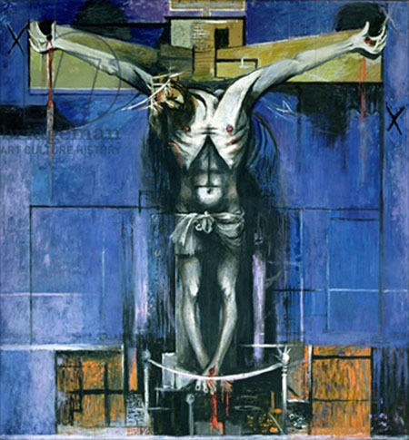](https://nladesignvisual.files.wordpress.com/2013/06/crucifixion-1-graham-sutherland.jpg)

**Life dates of the artist:** 1903-1980

**Medium:** oil on hardboard

Size: H2.75m W2.62m

**Location:** Northampton Church

**Patron:** Sir Walter Hussey

**Style:** Neo-Romanticism

**Nationality:** British

**Genre:** History (religious)

**Subject:** The Crucifixion

**Scope of Work:** the Divine

**Other important works:**

* Portrait of Winston Churchill (1954) (destroyed by Lady Churchill)
* Tapestry of Christ, Coventry Cathedral (1954)
* Devastation, a house on the Welsh border (1940 Tate)

**TRAINING**

Sutherland, born in London, trained initially as a railway engineer; and then as an artist (in etching and engraving) at Goldsmith's College, (1921-6). From 1928-39 he taught at Chelsea School of Art. His experiences during the war as a war artist altered his style. He moved from romanticism (he had as a student been heavily influenced by Samuel Palmer) to a harsher, spiky approach reflecting the horrors of war. He undertook several religious paintings after an early career which focused mainly on landscape. He had strong links with Pembrokeshire (which influenced his work) and with France (where he bought a house in 1955).

**PATRONAGE**

Walter Hussey, (vicar of St Matthew’s Northampton) asked for a painting of the ‘Agony in the Garden’ (The Agony in the Garden of Gethsemane refers to the events in the life of Jesus as recorded in the New Testament, between the Farewell Discourse at the conclusion of the Last Supper and Jesus' arrest.) GS asked to do a “significant sized” Crucifixion instead.

Walter Hussey was the son of John Hussey who had been vicar of this church since it was built in 1893. As vicar of St Matthew's he celebrated the church's 50th anniversary by commissioning *Rejoice in the Lamb* from Benjamin Britten. He later organised a concert by Kirsten Flagstad. Other commissions included Henry Moore's *Madonna and Child* sculpture, a *Litany and Anthem for St Matthew's Day* from W. H. Auden, *Lo, the full, final sacrifice* from Gerald Finzi, *Crucifixion* from Graham Sutherland, and *The Outer Planet* from Norman Nicholson. In his book, Patron of Art, Hussey wrote 'Perhaps my succeeding him may suggest nepotism, but I don't think it was. I was not anxious to go there; it seemed that there was little one could do but let the parish down ... my various authorities advised me that it was right that I should go.”

**STYLE**

Why do you think both images seemed relevant in 1946? And why do you think Hussey allowed Sutherland to make the final decision?

In British art history, the term "neo-romanticism" is applied to a loosely affiliated school of landscape painting that emerged around 1930 and continued until the early 1950s. It was first labelled in March 1942 by the critic Raymond Mortimer in the New Statesman. These painters looked back to 19th-century artists such as William Blake and Samuel Palmer, but were also influenced by French cubist and post-cubist artists such as Pablo Picasso, André Masson, and Pavel Tchelitchew (Clark and Clarke 2001; Hopkins 2001). This movement was motivated in part as a response to the threat of invasion during World War II. Artists particularly associated with the initiation of this movement included Paul Nash, John Piper, Henry Moore, Ivor Hitchens, and especially Graham Sutherland.

How useful is the style label ‘Neo-Romanticism’ for this work? What are the advantages and limitations of identifying it like this?

**CONTEXTUAL INFLUENCES**

In the spring of 1945, photographs and eyewitness accounts from the liberation of camps like Bergen-Belsen afforded the disbelieving world outside of Europe its first glimpse into the abyss of Nazi depravity. It's difficult to grasp just how shocking these first revelations really were. The most horrific rumours about what was happening to the Jews and millions of other "undesirables”—Catholics, pacifists, homosexuals, Slavs—in Nazi-occupied lands paled before the reality revealed by the liberation of the camps.

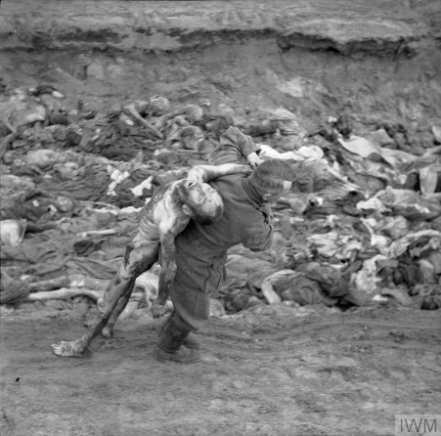Faced with this symbol of endless cruelty of human beings to each other, Sutherland’s Christ seems close to these victims which must have added hugely to the impact of this work at the time it was unveiled.

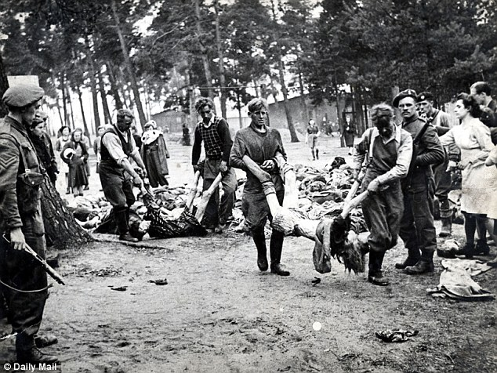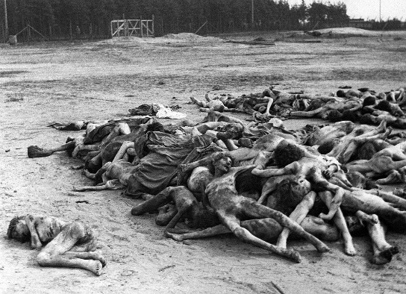

**ARTISTIC INFLUENCE FROM EARLIER ARTISTS**

*(right)* **Grünewald**’s Crucifixion in the Isenheim Altarpiece (1512-1516)

(Painted for the Monastery of St. Anthony in Isenheim near Colmar, which specialized in hospital work. The Antonine monks of the monastery were noted for their care of plague sufferers. The image of the crucified Christ is pitted with plague-type sores, showing patients that Jesus understood and shared their afflictions.)

[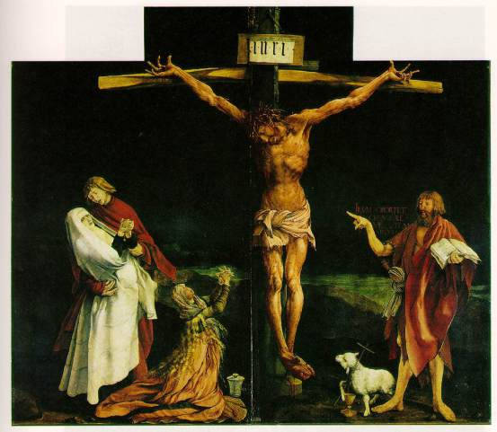](https://nladesignvisual.files.wordpress.com/2013/06/crucifixion-grunewald.jpg)

List 5 ways in which you think Sutherland has been influenced by Grunewald’s work?

**COMPARISON WITH A CONTEMPORARY WORK**

During and after the devastation of the Second World War, two modern British Painters Graham Sutherland and Francis Bacon, both created religious images that were tortured and brutal.

*Read this comparison and commentary on the two works. Make sure you check the meaning of any words (highlighted in bold) that you do not understand.*

In Sutherland’s work, the use of distortion is shown in terms of the outstretched arms nailed to the cross, with hands open and facing upwards, slumped head, ribs and sunken, emaciated torso, emphasises the suffering of Christ

In front of the crossed over feet of Christ, there is a single rope barrier separating the viewer from the image.  
The use of colour is interesting. The strong orange rectangular shape at the base of the composition forms a dynamic [](https://nladesignvisual.files.wordpress.com/2013/06/crucifixion-1-graham-sutherland.jpg)contrast with the **complementary** blue of the background. Touches of lilac are **scumbled** over the blue background in places. A more dominant lilac area is painted next to the right leg of Christ and helps to emphasise the verticality of [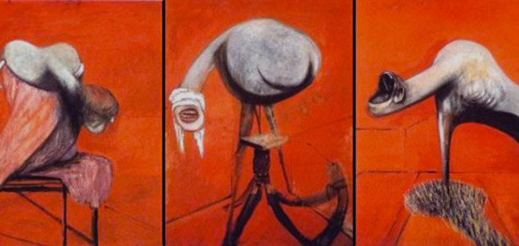](https://nladesignvisual.files.wordpress.com/2013/06/crucifixion-studies-bacon.jpg)the figure. The dark black shadows behind the white figure of Christ and parts of the cross, pushes the agonised figure forward. This, and the slight use of perspective seen at the top of the cross, gives the sense of limited space in the composition.

*Above: Francis Bacon, Three Studies for Figures at the Base of a Crucifixion, 1944*

*Right: Graham Sutherland ‘The Crucifixion’ 1946*

Strong structural/directional lines are evident on both the orange rectangle and blue background. These also tend to flatten the space. The figure is outlined boldly in black.

Bacon began to paint images based on the Crucifixion in 1933. This is a **triptych**. The work is based on the **Greek Furies** and his interpretations of the Crucifixion, and depicts three writhing **anthropomorphic** creatures set against a flat burnt orange background. *Three studies…* was done in oil paint and pastel on fibre board and completed within the space of two weeks. His intention was to paint a huge Crucifixion figure and place these figures at the foot of the cross. This was never done. The Three studies triptych is generally considered Bacon’s first mature piece – he regarded the works he created before the triptych, as irrelevant, and throughout his life tried to suppress their appearance on the art market.

In this work he makes use of deliberately distorted, elongated, dislocated organic forms- half human, half animal. One feels that they could bite, probe, and suck, with their very long eel-like necks and open mouths – but strangely, they are sightless. Each panel shows a single taut sculptural form contrasted against a harsh red /orange background. Perhaps it is this red /orange background that makes one think of entrails, of an anatomy or a vivisection. It makes us feel squeamish. The flesh tones of the figures were achieved by overlaying grey and white brushstrokes, while the figures’ props were coloured using a variety of yellow, green, white, and purple tones.  
It has been suggested that of the three figures, the one on the left most closely resembles a human form, and that it might represent a mourner at the cross.

Seated on a table-like structure, this limbless creature has an elongated neck, heavily rounded shoulders, and a thick mop of dark hair. Like its sister objects, the left-hand figure is portrayed with layers of white and grey paint.  
The central figure’s mouth is positioned directly on its neck, rather than on a distinct face. It bares its teeth as if in a snarl, and is blindfolded by a drooping cloth bandage. This creature faces the viewer directly and is centralised by a series of converging lines radiating from the base of the pedestal. Situated on an isolated patch of grass, the right-hand figure’s toothed mouth is stretched open as if screaming, or perhaps yawning. Its mouth is open to a degree impossible for a human skull. The orange background of this panel is brighter than on the other two panels, and the figure’s neck opens up into a row of teeth, while a protruding ear juts out from behind its lower jaw.

Bacon made use of an interesting spatial dynamic of three lines radiating from the central figure. The other two panels suggest an interior space – a low-ceilinged, windowless and oddly proportioned space – other than that the space has been flattened due to the strong red background that jumps forward towards the viewer. One cannot ignore the demonic creatures thus creating a mood that is violent and foreboding. These frightened, blind, raging figures are visceral in their impact, jolting one into sensations of fright, horror, isolation and angst. We react to them as self-conscious creatures, their postures and expressions revealing feelings of petrified isolation, searing horror, pain and blind confusion. When the painting was first exhibited in 1945, it caused a sensation, and helped to establish him as one of the foremost post-war painters.

**Further reading and watching:**

* The World in Three Colours – Blue. First section here: <https://www.youtube.com/watch?v=peh1_VEtzP8>
* Original footage of Graham Sutherland as Official War Artist from the BBC: <https://www.youtube.com/watch?v=HBrsEQsgpME>
* MUST WATCH James Fox: British Masters A New Jerusalem: <https://www.youtube.com/watch?v=eMHcgfjhR5U>

*Now answer the following questions:*

Why does Sutherland decide to exclude all other figures from around Christ?

Which industries and areas was Sutherland asked to focus on as an Official War Artist? And how do you think this experience is relevant to this work?

*What happened at the following and when?*

Do you think that the social and historical context of a work of art ALWAYS has a place in the discussion or is it sometimes valid to look only at the formal elements?

Why do you think he includes the black and white geometrical lines?

How would you describe the body of Christ?

Why does he use blue?

|  |  |  |
| --- | --- | --- |
| Where? | What happened? | When? (Or when did news arrive in Britain? |
| Belsen |  |  |
| Hiroshima |  |  |
| Nagasaki |  |  |
| Auschwitz |  |  |