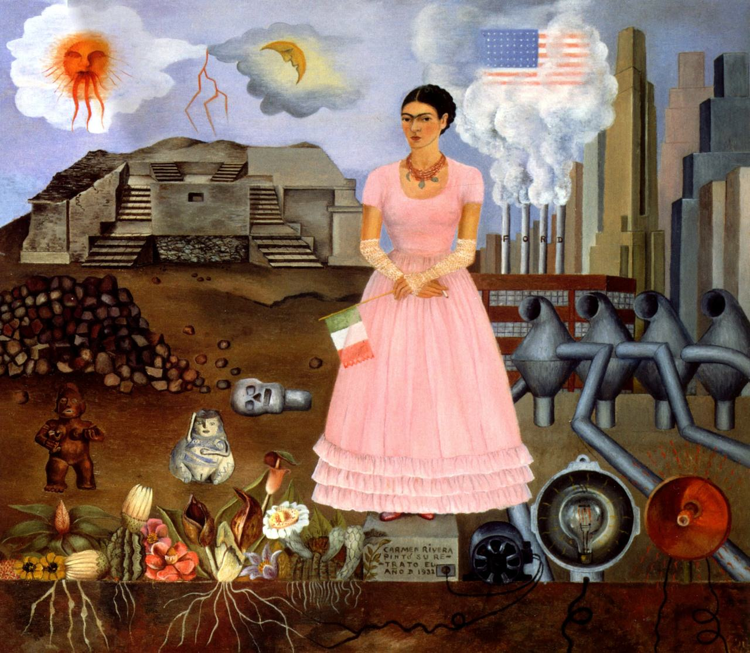Frida Kahlo

**‘Self Portrait on the borderline between Mexico and the USA’**

**Key facts:**

* **Date:** 1932, whilst living in Detroit, USA
* **Size:** 28 cm x 34 cm
* **Materials:** oil on tin
* (**Location:** In a private collection)
* **Scope of work:** can be used as a PORTRAIT IN 2D, or for GENDER or for ETHNIC identity. It is also a listed example from BEYOND THE EUROPEAN TRADITION on the specification.

*This is a highly relevant image for the Trump (and Brexit) world in which we live today. The Mexican artist, Frida Kahlo (1907-54), explores her ideas of identity – both as a Mexican and a woman – at a time in which she faced discrimination and prejudice on both counts. At the time she painted this, she was living in the USA as the wife of her painter husband, Diego Rivera.*

How does Kahlo represent her **Mexican** identity? (What symbols does she use and what idea or importance is each accorded?)

Here are some photographic images of the borderline between Mexico and the USA today. Comment briefly on each one in the space provided. As you compare each image with Kahlo’s work, you might want to think about some of the following ideas: artistic migration; freedom and restriction; coming or going or stuck in between; why people travel over this border; how language, culture and ideas travel and how people and products travel. What can most easily be held back by a border or wall? Do ideas and/or people stay the same as they travel? (The final two images are proposals for Trump’s wall…)

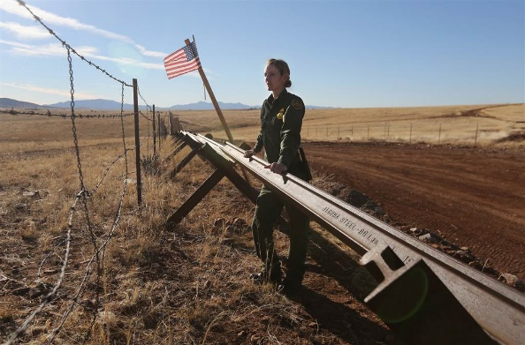

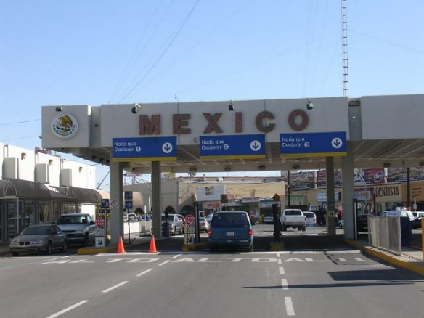

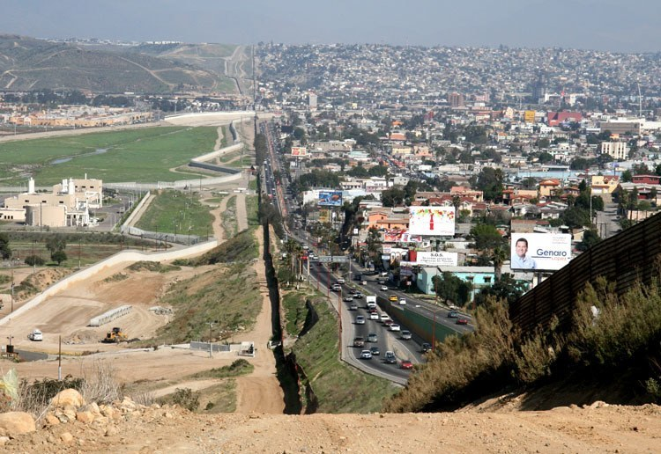

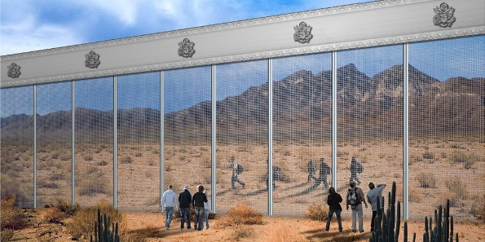

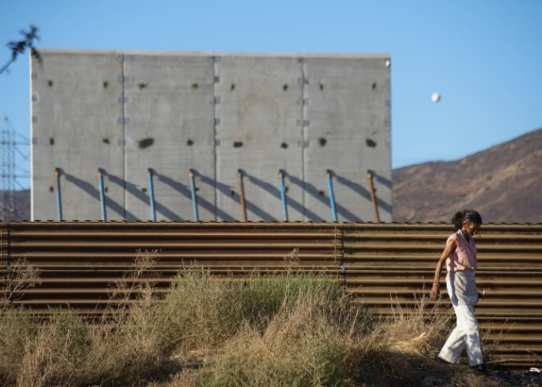

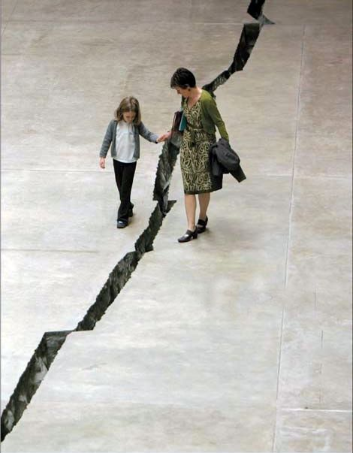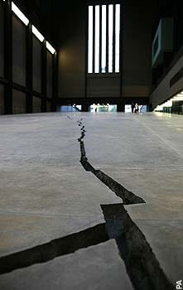Doris Salcedo **Shibboleth** 2007.

This Columbian born artist is renowned for her installations, many of which indirectly address issues from her Columbian political history. **Shibboleth** was commissioned for the Tate Modern Turbine Hall in London in 2002.

She created a large crack that ran the length of the concrete floor of the Turbine Hall. The walls of this chasm were covered by a steel mesh fence.

A ’shibboleth; is a custom or mode of dress which distinguishes a particular social group or class and can be used to define social or racial exclusion. This work might make you think of the problems of shaky foundations. Now look back at the Kahlo work – what is she saying about foundations and roots?

How does she see the world of **America** in comparison? (Again, list the symbols that she includes and explore why/what each represents? She is literally ‘in’ this world – but does she feel like she belongs?)

**Tacita Dean** and **Jeremy Deller** have defined place as follows: ***“one might say that place is to landscape as identity is to portraiture.”***

Using this definition, explain what Kahlo is saying about her identity by her reference to place in this work?

Now think about the formal features of this work. Explore the choices the artist has made and the effect/impact of that choice on the viewer:

1. Composition (What are the main elements of the work/effect or impact, where are they placed/why. Is the work balanced/symmetrical/effect?)
2. Colour (There are two distinctive palettes used for the two sides of the painting: describe the colours and effects of the left and right side:

LEFT HAND SIDE:

RIGHT HAND SIDE:

1. Space and depth (Where is the horizon line, how is space depicted; overlapping, atmospheric perspective, linear perspective, scale, shadows etc.) Is this space realistic and convincing? Why do you think Kahlo has made these choices -what does it suggest is important (think about the relationship between reality and imagination, memory and a sense of belonging etc, making something more or less important to you?)

*Watch this video:*

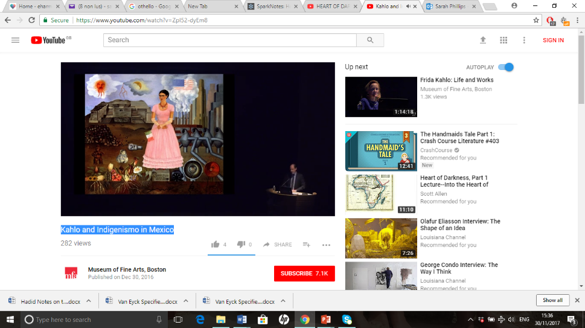Kahlo and Indigenismo in Mexico: <https://www.youtube.com/watch?v=ZpI52-dyEm8>

Museum of Fine Arts, Boston, from 6.32minutes to 43minutes, exploring the rediscovery of Aztec art and architecture during Kahlo’s lifetime and her own collecting and adoption of Mexican dress and jewellery.

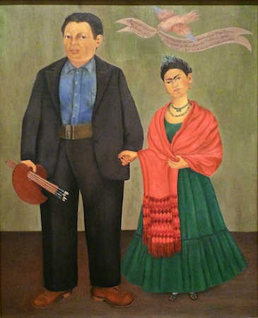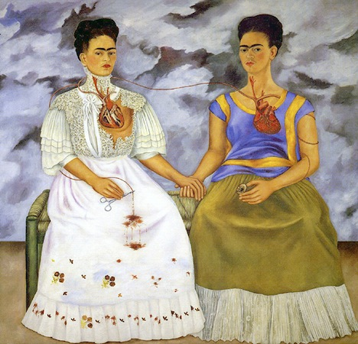

In other works, Frida Kahlo chooses to put less emphasis on place in addressing her identity. Above in ‘The Two Fridas’ (1939 – the year she divorces Diego) she portrays herself twice. Explore the differences between the two ‘sides’ of her personality here. On the right, ‘Diego and Frida Rivera (1931 – before they leave for the USA) she depicts herself in a double portrait with her husband, who she first married in 1929.

Penny Huntsman (Thinking About Art) claims that in this key work ‘Self Portrait on the borderline’, Kahlo “*paints the United States as the bastion of capitalism and Mexico as a cultural heartland rejuvenated by the post-revolution transformation of the nation.”*

*Define each of these terms?*

|  |  |
| --- | --- |
| Bastion |  |
| Communism |  |
| Campitalism |  |
| Tehuana |  |
| Retablo |  |
| Ex-voto |  |
| Pre-Columbian |  |
| Mexicanidad |  |
| Indigenous |  |
| Mestiza |  |

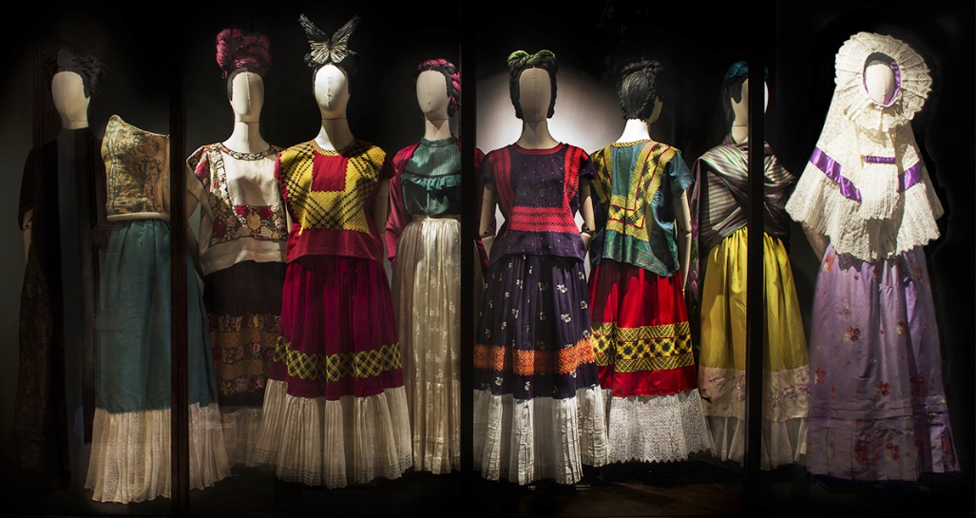Look at the differences between Mexican and European dress here:

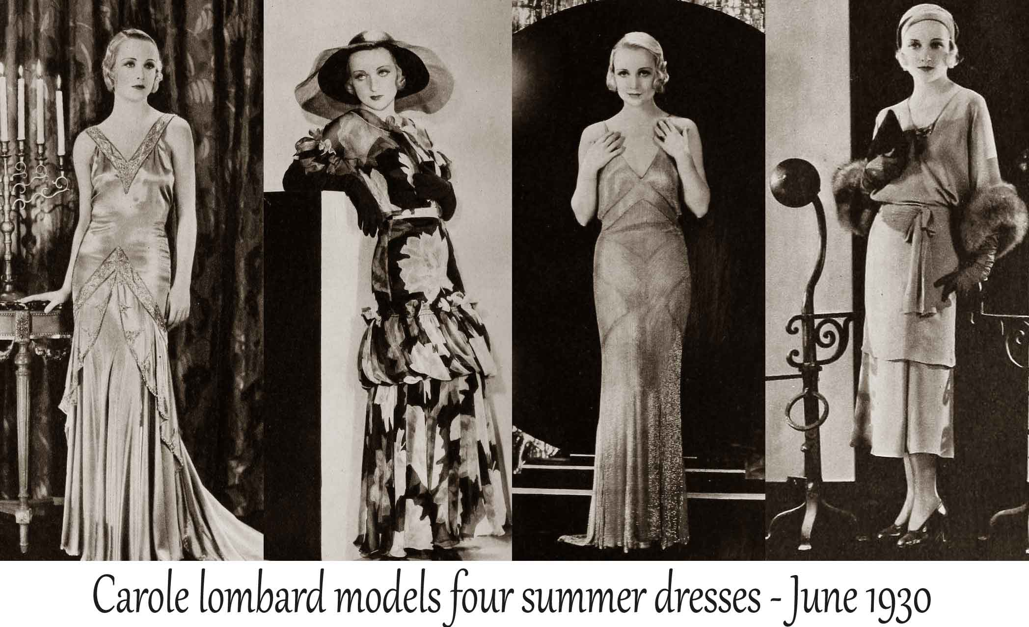

Use this website for an opportunity to view the tiny work in great detail: <https://www.artsy.net/artwork/frida-kahlo-self-portrait-on-the-border-line-between-mexico-and-the-united-states>

*Some brief extracts you might find useful to read. Highlight key words or passages:*

**Function of the work:** As a portrait the painting records the appearance of Frida Kahlo.

Frida, has stated in her personal correspondence and her own writing that one of the main functions of this work was to alleviate her sense of isolation. She said that she painted *Self Portrait Between the Borderline of Mexico and the*United States in order to express the trauma of not only being homesick but also because she felt tremendously isolated especially after her second miscarriage. Later she told a friend "My painting carried with it the message of pain.... Painting completed my life. I lost three children.... Painting substituted for all this."

**Cultural and political context**: Frida Kahlo was a child during the Mexican Revolution and grew up in an era of social change. In the 1920s Frida espoused a Communist philosophy, and did not agree with Capitalism. The official stance of the Mexican government was hardly communist, but it was much more left-leaning than the United States, and the government did split up numerous haciendas and ranches and parceled the land out in the form of *ejidos*(jointly owned farms) to many Mexican rural communities. Frida believed that industry was part of Capitalism, and even though Diego Rivera believed in the necessity of technological progress, Frida believed machines to be bad luck and the cause of pain.

**Personal context:** Frida Kahlo executed this painting while she waited for Rivera to finish his mural in Detroit. During this time she had a traumatic miscarriage and stayed in the Henry Ford hospital. She felt very alone and isolated from reality. This painting is an expression of how Kahlo saw her situation stuck somewhere in limbo, in a space disconnected from her ancient homeland.

*Use this page to write two paragraphs (200-300 words) in response to each question.*

**Explore how gender identity is presented in this work?**

**Explore how ethnic or national identity is presented in this work?**

And lastly, try to write a similar length response to this question (you will need to select ideas and interpretation from your previous two answers)

**Explore how character and identity are presented in this work?**