Speaking practice

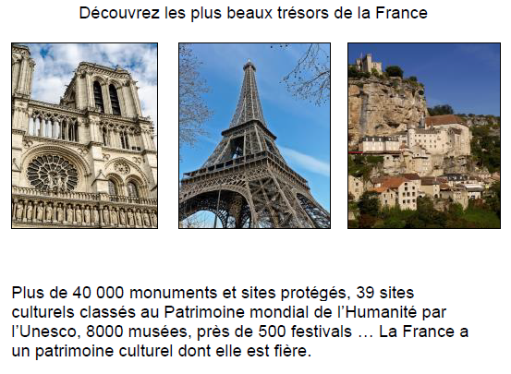

**Les questions:**

* **Que dit-on ici sur le patrimoine culturel français?**
* **Quelle est votre réaction aux informations sur cette carte?**
* **Selon ce que vous en savez, qui bénéficie de la protection des sites culturels en France ou ailleurs dans le monde francophone?**

**Carte- Découvrez les plus beaux trésors de France**

***Que dit-on ici sur le patrimoine culturel français ?***

Student responses will take the information in the text as a starting-point but should try to use their own words

***Quelle est votre réaction aux informations sur cette carte ?***

A thoughtful and developed response to this type of question will include developed arguments and justified points of view. It will link the information on the card to the knowledge gained through the student’s study of the sub-theme and therefore this could prompt:

* general confirmation that the information is borne out by this wider study;
* a personal reaction to the scale of evidence given on the card – the number of sites, museums etc.
* reference to some knowledge that endorses/contradicts the information
* reference to more recent evidence than that provided on the card
* reference to the trend outside of mainland France but in the context of the French-speaking world.

***Selon ce que vous en savez, qui bénéficie de la protection des sites culturels, en France ou***

***ailleurs dans le monde francophone ?***

This is an opportunity for the student to demonstrate knowledge beyond the specific focus of the

card but which is nonetheless relevant to the sub-theme. It should include justified points of view

and conclusions based on understanding. This could include:

* knowledge and examples of local, regional, national cultural heritage projects and how communities have benefited
* how initiatives can unite communities and reinforce identity and cultural awareness
* general educational benefits in terms of history and cultural understanding
* contribution to tourism and thus economic benefits.