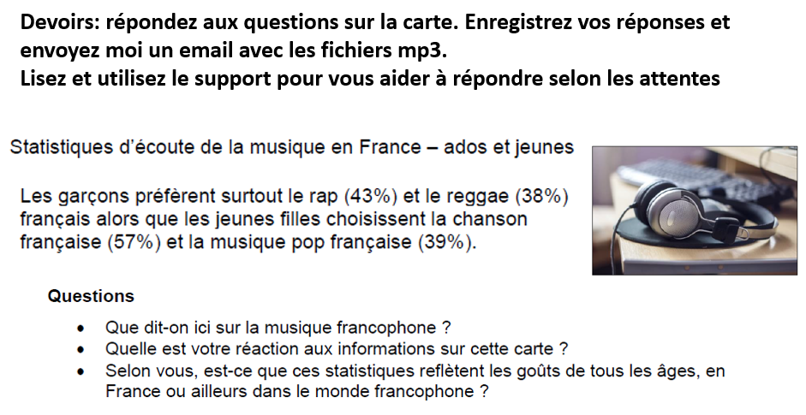**Devoirs pour la session de conversation**

**Support to read before answering the questions**

The printed questions are a starting-point for discussion: a student’s response will open up different directions for the examiner to pursue. Some students will have a wide range of facts and figures to quote but this is not a prerequisite for demonstrating knowledge of the sub-theme. Points related to specific questions:

• ***Que dit-on ici sur la musique francophone ?***

Student responses will take the information in the text as a starting-point and then some of the following points may be brought into the discussion by the examiner with reference to France or another French-speaking country depending on how the student responds: range and variety of francophone music and some knowledge perhaps of origins of different types of francophone music; some knowledge of different genres mentioned on the card and some examples or understanding of history of music; particular artistes or songs that the student has heard; popularity (or not) of francophone music beyond French-speaking audiences.

• ***Quelle est votre réaction aux informations sur cette carte ?***

A thoughtful and developed response to this type of question will include developed arguments and justified points of view. It will link the information on the card to the knowledge gained through the student’s study of the sub-theme and therefore this could prompt: general confirmation that the information is borne out by this wider study; a personal reaction about any or all of the statistical information and or the gender-divide; reference to some knowledge that endorses/contradicts the information; reference to more recent evidence than that provided on the card; reference to the trend outside of mainland France but in the context of the French-speaking world.

• ***Selon vous, est-ce que ces statistiques reflètent les goûts de tous les âges, en France ou***

***ailleurs dans le monde francophone ?***

This is an opportunity for the student to demonstrate knowledge beyond the specific focus of the card but which is nonetheless relevant to the sub-theme. It should include justified points of view and conclusions based on understanding. This could include: reference to tastes and preferences of other sections of society and age-groups; popularity of certain musical genres and how tastes have evolved; popularity of music other than *musique* *francophone* within a more globalised music-market and environment; some discussion perhaps of the threat to the future of francophone music.