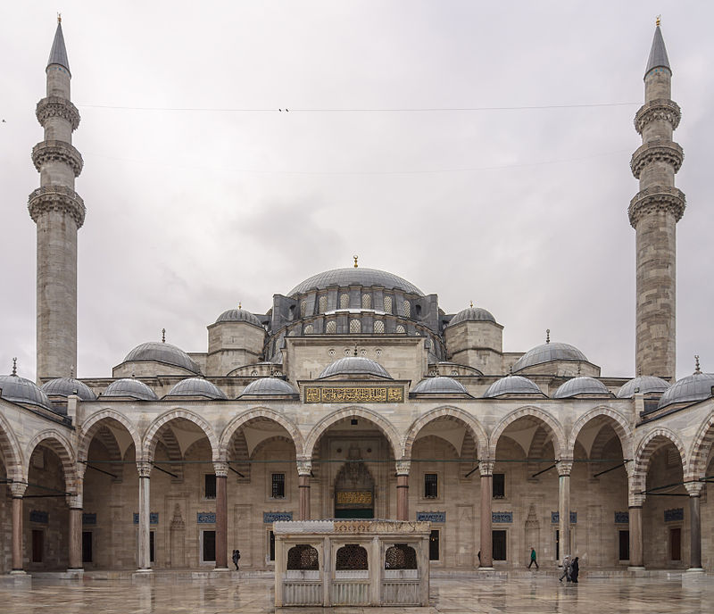

**Suleymaniye Mosque**, Istanbul, Turkey

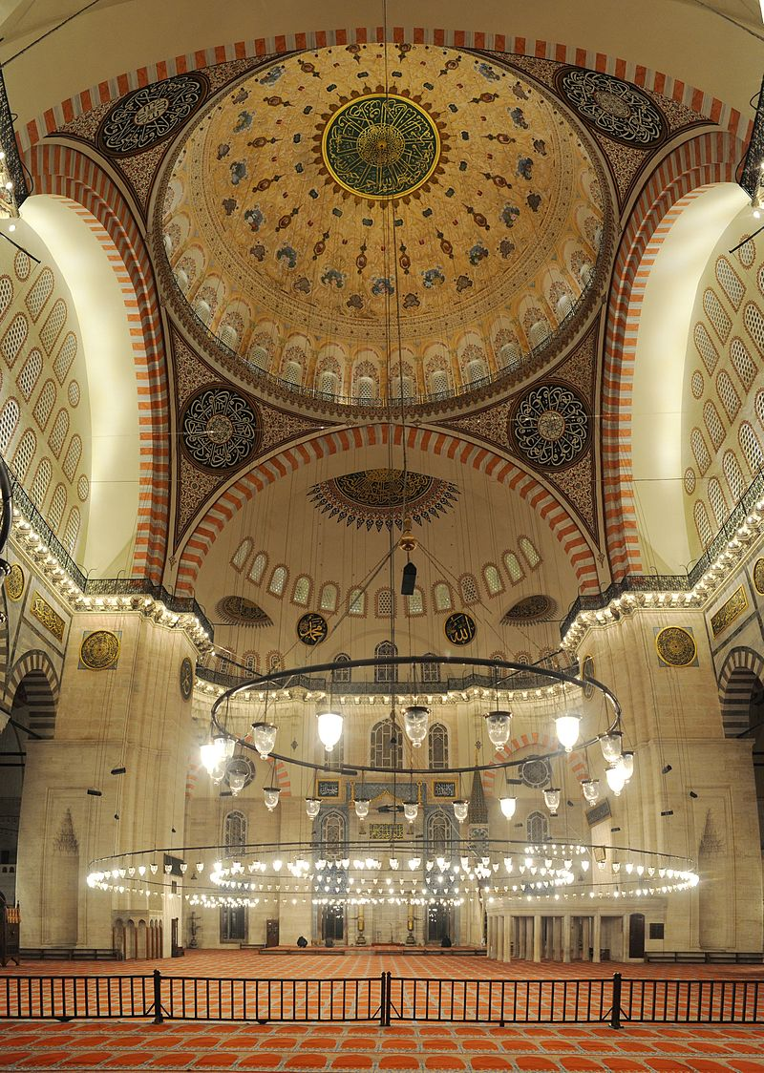**Key facts**

* **Architect**: Mimar Sinan (1490-1588)
* **Patron**: Sultan Suleyman I (ruled from 1520-66)
* **Date of construction**: 1550-1557
* **Function**: Mosque, monument to Imperial grandeur
* **Nationality**: Ottoman
* **Location**: Istanbul (previously Constantinople), Turkey
* **Size**: interior 59m square, dome 53m high
* **Materials**: marble, granite and porphyry

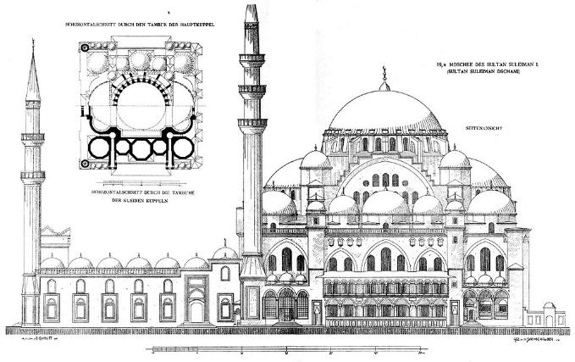

* 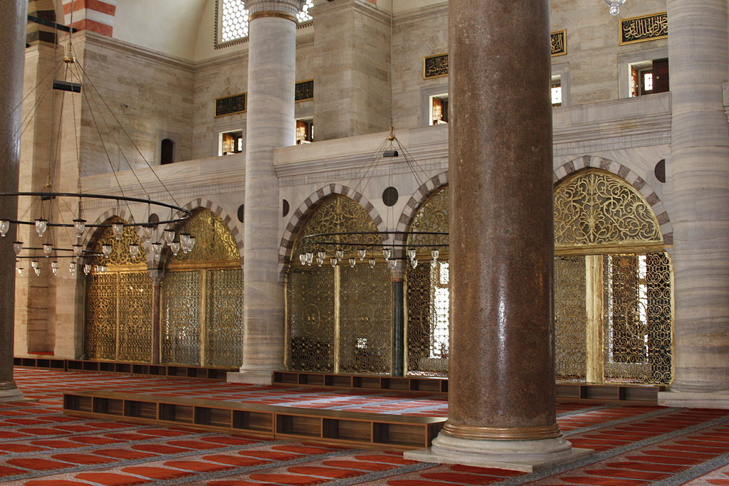Influences: **Hagia Sofia**, Istanbul (Byzantine) and the **Dome of the Rock**, Jerusalem (Islamic)

**Key terms and concepts**

* Huge **courtyard** (avlu/sahn) on west side
* **Hypostyle** mosque: one with many columns (Colonnaded peristyle arcade)
* 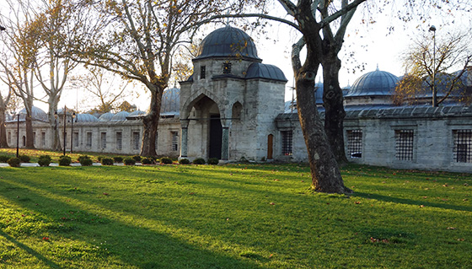Four **minarets** (towers – for calling the faithful to prayer and as a visual symbol) – shows it has been endowed by a Sultan (otherwise would have only one or two)
* Ten galleries (**serifes**) shows that Suleyman was the 10th Ottoman sultan
* **Central plan**
* Square interior
* **Dome** (qubba in Arabic) (53m high, 27.5m diameter): represents the vault of heaven
* Dome flanked by **semi-domes** with buttresses in the walls, half inside the building and half outside.
* 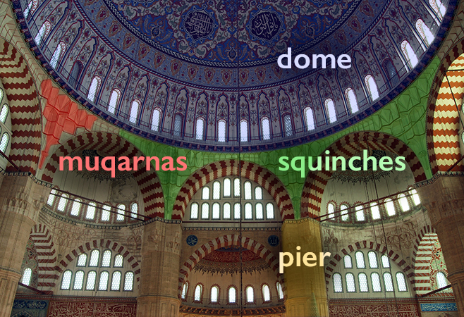**Pendentives**: supports which lift the dome above the piers
* **Mihrab**: a niche in the wall which indicates the direction of Mecca, towards which all Muslims pray
* **Minbar**: pulpit or elevated platform from which the Imam leads the service
* **Muqarnas**: ornamental vaulting
* **Iznik tiles**: richly coloured tiles for architectural decoration
* **Qibla**: wall in which the **mihrab** is set

**Wider reading/watching:**

* From Smarthistory on the **Suleymaniye Mosque**: <https://www.youtube.com/watch?v=Q48ddBmCjQA>
* If you do not know much about the beginnings of **Islam**, please read this: <https://smarthistory.org/introduction-to-islam/>
* 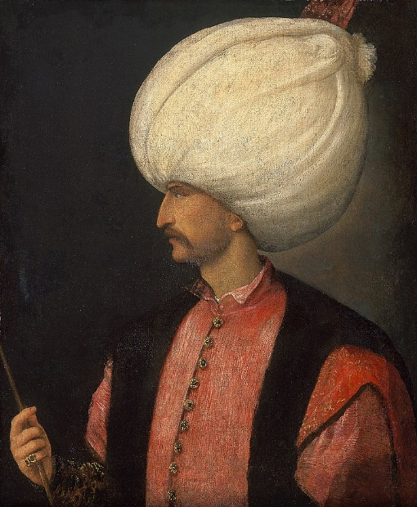And this is an excellent introduction to **mosque architecture**: <https://smarthistory.org/introduction-to-mosque-architecture/>
* From the Metropolitan Museum of Art:

<https://www.metmuseum.org/toah/hd/suly/hd_suly.htm>

**Who was Suleyman?**

Suleyman was the tenth and longest reigning Sultan of the Ottoman Empire. Under his rule, the Empire numbered some 15-25 million people.

Under his rule (1520-1566), the Ottoman Empire enjoyed great success in financial, military and cultural terms. He personally led charges on Belgrade and Rhodes and conquered most of Hungary, signing a peace treaty with the Holy Roman Emperor, Charles V of Spain and Ferdinand 1 of Austria in 1547 (an achievement celebrated by the construction of this mosque). He annexed much of the Middle East and large 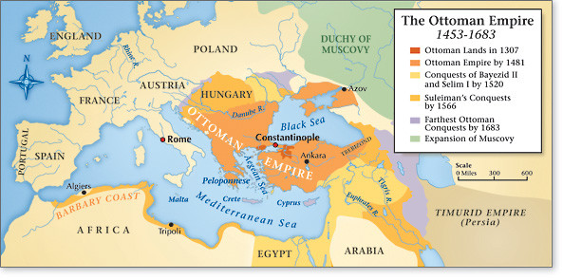areas of North Africa as far west as Algeria. The Ottoman Turks had captured Constantinople in 1453, by this point, the Empire goes from Budapest to Baghdad, including Mecca and North Africa.

*Portrait of Suleyman 1, painted by Titian 1530*

The Ottoman fleet also dominated the seas from the Mediterranean to the Red Sea and the Persian Gulf. If you are studying **Othello** in English Literature, you will be aware of the Venetian Duke sending Othello to Cyprus to fight the Ottoman fleet (called Turkish in modern editions).

Known to his people as Suleyman the Lawgiver, he instituted major legislative changes relating to society, education, taxation and criminal law. He harmonized the relationship between the two forms of Ottoman law; sultanic ([Kanun](https://en.wikipedia.org/wiki/Qanun_(law)" \o "Qanun (law))) and religious ([Sharia](https://en.wikipedia.org/wiki/Sharia)). He was a distinguished poet and goldsmith; he also became a great patron of culture, overseeing the ["Golden" age](https://en.wikipedia.org/wiki/Golden_Age) of the Ottoman Empire in its [artistic](https://en.wikipedia.org/wiki/Culture_of_the_Ottoman_Empire), [literary](https://en.wikipedia.org/wiki/Turkish_literature#Ottoman_literature) and [architectural](https://en.wikipedia.org/wiki/Ottoman_architecture#Classical_period_.281437.E2.80.931703.29) development.

Education was another important area for the Sultan. Schools attached to mosques and funded by religious foundations provided a largely free education to Muslim boys in advance of the Christian countries of the time. In his capital, Suleyman increased the number of *mektebs* (primary schools), teaching boys to read and write as well as the principles of Islam. Young men wishing further education could proceed to a [medrese](https://en.wikipedia.org/wiki/Madrasah" \o "Madrasah) (college), where studies included grammar, metaphysics, philosophy, astronomy and astrology. Higher *medreses* provided education of university status, whose graduates became *imams* (teachers). Educational centres were one of many buildings surrounding the courtyards of mosques, others included libraries, baths, soup kitchens, residences and hospitals for the benefit of the public.

Suleyman is also famous for his writings as a poet (in both Turkish and Persian). This is his most famous verse:

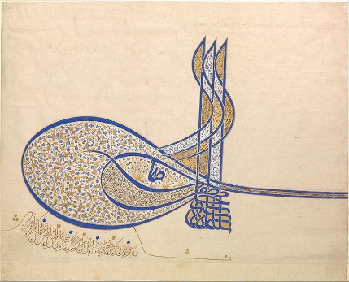The people think of wealth and power as the greatest fate,  
But in this world a spell of health is the best state.  
What men call sovereignty is a worldly strife and constant war;  
Worship of God is the highest throne, the happiest of all estates.

Suleyman also became renowned for sponsoring a series of monumental [architectural](https://en.wikipedia.org/wiki/Ottoman_architecture#Classical_period_.281437.E2.80.931703.29) developments within his empire. The Sultan sought to turn Constantinople into the centre of Islamic civilization by a series of projects, including bridges, mosques, palaces and various charitable and social establishments. He was responsible for over three hundred monuments throughout the empire, including this masterpieces, Suleyman also restored the [Dome of the Rock](https://en.wikipedia.org/wiki/Dome_of_the_Rock) in Jerusalem and the [Jerusalem city walls](https://en.wikipedia.org/wiki/Walls_of_Jerusalem) (which are the current walls of the [Old City of Jerusalem](https://en.wikipedia.org/wiki/Old_City_(Jerusalem))), renovated the [Kaaba](https://en.wikipedia.org/wiki/Kaaba) in [Mecca](https://en.wikipedia.org/wiki/Mecca), and constructed a complex in Damascus.

*Official signature of Sultan Suleyman*

* The Suleymaniye Mosque was built 36 years into his reign as his legacy and crowning achievement.

**Who was Mimar Sinan?**

Chief royal architect: 1539-88, so he was the Sultan’s chief architect for twelve years before beginning construction on this mosque. An earlier career in the military meant he travelled widely across the enormous Ottoman Empire.

“The most celebrated architect of the premodern Islamic lands is bolstered by his affinity between his centrally planned domed mosques and Italian Renaissance churches: an affinity based in the shared Roman-Byzantine heritage of the eastern Mediterranean basin.” (Necipoglu) Sometimes called the ‘Turkish Michelangelo’ or the ‘grand master of the Turkish Renaissance’ (Babinger).

Understanding **Byzantine** influences:

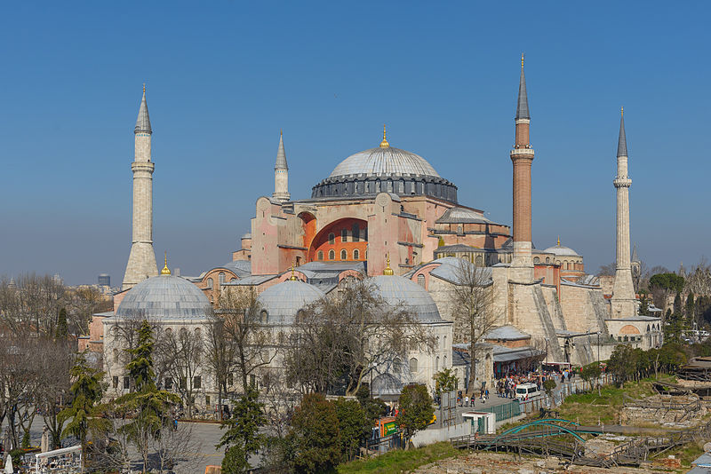The Emperor Constantine adopted Christianity and in 330 moved his capital from Rome to Constantinople (modern-day Istanbul), at the eastern frontier of the Roman Empire. Christianity flourished and gradually supplanted the Greco-Roman gods that had once defined Roman religion and culture. This religious shift dramatically affected the art that was created across the empire.

The earliest Christian churches were built during this period, including the famed **Hagia Sophia**, (right), built in the sixth century under Emperor Justinian. Suleyman was trying to surpass this structure.

|  |  |
| --- | --- |
| *Give the architectural term for each of these images from the* ***Suleymaniye Mosque****:* | |
| Istanbul - Süleymaniye camii - Foto G. Dall'Orto 26-5-2006 - 14b.jpg |  |
| Image result for minaret of suleymaniye mosqueImage result for mihrab of suleymaniye mosque |  |
|  |  |
| Image result for pendentive of suleymaniye mosque |  |
| Image result for minbar of suleymaniye mosque |  |
| Image result for hypostyle of suleymaniye mosque |  |
|  |  |
| Image result for dome of suleymaniye mosqueImage result for iznik tiles in Suleymaniye mosque |  |

**Functions of the Suleymaniye Mosque**:

* Tombs of Sultan Suleyman and his family are just outside the mosque’s walled garden.
* Primary school and 5 seminary buildings, including a Hadith College
* 3 sided courtyard with central fountain for ablutions, 4th side with open view over city
* Street underneath would have housed the mosque’s street of shops
* Prayer hall
* Soup kitchen, hospital
* Baths

**Materials, processes and techniques of the Suleymaniye Mosque**:

“The large outer court is entered by 11 portals. The inner court, rectangular in form, is reached through three portals, one central, the others flanking this. The central portal is dressed with fine stonework, and surmounted by an inscription containing the Islamic proclamation of faith.

Flanking the portal on both sides are three rows of cells and 12 windows. The courtyard is paved in marble, and framed by a revak covered with 28 cupolas. In the centre is a rectangular fountain with an ornamented central piece. Two of the four minarets of the mosque which both have two serifes (balconies) are situated in the two corners of the northern facade. The other two are to be found on the rear facade of the mosque; these are taller than the first pair and dressed with three balconies. The total of ten balconies was to indicate that Suleyman being the tenth Ottoman sultan. The mosque itself is almost square in plan, measuring 58x59 m. The height of the dome is 53 m. Entrance is through the central portal of the main facade, and the two side portals, which lead, respectively, to the imperial gallery and to the public nave. The central dome rests on four arches springing from four great piers; while a semidome is placed over the mihrab and the entrance portal. On either side of the main dome are five cupolas, supported on pillars set between the main piers, and resting on the arches from these piers. Thus, an outstanding area was left free for congregational prayer. On the street to the left of this mosque are situated the primary school and madrasas of the complex, which are now the Library of Suleymaniye; The Medical School on the corner of the street is today used as a Dispensary, while on the opposite side of hospital is today a Military Printing Office.

The magnificence of the mosque, clearly reflected in its architecture, also prevails on the interior, in the fine portal gates, carved marble mihrab and minbar, and even in the carpets, chandeliers and bronze candlesticks. The mosque is illuminated by 138 windows which bestow a superb light upon the interior. The mihrab is decorated with blue and white Kutahya tiles and the mosque has an acoustics quality which attests to the mastery of its architect. The materials used in the building of the mosque were brought to the site from the Istanbul area, and even from the farthest part of the empire. Two of the piers originated from the city of Istanbul, one from Alexandria in Egypt and one from the ruins of Baalbeek. The tomb of the sultan, also the work of Sinan, is an appropriate edifice to the magnificence of all. The tomb, built by Sinan for the sultan on his death at the age of 71, in 1566, is octagonal, each face decorated with inscriptions and five windows, two below and three attached to the clerestory. The dome of the tomb is ornamented with a marble crested console. The tomb is surrounded by a covered gallery resting on 29 columns. The portal door is of ebony inlayed with ivory and decorated with relief work, the walls on either side of the portal with turquoise, dark blue, white, red and harmonious yellow tile panels. Within the tomb, four of the eight columns resting on marble bases are of white marble, four are pink marble. The capitals are decorated with gilded inscriptions.”

The dome of the tomb is supported on these columns, and this is decorated with designs typical of the period, in which burgundy is the dominating tone. There are seven catafalques (decorated platforms on which the coffin of a famous person lies) in the tomb of Suleyman, whose own catafalque is the high structure in the centre of the mausoleum. ([www.exploreturkey.com](http://www.exploreturkey.com))

* Marble,
* Granite
* Porphyry
* Iznik tiles
* Decorations include: ebony, mother of pearl inlay, gilding

We can look at the **Suleymaniye Mosque** as an example of **classical Ottoman** architecture, which in this instance is both a style and a nationality.

*Give a brief definition of the Ottomans:*

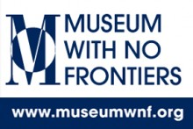*And read this:*

<http://www.discoverislamicart.org/gai/ISL/page.php?theme=10>

They mastered the technique of building vast inner spaces confined by seemingly weightless yet massive domes, and achieving perfect harmony between inner and outer spaces, as well as [articulated](https://en.wikipedia.org/wiki/Articulation_(architecture)) light and shadow. Islamic religious architecture which until then consisted of simple buildings with extensive decorations, was transformed by the Ottomans through a dynamic architectural vocabulary of [vaults](https://en.wikipedia.org/wiki/Vault_(architecture)), domes, semi domes and columns. The mosque was transformed from being a cramped and dark chamber with [arabesque](https://en.wikipedia.org/wiki/Arabesque)-covered walls into a sanctuary of aesthetic and technical balance, refined elegance and a hint of heavenly transcendence. (extract from Wikipedia)

*Make bullet point lists in answer to the following questions:*

1. What features are Ottoman?

*(Eg: Pencil minarets…)*

1. Which features show the influence of earlier Islamic structures? And which one in particular?

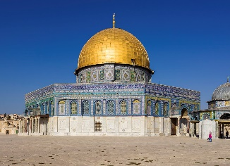

1. And earlier Byzantine architecture? Give an example of a key influential building?

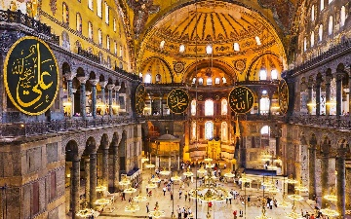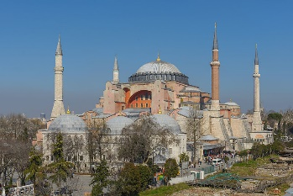

1. What features show its religious identity as a mosque?

****The **Suleymaniye Mosque** is built at the same time as **St Peter’s Basilica** in Rome. Think about the similarities and differences you see in the images of façade, plans and domes below. (Bramante’s original central plan for St Peter’s has been illustrated here. It was later modified during construction by both Raphael and Michelangelo. The nave of the building you see today was been further extended by Sangallo.)

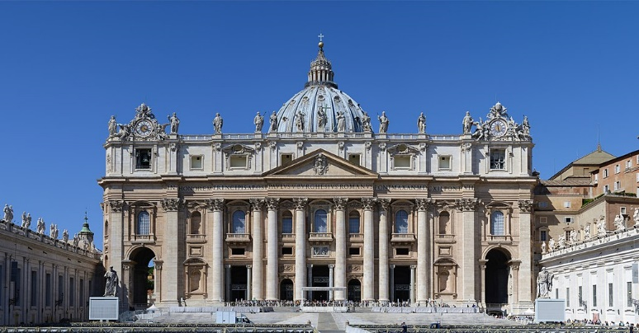

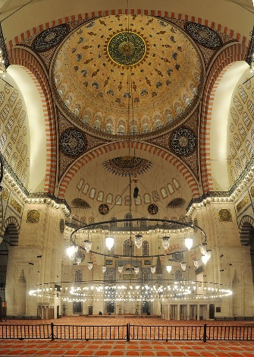

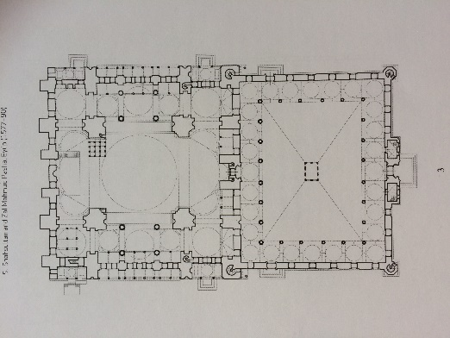

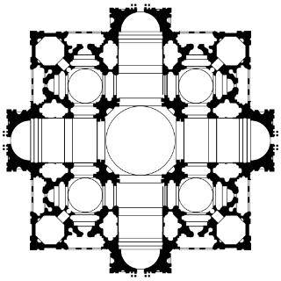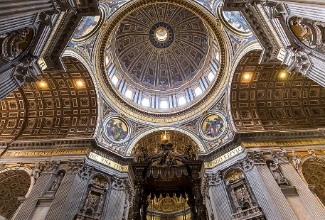

List the similar architectural features and consider the ways in which they have been used and the effect created.

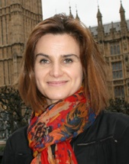Many people think that the differences between Islamic and Christian faiths makes understanding and mutual respect difficult. Perhaps, this exercise will make you think of Labour MP, Jo Cox’s words “we have more in common than that which divides us.”

*Now practise some exam style questions. (Write 200-300 words in each case)*

1. **How does this building express the identity of its patron?**
2. **How does this building demonstrate national identity?**

*(Make sure you identify the building, location, architect and ‘national’ identity of the Sultan ie Ottoman, in your opening sentence.)*