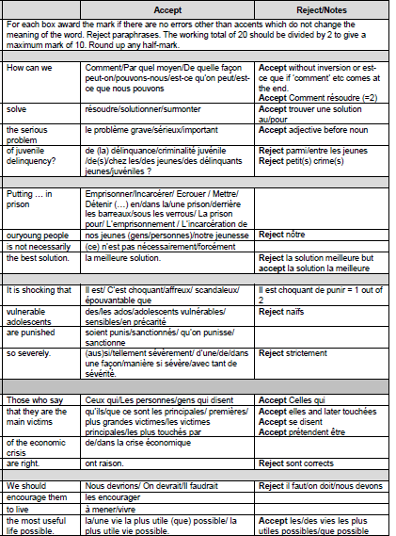

mark out of 20

divide by 2 and round up