Key work: David Hockney

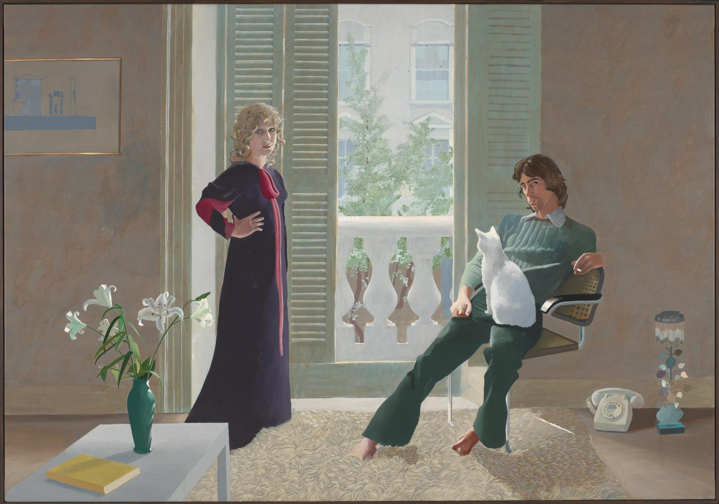**Born**: 1937 (now aged 80)

**Title**: ‘Mr and Mrs Clark and Percy’

**Genre:** Double portrait

**Date:** 1970-1

**Medium**: Acrylic on canvas

**Size:** 304 x 213 cm

**Scope of work**: Portrait in 2D

**Style:** Pop Art

Often called ‘one of the ten greatest paintings in Britain’ and the most popular work in the Tate…

Hockney sets this double portrait in the domestic setting of their Notting Hill home. It is simply furnished in an uncluttered environment. This makes the specific furnishings both important and symbolic. Celia is standing, pregnant, on the left and is often said to be the more assertive of the pair. She was a textile designer and Ozzie was a fashion designer. At this stage, they were collaborating on work for Quorum. His shirt collar is made from one of her prints and her dress is one of his designs, although she says she wasn’t wearing it when she sat for the work.

Explore Hockney’s own ideas and more recent work (shown in 2017 at the Royal Academy) in this interview documentary with Andrew Marr: <https://www.youtube.com/watch?v=cO5rCS6G3XU>

And if you are interested in fashion and textiles, you might enjoy Celia Birtwell being interviewed by Kirsty Young on BBC Radio 4, Desert Island Discs: <http://www.bbc.co.uk/programmes/b01n6064>

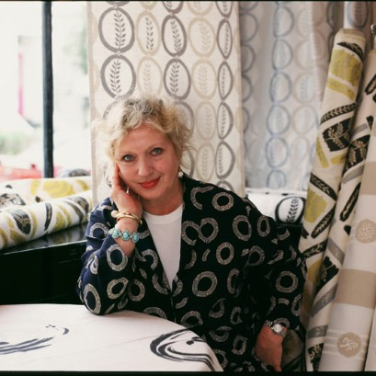

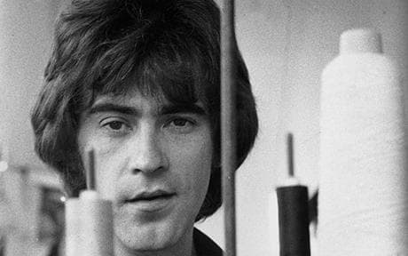

**Influences:**

Obviously, the **Arnolfini Portrait** by Van Eyck, but also a key work by another British artist: Hogarth’s **Rake’s Progress**. Look this series up and add an image of the single work that you think fits most closely. You might also think about the work we saw in the National Gallery by Gainsborough **Mr and Mrs Andrews**.

Sketch out the composition of the Arnolfini, Mr and Mrs Andrews and Mr and Mrs Clark below, so that you can see the significance of the placement of the figures within their space.

Make notes on the light and tone in Hockney’s work.

Find a definition for the ‘Pop Art’ style and list the characteristics that you think might make this work be said to fit this style.

And the use of colour?

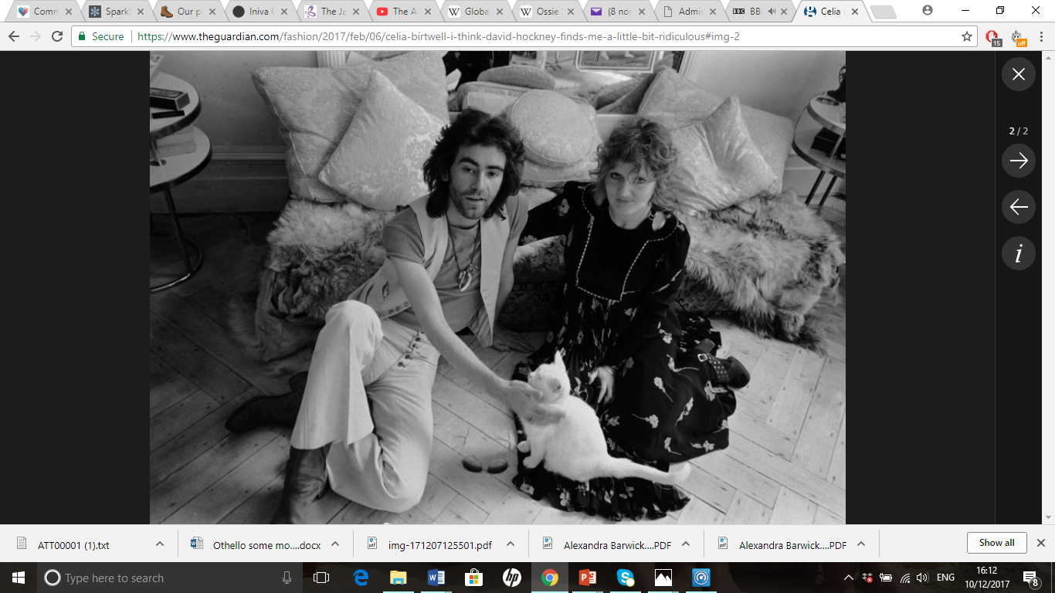

Look up the Clarks’ 1960/70s designs for Quorum and Celia Birtwell’s most recent ones for Top Shop…..