

NAME:

**Ancient History**

**Period Study: Relations Between Greek States and Between Greek and Non-Greek States, 492-404 BC**

**TOPIC 5:**

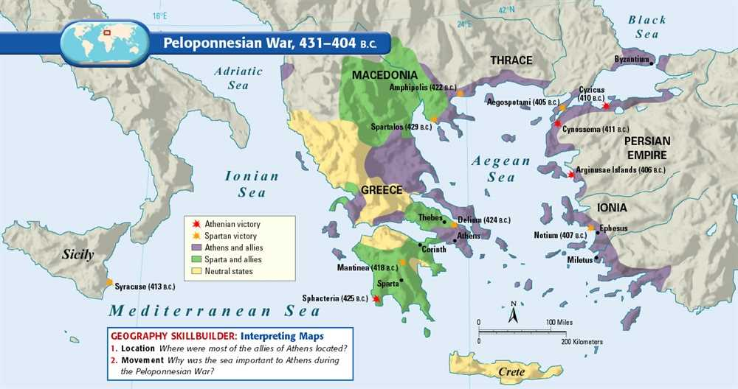**The End of the Peloponnesian War and its Aftermath, 419-404 BC**

***Aims of this Booklet:***

* **Identify the reasons for the breakdown in relations after the Peace of Nicias**
* **Appreciate the impact of the following events of the war – the Battle of Mantinea (418), the Sicilian Expedition (415-413), the occupation of Decelea**
* **Investigate the impact of Persia in the final years of the war**
* **Evaluate the reasons for Athens’ defeat in the Peloponnesian War**

**Suggested Reading**

**History Today Articles (go to** [www.historytoday.com](http://www.historytoday.com) **username= Godalming; password= history)**

# Thucydides: the Compassionate Scientist

By [P.A. Brunt](http://www.historytoday.com/author/pa-brunt)

Published in [History Today](http://www.historytoday.com/archive/history-today/latest) [Volume 7 Issue 12 December 1957](http://www.historytoday.com/archive/history-today/volume-7-issue-12-december-1957)

# Thucydides, Chance and the Dilemma of Imperialism

By [Irene Brown](http://www.historytoday.com/author/irene-brown)

Published in [History Today](http://www.historytoday.com/archive/history-today/latest) [Volume 31 Issue 3 March 1981](http://www.historytoday.com/archive/history-today/volume-31-issue-3-march-1981)

# Architects of the Athenian Empire, Part II: Pericles

By [Stephen Usher](http://www.historytoday.com/author/stephen-usher)

Published in [History Today](http://www.historytoday.com/archive/history-today/latest) [Volume 17 Issue 6 June 1967](http://www.historytoday.com/archive/history-today/volume-17-issue-6-june-1967)

**Textbooks**

* C. Cottam, D. Hodgkinson *et al*, *OCR Ancient History, Component 1: Greece*, Bloomsbury, 2017

**Books in the ILC**

* J. T. Roberts, *The Plague of War: Athens, Sparta and the struggle for Ancient Greece,* Oxford, 2017
* J. Ober, *The Rise and fall of Classical Greece*, Princeton, 2016
* R. Garland, *Ancient Greece: everyday life in the birthplace of western civilisation,* New York, 2013
* R. L. Fox, The Classical World: an Epic History of Greece and Rome, Penguin, 2006
* P. Cartledge, *Ancient Greece: A very Short Introduction*, Oxford, 2011
* J. Boardman, *The Oxford History of Greece & the Hellenistic World*, Oxford, 1986

**eBooks on** [**www.dawsonera.co.uk**](http://www.dawsonera.co.uk)

* G. Cawkwell, *The Greek Wars: The Failure of Persia*, Oxford, 2005
* P. Rhodes, *A History of the Classical Greek World 478-323 BC*, Wiley-Blackwell, 2009
* P. Cartledge, *After Thermopylae,* Oxford, 2013
* Powell, *Athens and Sparta,* Routledge, 2016
* P. De Souza, *The Greek and Persian Wars 499-386 BC*

**Useful Websites**

* <https://www.bloomsbury.com/cw/ocr-as-and-a-level-ancient-history/?pid=330294> (A companion website for the OCR Ancient History textbook – good selection of wider reading and revision quizzes)
* <http://www.ancient.eu/>
* <http://ancient-greece.org/index.html>
* <http://www.livius.org/>
* [www.ocr.org.uk](http://www.ocr.org.uk)

 **Podcasts**

Sparta **-** <http://www.bbc.co.uk/programmes/b00nvz72>

The Battle of Themopylae - <http://www.bbc.co.uk/programmes/p004y278>

The Battle of Salamis - <http://www.bbc.co.uk/programmes/b08j99jl>

Thucydides - <http://www.bbc.co.uk/programmes/b050bcf1>



*For help in accessing the ebook catalogue on dawsonera, go to the ILC’s page on Godalming Online and read their guide to accessing ebooks.*

*Ebooks can be read using your college log on details whilst in college or at home.*

**ANCIENT HISTORY LUNCHTIME SUPPORT**

**If you need any help in Ancient History going over content, completing homework, attempting assessed questions or preparing for exams, there will be a lunchtime support session each Wednesday between 1 and 2 pm in room 211.**

**The Breakdown of Relations**

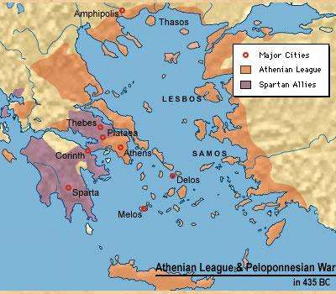***RECAP:*** Give and explain three reasons why the Peace of Nicias was unsustainable:











The Peace of Nicias had primarily been an alliance between Athens and Sparta meaning that the allies of each felt alienated and frustrated. Corinth was particularly angered by the peace treaty and immediately began to try to undermine it. They were unhappy with the clause in the treaty that allowed Athens and Sparta to alter the terms if they both agreed but without having to consult their allies.

The Corinthians turned to **Argos** to try and arrange a secret alliance designed to undermine Sparta’s position as the leader of the Peloponnesian League. For its part, Argos had had a separate thirty year truce with Sparta but now felt that war was inevitable and that Sparta was weak enough that Argos might be able to win and take leadership of the Peloponnese. This threatened to split the league as two other states, **Mantinea** and **Elis** sided with Corinth and Argos whilst **Megara** and the states of **Boeotia** stayed with Sparta.

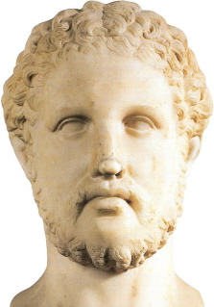The Spartans were keen to keep the Peloponnesian League united and under their control and began by trying to persuade their Boeotian allies to form an alliance with Argos and then bring Argos into alliance with Sparta (this demonstrates how delicate Spartan-Argive relations were). Sparta did, however, make a new alliance with the Boeotians, in return for control of Panactum (a small border town near Attica). This alliance was a breach of Sparta’s treaty with Athens but was carried out anyway causing anger in Athens. **Alcibiades** (right)had emerged in Athens as one of the leading advocates of war, following the death of Cleon, and he now called for a peace treaty with Argos.

**Prescribed Source - Thucydides, 5.43**

Now that relations between Athens and Sparta had taken this turn for the worse, the party in Athens also which wanted to put an end to the peace began to make itself felt immediately. The leader of this group was Alcibiades, the son of Clinias, a man who was still young in years (or would have been thought so in any other city in Hellas), but who had reached a position of importance owing to the respect in which his family was held. He was genuinely convinced that the best thing for Athens was an alliance with Argos – though it is true also that considerations of his own dignity affected his opposition to the peace with Sparta. He did not like the fact that the Spartans had negotiated the treaty through Nicias and Laches, paying no attention to him because of his youth; nor had they treated him with the respect he thought due to the fact that in the past his family had looked after Spartan interests in Athens – a post which his grandfather had given up, but which he himself wanted to take up again, as he had shown by his attentions to the prisoners captured on the island. He considered therefore that in every direction he was receiving less than his due, and from the first he had opposed peace, saying that the Spartans could not be relied upon, and that their only object in making the treaty was to be able in this way first to crush Argos and afterwards isolate Athens and attack her. Now, with relations strained as they were, he at once sent a personal message to the Argives, urging them to come as quickly as possible to Athens with the Mantineans and the Eleans and to make proposals for an alliance; this, he said, was the right moment for doing so, and he would do everything he could to help.

1. How does Thucydides present Alcibiades in this passage?

Alcibiades’ aim was to move public support in Athens away from the Peace of Nicias and towards a peace with Argos. He proposed a four-way alliance between **Athens, Argos, Mantinea and Elis**. This move was designed to provoke Sparta as it would mean that they would be encircled by the Athenian forces at Pylos and Cytheria, and by the three Peloponnesian states to the north.

Athens and its Peloponnesian allies then tried to isolate Corinth from the rest of the league as Argos attacked the city of Epidaurus, which Sparta sent forces to defend in 419 BC. Sparta at this point was seriously threatened in the Peloponnese and sent a large army to the north to confront Argos and Mantinea who were supported by 1,000 Athenian hoplites. Argos, Mantinea and Athens were attempting to win over the city of Tegea to their side which would have cut off a land route out of Laconia for Sparta. Under the king **Agis**, however, the Spartans won a decisive victory at the **Battle of Mantinea** in 418. The Spartan victory saw the collapse of the Athenian forces against it in the Peloponnese – Argos was taken over by an oligarchic faction (it had previously been democratic) who agreed a new fifty-year peace with Sparta; without Argive support, Mantinea was also forced to agree a new treaty with Sparta.

1. Why do you think that the victory at the Battle of Mantinea was particularly important to Sparta? (Think about what it achieved but also about what had happened recently before).

**The Breakdown of Relations 420-417 BC**

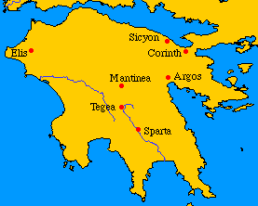*Who do you think was more responsible for the breakdown of the Peace of Nicias and why?*

**The Breakdown Relations 420-417 in Five Steps**

**The Sicilian Expedition**

***Recap:***

1. *What three objectives or rules had Pericles set out for Athens at the start of the war?*
2. *What does Thucydides claim happened to these rules after Pericles’ death and why*
3. *How does Thucydides portray Pericles?*

**Watch the following clip:** [**https://www.youtube.com/watch?v=H_ogvg7PiKw**](https://www.youtube.com/watch?v=H_ogvg7PiKw) **and answer the questions below.**

1. What event in 425 changed the course of the Peloponnesian War?
2. Why was Athens eager for peace in 421?
3. Why was Sparta eager for peace in 421?
4. How long was the Peace of Nicias meant to last for?
5. What problems were there with the Peace of Nicias?
6. Who was Alcibiades raised by and what impact did this have?
7. Which three Peloponnesian states did Alcibiades negotiate an alliance with?
8. In what ways did the Spartans break with tradition at the Battle of Mantinea?
9. What was the target of the Sicilian expedition?
10. How did Nicias try to scare off the Athenians from the expedition and why did this fail?
11. What ‘nasty business’ happened before the expedition sailed?

**TASK**

Working in groups you will prepare a presentation on the Sicilian expedition. This will need to cover the following topics:

* The background or causes of the expedition
* The events of the expedition
* The role of key figures (must include Nicias, Alcibiades & Gylippus at least)
* The outcome and significance of the expedition

Your presentation will need to be well-researched and clearly presented using a maximum of 5 slides. Your presentation will be used by other students to take notes so need to be clear and visually engaging – avoid big sections of solid text or text that is too small to read.

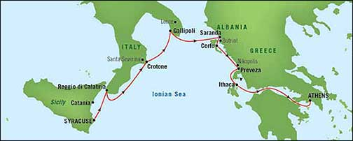

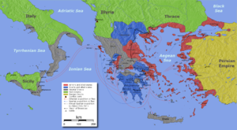**The Sicilian Expedition 415-413**

**Outcome/Significance**

**Role of Key Figures**

**Causes/Background**

**Events of the Expedition**

**Prescribed Source - Thucydides, 6.8**

At the beginning of spring next year the Athenian delegation came back from Sicily. They were accompanied by the Egestaeans, who brought sixty talents of uncoined silver – a month’s pay for sixty ships, which was the number they were going to ask the Athenians to send them.

The Athenians held an assembly and listened to what the Egestaeans and their own delegation had to say. The report was encouraging, but untrue, particularly on the question of the money which was said to be available in large quantities in the treasury and in the temples. So they voted in favour of sending sixty ships to Sicily and appointed as commanders with full powers Alcibiades, the son of Clinias, Nicias, the son of Niceratus, and Lamachus, the son of Xenophanes, who were instructed to help the Egestaeans against the Selinuntines, to re-establish Leontini also, if things went well with them in the war, and in general to make the kind of provisions for Sicily which might to seem to them most in accordance with Athenian interests.

Five days later another assembly was held to discuss the quickest means of getting the ships ready to sail and to vote any additional supplies that the general might need for the expedition. Nicias had not wanted to be chosen for the command; his view was that the city was making a mistake and, on a slight pretext which looked reasonable, was in fact aiming at conquering the whole of Sicily – a very considerable undertaking indeed. He therefore came forward to speak in the hope of making the Athenians change their minds. The advice he gave was as follows:

**Prescribed Source - Thucydides, 6.12-13**

‘We should also remember that it is only recently that we have had a little respite from a great plague and from the war, and so are beginning to make good our losses in men and money. The right thing is that we should spend our new gains at home and on ourselves instead of on these exiles who are begging for assistance and whose interest is to tell lies and make us believe them, who have nothing to contribute themselves except speeches, who leave all the danger to others and, if they are successful, will not be properly grateful, while if they fail in any way they will involve their friends in their ruin.

‘No doubt there is someone sitting here who is delighted at having been chosen for the command and who, entirely for his own selfish reasons, will urge you to make the expedition – and all the more so because he is still too young for his post. He wants to be admired for the horses he keeps, and because these things are expensive, he hopes to make some profit out of his appointment. Beware of him, too, and do not give him the chance of endangering the state in order to live a brilliant life of his own. Remember that with such people maladministration of public affairs goes with personal extravagance; remember, too, that this is an important matter, and not the sort of thing that can be decided upon and acted upon by a young man in a hurry.

‘It is with real alarm that I see this young man’s party sitting at his side in this assembly all called in to support him, and I, on my side, call for the support of the older men among you. If any one of you is sitting next to one of his supporters, do not allow yourself to be brow-beaten or be frightened of being called a coward if you do not vote for war. Do not, like them, indulge in hopeless passions for what is not there. Remember that success comes from foresight and not much is ever gained simply by wishing for it. Our country is now on the verge of the greatest danger she has ever known. Think of her, hold up your hands against this proposal, and vote in favour of leaving the Sicilians alone to enjoy their own country and manage their own affairs within the boundaries (perfectly satisfactory to us) which now divide us from them – the Ionian sea, for the voyage along the coast, and the Sicilian sea, for the direct voyage. And let the Egestaeans, in particular, be told that, just as they started their war with the Selinuntines without consulting Athens, so they must themselves be responsible for making peace.; and in the future we are not making allies, as we have done in the past, of the kind of people who have to be helped by us in their misfortunes, but who can do nothing for us when we need help from them.

**Prescribed Source - Thucydides, 6.15**

After this speech of Nicias most of the Athenians who came forward to speak were in favour of making the expedition and not going back on the decision which had already been passed, though a few spoke on the other side. The most ardent supporter of the expedition was Alcibiades, the son of Clinias. He wanted to oppose Nicias, with whom he had never seen eye to eye in politics and who had just now made a personal attack on him in his speech. Stronger motives still were his desire to hold the command and his hopes that it would be through him that Sicily and Carthage would be conquered – success which would at the same time bring him personally both wealth and honour. For he was very much in the public eye, and his enthusiasm for horse-breeding and other extravagances went beyond what his fortune could supply. This, in fact, later on had much to do with the downfall of the city of Athens. For most people became frightened at a quality in him which was beyond the normal and showed itself both in the lawlessness of his private life and habits and in the spirit in which he acted on all occasions. They thought that he was aiming at becoming a dictator, and so they turned against him. Although in a public capacity his conduct of the war was excellent, his way of life made him objectionable to everyone as a person; thus they entrusted their affairs to other hands, and before long ruined the city.

On this occasion Alcibiades came forward and gave the following advice to the Athenians:

**Prescribed Source - Thucydides, 6.24**

In making this speech Nicias thought that either the Athenians would be put off by the scale of the armament required, or, if was forced to make the expedition, he would in this way sail as safely as possible.

The Athenians, however, far from losing their appetite for the voyage because of the difficulties in preparing for it, became more enthusiastic about it than ever, and just the opposite of what Nicias took place. His advice was regarded as excellent, and it was now thought that the expedition was an absolute safe thing. There was a passion for the enterprise which affected everyone alike. The older men thought that they would either conquer the places against which they were sailing or, in any case, with such a large force, could come to no harm; the young had a longing for the sights and experiences of distant places, and were confident that they would return safely; the general masses and the average soldier himself saw the prospect of getting pay for the time being and of adding to the empire so as to secure permanent paid employment in future. The result of this excessive enthusiasm of the majority was that they few who actually were opposed to the expedition were afraid of being thought unpatriotic if they voted against it, and therefore kept quiet.

**Prescribed Source - Thucydides, 6.31**

At this moment when they were really on the point of parting from each other with all the risks ahead, the danger of the situation came more home to them than it had at the time when they voted for the expedition. Nevertheless they were heartened with the strength that had and with the sight of the quantities of every kind of armament displayed before their eyes. As for the foreigners and the rest of the crowd, they came merely to see the show and to admire the incredible ambition of the thing.

Certainly this expedition that first set sail was by a long way the most costly and the finest looking force of Hellenic troops that up to that time had ever come from a single city. In number of ships and hoplites it was no greater than the force which Pericles took to Epidaurus and the same force which went against Potidaea with Hagnon, which consisted of 4,000 Athenian hoplites, 300 cavalry, and 100 triremes, with the addition of 50 more ships from Lesbos and Chios and many allied troops as well. That force, however, went only on a short voyage and was equipped in the ordinary way, whereas this expedition was planned with a view to its being away for a long time and was equipped for both kinds of fighting, whichever should be required, both with warships and with round troops. The fleet was in a high state of efficiency and had cost a lot of money to both the captains and the State. Every sailor received a drachma a day from the Treasury, which also provided empty ships (sixty fighting ships and forty for the transport of hoplites) all manned by the best crews available. The captains, too, offered extra pay, in addition to that provided by the State to the *thranitae* and the rest of the crews, and they went to great expense on figure-heads and general fittings, every one of them being as anxious as possible that his own ship should stand out from the rest for its fine looks and for its speed. As for the land forces, they had been chosen from the best men who were liable for calling-up, and there had been much rivalry and much pains spent by everyone on his armour and personal equipment. It therefore happened that there was not only all this competition among the Athenians themselves, each with regard to his own particular piece of responsibility, but to rest of Hellas it looked more like a demonstration of the power and the greatness of Athens than an expeditionary force setting out against the enemy. It would have been found that a grand total of many talents of money were being taken out of the city, if one reckoned up the sums spent by the State and the private expense of those who were serving – a total which would include what the State had already spent and what was being sent out in the hands of the generals, what individuals had spent on equipment, what the captains had spent and were still to spend on their ships; and in addition to all of this there would have to be included the money for private expenses which everyone was likely to have taken with him over and above his pay from the State on an expedition which was to last for a long time, and also what the soldiers or traders took with them for purpose of exchange. And what made this expedition so famous was not only its astonishing daring and the brilliant show it made, but also it great preponderance of strength over against whom it set out, and the fact that this voyage, the longest ever made by an expedition from Athens, was being undertaken with hopes for the future which, when compared with the present position, were of the most far-reaching kind.

**Prescribed Source - Thucydides, 6.89-91**

‘The first thing I must do is to deal with the prejudice which you feel against me, so that you may listen to matters of common interest without being biased by any suspicion of me personally. My ancestors used to hold the position of official representatives for Sparta in Athens; because of some misunderstanding they gave up this position, but I myself took it up again and put my services at your disposal, particularly with regard to the losses which you sustained at Pylos. I remained anxious to help you throughout, but when you made peace with Athens you negotiated through my personal enemies, thus putting them in a stronger position and discrediting me. You have no right therefore to blame me for the injuries you suffered when I turned to Mantinea and to Argos and opposed you in various other ways. And if in those days when you were actually suffering any of you were unreasonably angry with me, the time has now come for you to look at the matter in its true light and to change your views. Or if anyone thought the worse of me because I was rather on the side of the people, here again he should see that this was no good reason for being against me. My family has always been opposed to dictators; democracy is the name given to any force that opposes absolute power; and so we have continued to act as the leaders of the common people. Besides, since democracy was the form of government in Athens, it was necessary in most respects to conform to the conditions that prevailed. However in the face of the prevailing political indiscipline, we tried to be more reasonable. There have been people in the past, just as there are now, who used to try to lead the masses into evil ways. It is people of this sort who have banished me. But we were leaders of the State as a whole, and our principles were that we should all join together in preserving the form of government which had been handed down to us under which the city was most great and most free. As for democracy, those of us with any sense at all knew what that meant, and I just as much as any. Indeed, I am well equipped to make an attack on it; but nothing new can be said of a system which is generally recognized as absurd. As for changing the system, that appeared to us as unsafe while you were engaged in war with us.

‘So much for things which have created prejudice against me. I now want you to listen to what I have to say on the subject which you are to discuss – a subject on which I am perhaps peculiarly well qualified to speak. We sailed to Sicily to conquer first, if possible, the Sicilians, and after them the Hellenes in Italy; next we intended to attack the Carthaginian empire and Carthage herself. Finally, if all or most of these plans were successful, we were going to make our assault on the Peloponnese, bringing with us all the additional Hellenic forces which we should have acquired in the west and hiring as mercenaries great numbers of native troops – Iberians and others who are now recognized as being the best fighting material to be found in those parts. In addition to our existing fleet we should have built many more triremes, since Italy is rich in timber, and with all of them we should have blockaded the coast of the Peloponnese, while at the same time our army would be operating on land against your cities, taking some by assault and others by siege. In this way we hoped that the war would easily be brought to a successful conclusion and after that we should be masters of the entire Hellenic world. As for money and provisions, there could be no fear of them running short, since sufficient supplies were to be provided by our new conquests in the west without touching our revenues here in Hellas.

‘You have now heard from the man who knows most about it what were in fact the objects of the present expedition; and the generals who are left will, if they can, continue just the same carry out these plans. What you must now realize is that, unless you help her, Sicily will be lost. The Sicilians lack the experience which Athens has, but might even now survive if they all united together. The Syracusans themselves, however, whose total force has already been defeated in one battle and who are at the same time blockaded by sea, will not be able to hold out against the Athenian forces now in Sicily. And if Syracuse falls, all Sicily falls with it, and Italy soon afterwards. It would not then be long before you were confronted with the dangers which I have just told you threatened you from the west. So do not imagine that it is only the question of Sicily that is under discussion; it will be the question of the Peloponnese unless you quickly take the following measures: you must send out to Sicily a force of troops that are able to row the ships themselves and to take the field as hoplites as soon as they land ; and – what I consider even more useful than the troops – you must send out as commander a regular Spartan officer to organize the troops that are there already and to force into the service those who are shirking their duty. This is the way to put fresh heart into your friends and make the waverers less frightened of joining in. Then, too, the war in Hellas must be carried on more openly This will have the effect of stiffening Syracusan resistance, when they see that you are taking an interest in them, and will make it harder for the Athenians to reinforce their army in Sicily. And you must fortify Decelea in Attica; it is the thing of which the Athenians have always been most frightened, and they think that of all the adversities of the war this is the only one that they have not experienced. The surest way of harming an enemy is to find out certainly what form of attack he is most frightened of and then to employ it against him. He is likely to know himself more accurately than anyone else where his danger lies, and that is why he is frightened. As for what you will gain and what you will force Athens to lose if you fortify Decelea, I shall merely summarize the most important points, omitting many others. Most of the property in the area will come into your hands, some by capture, some without your having to move a finger. Athens will immediately be deprived of her revenues from the silver mines at Laurium and from what she gets at present from the land and from the law-courts. Most important of all, she will lose her tribute from the allies, since they will pay it in much less regularly and will be cease to be overawed by Athens herself once they see that you are now really making war seriously.

**Prescribed Source - Thucydides, 6.82-83**

‘The reason we came here was to renew the former alliance, but now, after this attack from the Syracusan, I am forced to speak about our empire and the good reasons we have for holding it. As a matter of fact the Syracusan representative himself put forward the best piece of evidence on this point when he said that the Ionians are always the enemies of the Dorians. This is quite true. Now, we are Ionians and the Peloponnesians are Dorians; they are more numerous than we are and they live close to us. We therefore looked about for the best means of preserving our independence, and after the Persian war, by which time we had built our navy, we broke free from the Spartan empire and from Spartan leadership. They had no more right to give us orders than we had to give orders to them, except that at the time they were stronger. We ourselves were appointed to the leadership of those who had previously been under the King of Persia, and we continue to manage their affairs. Our view is that in this way we are least likely to fall under the domination of the Peloponnesians, since we have the power to defend ourselves, nor, if one considers the real facts of the situation, do we think that we have done anything wrong in subjugating the Ionians and the islanders, who according to the Syracusans, are our oppressed kinsmen. The fact is that these kinsmen joined the Persians in attacking their mother country – namely, Athens – and, unlike us, when we abandoned our city, did not have the courage to revolt, which would have meant losing their property. Instead of this they chose to be slaves themselves and wanted to make us slaves too.

‘We therefor deserve the empire which we have, partly because we supplied to the cause of Hellas the largest fleet and a courage that never looked back, while these subjects of our harmed us by being just as ready to act in the service of Persia, partly because we wanted to have the strength to hold our own in relation to the Peloponnesians. We are not making any dramatic statements such as that we have a right to rule because single-handed we overthrew the foreign invader, or that the risks we took were for the liberty of these subjects of ours any more than for the liberty of everyone, ourselves included; no one can be blamed for looking after his own safety in his own way. So now it is for our own security that we are in Sicily, and we see that here your interests are the same as ours. This we can prove from what the Syracusans are saying against us and from the suspicions of us which you yourselves, in your rather over-anxious mood, no doubt entertain; because we know that when people are frightened and suspicions, they enjoy for the moment an argument that fits in with their feeling, but in the end, when it comes to the point, they act in accordance with their interests.

‘We have told you that it is because of fear that we hold our empire in Hellas, and it is also because of fear that we have come here to settle matters for our own security, together with our friends; not to enslave anybody, but rather to prevent anybody from being enslaved.

**The War in Attica – The Occupation of Decelea**

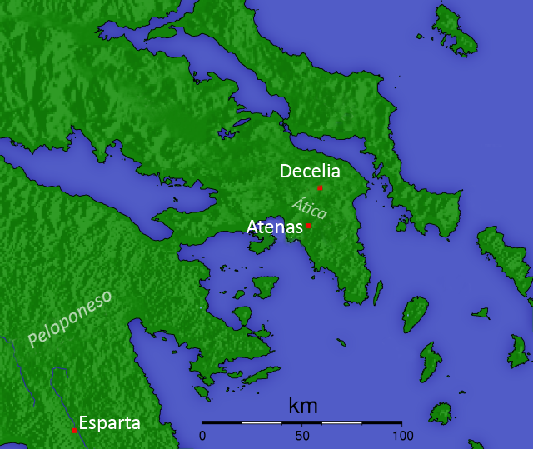Although relations had started to break down between Athens and Sparta from 418 BC with the Battle of Mantinea, it was not until 414 that Sparta decided to renew the war fully, believing that this point that peace was unsustainable. Alcibiades had encouraged Sparta to attack Attica again when he was in exile in the city and the place he pointed them towards was **Decelea**. This was an important location as it sat in between **Oropus**, the port at which food supplies from Euboea arrived, and Athens. If the Spartans occupied Decelea, therefore, they could start to cut off these supplies and starve Athens. The occupation of Decelea was different to the original Spartan strategy of launching annual invasions because whereas these lasted for a matter of weeks at most, the Spartans **permanently occupied Decelea** and denied Athens the supplies that were meant to come through here.

***Recap:***

*Can you remember the Greek term for establishing a fortified base in enemy territory?*

What advantages does Alcibiades say will come from occupying Decelea?

How reliable is this source? (Think about the context)

**Prescribed Source – Thucydides 6.91**

Then, too, the war in Hellas must be carried on more openly This will have the effect of stiffening Syracusan resistance, when they see that you are taking an interest in them, and will make it harder for the Athenians to reinforce their army in Sicily. And you must fortify Decelea in Attica; it is the thing of which the Athenians have always been most frightened, and they think that of all the adversities of the war this is the only one that they have not experienced. The surest way of harming an enemy is to find out certainly what form of attack he is most frightened of and then to employ it against him. He is likely to know himself more accurately than anyone else where his danger lies, and that is why he is frightened. As for what you will gain and what you will force Athens to lose if you fortify Decelea, I shall merely summarize the most important points, omitting many others. Most of the property in the area will come into your hands, some by capture, some without your having to move a finger. Athens will immediately be deprived of her revenues from the silver mines at Laurium and from what she gets at present from the land and from the law-courts. Most important of all, she will lose her tribute from the allies, since they will pay it in much less regularly and will be cease to be overawed by Athens herself once they see that you are now really making war seriously.

**Prescribed Source - Thucydides, 7.18**

The Spartans also prepared to invade Attica, as they had already decided to do and as they had been asked to do by the Syracusans and Corinthians, who, when they heard that Athens was sending reinforcements to Sicily, hoped that this would be stopped by an invasion. Alcibiades, too, was constantly urging them to fortify Decelea and to carry on the war with vigour. But what chiefly encouraged the Spartans to act with energy was their belief that Athens, with two wars on her hands – one against them and one against the Sicilians – would be now easier to crush. There was also the fact the Spartans considered that Athens had been the first to break the peace treaty. In the first war they thought that the fault had been more on their side, partly because the Thebans had entered Plataea in peace time and partly because, in spite of the provisions in the previous treaty that there should be no recourse to arms if arbitration was offered, they themselves had not accepted the Athenian offer of arbitration. They therefore thought that there was some justice in the misfortunes they had suffered and took to heart the disaster of Pylos and their other defeats. But now, in addition to the constant raids from Pylos, the Athenians had come out with thirty ships from Argos and laid waste part of Epidaurus and Prasiae and other places; also whenever any dispute arose on doubtful points in the treaty, it was Sparta who had offered to submit to arbitration and Athens who had refused the offer. It was now Athens therefore, the Spartans thought, who was in in the wrong through having committed exactly the same fault as theirs had been before, and they went into the war with enthusiasm. This winter they sent round to their allies for supplies of iron and got ready all the other materials for building fortifications. At the same time they organized a force of their own and conscripted other forces from the rest of the Peloponnese to be sent out in merchant ships to the help of their allies in Sicily. So the winter ended, and the eighteenth year of this war recorded by Thucydides.

1. Why according to Sparta’s allies was the timing right for a new invasion of Attica and the occupation of Decelea?
2. In what way did the situation on Pylos encourage Sparta to invade Attica?

The Spartan occupation of Decelea does not receive a lot of coverage in Thucydides ‘History of the Peloponnesian War’ but it nevertheless had a damaging impact on Athens:

* Decelea was 13 miles from Athens and meant that the city walls now needed to be guarded all year round
* To push back the Spartans and their allies, the Athenians had to regularly send out cavalry but soon their horses became lame
* An estimated 20,000 slaves deserted Athens fleeing for enemy held territory
* The food supply from Euboea was interrupted meaning that food had to be sailed around to Athens costing time and money

Arguably, however, the impact of the occupation of Decelea was made worse because the Athenians refused to abandon their expedition in Sicily and in fact sent a second fleet under Demosthenes to the island. This meant that Athens was fighting two major wars at once.

**Prescribed Source – Thucydides, 7.27-28**

In this same summer there arrived in Athens 1,300 peltasts from the Dii, one of the Thracian tribes who are armed with short swords. They were meant to have sailed to Sicily with Demosthenes, and, as they had arrived too late for this, the Athenians resolved to send them back to Thrace, where they came from, since it seemed too expensive – each man was paid a drachma a day – to retain their services for dealing with the attacks made on them from Decelea.

The position was that, ever since Decelea had been first fortified by the whole of the invading army during the summer and had then been used as a hostile post against the country, with garrisons from the various cities relieving each other at fixed intervals, Athens had suffered a great deal. Indeed, the occupation of Decelea, resulting, as it did, in so much devastation of property and loss of manpower, was one of the chief reasons for the decline of Athenian power. The previous invasions had not lasted for long and had not prevented the Athenians from enjoying the use of their land for the rest of the time; now, however, the enemy were on top of them throughout the year; sometimes there were extra troops sent in to invade the country; sometimes it was only the normal garrison overrunning the land and making raids to secure supplies; and the Spartan King Agis was there in person, treating the whole operation as a major campaign. The Athenians therefore suffered great losses. They were deprived of the whole of their country, more than 20,000 slaves, the majority of whom were skilled workmen, deserted, and all the sheep and farm animals were lost. As the cavalry rode out to Decelea every day to make attacks on the enemy or to patrol the country, the horses were lamed on the rough ground and by the continuous hard work to which they were put, or else were wounded by the enemy. Then the supplies of food from Euboea, which previously had been brought in by the quicker route overland from Oropus through Decelea, now, at great expense, had to go by sea round Sunium. Every single thing that the city needed had to be imported, so that instead of a city it became a fortress. By day detachments took it in turn to mount guard on the battlements, by night all except the cavalry were on duty, some at the various armed posts and others on the walls. So, summer and winter, there was no end to their hardships. What wore them down more than anything else was the fact that they had two wars on their hands at once, and indeed they had got themselves into such a state of obstinate resolution that no one would have believed it possible if he had been told of it before it actually happened. For it was incredible that, besieged by the Peloponnesians who were based on a fortress in Attica, they should not only leave Sicily, but actually stay on and lay siege in just the same way to Syracuse, a city which was in itself as big as Athens, and should give the Hellenic world such an astonishing demonstration of their power and of their daring; how astonishing can be seen from the fact that at the beginning of the war some thought that, if the Peloponnesians invaded Attica, Athens might survive for a year, and while others put the figure at two or three years, no one imagined she could last for more than that; yet now, in the seventeenth year after the first invasion, having suffered every kind of hardship already in the war, here were the Athenians going out to Sicily and taking upon themselves another war on the same scale as that which they had been waging all this time with the Peloponnesians.

For all these reasons – the great damage done by the occupation of Decelea and the other heavy expenses which fell upon them – the Athenians were becoming embarrassed financially, and it was about this time that they imposed upon their subjects, a tax of five per cent on all imports and exports by sea, thinking that this would bring in more money. Expenditure was not the same as it had been, but had grown bigger as the war grew bigger, while revenue was declining.

1. How according to Thucydides did the Peloponnesians maintain their year-round presence at Decelea?
2. Write down one quote from this source that summarises Thucydides’ view on the importance of the occupation of Decelea
3. What does Thucydides find ‘incredible’ and do you agree with his view?

**Persia’s Impact on the Peloponnesian War**

**The Ionian War** – the name given to the final stage of the Peloponnesian War between 413 and 404 BC. It is referred to as this as most of the fighting took place in the eastern Aegean

**Prescribed Source - Thucydides, 8.2**

Next winter the whole of Hellas, after the great disaster in Sicily, turned immediately against Athens. Those who had not been allied to either side thought that, even though they were not asked, they ought not to keep out of the war any longer and should go against the Athenians of their own accord, since the Athenians, in the view of each state, would have gone against them, if they had been successful in Sicily, and at the same time they thought that the war would soon be over and that they would gain credit for taking part in it. And those who were allies of Sparta were all the more eager than ever to be freed quickly from all the sufferings they had endured so long. In particular the subjects of Athens were all ready to revolt; indeed they were more ready than able, since they were incapable of taking a dispassionate view of things, and would not admit the possibility that Athens might survive the coming summer. In Sparta all this produced a mood of confidence, and what was even more encouraging was the probability that in the spring they would be joined by their allies from Sicily in great force and now with the additional advantage of the navy which they had had to build. And, so with good reasons for confidence in every direction, the Spartans determined to throw themselves into the war without any reservations, calculating that, when once it was successfully over, they would be free for the future from the kind of danger which might have beset them if Athens had added the resources of Sicily to her own, and that, when the power of Athens had been destroyed, they themselves would be left secure in the leadership of all Hellas.

**TASK:** List as many reasons as you can think of why Athens’ ‘subjects’ (e.g. parts of its empire) would be ready to revolt by 413 BC

By 413 BC the Spartan King **Agis**, camped in Decelea, began to receive representatives from parts of Athens’ empire which wanted to revolt and break away. Representatives from Euboea, Lesbos and Chios came to the Spartans looking for guarantees of support if they revolted from Athens. In addition to these Greek states, **Persian Satraps** also sent representatives to Sparta. Representatives of **Tissaphernes**, the governor of Caria in Asia Minor, and **Pharnabazus** from the Hellespont arrived hoping to be able to reclaim territory and influence lost after the Persian Wars.

**Prescribed Source - Thucydides, 8.6**

Thus the Chians and Tissaphernes were acting together for the same object. And about the same time there arrived at Sparta, Calligeitus, the son of Laophon, a Megarian, and Timagoras, the son of Athenagoras, a Cyzicene, both exiles from their own cities, living at the court of Pharnabazus, the son of Pharnaces. They had been sent by Pharnabazus to try to get a fleet to operate in the Hellespont, so that he might do himself just what Tissaphernes wanted to do – that is to say, procure the tribute by getting the cities in his province to revolt from the Athenians, and gain the credit for bringing the Spartans into alliance with the King.

Each of the two parties – that of Pharnabazus and that of Tissaphernes – was trying to make its own separate arrangements, and so there was much canvassing in Sparta about whether a fleet and army should be sent first to Ionia and Chios or to the Hellespont. The Spartans, however, were very much on the side of the Chians and of Tissaphernes, who were also supported by Alcibiades who was a family friend of Endius, one of the ephors, and on very good terms with him. It was because of this family connection that his house adopted its Laconic name; ‘Alcibiades’, in fact, was used as a surname by Endius. Nevertheless the Spartans first sent Phrynis, one of the perioeci, to Chios to find out whether they had as many ships as they said and whether the city was in other respects as strong as it had been made out to be. Phrynis came back with the news that all this was just as they had been told, and they then immediately made an alliance with the Chians and the Erythraeans and voted to send them forty ships, assuming there to be already sixty ships available on the spot, according to what the Chians had said. Their first intention was to send ten of these ships themselves, with their admiral Melanchridas they sent Chalcideus, and instead of the ten ships they only equipped five in Laconia. So the winter ended the nineteenth year of this war recorded by Thucydides.

1. What according to this source was the aim of the Persian Satraps Tissaphernes and Pharnabazus?

It is clear from Thucydides that this was not the first time the Persians had tried to make contact with Sparta as previously. In the source below he explains how the Athenians had previously intercepted a Persian messenger and that when they translated the message, it showed evidence that Sparta had asked for Persian help.

**Prescribed Source - Thucydides, 4.50 (425 BC)**

In the following winter Aristides, the son of Archippus, one of the commanders of the Athenian ships which were sent out to collect money from the allies, captured at Eion, on the Strymon, a Persian called Artaphernes, who was on his way to Sparta from the King of Persia. He was taken to Athens and there the Athenians had his dispatches translated from the Assyrian characters and read them. A number of subjects were mentioned, but the main point for the Spartans was this – that the King, did not understand what they wanted, since the many ambassadors who had come to him all said different things: if, therefore, they had any definite proposals to make, they were to send him some delegates with this Persian. Afterwards the Athenians sent Artaphernes back in a trireme to Ephesus and sent some ambassadors with him. There, however, they heard that Artaxerxes, the son of Xerxes, had just died (his death took place just about this time), and they returned home.

*Why might Sparta ask for Persian help in 425 specifically?*

There is also evidence, however, that Athens had concluded a peace treaty with Persia somewhere between 424-423 BC. There are only small glimpses of evidence to suggest this:

***TASK:*** *Read the two sources below and highlight any evidence that supports the idea of a treaty between Athens and Persia*

**Prescribed Source - Aristophanes, *Akharnians* 61–71 (425 BC)**

The long absence of Athenian ambassadors to Persia ridiculed

HERALD. The ambassadors from the King!

DIKAIOPOLIS. What sort of a king? I’m fed up with ambassadors and peacocks and flattery.

HERALD. Silence

DIKAIOPOLIS. Bless me! The shape of Ekbatana!

AMBASSADOR. You sent us to the Great King, paid at 2 drachmas a day, in the archonship of Euthymenes (437/6)

DIKAIOPOLIS. Aaaagh! The cost!

AMBASSADOR. We were worn out with wandering through the plain of the Kayster, lying on soft cushions in our carriages, done for.

**Prescribed Source - Andokides, 3.29 (No. 61)**

We are the people who first made a treaty with the Great King – I must remind you of past events in order to give you the best advice – and agreed to friendship for all time, a treaty which Epilykos son of Tisander, my mother’s brother, was responsible for as ambassador, and then, persuaded by the King’s banished subject Amorges, we cast off the King’s power, as if it was worth nothing, and took up the friendship of Amorges, considering him to be stronger.

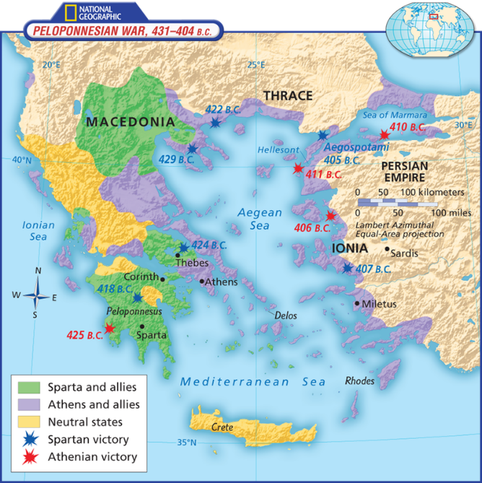

The idea of an Athenian-Persian treaty in 424-23, possibly called the **Peace of Epilycus** has little supporting evidence but would have made sense. The loss of Amphipolis in 424 to Brasidas, threatened to take control of the northern Aegean and the Hellespont away from Athens. If they lost this then they would lose their supply of grain that came through the Hellespont from the Black Sea region. The Persians may also have wanted friendly relations with Athens around 423 BC as the new King **Darius II** had come to the throne and needed time to establish his power against the other sons of the previous ruler Artaxerxes.

It is clear that Persia had not been inactive during the Peloponnesian War but had been watching closely. By 413 BC, Darius II now felt secure enough on his throne to fully support Sparta and try to reclaim Persia’s lost territory and tribute around the Aegean.

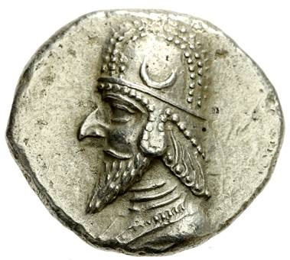

Darius II (423-c.404 BC)

The first target for Sparta and Persia was the Island of **Chios** which by this point was the only part of the Athenian empire paying tribute in the form of ships.

***RECAP:*** *can you remember what had happened to the other remaining ship-paying state in 428 BC?*

**Prescribed Source - Thucydides, 8.9**

They were now anxious to start the voyage, but it was the date of the Isthmian festival, and the Corinthians were reluctant to sail with them until they had celebrated it. Agis was quite prepared to make the expedition his own personal responsibility, so that the Corinthians would not be in the position of breaking the Isthmian truce, but the Corinthians would not agree to this and matters were held up. During this time the Athenians began to realize what was happening in Chios and sent Aristocrates, one of their generals, there and confronted the Chians with the evidence. When they denied it, the Athenians ordered them to show their good faith by sending ships to join their fleet, and the Chians sent seven. The reason why these ships were sent was because the general mass of the people at Chios knew nothing of the negotiations, and the oligarchical party were not yet ready to have the people against them until they had something solid to depend upon, and, because of the delay that had taken place, they were no longer expecting the Peloponnesians to arrive.

1. From this source, who in Chios appeared to be negotiating with the Spartans and Persians about revolting from Athens?

Despite their confusion, the Spartans sailed to Chios and through the connections and persuasiveness of **Alcibiades** made **Chios** and **Miletus** revolt from Athens. This was then followed by a formal treaty between Persia and Sparta.

**Prescribed Source - Thucydides, 8.17-18**

Chalcideus and Alcibiades had driven Strombichides into Samos. Then, after arming the crews of the ships from the Peloponnese and leaving them at Chios, they recruited rowers from Chios to take their place and, manning twenty other ships as well, set sail for Miletus to start a revolt there. Alcibiades, who was on good terms with the leading people in Miletus, wanted to bring the city over before the ships from the Peloponnese arrived and so, by organizing revolt in as many cities as possible with the aid of the Chian forces and of Chalcideus, gain all the credit for the Chians and for himself and Chalcideus and, as he promised, Endius, who had sent the expedition out. So for most of their voyage they escaped observation and started the revolt in Miletus, arriving there a little before Strombichides and Thrasicles, who had just come from Athens with twelve ships and who had joined in the pursuit. The Athenians sailed up close on their heels with nineteen ships and, as the people of Miletus would not receive them, took up their position at Lade, the island off Miletus. Directly after the revolt of Miletus the first alliance between the King of Persia and the Spartans was concluded by Tissaphernes and Chalcideus. It was as follows:

‘The Spartans and their allies made a treaty of alliance with the King and Tissaphernes on the following terms:

‘All the territory and all the cities held now by the King or held in the past by the King’s ancestors shall be the King’s. As for the money and everything else which has been coming in to the Athenians from their cities, the King and the Spartans and their allies shall co-operate in preventing the Athenians from receiving the money or anything else.

‘The war with Athens shall be carried on jointly by the King and the Spartans and their allies. It shall not be permitted to bring the war with the Athenians to an end unless both parties are agreed, the King on his side, and the Spartans and their allies on their side. Any people who revolt from the King shall be regarded as enemies by the Spartans and their allies; and any people who revolt from the Spartans and their allies shall, in the same way, be regarded as enemies to the King.’

**Terms of the Treaty:**

1. All of the territories that had previously belonged to Persia would be returned
2. All the money paid to Athens by former Persian subjects would go to Persia
3. Persia and Sparta would carry out the war jointly
4. Anyone who revolted from Persia would be an enemy of Sparta
5. Anyone who revolted from Sparta would be an enemy of Persia

***Which of these terms are pro- Persian or pro-Spartan?***

**VERSION TWO OF THE TREATY**

**Prescribed Source - Thucydides, 8.37**

‘An agreement made between the Spartans and the allies with King Darius and the sons of the King and with Tissaphernes for a treaty of friendship on the following terms:

‘Neither the Spartans nor the allies of the Spartans shall make war against or do any damage to the country or the cities which now belong to King Darius or did belong to his father or to his ancestors.

‘No tribute shall be taken from these cities either by the Spartans or by the allies of the Spartans.

‘Neither King Darius nor any of the subjects of the King shall make war against or do any damage to the Spartans or to the allies. If the Spartans or their allies should need help from the King, or if the King should need help from the Spartans or their allies, it shall be right and proper to take whatever steps are decided upon between the two parties. Both parties shall make war jointly against the Athenians and their allies; and if peace is made, both parties shall make peace jointly.

‘All troops that are in the King’s country, by the King’s request, shall have their expenses paid by the King.

‘If any of the states who have made this agreement with the King shall attack the King’s country, the others shall take all practicable measures to stop them and defend the King. If anyone in the King’s country or in the countries under the King’s control shall attack the country of the Spartans or their allies, the King shall take all practicable measures to stop this and to defend the Spartans and their allies.’

**VERSION THREE OF THE TREATY**

**Prescribed Source - Thucydides, 8.52**

After this Alcibiades went on with his attempts to persuade Tissaphernes to become the friend of the Athenians. Tissaphernes himself was afraid of the Peloponnesians because they had more ships on the spot than the Athenians; on the other hand, he was still willing to be won over, if he could see his way to it, particularly now that he was aware of the disagreement expressed by the Peloponnesians at Cnidus about the Treaty of Therimenes. The quarrel about this had taken place already, since at this time the Peloponnesians where in Rhodes. On this subject the argument used earlier by Alcibiades, about the Peloponnesians liberating all the cities, had been proven right by the statement made by Lichas to the effect that it was intolerable for any agreement to stand under which the King was to rule over all the states that had ever been ruled over in the past by himself or by his fathers. Alcibiades, therefore, with so much to gain or lose by his efforts, was constantly in touch with Tissaphernes, and did everything he could to bring him round.

From the changes you can see in these sources, the Spartans seemed anxious that by allowing the Persians to reclaim all of the land which had previously belonged to the King “and his ancestors” they were in fact allowing Persia to claim large areas of mainland Greece. The regions of Thessaly, Locris and Boeotia had all allied with Persia during the Persian Wars and in could in theory be claimed (see source 8.52 above).

The final form of the treaty agreed to allow the Persians to control and receive the taxes of the ‘Asiatic’ Greeks i.e. those in Asia Minor. The Persians meanwhile agreed to pay for the Peloponnesian fleet until a Persian one arrived. Having said all of this, it is unlikely that there would in fact have been three completely separate treaties between Sparta and Persia and instead these were probably drafts leading to a final agreement.

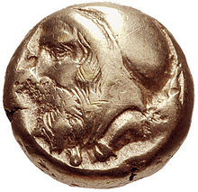

Tissaphernes

Tissaphernes, the Persian Satrap, was increasingly under the influence of Alcibiades who by this time had fallen out with the Spartans and was living in Tissaphernes’ court. Under this influence, it is likely that Tissaphernes aimed to weaken all the Greeks involved in the war and was consequently late in paying for the rowers of the Peloponnesian fleet (as the treaty had promised to do).

**Prescribed Source - Thucydides, 8.29**

Next winter when Tissaphernes had seen to the garrisoning of Iasus he went on to Miletus, and, as he had promised at Sparta, gave a month’s pay to all the ships at the rate of an Attic drachma a day for each man. He proposed paying only three obols for the future, until he had consulted the King, but would, he said, pay the full drachma if that was the King’s wish. Hermocrates, the Syracusan commander, protested against this; no stand was made about the pay by Therimenes, who was not an admiral, and was merely sailing with the fleet to hand it over to Astyochus. An agreement was reached by which an extra sum equal to five ships’ pay was to be given, in addition to the three obols a day for each man. For fifty-five ships Tissaphernes was paying thirty talents a month, and to the rest, above that number, the payment was in the same proportion.

**Prescribed Source - Thucydides, 8.87**

In the same summer Tissaphernes made ready to go to Aspendus to fetch the Phoenician fleet, and invited Lichas to accompany him. This was just at the time when, because of his general behaviour, and particularly because of the recall of Alcibiades, he was most unpopular with the Peloponnesians, who thought that he was now quite openly collaborating with the Athenians, and Tissaphernes wanted, or made it look as though he wanted, to clear himself of these suspicions. He said that he would leave behind his deputy Tamos with instructions to provide pay for the forces during his absence. Different explanations are given, and it is not easy to be sure what his intention was in going to Aspendus and then, when he got their, in not bringing back the ships. It is certain that 147 Phoenician ships came as far as Aspendus; various conjectures have been made to account for their not coming on from there. According to one view he went away in accordance with his original plan of wearing down the Peloponnesian forces; and certainly Tamos, whose job it was, paid them worse instead of better. Others say that his purpose in bringing the Phoenicians to Aspendus was to make money out of the crews, whom he never intended to employ in any case, and who would pay to be discharged. Another theory is that it was because of the attacks being made against him in Sparta, and that he wanted to have it said that he was not in the wrong, but had actually set out to fetch a fleet which really did have it full complement of men. I myself feel quite sure that his motives in not bringing up the fleet were to wear down the Hellenic forces and to keep matters in suspense; their efficiency was being impaired during all the time he took going down to Aspendus and waiting about there; and he was keeping the two sides evenly balanced, by not committing himself to either side and so giving it the advantage. Certainly his intervention, so long as there was nothing irresolute about it, could, if had really wanted it, have put an end to the war. By bringing up the fleet he would in all probability have given victory to the Spartans who already faced the Athenians with a naval force that was equal to theirs rather than inferior. Then there is a most convincing piece of evidence in the excuse he gave for not bringing the ships. What he said was that fewer ships had been collected than the King had ordered; but in that case he could surely have gained all the more credit by not spending much of the King’s money and by using smaller means to effect the same result.

However, whatever his real intentions were, Tissaphernes went to Aspendus and met the Phoenicians; and the Peloponnesians sent out at his request, supposedly to fetch the fleet, a Spartan called Philip with two triremes.

1. Explain in your own words what Thucydides own view is as to why Tissaphernes delayed in bringing ships to support Sparta and the Peloponnesians.

**The Oligarchic Coup in Athens, 411 BC**

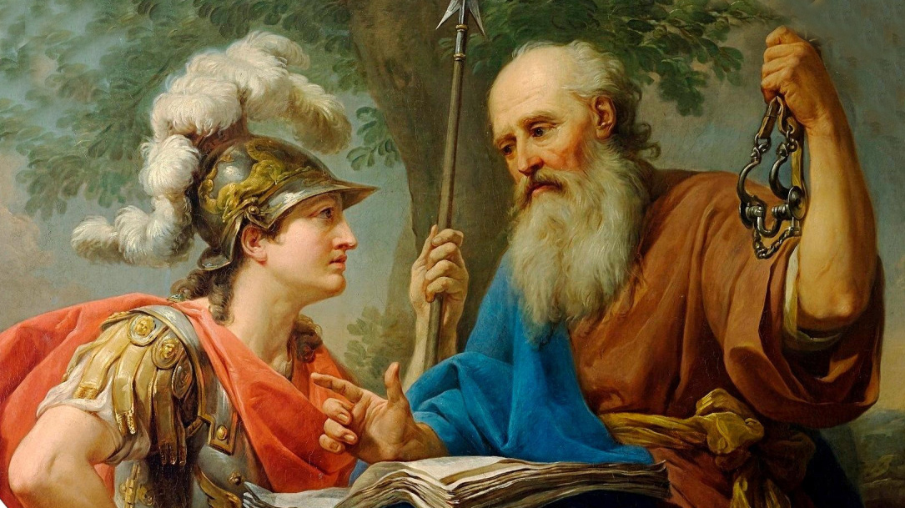

Alcibiades being taught by Socrates

#### The oligarchic coup of 411

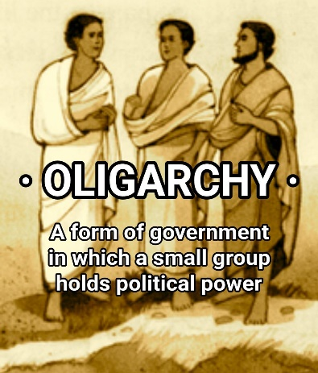The turmoil in Athenian politics and revenues resulting from the Sicilian defeat opened the way for some influential Athenian men, who had long harbored contempt for the broad-based democracy of their city-state, to stage what amounted to an oligarchic coup d'état. They insisted that a small group of elite leaders could manage Athenian policy better than the democratic assembly. **Alcibiades furthered their cause by promising to make an alliance with the Persia satraps in western Anatolia and secure funds from them for Athens if only the democracy would be overturned and an oligarchy installed.**[1](http://www.perseus.tufts.edu/hopper/text?doc=Perseus%3Atext%3A1999.04.0009%3Achapter%3D12%3Asection%3D1%3Asubsection%3D17#note1) He apparently hoped that the abolition of the democracy would led to the possibility of his being permitted to return to Athens. He had reason to want to go home again because his negotiations with the satraps had by now aroused the suspicions of the Spartan leaders, who rightly suspected that he was intriguing in his own interests rather than theirs. **He had also made Agis, one of Sparta's two kings, into a powerful enemy by seducing his wife.**[2](http://www.perseus.tufts.edu/hopper/text?doc=Perseus%3Atext%3A1999.04.0009%3Achapter%3D12%3Asection%3D1%3Asubsection%3D17#note2) Alcibiades' promises helped the oligarchical sympathizers in Athens to play on the assembly's hopes by holding out the lure of Persian gold. **In 411 they succeeded in having the assembly members turn over all power to a group of four hundred men,**[3](http://www.perseus.tufts.edu/hopper/text?doc=Perseus%3Atext%3A1999.04.0009%3Achapter%3D12%3Asection%3D1%3Asubsection%3D17" \l "note3)hoping that this smaller body would provide better guidance for foreign policy in the war and improve Athens' finances. These four hundred were supposed to choose five thousand to act as the city's ultimate governing body, but they in fact kept all power in their own hands. The oligarchic regime did not last long, however. In Athens, the oligarchs soon lost their unity in struggling with each other for dominance. In the Athenian fleet, which was currently stationed in the harbor of the island city-state of [Samos](http://www.perseus.tufts.edu/hopper/entityvote?doc=Perseus:text:1999.04.0009:chapter=12:section=1:subsection=17&auth=perseus,Samos%20City&n=1&type=place)[4](http://www.perseus.tufts.edu/hopper/text?doc=Perseus%3Atext%3A1999.04.0009%3Achapter%3D12%3Asection%3D1%3Asubsection%3D17#note4), a staunch ally of democractic Athens, the crews threatened to sail home to restore democracy by force unless the oligarchs stepped aside. In response, **a mixed democracy and oligarchy called the constitution of the Five Thousand was created,**[5](http://www.perseus.tufts.edu/hopper/text?doc=Perseus%3Atext%3A1999.04.0009%3Achapter%3D12%3Asection%3D1%3Asubsection%3D17" \l "note5) which Thucydides praised as “the best form of government that the Athenians had known, at least in my time.”**This new government voted to recall Alcibiades and others in exile**[6](http://www.perseus.tufts.edu/hopper/text?doc=Perseus%3Atext%3A1999.04.0009%3Achapter%3D12%3Asection%3D1%3Asubsection%3D17#note6) in the hope that they could improve Athenian military leadership.

**Thomas R. Martin, *An Overview of Classical Greek History from Mycenae to Alexander***

Alcibiades was recalled from the court of Tissaphernes by the pro-democracy Athenians in the navy (based at this point at Samos). Alcibiades argued against immediately moving against the Council of 400 (the oligarchs) as this would leave Samos and the Aegean unprotected. The Spartans and their allies, meanwhile decided try and cause revolt in Euboea and the city of Eretria in particular (the region of Euboea was a major supplier of food to Athens and many Athenian farmers had moved their flocks here at the start of the war).

Athens short on ships and sailors was forced to raise a new fleet of inexperienced rowers to try to intercept the attack. Unsurprisingly the Athenians lost but worse still, when the Athenians retreated to the city of Eretria, thinking that it was friendly, they were attacked and murdered.

This defeat sent shockwaves through Athens and the Council of 400 was removed and replaced by a more moderate council of 5,000. This was still an oligarchy but was also a compromise with the democrats as all those capable of fighting were meant to be on the Council.

**TASK:**

Produce a 1 side profile of **Alcibiades.** This should include any basic biographical information you can find e.g. dates he was alive, upbringing etc., and information on his conduct during the Peloponnesian War. In particular try to explain when and when Alcibiades switched sides from Athens to Sparta to Persia and back to Athens.

**THE FINAL STAGES OF THE IONIAN WAR**

In 411/10 the Spartans lost patience with the Persian Satrap Tissaphernes and his delays in providing money and a fleet. They instead took up the invitation of the other local satrap **Pharnabazus** (satrap of the Hellespont) and moved their fleet to the north of the Aegean.

***Recap:***

*Can you remember why the Hellespont and the North of the Aegean was such a vital area for Athens?*

A number of naval battles occurred resulting in Athenian victories at **Cynossema** and **Abydos** **in** 411 BC. In 410 this was followed up by a much more significant Athenian victory at **Cyzicus** in which as many as 60 Spartan ships and up to 10,000 men, including their commander **Mindarus** were lost. The Athenian forces were commanded by three individuals: **Alcibiades, Thrasybulus** and **Theramenes**.

These victories restored Athenian confidence and in 410 the Council of 400 was removed and replaced by the Council of 5,000. The writer Diodorus even suggests that at this point the Spartans asked for peace only for the Athenians to refuse.

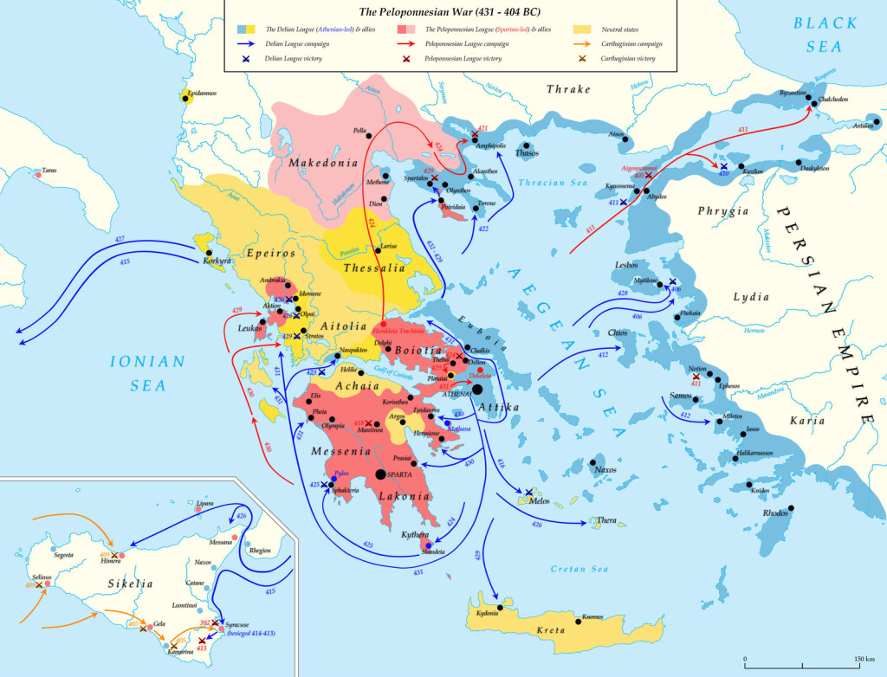***Task:* Locate and label the battles listed above on the map below.**

**Primary Source – Author**

**Xenophon**

* Wrote *A History of My Times* (also known as *Hellenica*)
* Born c. 430 BC
* Died 354 BC
* An Athenian Citizen
* The *Hellenica* picked up the final years of the Peloponnesian War from when Thucydides’ account stopped in 411 BC
* Lacks the same depth of detail and analysis in his writing as Thucydides
* Diodorus Siculus also covers this period but viewed as less reliable
* Later discovery of contemporary fragments known as the ‘Oxyrchynchus Historian’ were believed to be the basis of Ephorus’ work who was in turn the basis of Diodorus. This has led some to argue Diodorus is in fact reliable

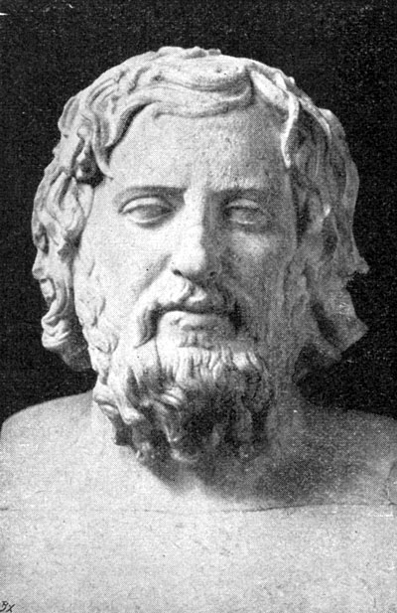

Following the Athenian victories in 411/410 there was a three-year pause in the fighting as the Persians paid for the building of a Peloponnesian fleet. In 407 King Darius II officially announced that Persia would now support Sparta and there was possibly a new treaty between Sparta and Persia known as the **Treaty of Boeotia** (although the existence of this is debated).

**Prescribed Source - Xenophon, 1.4. 1-7**

The news of what had happened at Byzantium reached Pharnabazus and the ambassadors while they were spending the winter at Gordium in Phrygia. At the beginning of the spring they were on their way again to the king, but met with another party on its way back. These were the Spartan ambassadors, Boeotius and those with him, and the other messengers. Their report was that the Spartans had got everything they wanted from the King; also that Cyrus had been appointed to take command of the whole coastline and to help the Spartans in the war. Cyrus had a letter with him, bearing the King’s seal and addressed to all the inhabitants of the coastal areas. Among other things it contained the following words: ‘I am sending Cyrus down to the coast at *caranus* [a word which means “lord”] of those whose mobilization centre is Castolus.’

After the Athenian ambassadors had heard this news and had seen Cyrus himself, they wanted in the first place, and if it were possible to return home. Cyrus, however, did not want the Athenians at home to know what was going on and he told Pharnabazus either to leave the ambassadors in his charge, or at any rate not to let them go home yet. So Pharnabazus in order to avoid trouble with Cyrus, kept the ambassadors with time for the time being. Sometimes he pretended that he was just on the point of taking them to see the King and at other times that he was just getting ready to escort them home, adding ‘so you won’t have to blame me’. So three years went by. In the end Pharnabazus asked Cyrus to release them, saying that he had sworn an oath that he would take them back to the coast if could not take them to the King. So the ambassadors were sent to Ariobarzanes, who was instructed to escort them. Ariobarzanes conducted them to Cius, in Mysia, and then sailed from there to rejoin the Athenian army.

1. Who did Darius II give command of the Persian forces and mission to?
2. Why were the Persians keen not to allow the Athenian ambassadors to go home?

Darius’ decision to give the Spartan’s full support, along with the appointment of **Lysander** as the commander of Spartan forces were both turning points in the Ionian War. Lysander was a dynamic commander who now started to receive proper amounts of Persian money to pay for his ships’ crews.

**Prescribed Source - Xenophon, 1.5. 1-3**

Not long before this the Spartans had sent out Lysander as admiral to replace Cratesippidas, whose term of office had expired. Lysander went to Rhodes, where he took over the ships stationed there and then sailed to Cos, Miletus and Ephesus, where he remained with seventy ships until Cyrus arrived at Sardis. He then went inland to visit Cyrus and took with him the ambassadors from Sparta. They lost no time in telling Cyrus how badly in their opinion, Tissaphernes had behaved and they begged him to take a really serious and energetic part in the war. ‘That,’ said Cyrus ‘is exactly what my father has asked me to do and that is what I mean to do myself. I shall do all that I can.’ He told them that he had brought 500 talents with him. If that was not enough, he said that he would use his own money, which had been given him by his father, and if that also ran out, he would break up the throne of silver and gold on which he sat.

1. How well do you think this first meeting between Lysander and Cyrus went?

In Athens, meanwhile, Alcibiades had returned to the city and was given command of Athenian forces. He delegated command to **Antiochus** with orders not to engage the Peloponnesian fleet. Antiochus disobeyed these orders attacking Lysander at the **Battle of Notion** in 406 BC where the Athenians were defeated, 15 ships lost and Antiochus killed. Following the battle, the Athenian Assembly banished Alcibiades (again) and deprived the city of one of its most capable commanders when they were most needed.

In 406 Lysander was replaced as commander (they were only appointed for 1 year) by **Callicratidas** who was much less enthusiastic about an alliance with Persia and preferred a negotiated deal with Athens.

**Prescribed Source - Xenophon, 1.6. 6-11**

No one ventured to suggest any other course of action except that he should obey the authorities at home and carry on the work for which he had been appointed. He then went to Cyrus and asked him for the pay of the sailors, but Cyrus told him to wait two days. Callicratidas was furious at being put off and at having to keep behaving like a courtier. It was a sad day for the Greeks, he said, when they had to make up to foreigners for the sake of money, and he declared that if he got home safely he would do his best to make peace between Athens and Sparta. He then sailed away to Miletus and from there sent triremes to Sparta to ask for money. Next he called an assembly of the people of Miletus and addressed them as follows: ‘What I have to do, men of Miletus, is to obey my home government. As for you, I think that you ought to show the greatest possible willingness to help in this war, since you live surrounded by foreigners and you have suffered a great deal from them in the past. It is up to you to give a lead to the other allies and show them how we can do the most damage to the enemy in the shortest time, until my messengers return from Sparta. I sent them there to get money, since Lysander, before going away, gave back to Cyrus all the money he had as though we had enough already. I went to Cyrus, but he kept on avoiding an interview with me and I could not bring myself to hang around his court. But I promise you that I shall show a fitting gratitude in return for all successes that we win during the time that we are waiting for the money from Sparta. Let us then, with the help of heaven, show the foreigners that, even without paying excessive attention to them, we can still make our enemies suffer for what they have done.’

1. How well do you think this first meeting between Callicratidas and Cyrus went?
2. What was Callicratidas’ attitude towards working with the Persians?
3. What, according to Xenophon did he urge the people of Miletus to do and why?

Callicratidas focused his fleet around Mytilene where he hoped to trap the Athenian commander **Conon**. The Athenians however sent a new fleet which fought the Peloponnesians at **Arginusae** in **406** winning a huge victory: 77 Peloponnesian ships were destroyed for the loss of 25 Athenian, and Callicratidas was killed.

The Battle of Arginusae should have been an Athenian triumph but this was undermined by the actions of the assembly back home. After the battle the Athenians did not recover all of the bodies of the dead soldiers from the water which caused outrage back home. Six out of the eight Athenian commanders were sentenced to death as a result. At this point the Spartans may have again asked for a peace treaty with Athens but this was again refused under the influenced of **Cleophon** who whipped up Athenian nationalistic feeling.

In 405 BC a conference of the Asiatic Greeks demanded the return of Lysander as commander of the Peloponnesian forces who was reinstated as vice-admiral but effectively was in charge

**Prescribed Source - Xenophon, 2.1. 7-14**

So the ambassadors were sent and were accompanied by messengers from Cyrus who supported their request. The Spartans sent Lysander out with the office of vice-admiral with Aracus as admiral. This was because they have a law forbidding the same man to be admiral twice. However, the ships were in fact under the command of Lysander.

The war had now lasted twenty-five years. It was in this year, too, that Cyrus put to death Autoboesaces and Mitraeus the sons of Darius’ sister (daughter of Xerxes, the father of Darius). He did this because when they met him they failed to push their hands through the *core* – a gesture that is made only in the presence of the king. (The *core* is a kind of sleeve, longer than the *cheiris*, and anyone with their hand inside it would be incapable of doing anything.) Hieramenes and his wife then told Darius that it would be a disgrace if he were to overlook such an act of violence and of arrogance, and Darius sent messengers to summon Cyrus, pretending that he was ill.

What development here threatened the Spartan war effort?

Next year was the year in which Archytas was ephor and Alexias was archon at Athens. Lysander arrived at Ephesus and instructed Eteonicus to meet him there with the fleet from Chios. He himself got together all of the ships that he could lay his hands on anywhere, and started refitting them and building others at Antandrus. He also went to see Cyrus and asked him for money. Cyrus pointed out that all the money supplied by the King had been already spent, and indeed a great deal more besides, and he gave him an account of the sums which each of the admirals had received. However, he did give him money and Lysander, when he got it, appointed captains for each trireme and paid the sailors all the pay that was due to them. Meanwhile the Athenian generals at Samos were also getting their fleet ready for action.

Cyrus now sent for Lysander. The messenger had arrived from his father saying that he was ill and wanted to see him. At this time Cyrus was in Thamneria, in Media, near the territory of the Cadusians, who had revolted and against whom he had been marching. When Lysander arrived, Cyrus advised him not to fight any action with the Athenians unless he found himself with great numerical superiority. He pointed out that both the King and he himself had plenty of money, so that, so far as that was concerned, it would be possible to man a great many ships, He then allotted to Lysander all the tribute from the cities to which he personally was entitled and also gave him all the surplus which he had by him. After reminding him of the friendly feelings he entertained both for Sparta and for Lysander himself, he set out on the journey inland to his father.

In your own words explain what Cyrus did before going back to his father.

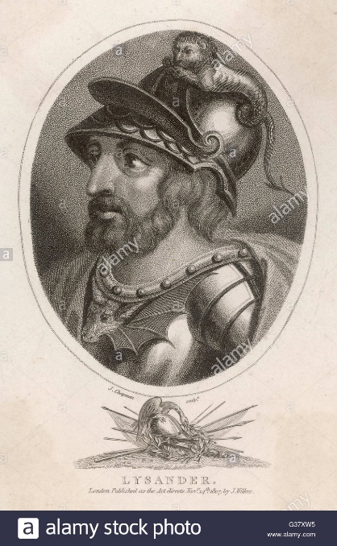Lysander again focused his campaign against Athens around the Hellespont realising that this was the vital connection to the city’s food supplies. The Peloponnesian forces took up position on one side of the Hellespont and the Athenians on the other (where many of their crews got off their ships and foraged for supplies).

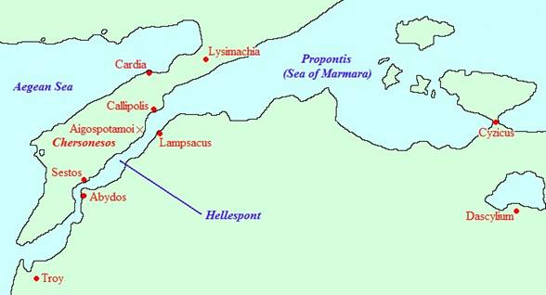After a four-day stand-off, Lysander attacked the Athenians at **Aegospotami**. 170 Athenian ships were taken and the Athenian sailors were executed.

**Prescribed Source - Xenophon, 2.1. 20-32**

The Athenians had been sailing close behind and with their fleet of 180 ships, came to anchor at Elaeus in the Chersonese. It was here, while they were having their morning meal, that they received the news about Lampsacus. They set out at once for Sestus where they took provisions aboard and then went straight on to Aegospotami, which is opposite Lampsacus. The Hellespont here is about two miles wide. It was here that the Athenians had their evening meal.

The night passed and at dawn Lysander ordered his men to have breakfast and embark. He had the side-screens put up on the ships and made all preparations for battle, but gave orders that no one should leave his position or put out into the open sea.

As soon as the sun rose the Athenians came up with their fleet in line of battle to the mouth of the harbour. However, Lysander did not put to sea against them, so, when it was late in the day, they sailed back again to Aegospotami. Lysander then instructed some of his fastest ships to follow the Athenians and, when they had disembarked, to observe what they were doing and then to report back to him. He did not allow his own men to go ashore until these ships had returned.

Both he and the Athenians did the same thing for four days. All of this time Alcibiades was in his castle and he could see from there that the Athenians were moored on an open shore with no city behind them and that they were getting their supplies from Sestus, which was about two miles away from the ships, while the enemy, inside a harbour and with a city at their backs, had everything they wanted. He therefore told the Athenians that they were in a very poor position and advised them to shift their anchorage to Sestus, where they would have the advantage of a harbour and a city. ‘Once you are there,’ he said, ‘you can fight whenever you please.’

The generals, however – particularly Tydeus and Menander – told him to go away. ‘We are in command now’, they said, ‘not you.’ So Alcibiades went away.

On the fifth day as the Athenians sailed up, Lysander gave special instructions to the ships that they were to follow them. As soon as they saw that the Athenians had disembarked and had scattered in various directions over the Chersonese – as they were now doing more freely every day, as they had to go a long way to get their food and were now actually contemptuous of Lysander for not coming out to fight – they were to sail back and signal with a shield when they were half-way across the straits. These orders were carried out, and as soon as he got the signal, Lysander ordered the fleet to sail at full speed. Thorax and his men went with the fleet.

When Conon saw that the enemy were attacking, he signalled to the Athenians to hurry back as fast as they could come to their ships. But they were scattered in all directions; some of the ships had only two banks of oars manned, some only one, and some were not manned at all. Conon himself in his own ship with seven others and also the state trireme *Paralus* did get to sea fully manned and in close order. All the rest were captured by Lysander on land. He also rounded up nearly all the crews, though a few managed to escape into various fortified places in the neighbourhood.

Conon, escaping with his nine ships, could see that for the Athenians all was over. He put in at Abarnis, the headland off Lampsacus, and there seized the cruising masts of Lysander’s fleet. Then, with eight ships, he sailed away to King Evagoras in Cyprus. The *Paralus* sailed to Athens to report what happened.

Lysander brought the ships, the prisoners and all his other prizes to Lampsacus. Among the prisoners were Philocles, Adimantus and others of the generals. And on the very day of the victory he sent Theopompus, the Milesian pirate, to Sparta to report what had happened. Theopompus arrived with the news in three days.

1. How significant does Lysander’s leadership appear to be (according to Xenophon) in achieving Spartan victory at Aegospotami?

**THE End of the War and its Aftermath**

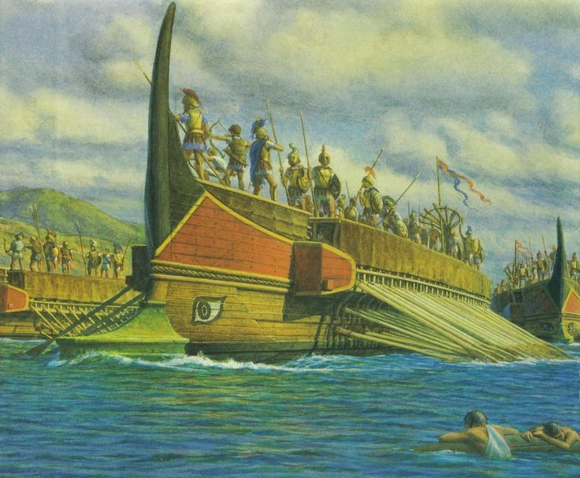With the defeat at Aegospotami any hope Athens had of continuing the war disappeared. Lysander and the Peloponnesians could now cut off Athens’ food supplies whilst Athens had lost almost all of its navy.

In 404 BC Athens was starved into submission and surrendered. The Long Walls connecting the city to Piraeus were torn down and Athens was forced to join the Peloponnesian League. Some of Sparta’s allies called for the execution of every Athenian man and the enslavement of the women and children.

Instead, the Spartans (and Lysander in particular) imposed an oligarchic system of government on the city and on the former parts of Athens’ empire. The governing body of Athens, known as the ‘Thirty’ would commit many murders on those who had supported the war and also confiscate property. Eventually, however, a democratic government would be restored by 403 BC but it ruled over a city which was a shadow of its former self.

**Key BAttles of the Peloponnesian War, 431-404 BC**

|  |  |  |  |
| --- | --- | --- | --- |
| ***Battle*** | ***Date*** | ***DETAILS*** | ***HOW DECISIVE (MARK OUT OF 10)*** |
| **Naupactus** |  |  |  |
| **Pylos and Sphacteria** |  |  |  |
| **Delium** |  |  |  |
| **Amphipolis** |  |  |  |
| **Mantinea** |  |  |  |
| **Syracuse** |  |  |  |
| **Cynossema** |  |  |  |
| **Cyzicus** |  |  |  |
| **Notion** |  |  |  |
| **Arginusae** |  |  |  |
| **Aegospotami** |  |  |  |

**Key debate: Why did Athens lose the Peloponnesian War?**

**TASK: Place the following reasons for Athenian defeat in order of importance on the next page. For each explain how significant it was and justify its position.**

**Reasons for Athenian Defeat:**

1. **Athens did not keep to Pericles’ strategy in the Archidamian War**
2. **Up to 30% of the population was lost during the plague**
3. **The defeat in Sicily**
4. **Rebellions from within the Athenian empire during the war**
5. **The Spartan decision to engage in naval warfare**
6. **Dynamic and effective leadership in Sparta**
7. **Persian financial support to the Peloponnesians**
8. **The Peloponnesian occupation of Decelea**
9. **Poor Athenian leadership**

**Can you think of any additional reasons why Athens lost the Peloponnesian War? List and explain these here.**

**Key debate: Why did Athens lose the Peloponnesian War?**

**Map of Ancient Greece**

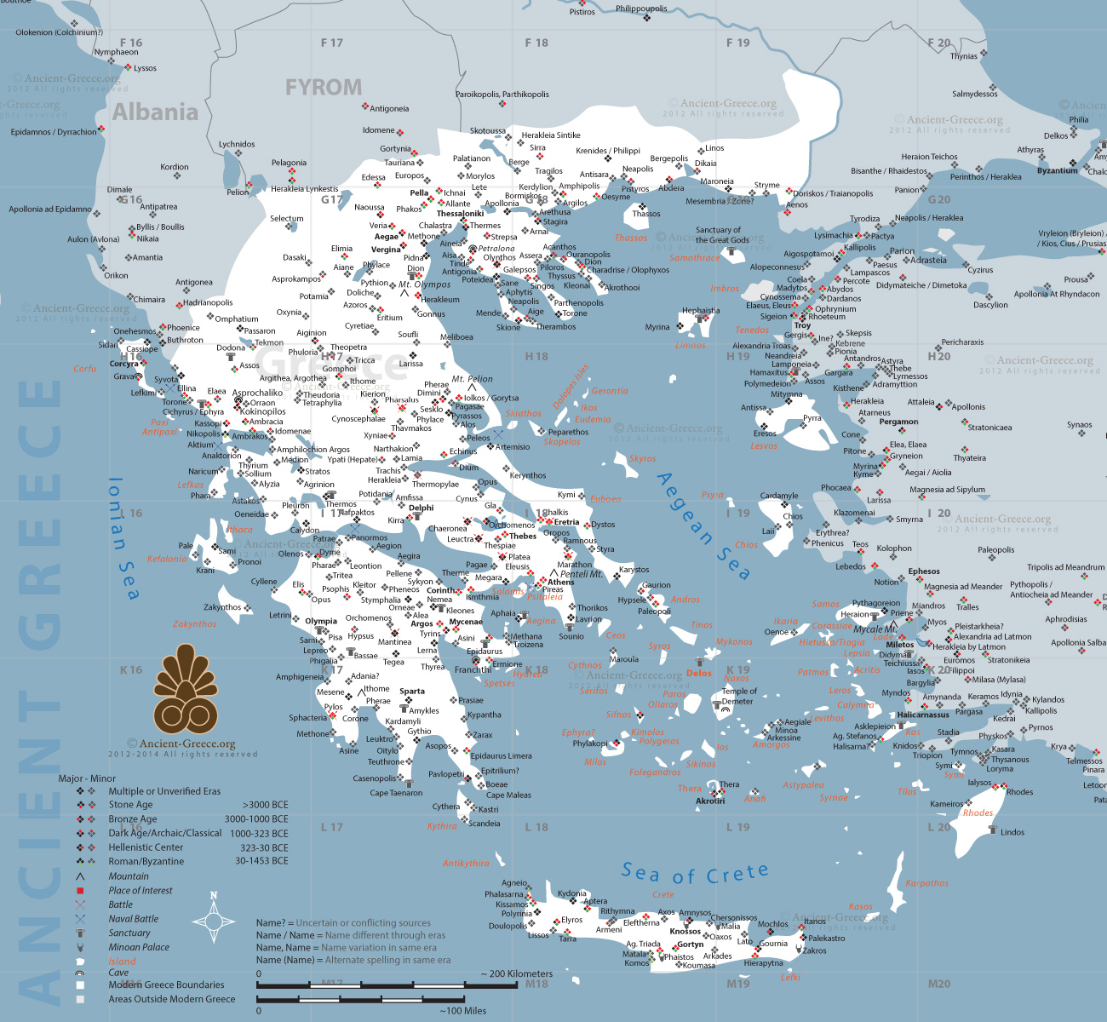

**KEY TERMS**

|  |  |
| --- | --- |
| **Term** | **Description** |
| **The Ionian War** |  |
| **Epiteichismos** |  |
| **Peace of Epilycus** |  |
| **Oligarchy** |  |
| **Council of 400** |  |
| **Council of 5,000** |  |
|  |  |

**KEY FIGURES**

|  |  |
| --- | --- |
| **nAME** | **Description** |
| **King Agis** |  |
| **Tissaphernes** |  |
| **Pharnabazus** |  |
| **Darius II** |  |
| **Alcibiades** |  |
| **Lysander** |  |
| **Mindarus** |  |
| **Thrasybulus** |  |
| **Theramenes** |  |
| **Callicratidas** |  |
| **Cyrus** |  |
| **Conon** |  |
| **Gylippus** |  |

|  |  |  |  |
| --- | --- | --- | --- |
| ***Date set*** | ***Details*** | ***Date Due*** | ***Done?*** |
|  |  |  |  |
|  |  |  |  |
|  |  |  |  |
|  |  |  |  |
|  |  |  |  |
|  |  |  |  |
|  |  |  |  |
|  |  |  |  |
|  |  |  |  |
|  |  |  |  |



HOMEWORK RECORD