Topic 5: The End of the Peloponnesian War and its Aftermath, 419-404 BC

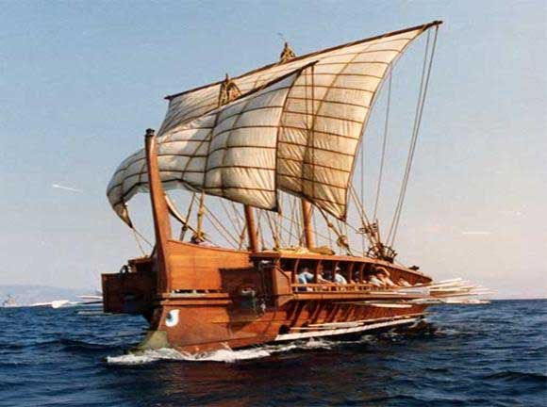**The Sicilian Expedition 415-413**

**Source 6.15**

*What do you learn from this source about who Alcibiades was?*

*How does Thucydides portray Alcibiades in this source?*

**Source 6.12-13**

*Who is delivering this speech?*

*Why does he argue against the war?*

*Who does he attack in this source and why?*

**Source 6.8**

*What did the Athenian Assembly vote to do?*

*Who did they appoint as the three commanders?*

*What did Nicias believe about the expedition?*

**Source 6.89-91**

*In this speech Alcibiades is addressing the Spartans, what is his view on democracy?*

*What according to Alcibiades was the aim of the Sicilian expedition?*

*How does Alcibiades try to motivate the Spartans to send forces to support the Syracusan forces?*

*How convincing do you find Alcibiades’ views in this source?*

**Source 6.82-83**

*How do the Athenians justify their presence in Sicily in this source? (They are trying to gain the support of the Sicilian city Camarina)*

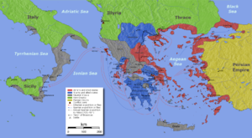

**Source 6.24**

*Can you work out from the opening sentence what Nicias had proposed and why?*

*How did Nicias’ plan backfire?*

**Source 6.31**

*How many hoplites and how many ships did the Athenian expedition have?*

*How was the Athenian force that left different from previous large forces?*

*What appeared to be the mood in Athens as the Sicilian expedition set sail?*