Deadline: page for detailed explanation).om Milford station. ephen Smith HW.**GRAPHIC DESIGN | Hand Lettering | Alphabet & Notes**

**Aim:** To improve hand lettering and drawing typography skills to provide a new perspective on design principles, along with a new mechanism for playing with design.

**Deadline:** WEEK 13 homework set on 13/12/17. Due lesson WEDNESDAY 3/1/18

**Task:** Hand lettering alphabet (3hr); post it notes (2hr).

Nowadays, people try to be discernible and unique among thousands similar ones. Business owners strive at the uniqueness of their brand and often demand something special from designers. The majority of original things are made by hands. Custom hand lettering took its place among other design techniques a long time ago and it never gets old. All the advanced digital tools still couldn’t replace it and even more, they only supplemented it with new opportunities. This [article](https://tubikstudio.com/get-original-benefits-of-handcrafted-lettering-in-design/) reveals the essence of lettering and shows its role in the design industry.

## What is lettering?

The essence of the term “lettering” is already hidden within its name. To be specific, lettering is the art of letter drawing when a word or phrase is presented as an artwork. Each letter is drawn in an original way and together they form a unique composition. Lettering masters usually work by hands using various pencils, brushes, ink, or chalk. Some may prefer applying graphic tablets and stylus but it can be more challenging because it requires advanced skills in special programs like Adobe Illustrator. A distinctive characteristic of hand lettering is that an artwork can be carefully developed as well as absolutely **spontaneous**.

Read

<https://tubikstudio.com/get-original-benefits-of-handcrafted-lettering-in-design/>

<https://issuu.com/beatricecho/docs/update_1>

<https://www.thundertech.com/blog/August-2017/The-Art-of-Hand-Lettering>

For this homework, we will be looking at the work of…

Timothy Goodman <https://www.instagram.com/timothygoodman/>

Nate Williams <https://www.instagram.com/n8w/>

Andy Leek <https://www.instagram.com/notestostrangers/?hl=en>

Task A (3hr task)

*Fill 2x A4 pages with varied, interesting and decorative hand lettering of the alphabet (black and white / monochrome). You are to draw each letter from the alphabet 5 times (e.g. AAAAA BBBBB CCCCC etc.)*, use a range of pens (fine liner, sharpie, brush pen, marker etc.), pencils (black colouring pencil, 3B/4B/6B etc.), inks (black indian/quink) and paints (black acrylic). My approach (see example): I have drawn on 4x A5 size cream coloured paper; trimmed pages and then mounted into sketchbook. I recommend drawing on cartridge or paper.

For reference – [Nate Williams](https://www.instagram.com/n8w/) is a designer who specialises in [Illustration](http://www.n8w.com/) and [Hand Lettering](http://www.n8w.com/hand-drawn-lettering/) for books, magazines, packaging, advertising etc. – Nate’s website features a [hand letter generator](http://www.n8w.com/hand-letter-generator/), which you could use as reference for your hand lettering. I have tried the hand letter generator and the range of letters is limited, therefore I recommend drawing from interesting typefaces (via Illustrator/Photoshop/Word), also look for other inspiration online e.g. [#lettering](https://www.instagram.com/explore/tags/lettering/) and [#handlettering](https://www.instagram.com/explore/tags/handlettering/).

Task B (2hr task)

*You are to communicate 12x inspiring notes/quotes/phrases (nothing rude please!), using varied, interesting and decorative hand lettering. (Present 6 to an A4 page)*

You have been provided with a selection of coloured squares/post it notes. For design, layout and composition, take inspiration from Timothy Goodman’s body of work. For words/content, take inspiration from Andy Leek’s ‘note to strangers’ work. Timothy Goodman also recently launched a collaboration with [UNIQLO](https://www.uniqlo.com/us/en/featured/timothy-goodman), which is worth a look*.* Other inspiration online e.g. [#lettering](https://www.instagram.com/explore/tags/lettering/) and [#handlettering](https://www.instagram.com/explore/tags/handlettering/).

Suggestions:

* Think about interesting notes that could inspire other designers
* Consider using a typographic system for some notes
* Try central focus
* Fill the whole frame
* Short and sweet notes
* Lengthy and long… repetition – Timothy Goodman’s work features phrases that are repeated to further emphasise what is being communicated
* The more interesting your designs are, the more interesting your work will be in the next cw/hw tasks.
* Varied decorative letters – every letter of the note be to different
* Not looking drawing of hand lettering
* Continuous line drawing of letters
* Thicken the stroke/line

Examples of homework:

Example - Task A

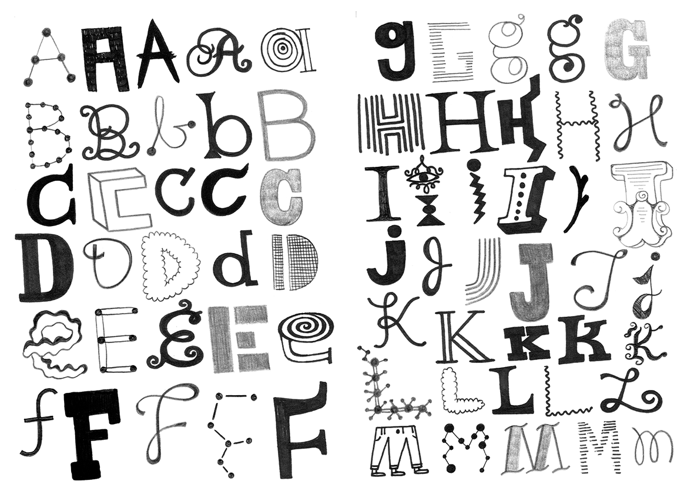­­­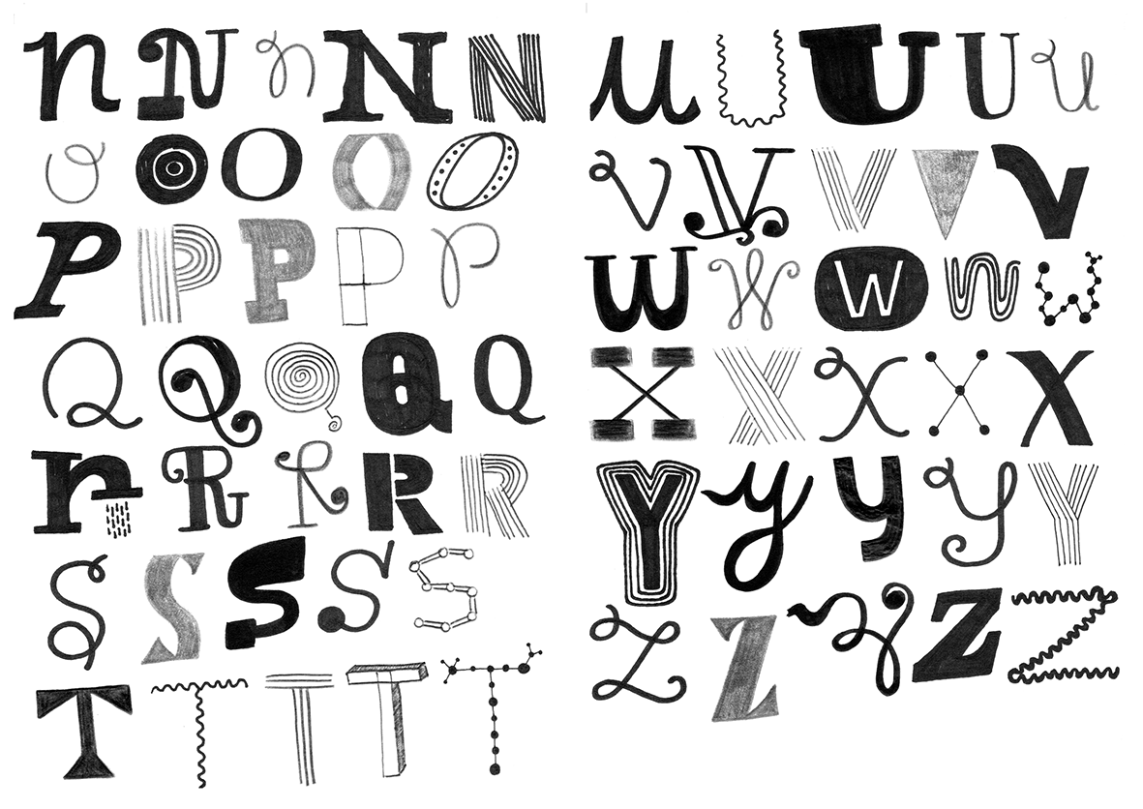

Example - Task B

