**Learning Aim C - Evaluation**

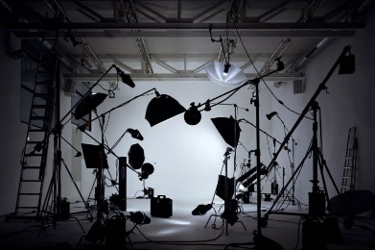To complete Unit 35 it is essential that you provide an evaluative review of the final product. This is not a review of the process – you have already completed this in your detailed diary entries – but an honest summative evaluation of the final piece of work. In **red** below are the specification requirements, followed by some questions in italics, designed to help you explore each area. Aim to produce approx. 1,500 words.

o **fitness for purpose of final product outcome**

*Does your product conform to the codes and conventions of a live multi-camera production? Explain why? What did you do to make it conform (audio choices, set, VT inserts, casting etc.)? Does the final product match that of your original vision / intentions? If not, why not.*

o **audience response  and peer review**

*Show your final product to a range of audiences – students and teachers – and record their views. What were the strengths recognised by your audience(s)? What were the weaknesses? Where could improvements have been made?*

o **comparison with similar products**

*Compare your product with two other similar productions; analyse how your production compares to studio sets, lighting, camera, sound, VT, etc.* ***Write a good couple of chunky paragraphs to cover this and make sure you use technical terminology.***

o **own role in contributing to the product outcome**

*What did you bring to the role of floor manager / cameraperson etc. How is this displayed in the final product?*

o **own strengths, weaknesses and plan for skills and knowledge development**

*What strengths or weakness were evident in your own performance as floor manager, director etc. What skills and knowledge have you developed from the process – technical and transferable (communication, working with others etc.)?*