The Theory of Labour Supply
TASK 1: Read pages 98-101 in your online textbook and complete the following questions on this worksheet

INDIVIDUAL SUPPLY CURVE | THE MARKET SUPPLY CURVE
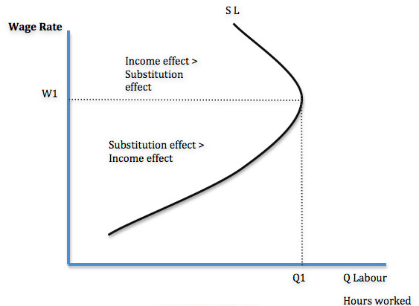 | Draw a labour market supply curve
MONETARY CONSIDERATIONS (movement along the curve): Explain why the diagram is shaped like it is using the terms ‘substitution effect’ and ‘income effect’ | MONETARY CONSIDERATIONS (movement along the supply curve): Explain what the curve that you have drawn above represents and why there might be movement along the curve?
NON-MONETARY CONSIDERATIONS (shifts in the curve): Explain why else there maybe changes to the diagram above? | NON-MONETARY CONSIDERATIONS (shifts in the curve): Explain why else there maybe changes to the diagram you have drawn above

Elasticity of Supply

Draw a relatively inelastic labour supply curve for a market | Draw a relatively elastic labour supply curve for a market | Bullet point and then explain the main determinants of the elasticity of supply of labour
Labour Supply and Trade Unions
TASK3: Using the internet, research the following questions and write brief notes:
What is a trade union?
Who are the three biggest Trade Unions in the UK today? Write a little summary of each one
Why is a trade union sometimes called a ‘monopoly of labour’?
What is ‘collective bargaining’ and how do trade unions use it?
Try and find the most recent Trade Union action in the newspapers and provide a very brief summary (who was the Union, what were they wanting, what did they do?

ASSESSMENT – How much have you understood?
TASK3: Answer the following questions on a separate sheet of paper without using any notes (if possible!) and each questions should have a diagram to explain it:–

- The demand for doctor’s increases. Explain why the wage will rise proportionally more than the increase in quantity supplied of doctors.
- Why is the labour supply curve upward sloping?
- Why might a worker reduce their supply of work when wages rise?
- Give one example as to why a teacher’s supply curve might shift?
- What would be the effect on a labour supply curve if the UK Government decided to cut benefits to the unemployed?

THE NEXT STEP – Perfectly Competitive Labour Markets
TASK 4: What would a labour supply curve look like in a ‘perfectly competitive’ labour market?

