**MICRO: The Labour Market Introduction**

**Wage Determination: The Supply and Demand for Labour**

**TASK:** Draw the supply and demand for labour of a footballer in the Premier League

|  |  |
| --- | --- |
|  | Explain why the demand curve is downward sloping?  Explain why the supply curve is upward sloping? |
| How is this different from the ‘markets for goods and services’ that we have studied since you started Econ? | |

**TASK:** On the diagram below, I have drawn the supply and demand curve schedules for six different professions. I would like you to allocate each equilibrium number (1-6) to the profession (A-F). You will need to use your analysis of demand and supply to explain why you have placed these numbers next to the professions. (make notes around the diagram)

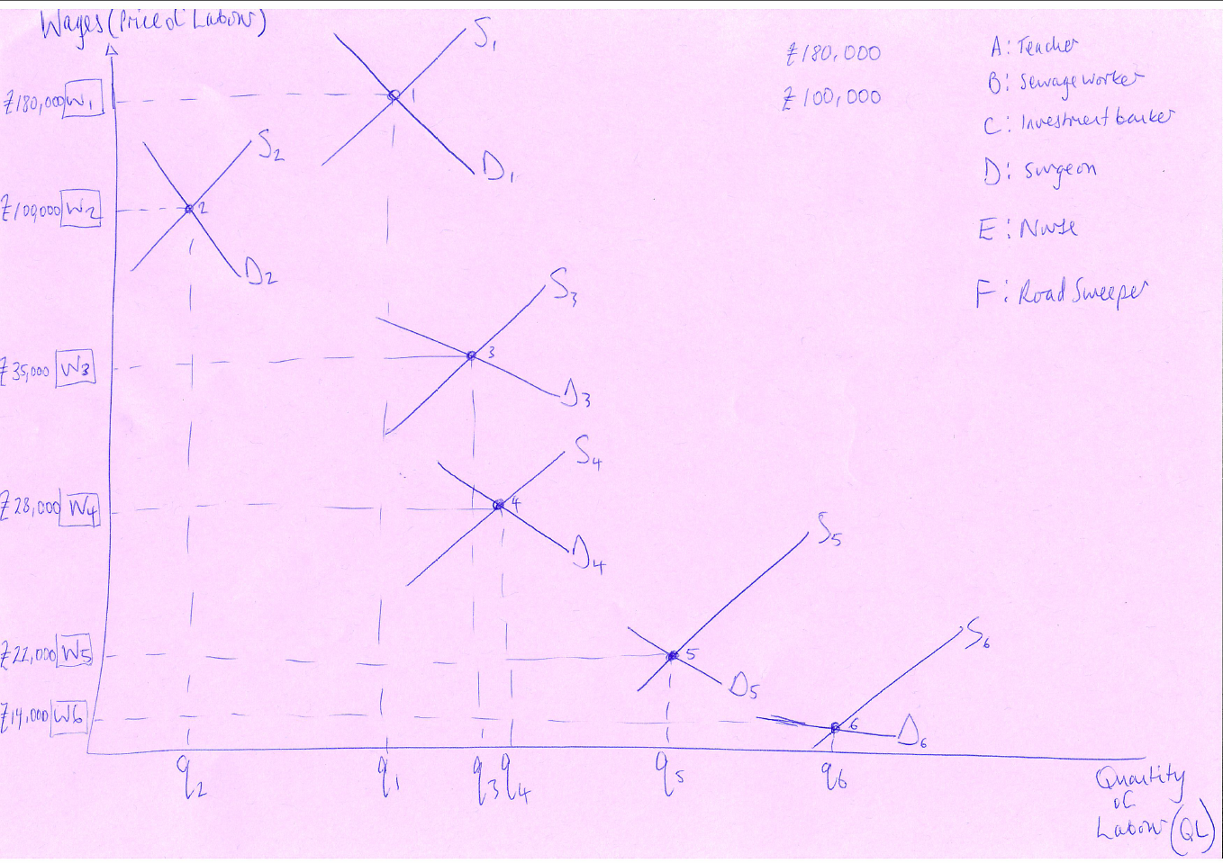

**MACRO: Introduction to Unemployment in the Labour Market**

Unemployment is defined as workers (between the ages of 16 and 64) who are out of work but are actively seeking work. If you are out of work in this age range but

TASK: Complete the following questions

|  |  |
| --- | --- |
|  | The mid-2016 population estimate which was published on the 23rd June 2017 was 65.648 million. Calculate the number of UK residents who are below the age of 16 and above the age range of 64.  Do people in this age bracket (0-16 and 64+) contribute to the UK economy in any way?  Using the graphs on the powerpoint, explain the types of people who might be considered economically inactive? |

**Equilibrium .v. Disequilibrium Unemployment**

TASK: Write notes on the following after my explanation

|  |  |  |
| --- | --- | --- |
| **DISEQUILIBRIUM UNEMPLOYMENT** |  | **‘Classical or Real Wage’ .v. ‘Keynesian or Demand Deficient’ Unemployment** |
| **EQUILIBRIUM UNEMPLOYMENT** |  | **‘Frictional and Structural Unemployment’** |