Deadline: page for detailed explanation).om Milford station. ephen Smith HW.**GRAPHIC DESIGN | Typography | Timothy Goodman**

**Aim:** To improve CAD lettering and digital typography skills to provide a new perspective on design principles, along with a new mechanism for playing with design.

**Deadline:** WEEK 14 homework set on 03/01/18. Due lesson WEDNESDAY 10/01/18

**Task:** CAD lettering in the style of Timothy Goodman.

For this homework, we will be looking at the work of Timothy Goodman. His work was introduced to you in week 13 homework.

Timothy Goodman <https://www.instagram.com/timothygoodman/> | <http://tgoodman.com>

Task A (Research Tab)

*Create a side tab using cartridge paper – research and type 250 words about Timothy Goodman + write an analysis of one of the artworks (selection of his artworks available via Godalming Online, also via his website and Instagram). Create this digitally and remember to use font size no larger than 10 pt. Attach research flap to side 1 of this homework. Include thumbnail side selection of images of Timothy’s artworks.*

Task B (Side 1 A4)

*You are to create 4x digital designs (use Adobe Illustrator) in the style of these artworks by Timothy Goodman:*

* *Love is underfeated*
* *You are loved*
* *HOW*
* *Things are what you make of them.*

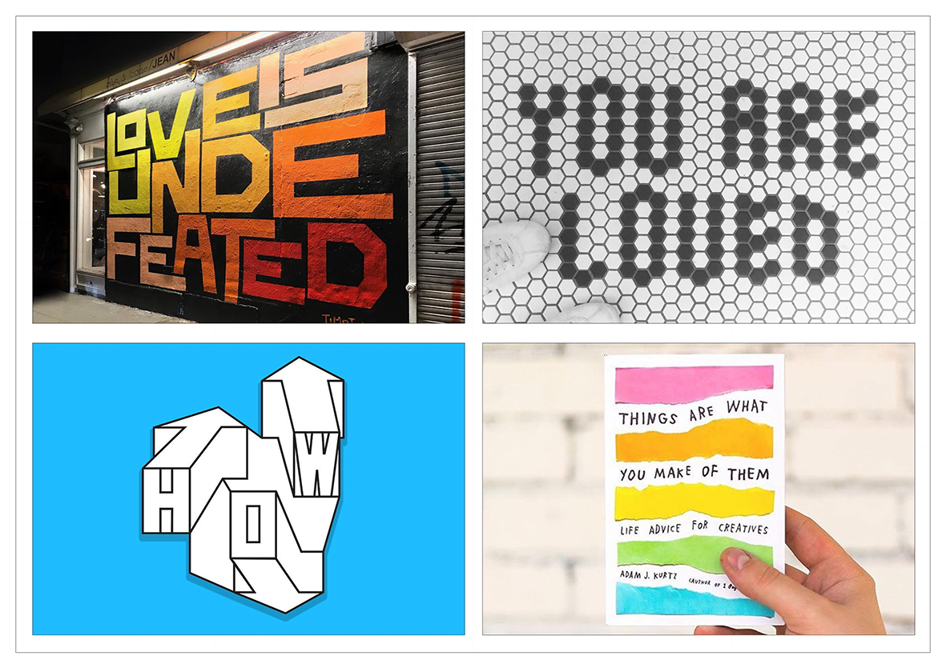

*Here is an example of 4x designs in the style of the reference images from previous page.*

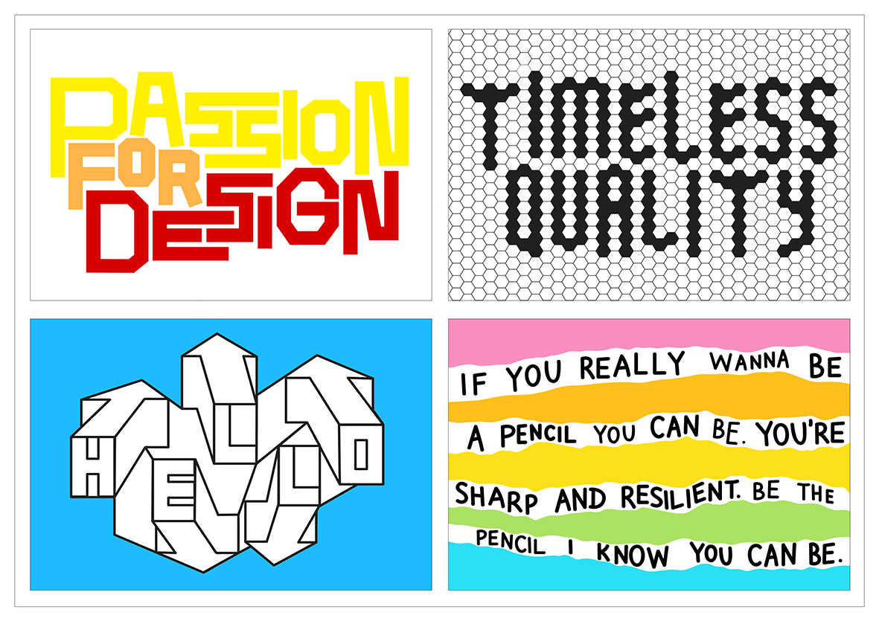

Task C (Side 2 A4)

*You are to create 1x digital map typography design (use Illustrator) in the style of this artwork by Timothy Goodman:*

[*http://tgoodman.com/work/fortune_mural*](http://tgoodman.com/work/fortune_mural)

