**PROJECT: COMPOSITION, SHAPE, MOVEMENT**

Task 1

You are to produce 9x handmade collages exploring composition using shapes, colour and text; straight cut and torn edges:

* + vertical and/or horizontal alignment
  + same shape, altered scales
  + detailed, complex layers
  + movement
  + designer's approach
  + use of geometric shapes
  + irregular shapes and random shapes
  + positive and negative
  + torn version

Materials and equipment are available in the classroom.

Example 1

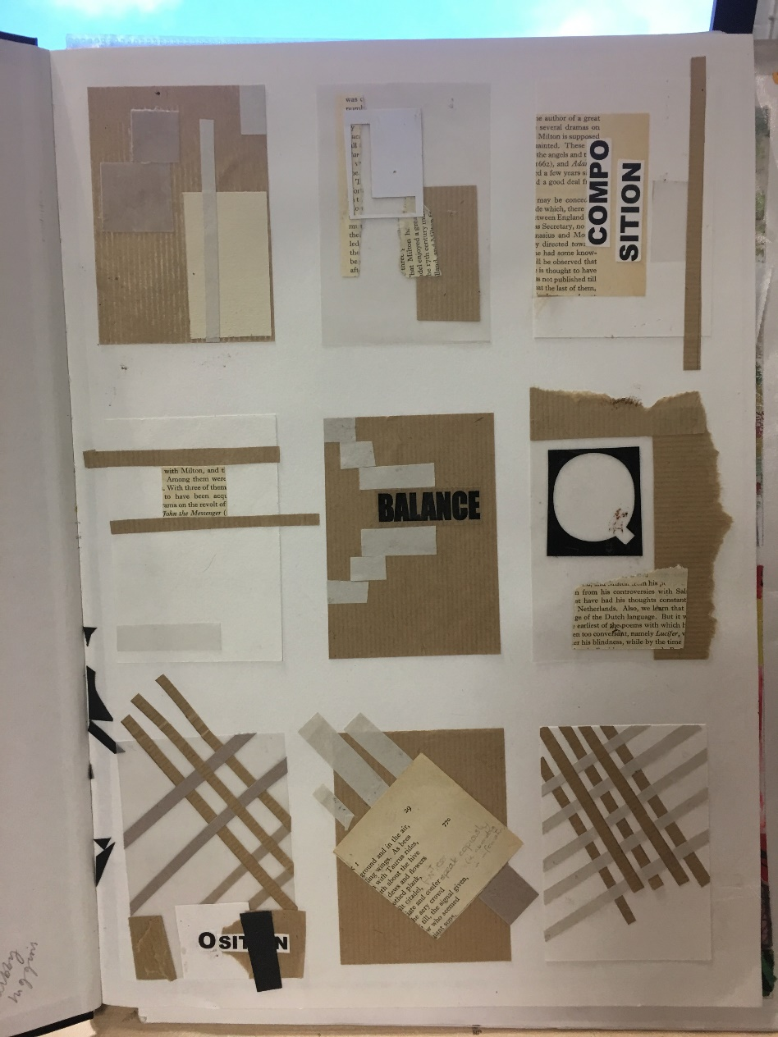

Example 2

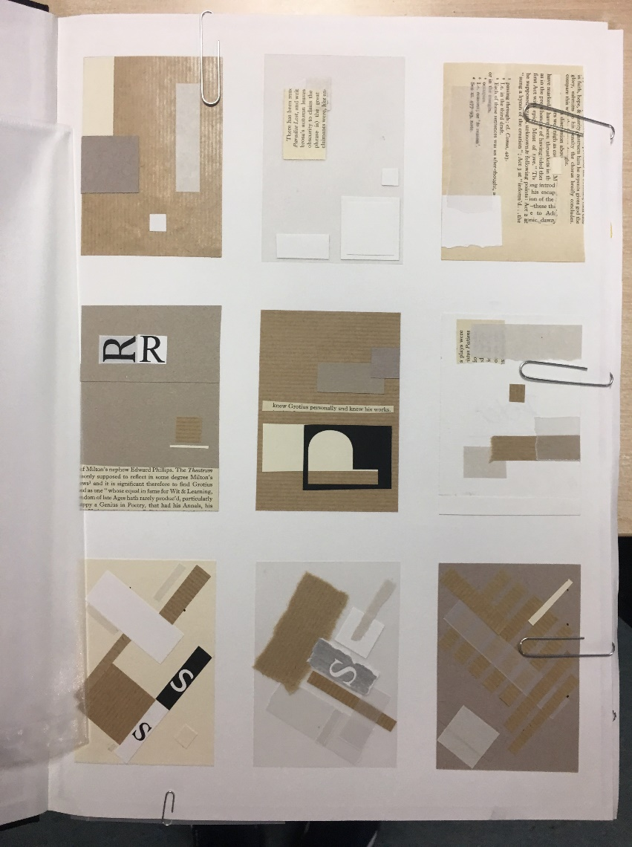

Presentation

You are to mount your 9x handmade collages using a glue stick, onto first page of your A3 sketchbook OR onto an A3 sheet of cartridge paper (ask teacher). Presentation is important so ensure the layout of your designs is neat with good spacing around the designs.

Useful information to help you with Task 1

