PROJECT: COMPOSITION, SHAPE, MOVEMENT
Task 2
Create 9x colour digital collage designs using Adobe Illustrator, continue to explore composition, alignment, movement. Use your 9x handmade pieces from task 1 as a starting point for reference. Incorporate typography. Incorporate patterns and mark making using shapes. Suggestions: repetition; symmetry, layers overlapping.
For these pieces, you are to use the style of these designers as reference. Search them on Pinterest:
  - Theo Van Doesburg
  - Josef Albers
  - Piet Mondrian
Example 1
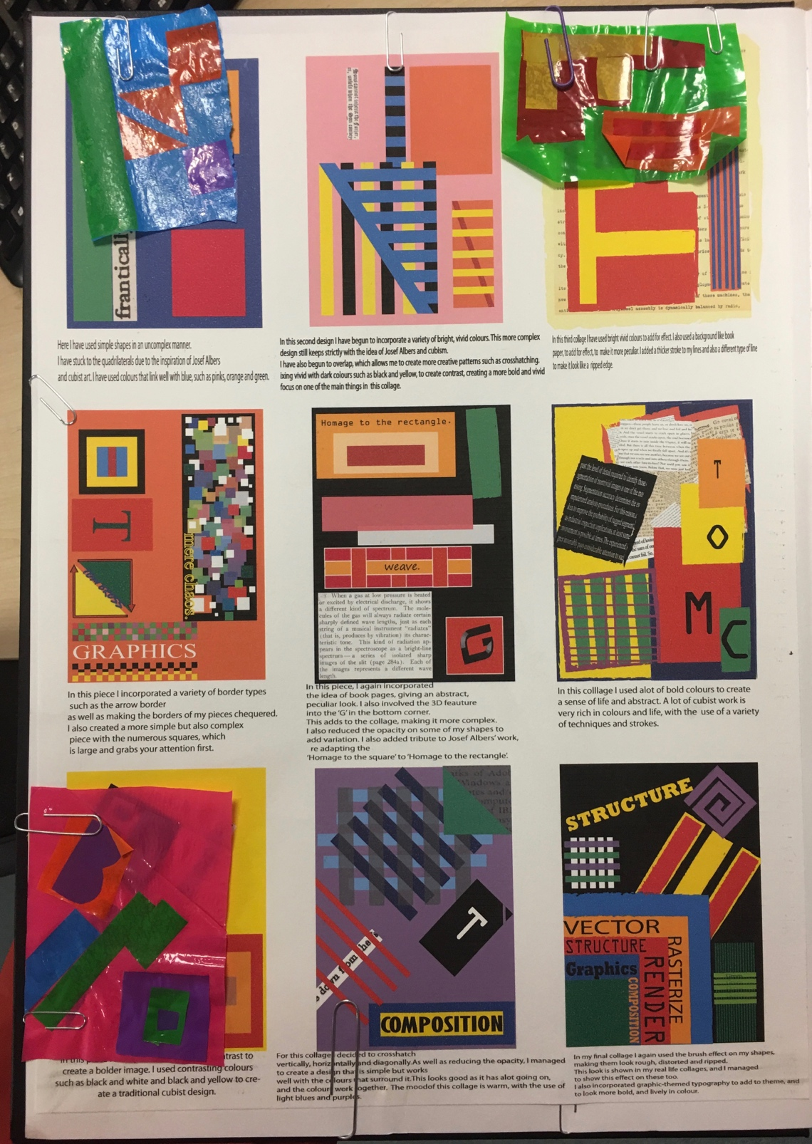
Example 2
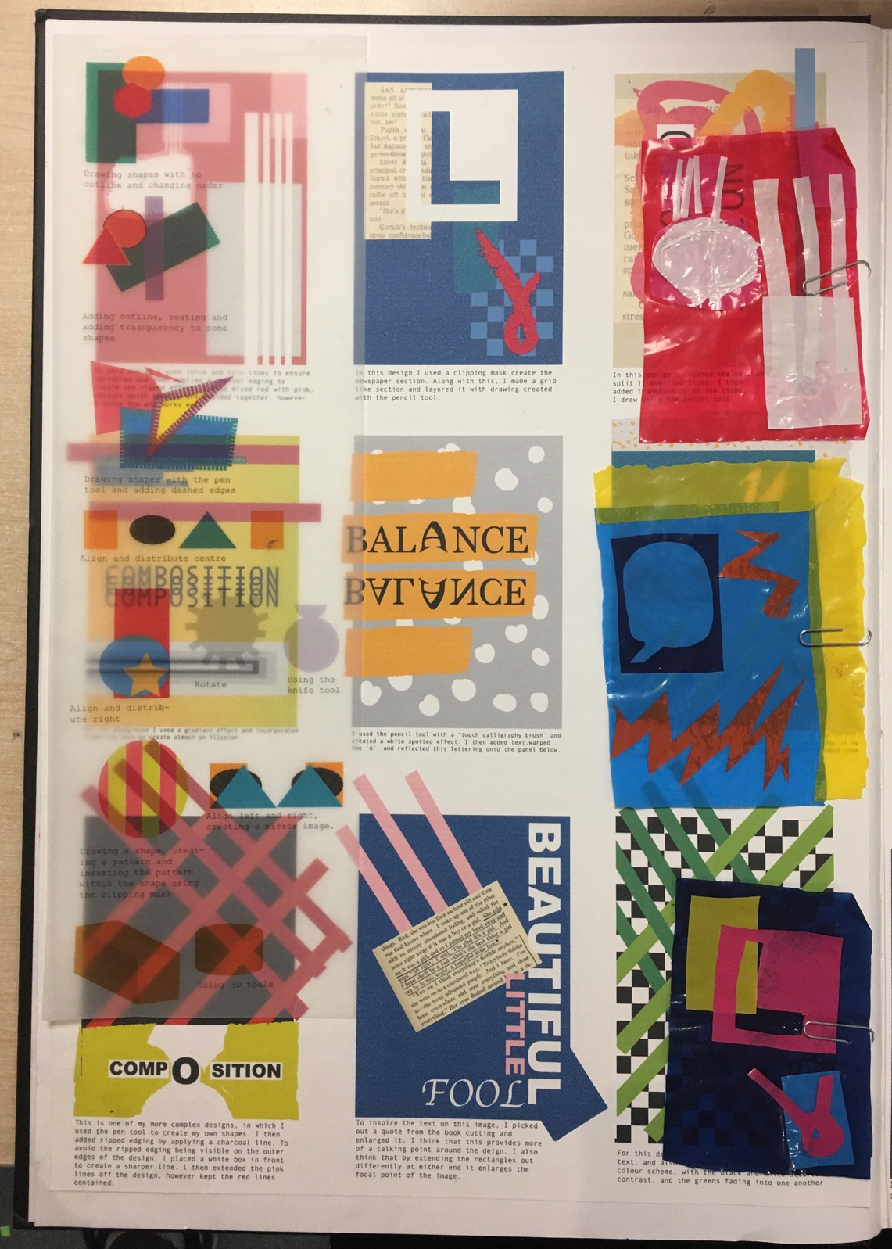

Presentation
Print and mount your 9x digital collage designs onto A3 cartridge paper. Trim edges and use glue stick to mount onto second paper of A3 sketchbook.

