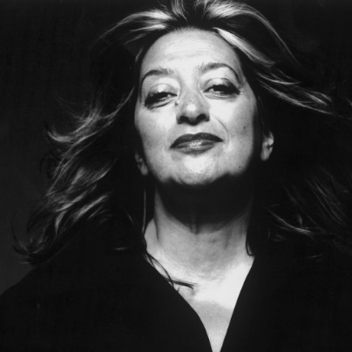

NAME: Zaha Hadid

DATES: 1950-2016

NATIONALITY: British, born Baghdad 1950

TRAINING: Studied at the Architectural Association, won Diploma Prize (1977)

WORK: Became a partner in the Office for Metropolitan Architecture (OMA) with Rem Koolhas

Opened own office 1980

AWARDS:

* 2004 First woman to win the Pritzker Prize
* 2010 Stirling Prize
* 2011 Stirling Prize
* 2012 Made a Dame by Queen Elizabeth II
* 2015 Royal Gold Medal, Royal Institute of British Architects

TWO KEY BUILDINGS:

1. MAXXI: National Museum of XXI Century Arts 1998-2009
2. 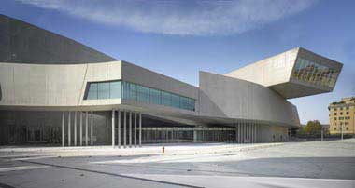London Aquatics Centre, for the Olympic Delivery Authority 2005-11

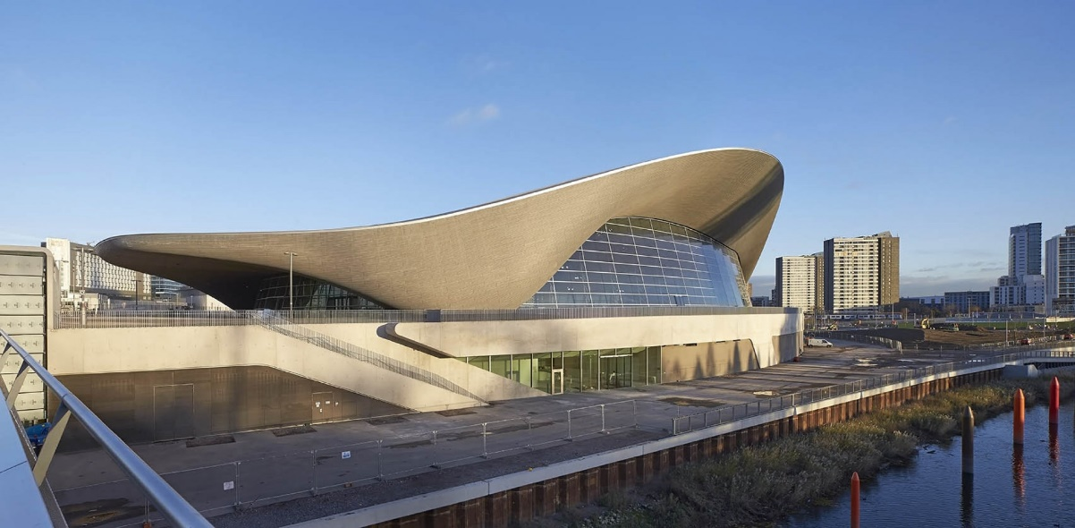

**The MAXXI The National Museum of XXI Century Arts, Rome 1998-2009**

**Key questions relevant to Identity**

1. 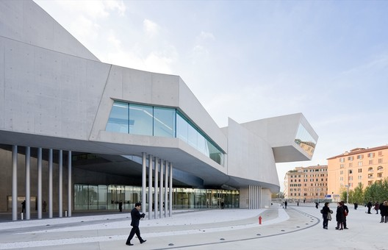How does this building respond to the past and present history of Rome?
2. How does this building reflect the identity of Zaha Hadid as an Iraqui born, British architect?
3. How does the choice and use of materials contribute to the sense of identity in this building?
4. How does this building sit in the architectural evolution of designs for art galleries and museums?
5. How does this building reflect the ideas of parametricism?

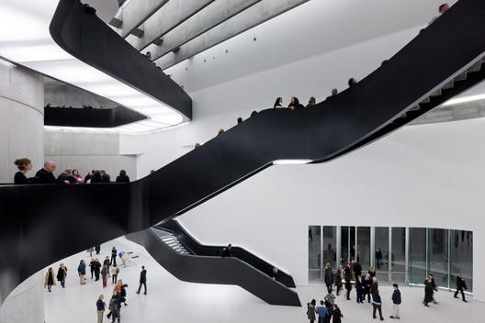She said: “A modernised site which draws on the insertion of a cultural programme. The urban context is expected to change over time and the project is seen as an agent of transformation. The internal geometric complexity in the Rome project is a condensation of the different orientations of the surrounding contexts. The project discovers urban routes, which lie dormant within the neighbouring context.

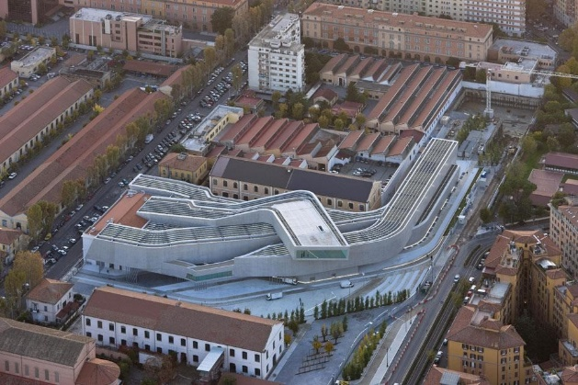**Client**: Italian Ministry of Culture. International design competition won by Hadid in 1999, although only one of her original 5 structures has been built.

**Location:** **Flaminio quarter of Rome, in the area of the former Montello military barracks.**

**Materials:** The building is a composition of bending oblong tubes, overlapping, intersecting and piling over each other, resembling a piece of massive transport infrastructure.

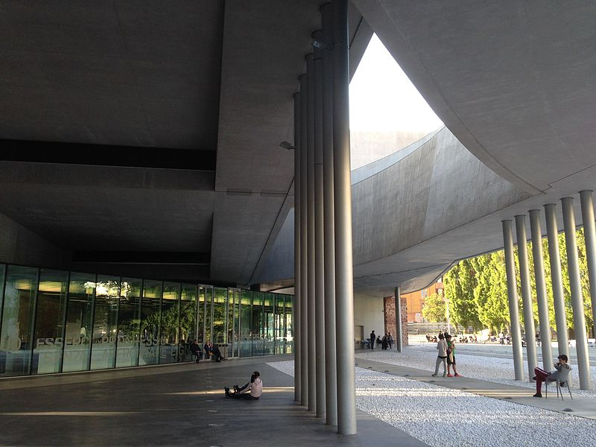The structure of the new building of the museum is composed of curved side walls made in self-consolidating concrete, the horizontal structures are mostly made of black-painted steel profiles, sometimes clad with fibre-reinforced concrete panels, as for the roof trusses.

This is an early work, closer in style to the Vitra Fire Station and Landscape Formation One buildings at Weil am Rein in Germany than her later curving structures. Compare her curving concepts those of to Frank Lloyd Wright’s Guggenheim Museum in New York (1943-59) and Frank Gehry’s Guggenheim Museum in Bilbao (1991-7) as well as Le Corbusier’s Villa Savoye (1929) and Notre Dame du Haut (1950-4).

**Function:** contemporary art gallery **housing two institutions: MAXXI Arte and MAXXI Architecture, aiming to promote art and architecture through collection, conservation, study and exhibition of contemporary works.** Looking for an open dialogue between artefact and environment across an open, drifting space rather than a highly directed exploration. Opening up spaces towards multiple functions as walls, ceilings and windows become more fluid. Relationship between exterior and surroundings also important to function as an invitation to visit.  Reinstating pedestrian access that had been blocked by the barracks becomes an important part of the new unity.

Designed as a true multi-disciplinary and multi-purpose campus of the arts and culture, the MAXXI creates an urban complex for the city that can be enjoyed by all. In addition to the two museums the MAXXI includes an auditorium, library and media library, bookshop and cafeteria, spaces for temporary exhibitions, outdoor spaces, live events and commercial activities, laboratories, and places for study and leisure.

Further reading:

<https://www.theguardian.com/artanddesign/2009/nov/16/zaha-hadid-maxxi-rome>

<https://www.theguardian.com/artanddesign/2010/jun/06/maxxi-rome-zaha-hadid>

<http://www.bdonline.co.uk/roman-horror-day-at-zaha-hadids-maxxi/3153497.article>

<http://www.nytimes.com/2009/11/12/arts/design/12zaha.html>

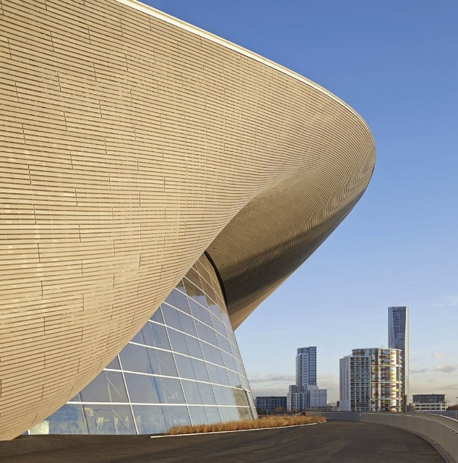

**The London Aquatics Centre, Olympic Park, London**

Key questions relevant to Identity

1. How does this building respond to the past and present history of London and the UK?
2. What were the commissioning requirements of the building and how far has the identity of the patron affected the appearance of the building?
3. How does this building reflect the identity of Zaha Hadid as an Iraqi born, British architect?
4. How does the choice and use of materials contribute to the sense of identity in this building?
5. How does this building sit in the architectural evolution of designs for Olympic and/or sports venues?
6. How does this building reflect the ideas of parametricism?
7. How does this building reflect Zaha Hadid’s stylistic journey?

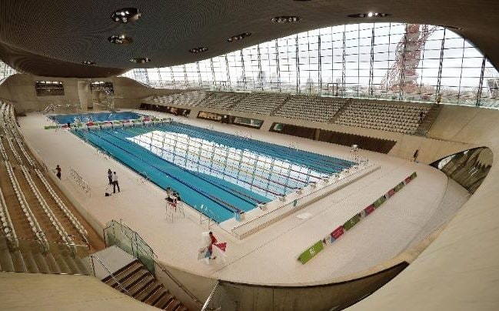She said the architecture “is inspired by the fluid geometry of water in motion.” An undulating roof rises from the ground and encloses the swimming pools in a “unifying gesture of fluidity”.

**Location:** Located on the southeastern corner of the Olympic Park. New pedestrian access (Stratford City Bridge) passes directly over the centre, serving as the primary gateway to the Park.

**Size:** The site is 45 metres high, 160 metres long, and 80 metres wide. The wave-like roof is stated to be (1,040 m2),

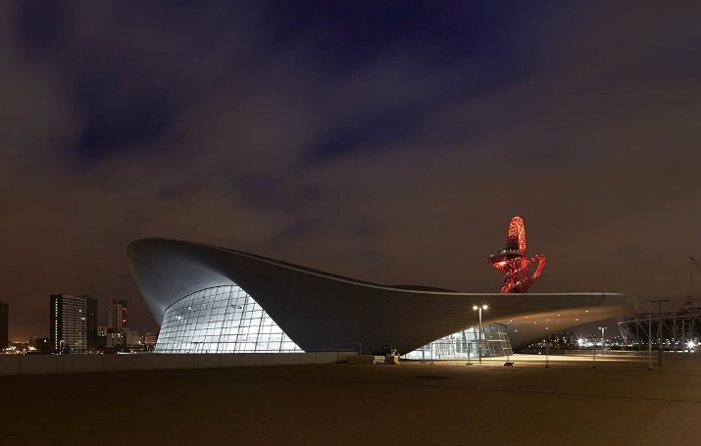**Function:** Structure contains 3 pools, one for training, one for swimming events and the diving pool., seating for 17,500 people around the main pool.

Hadid won the design contract in 2004, before London was awarded the Olympic Games in a decision announced the following year. The spectator seating was therefore not a part of the original design. Completed on time July 2011 for a budget of £269million.

**Materials, techniques and processes:** Steel and aluminium roof with double curvature parabolic arches. Curvature echoes in the diving boards and stairway as well as fenestration over the training pool. The design demonstrates the precast-concrete skills, by exposing the concrete finish rather than painting or cladding, which were provided by Peri. The floor terracing was also precast. The terracing units were delivered and positioned to accelerate the speed of construction. The unique six-board diving platform is made from 462 tonnes of concrete. The aluminium roof covering has a steel structure weighing 3,200 tonnes. The ceiling was built with 30,000 sections of Red Louro timber. The three pools hold around 10 million litres (2.6 million gallons) of water.

After the Paralympic Games, the Aquatic Centre was deconstructed to reduce its space. The frame wings on either side of the central space were removed, unbolted, and sold. The PVC wrap that temporarily enclosed the space was also sold, while the seats and toilets were reused elsewhere. As certain parts of the building were no longer needed, they were recycled via Vinyloop. This allowed the standards of the Olympic Delivery Authority concerning environmental protection to be met.

**Stylistic influences**

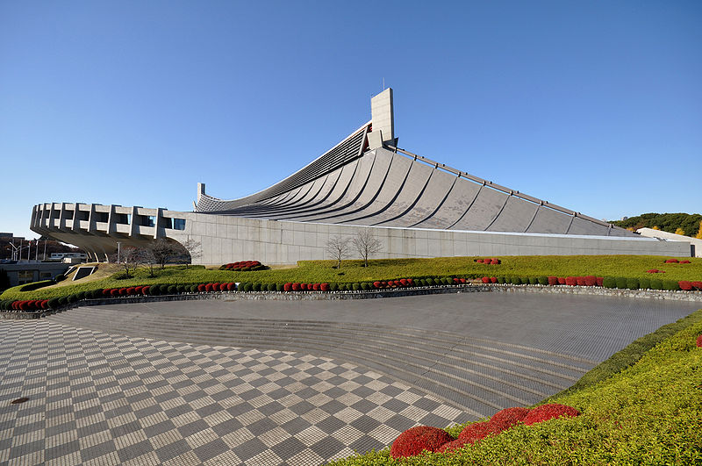Compare to Alexander Campbell’s Dollon Baths and Tange’s Gymnaisum for the 1964 Tokyo Olympics.

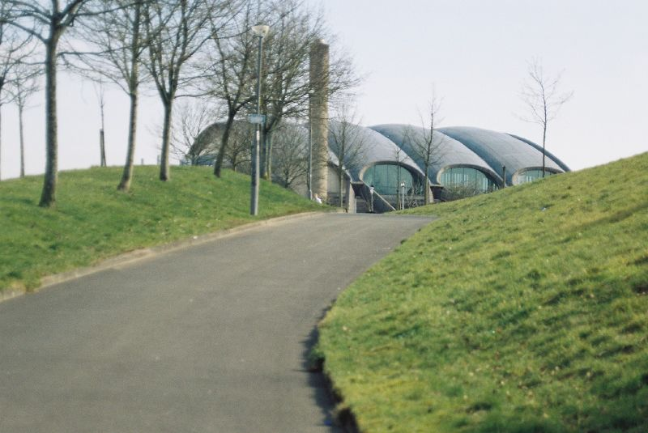

**Further reading:**

<https://www.theguardian.com/sport/2011/jul/31/london-olympics-aquatic-hadid-review>

<http://www.telegraph.co.uk/culture/art/architecture/10684024/Desperately-seeking-the-perfect-swimming-pool.html>

<https://www.architectural-review.com/buildings/zaha-hadids-aquatics-centre-versus-michael-hopkins-velodrome/8633443.article>