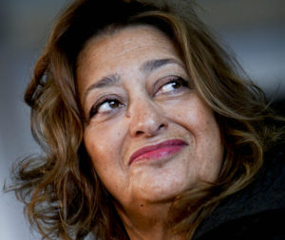Hadid (by Jodidio)

**Zaha Hadid (born Baghdad 1950, died California 2016)**

“Parametricism is the great new style after Modernism. Modernism was founded on the concept of space. Parametricism differentiates fields. Fields are full as if filled with a fluid medium. This is fitting for a time of fluid uncertainty that envelops health and security.” He characterises the style as favouring hybridization, morphing, uses splines and nurbs and avoids straight lines, right angles, corners and clear-cut territories.

Mark Wigley argues that “Architecture has always been a cultural institution valued above all for its provision of stability and order” but Deconstructivist architecture turned that dream into a nightmare by disrupting and contaminating ideas of pure form.

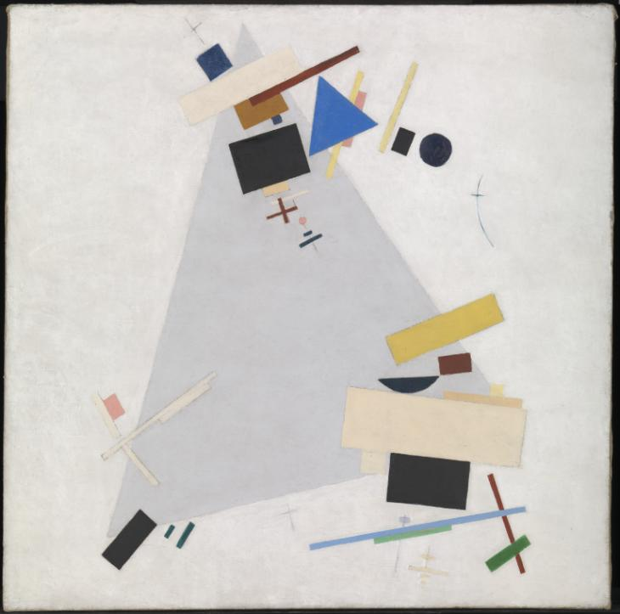*Key questions posed by the Pearson specification:*

* Explore and evaluate the influences on Zaha Hadid?
* How these works were influenced by the work of earlier or contemporary architects?
* How was Hadid influenced by her own experience of identity as an Iraqi born, British woman?
* What was Hadid’s contribution to contemporary architecture?
* What is the significance of location and setting on Hadid’s works?
* What is the impact of the commissioners on these works?
* How were these works shaped by their social, political and technological contexts?
* How does her use of materials express identity (and whose?)?
* What are the practical and aesthetic functions of these buildings?

Malevich **Dynamic Suprematicism**, 1915, Tate

**Using MAXXI National Museum, Rome 1998-2009 (30,000m²)**

She said the location related to city environment: “by intertwining the circulation wth the urban context, the building shares a public dimension with the city, overlapping tendril-like paths and open space.” She talks about the freedom (for curators and public) to be able to “drift through the centre… towards fields of multiple associations”.

With its emphasis on horizontal lines and cantilevered volumes, the architecture is marked by a wilful contrast between opaque surfaces and glazed or open surfaces.” The fluidity continues on the interior where volumes and pathways anre overlapping and linked in an uninterrupted pattern.

**London Aquatics Centre, 2005-11 (20,000 m²)**

Sports facility for the 2012 London Olympics and ‘legacy’ use.

Architecture is “inspired by the fluid geometry of water in motion”. Undulating roof rises from the ground to enclose the three pools. “The overall strategy is to frame the base of the pool hall as a podium connected to the Stratford City Bridge. Steel and aluminium roof with double curvature parabolic arches is probably the ‘signature’ element of the complex. Curving forms continued through the diving platforms, staircases and overhead lighting above the training pool.

Patron: London Olympic Delivery Authority

**Relevant previous projects by the architect:**

* ‘Mouth’ of Bergisel Ski Jump
* Piloti of Strasbourg tram station
* Curving concrete mass and forms and interlinking voids (**NURBS**) of Phaeno Science Centre, Germany
* Sweeping lines – **splines** - (on ceilings) of BMW Central Building, Leipzig

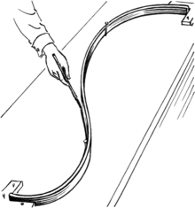**Techniques and Processes**

Computer assisted design: **FormZ** to move from drawing to 3D models on screen

**CNC Milling** (Computer Numerical Control) Milling = is the process of [machining](https://en.wikipedia.org/wiki/Machining) using rotary [cutters](https://en.wikipedia.org/wiki/Milling_cutter) to remove material by advancing a cutter into a workpiece. This may be done varying direction on one or several axes, cutter head speed, and pressure.

Non-uniform rational [basis spline](https://en.wikipedia.org/wiki/B-spline) (**NURBS**) is a mathematical model commonly used in [computer graphics](https://en.wikipedia.org/wiki/Computer_graphics) for generating and representing curves and surfaces.

**Materials**

A spline

* Reinforced concrete
* Glass
* Steel
* Aluminium

**Achievements/Biography**

Zaha Hadid was born in Bagdad and graduated in Mathematics from the American University in Beirut. She then moved to London, where she studied architecture at the Architectural Association and obtained her degree in 1977.

Her work is a revolutionary research bordering on town planning, architecture and design. Her innovative way of representing the project overturns the way we examine space, revealing new potentialities; it bestows on traditional elements of construction unforeseen communicative capabilities; it gives shapes new strength and dynamism. Her interest lies in the boundaries between geography, architecture and landscape, and her projects integrate natural topography and human-built structures, through a project path that capitalises experimental technologies. The lines of Hadid’s architecture are oblique, broken and elusive, the angles are mostly acute, the surfaces smooth; volumes are fractured and recomposed according to new orders, which stem from her efforts to create fluid spaces.

Hadid began her own practice in London in 1979. In 1986, she won the competition for the Kurfurstendamm in Berlin and, in 1989 the one for an arts and communication centre in Düsseldorf (1989). Among her completed projects, besides the MAXXI in Rome (1999/2010), are: the Fire Station of the Vitra Museum (1991/1993); the LF One Pavilion in Weil am Rhein, in Germany; the enlargement of the Ordrupgaard Museum in Copenhagen (2001/2005); the Rosenthal Center for Contemporary Arts in Cincinnati (1998/2003); the Phaeno Science Center in Wolfsburg. She has been especially active in Italy: among her most recent projects are the Salerno Maritime Terminal (2000), the master plan and City Life Tower for Milan’s Trade Fair (2004) and the Messner Mountain Museum in Plan de Corones. These are only a few of the projects Hadid has completed in her intense career, projects that can be analysed through three concepts: metaphor, as in the translation into architectural space of elements of the Information and Technology Age; space itself, generated by the same principles that model natural environment; and the idea of landscape, which is modelled by digital design to give life to complex, unusual and sometimes paradoxical images.

Among her many awards, Hadid was the first woman architect to win the Pritzker Prize in 2004.