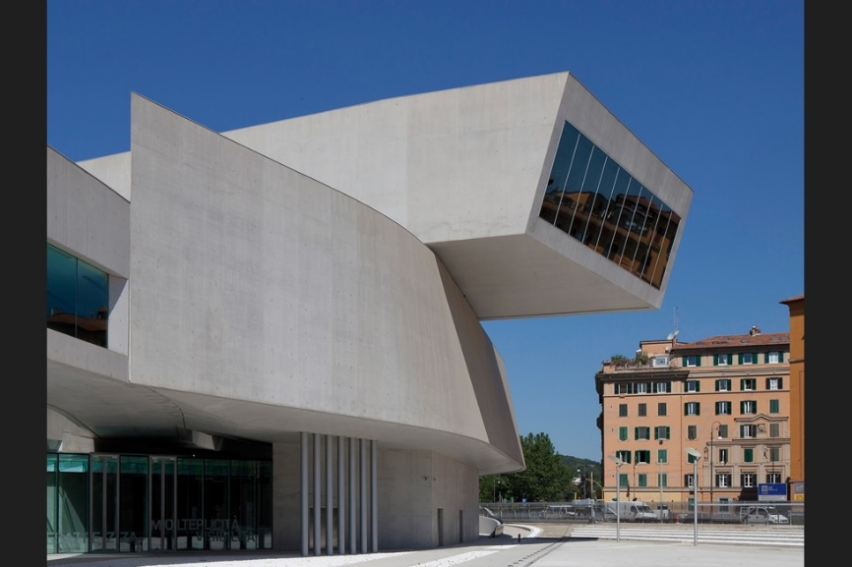**MAXXI by Zaha Hadid Architects, Rome, Italy**

1 July, 2010 By Catherine Slessor

Like a questing concrete periscope, the museum’s uppermost gallery cantilevers out precipitously over the former barracks site

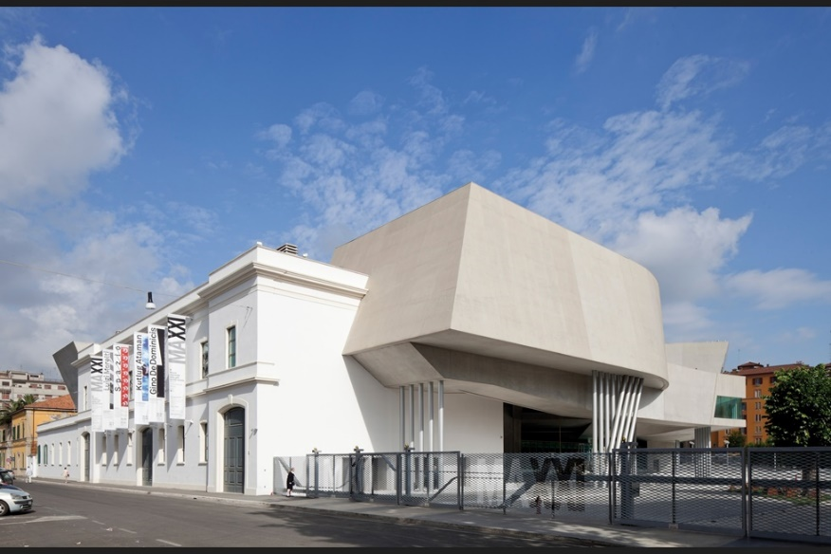An existing structure still defines the street edge, with the new building docking into it

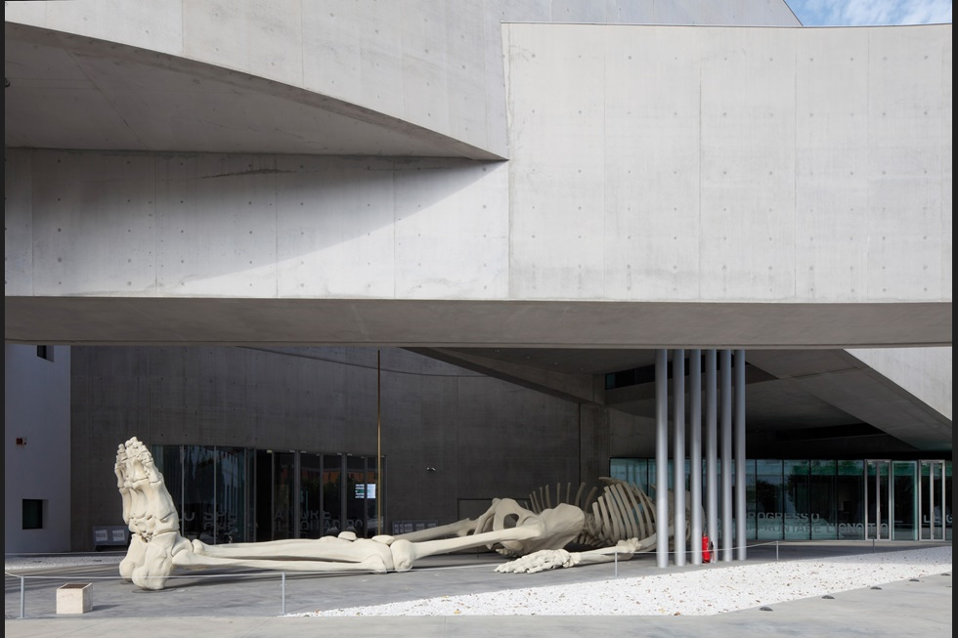Artefact and architecture in surreal conjunction

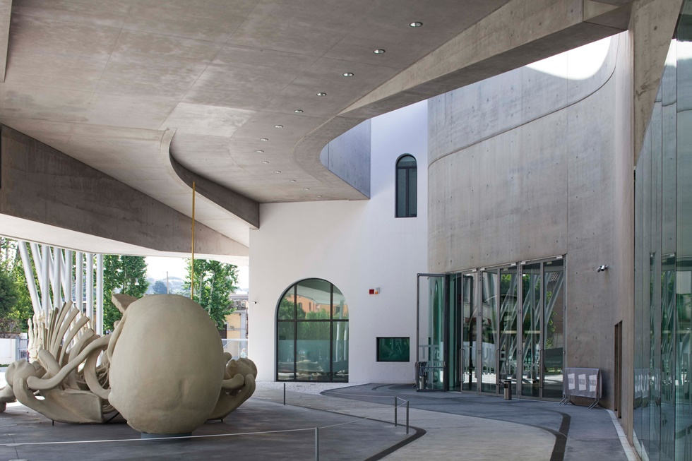

The entrance parvis, currently colonised by Gino de Dominicis’ giant plaster skeleton

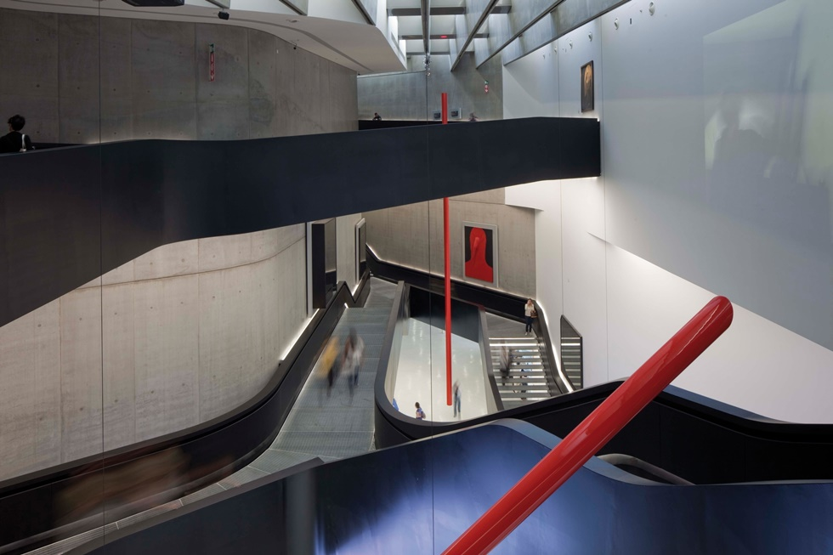

A centrifugal vortex at the heart of the museum connects the various gallery spaces

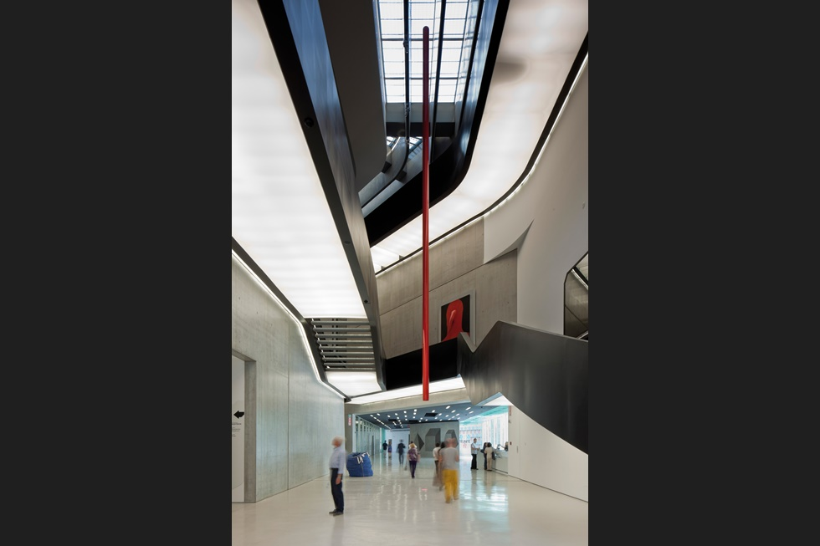

The vortex at entrance level. The dark ribbons of the staircases float on ‘lightboxes’

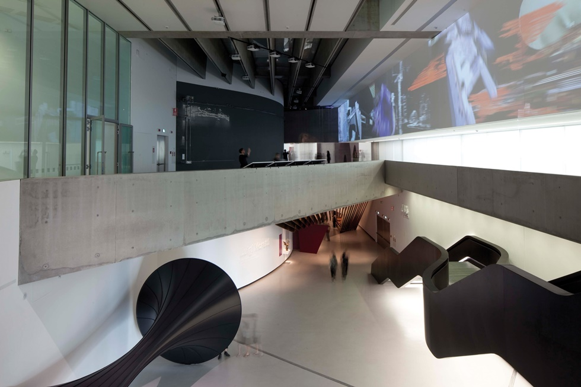

Galleries collide with and meld into each other; the spaces lend themselves to large-scale works, such as Anish Kapoor’s Widow

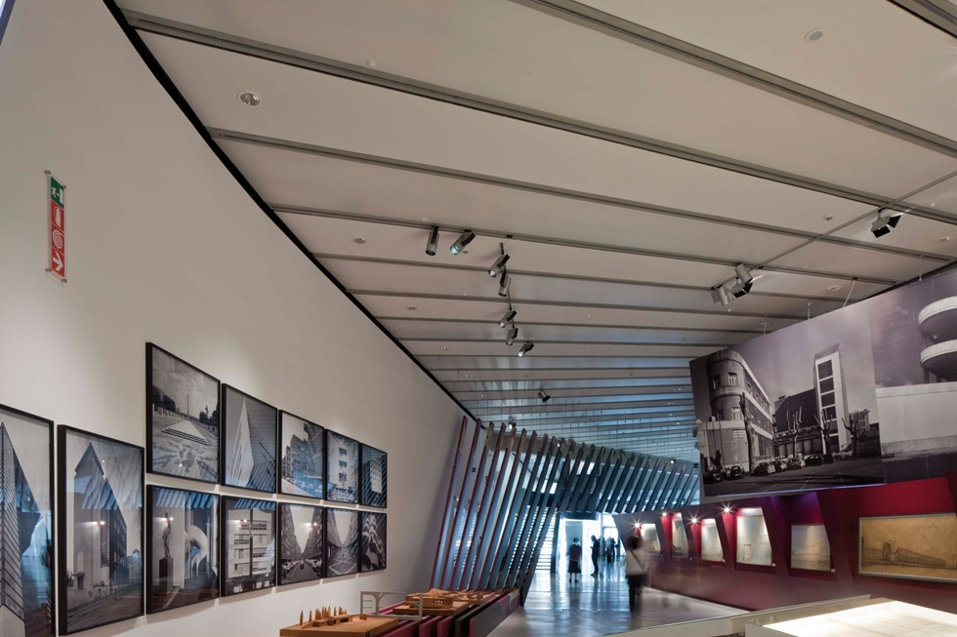

The ground-level gallery, with the Luigi Moretti retrospective. This part of the inaugural exhibition included works of all sizes, in contrast to the overwhelming scale of many other pieces

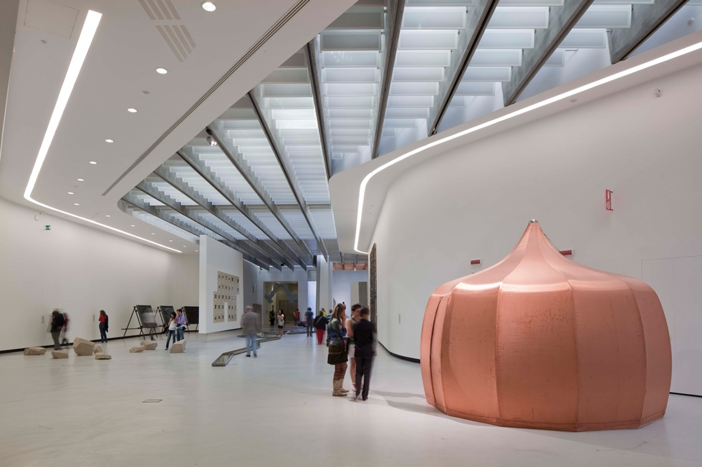

First-floor gallery with Jana Sterbak’s Faradayurt, a copper-clad yurt. Works are chosen with the museum’s architecture in mind

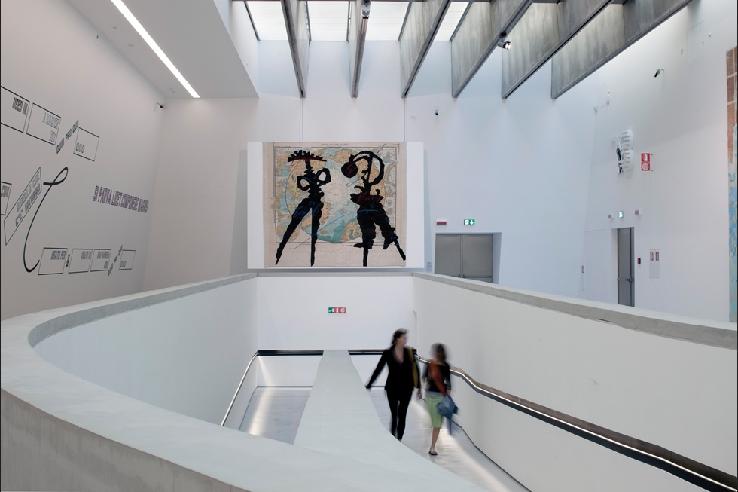

There is no prescribed route through the building – instead, visitors promenade through the cluster of galleries. In the background is William Kentridge’s North Polar Map

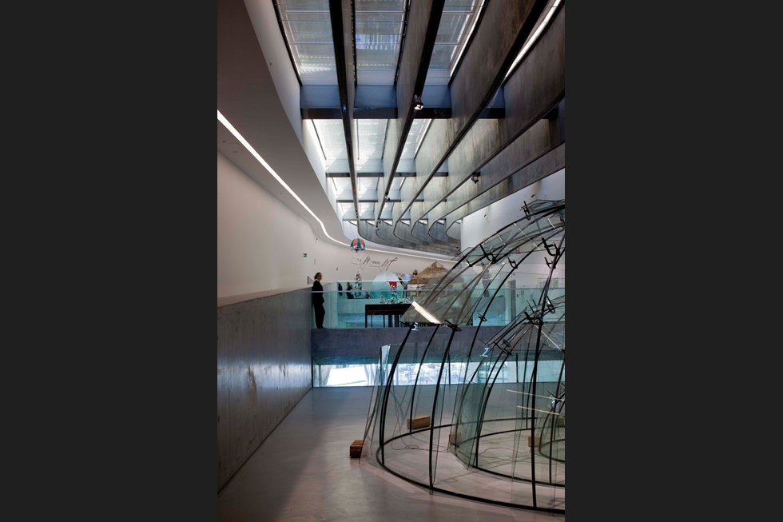

Cuts and shifts in the structure produce surprising views - in this case looking down over the entrance parvis. In the foreround is Mario Merz’s glass igloo

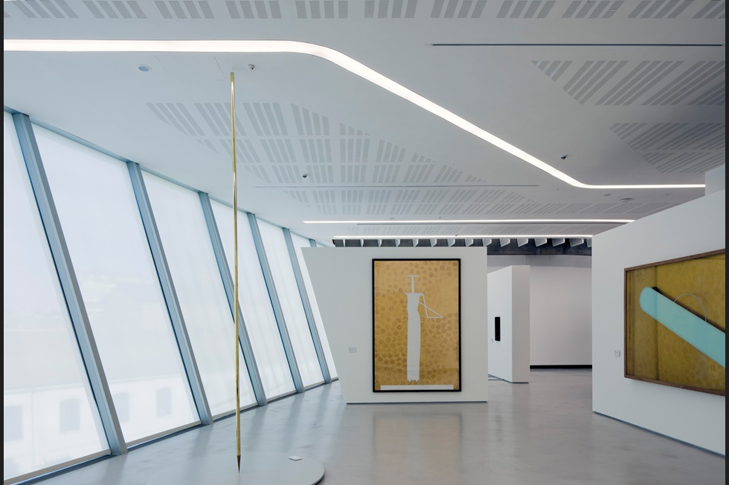

The topmost gallery with its periscope glazing

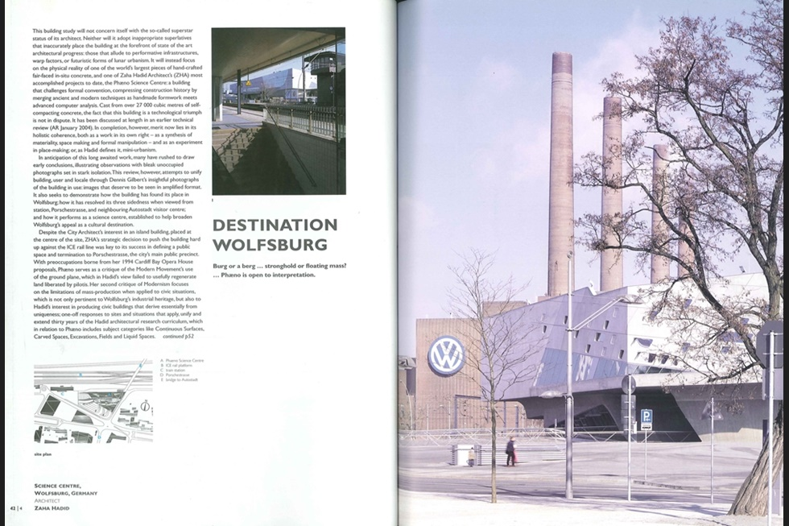

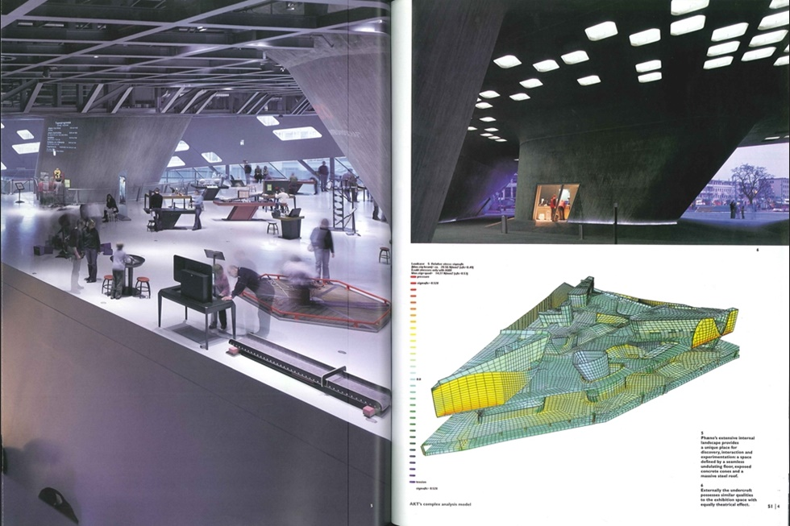

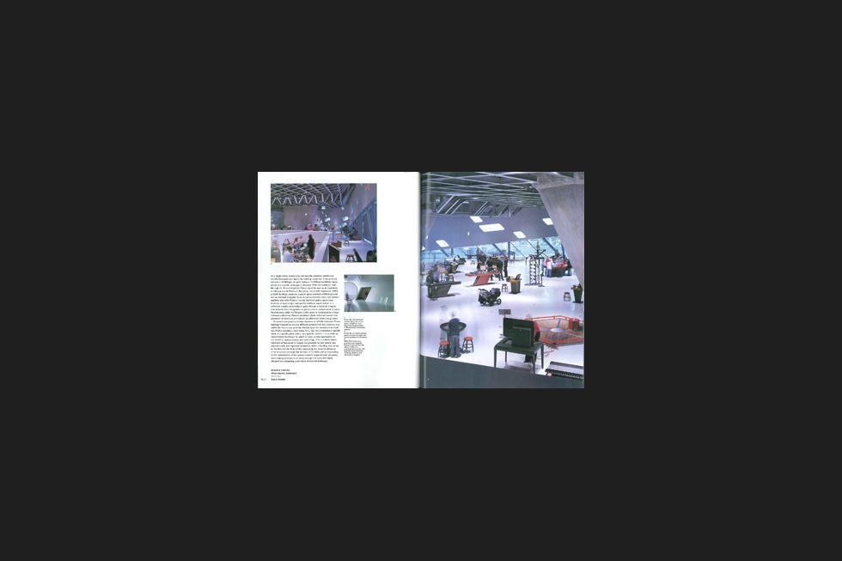

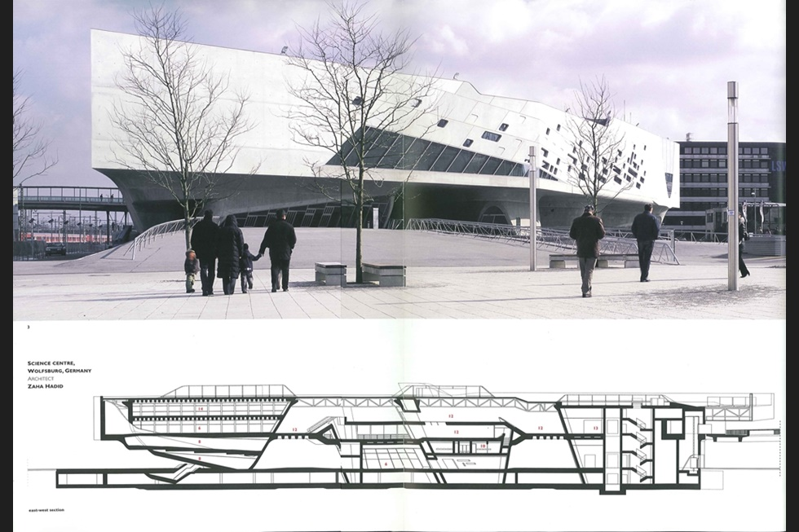

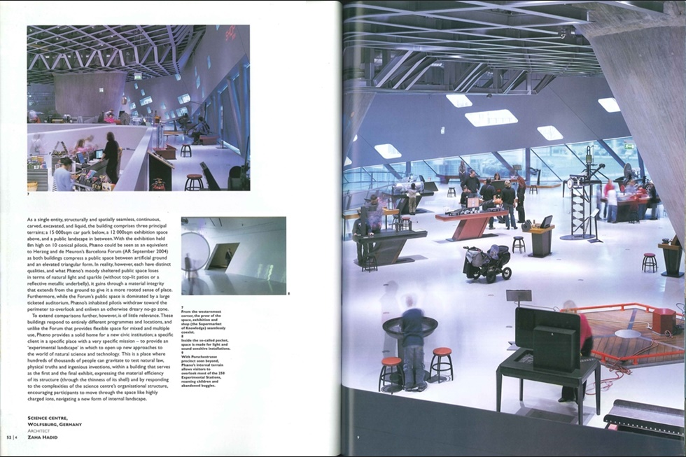

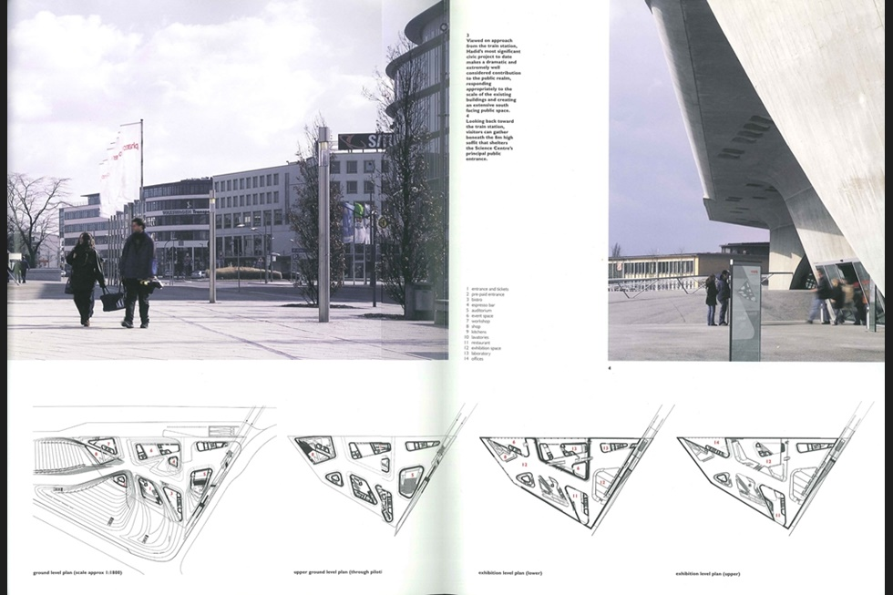

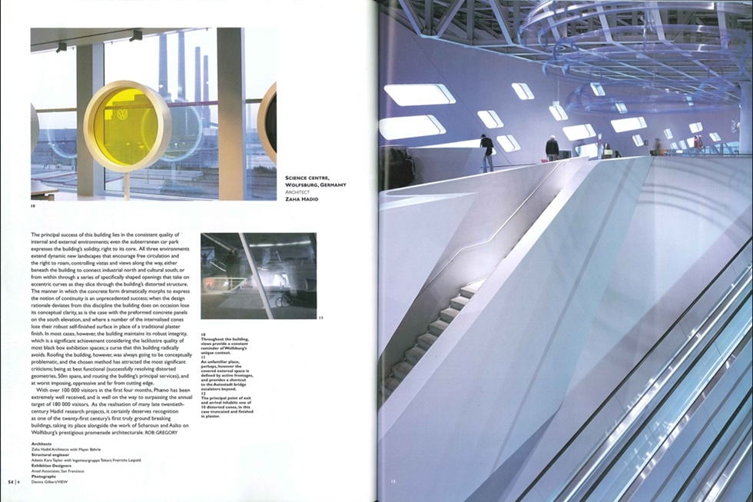

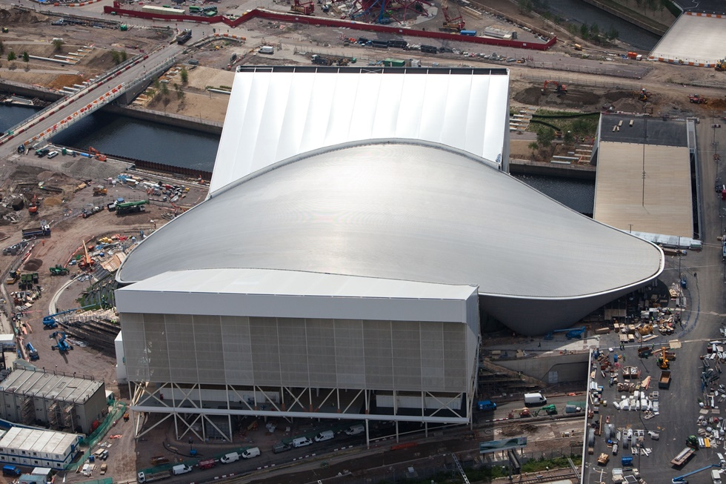

Aquatic Centre, London, by Zaha Hadid Architects

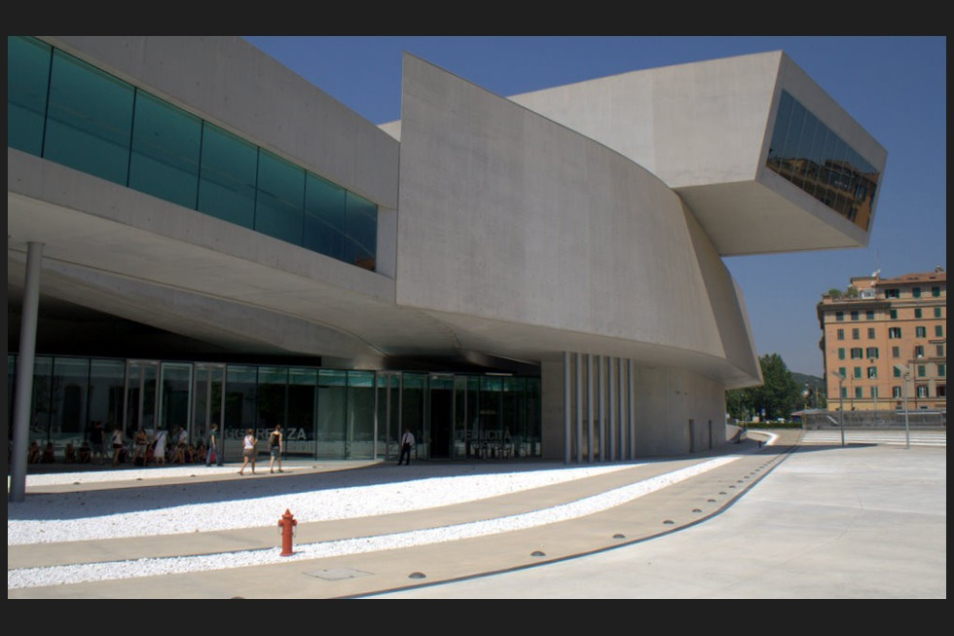

Maxxi by Zaha hadid

Now filled with Art, Zaha Hadid Architects’ bravura MAXXI finally opens its doors in Rome. Photography by Paul Raftery

‘Ah, finalmente,’ murmured the man beside me in mild exasperation as the press conference to inaugurate MAXXI got underway half an hour late. His sentiment is echoed in the more general exhalation of relief now rippling through art and architecture circles.

Teasingly unveiled to the architectural press last November (AR January 2010), Zaha Hadid’s MAXXI is now, finalmente, replete with art and open to the public. With an acronym punningly playing on the number 21 in Roman numerals, MAXXI is Italy’s first national museum dedicated to the art of this century, hosting ‘contemporary creativity’ across various disciplines, from painting and sculpture to dance and film.

Costing £133 million and with exhibition space equivalent to Bilbao’s Guggenheim, it has very big ambitions.Over 50,000 people applied for special free passes during its opening weekend, and the museum expects between 250,0000 and 500,000 paying visitors in its first year.

That might sound a lot, but London’s Tate Modern attracted five million art-lovers in its maiden year. However, given the competing attractions of La Città Eterna, such enthusiasm indicates a public fascination with a project that has, at last, emerged from the thicket of Italian (and specifically Roman) bureaucracy over a decade on from its conceptual genesis in 1998.

Yet even now it is still not totally complete. Hadid’s newly opened building is the mothership in an extended campus of suckling sub-structures, including a library, space for MAXXI’s architecture department, a restaurant and apartments for artists. When these are finally in place, the former barracks site in Flaminio, to the north of the Piazza del Popolo, will be transformed into the thriving, multidisciplinary, urban locus for exhibitions and research that was originally envisaged by both its architect and client.

‘The idea was to move away from the museum as object and towards the idea of a field of buildings,’ says Hadid. ‘It’s no longer just a museum, but an urban cultural centre where a dense texture of interior and exterior spaces have been intertwined and superimposed over one another.’

MAXXI’s ‘lightning in a bottle’ moment is captured in a set of Hadid’s early models and drawings that form part of the inaugural exhibition. Delicate white card models show a series of swooshing cuts incised on the grid of the barracks site, rupturing and reconfiguring the terrain. The original inward-looking order is subverted as site and building meld together, seeking new and unexpected connections with the wider city.

Though the vaguely L-shaped plan bears some resemblance to a circuit board, this implies a sanitised, technological precision. In the flesh MAXXI is muscular and visceral, a slab of agonised tissue flayed and staked out in the Roman sun. In a city full of suffering saints it’s an abstract, concrete San Bartolomeo, or a Bacon pope howling in infernal torment. It has no skin; its canted walls of fleshy concrete, silky to the touch, are both its structure and epidermis.

Cast in situ using self-compacting concrete, with some pours up to 50m long, the building is a tour de force of engineering and construction. Clearly the experience hard-gained in perfecting the concrete for Wolfsburg’s Phaeno Science Centre (AR April 2006) and the BMW offices in Leipzig (AR June 2005) has served Hadid’s team well. Because of MAXXI’s protracted gestation, both Wolfsburg and Leipzig were designed after MAXXI but built before it.

Belying its formal complexity, the architecture is underscored by the familiar concerns of light and layering, routes and materiality. Five enormous galleries whirl around a centrifugal vortex, an exhilarating set-piece space traversed by serpentine ‘light box’ stairs.

There are no prescribed promenades, rather visitors meander at leisure through the soaring, canyon-like spaces, looping around, doubling back, but always reconverging on the rim of the vortex. Rome’s lustrous light is filtered through a layered roof structure of louvres, glazing and concrete ribs that unspool overhead like oversized ribbons, emphasising the fluid sweep of the architecture.

Uniquely for an art museum, MAXXI aims to foster a much stronger than usual reciprocity between building and content, with the architecture shaping the collection and how it is shown. ‘The collection was the starting point for the architectural project,’ says Anna Mattirolo, director of MAXXI’s art programme, ‘and the artwork remained the unifying principle as it developed. The collection and worksite grew together. The museum will be a place for experimentation, a continuous workshop that will allow us to choose which works merit inclusion in our permanent collection.’

But inevitably perhaps, the scale of the galleries has encouraged a monumentalist tendency in the inaugural shows. One heroically scaled art incident follows another, making for slightly ponderous viewing - though there are individual highlights, such as Anselm Kiefer’s mammoth Sternenfall canvas and William Kentridge’s exquisite model theatre. More successful is the retrospective of Italian modernist Luigi Moretti, which features different sorts and scales of work and shows how a single gallery can be quite densely and richly inhabited.

MAXXI’s collection was assembled from scratch over the last five years, and has around 350 works, including pieces by international luminaries such as Kiefer, Kentridge, Anish Kapoor, Gerhard Richter and Francesco Clemente, along with lesser-known Italian artists.

There has been criticism that the collection lacks depth, but until recently the state took little interest in contemporary art, and MAXXI has some ground to make up.

Its opening coincided with previews of a new wing of MACRO, Rome’s municipal contemporary art museum designed by Odile Decq, suggesting a renewed engagement.

MAXXI will also host architectural exhibitions and research; its architectural department houses the archives of Carlo Scarpa, Aldo Rossi and Pier Luigi Nervi. Funded jointly by the Italian ministry of culture and private donations, the museum will continue its policy of acquisition, but Italy’s national cultural budget is due to be pared down, potentially limiting curatorial ambitions. And it must be said that in the current climate of economic entrenchment, the entire enterprise seems to belong to an easier, more gilded age.

One of the inaugural retrospectives, dedicated to minor Italian pop artist Gino de Dominicis features a giant plaster skeleton impaled in the building’s forecourt, a rather too obvious metaphor for the passing of a certain kind of era and a certain kind of architecture. MAXXI was originally due to be completed in the mid-noughties, and you sense that had it been unveiled four or five years ago it would have seemed more of its time and been less harshly scrutinised as a talisman for decadence and waste.

But that is not to underestimate the considerable achievement of its architecture. And in some ways it is the perfect Roman building. In a city marked by bouts of megalomania and fits of braggadocio, in historic thrall to mad popes and scheming politicians, shaped by radical architects, the forces of religion and the dark ecstasies of the baroque, MAXXI somehow feels right at home.