An Introduction to Economic Discrimination
Adapted from Economics Help Website 2017

An Introduction
Discrimination in the labour market occurs when employers make decisions on wages and employment based on prejudices, such as race, gender, religion. It can lead to variations in wages for the same job and different employment rates. In 1968, 850 women machinists at the Ford factory in Dagenham went on strike over equal pay. They received 87% of men’s’ wages. But, they argued their job was as skilled as the men. After a strike, Ford increased wages of the women to 92% of men’s. It also contributed to the Equal Pay Act of 1970, which prohibited preferential wages on grounds of gender.

Discrimination and effect on demand curve
THEORY 1: The Prejudiced Effect and MRP  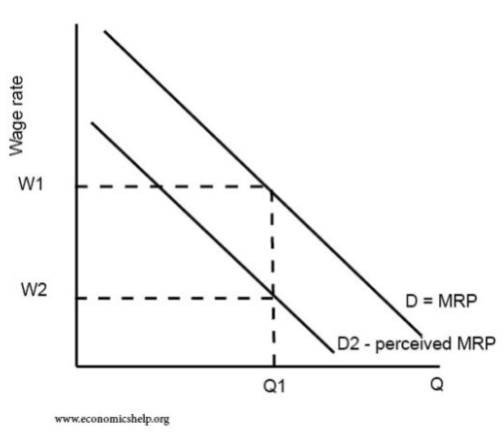 | D=MRP shows marginal revenue product of workers. However, because of discrimination and employers preferences to avoid certain groups of workers, the ‘perceived’ MPR of that group is lower than it actually is. This group will not be employed at W1 and will have to accept lower wages.  These groups maybe belong to an ethnic minority, be of a certain gender or sexuality? Basically any social group who in the past has been the victim of being stereotyped or suffered from prejudice.  Data shows that on average, these groups may face lower wages than white, heterosexual males!
THEORY 2: Crowding Out  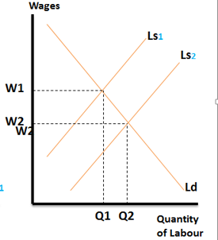 | This refers to the idea that over the past 50 years, more unskilled women have entered the workforce as the stigma of women working has reduced. Equally, it could be argued that greater immigration over the past 15 years from the EU and other countries has led to an influx of foreign workers into the UK.  The diagram on the right shows the labour supply curve shifting to the right. This is because of the increase in women in the workforce from the 1960’s onwards led to a greater supply of workers, thus pushing down their wages.  Equally an influx of immigration would lead to falls in wages for ethnic minorities for example compared to the majority white population.
THEORY 3: First-Degree Wage Discrimination  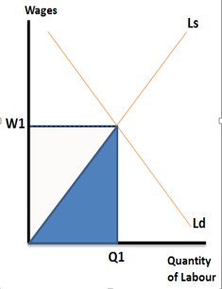 | With first-degree price discrimination theory a firm was able to charge different prices to different customer for the same good so that each customer would pay the maximum they were prepared to pay and would have no consumer surplus.  The labour market alternative is that firms would pay each worker what they were willing to work at thus cutting their costs (white and blue triangle) to just the blue triangle.  The assumption is that the employer is able to predict how much each worker will be prepared to work for and then pay them that exact amount.  It also assumes that the workers do not know how each of the others is being paid!

Problems of discrimination for economy and society
- Discrimination leads to deadweight welfare loss. Certain groups of workers may be out of work or have a wage less than their marginal revenue product.
- If firms have monopoly/monopsony power, discrimination enables firms to cut costs and receive more profits (at the expense of workers).
- However, in competitive markets, firms will tend to experience higher costs as a result of discrimination – leading to higher prices for consumers.
- Discrimination causes a sense of alienation, frustration and injustice. It can lead to social disorder with those discriminated on going on strike for better conditions.

Can Market Forces Self-Regulate and Prevent Discrimination?
YES | NO
- If we have a competitive labour and product market, there are profit incentives working against discrimination. If a company wanted to employ only white workers, it would push up the wages for white workers and increase its cost of production. However, the company would then be vulnerable to another firm entering the market and employing ethnic minorities. If ethnic minorities have been discriminated against, their average wages would be lower. The new company could then pay lower wages than the discriminatory firm and undercut its rival. The firm who discriminates against ethnic minorities is, therefore, penalising itself. Market forces would put pressure on the discriminatory employers to cut wages and employ all workers. In theory, this should put downward pressure on wages for ‘preferred’ groups of white workers and lead to equalising pressures. For example – Discrimination against Communist film producers: In the 1950s, many film producers, such as Dalton Trumbo were banned from working in Hollywood because of the Communist beliefs. But, profit making Hollywood studios started to find ways around these bans by secretly employing Communist script writers. The movie companies could pay lower prices to the blacklisted authors. The writers were happy to gain employment – even at a wage less than their MRP (Dalton Trumbo gained two Academy Awards whilst working as an anonymous script writer Roman Holiday and Brave One.) | The market can fail to end discrimination if:  - Discrimination occurs amongst consumers too (so-called ‘dual discrimination’). Suppose there is a market for private maths tuition. Companies may discriminate against female maths tutors and be less willing to employ women and/or pay lower wages. As a consequence, the pay for female tutors would be lower than male tutors and relatively higher for male tutors.For a firm who didn’t discriminate, there would be an opportunity to gain lower costs by employing female maths tutors. There is a profit incentive to avoid discrimination. However, suppose the prejudice against female maths tutors was also prevalent amongst customers. In this case, a firm employing female maths tutors may have difficulty selling their services – so the cost benefits of lower wages are lost. In this case, the market fails to end the discrimination because the racism/sexism isn’t just amongst employers but also consumers. Example – First Female Doctor in the UK: In 1865, Elizabeth Garret Anderson opened up a medical practice in London. She was the first female qualified doctor in the UK. For the first six months, she struggled to attract patients due to lingering suspicions about female doctors – even though her prices were relatively cheap. However, in 1865 there was a cholera epidemic affecting both rich and poor. In the crisis, the desire to see a doctor suddenly outweighed prejudice about gender and in 1866, she saw 3,000 new patients. Anderson broke down discrimination on grounds of gender.  - If firms have monopoly power – despite higher costs of discrimination, barriers to entry prevent new non-discriminatory firms from entering the market and so discrimination stays  - Discrimination – pre-labour market. One major cause of wage differentials is not discrimination by employers but different life chances and education of people entering the labour market. If black-Americans have fewer qualifications than average, economic theory would predict that even with non-discriminatory employers, average wages would be lower for certain groups.  - Government legislation enforces discrimination (apartheid laws in the US and South Africa)

