**A1. Understanding the Brief**

**Before starting the preparation for this unit, you must first create a folder in your personal college drive: name it UNIT 3. Create a sub-folder within UNIT 3 and call it Activity 1. Materials for the following task must be stored safely in this folder.**

To produce an effective digital media product, you must be able to read and understand the brief.

1. **Read** through the brief at least **three** times.
2. **Highlight** the **key elements** and **write** them down.
3. Review your notes and **prepare a plan** for making your own digital product. Consider and make notes on the following:

* The purpose of the brief
* The intentions of the client (what they want)
* The timing of the brief
* The length of the finish product (running time)
* Who are the intended audience (age, relationship to the product)?
* What does the client want to do for the audience (inform, entertain, market a product etc.)

1. Create a **timescale / schedule**. From reading the brief you must consider the following:

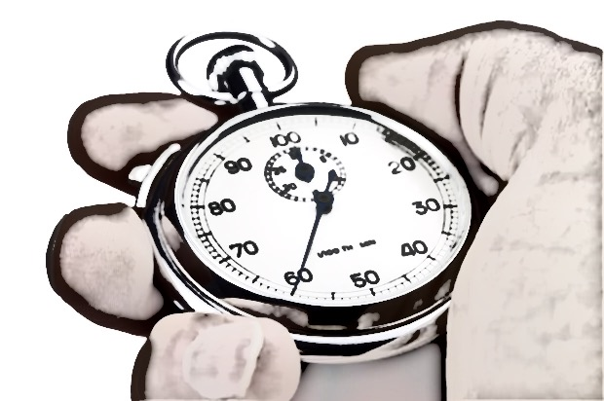

* What are the constraints on the timescale for production (personnel, college term times, access to equipment, obtaining permissions, etc.)
* What skills are required for completing the brief?
* What resources will you need?