**Period Study: The Julio-Claudians, 31 BC – 68 AD**

**T. Holland, *The Glorious Caesars*, BBC History Magazine, October 2015**

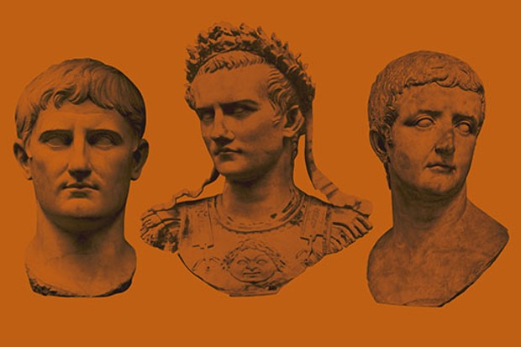<http://www.historyextra.com/period/roman/the-glorious-caesars/>

1. Who wrote the account of Gaius’s (Caligula’s) reign and when?
2. How had Julius Caesar expanded Rome’s power before the reign of the first emperor?
3. How did Augustus manage to maintain his power in Rome for so long? Make sure you explain this answer fully and in your own words
4. Why did Tiberius become emperor and why did this make some in Rome uncomfortable?
5. What according to Holland did the people of Rome ‘crave’ during the reigns of the Julio-Claudian emperors and why was this?
6. What do you understand by the idea of the *pax Romania*? What does Holland mean when he uses this phrase?
7. Control of what two things gave emperors their power?
8. What is Holland arguing when he says that “A good emperor had no choice but to be a good dictator”? Explain this in your own words.
9. Record the dates of the reigns of each of the following emperors:

* **Augustus**
* **Tiberius**
* **Gaius**
* **Claudius**
* **Nero**