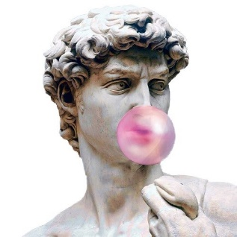Handout sheet questions

Fill in roman societal order

When was Rome founded?

Fill in the blanks

One myth is that Rome was founded by and , two demi-god brothers from the war god Mars. As babies, they were looked after by a she-wolf. They fought over who would rule the city/where the city would be and Romulus ended up Remus and naming Rome after himself.

Make an Acronym for the 7 hills of Rome

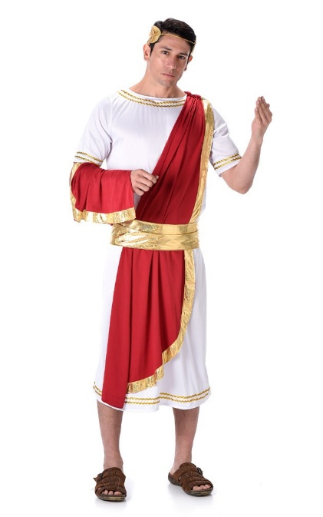This is a senate called Gaius; describe his position in roman society

What did the censors monitor?

Draw out a scene depicting a Roman myth; Jonathan will judge the best drawing and in return you get nothing but the satisfaction of having the best drawing.