

NAME:

**Ancient History**

**Period Study: The Julio-Claudian Emperors, 31 BC – AD 68**

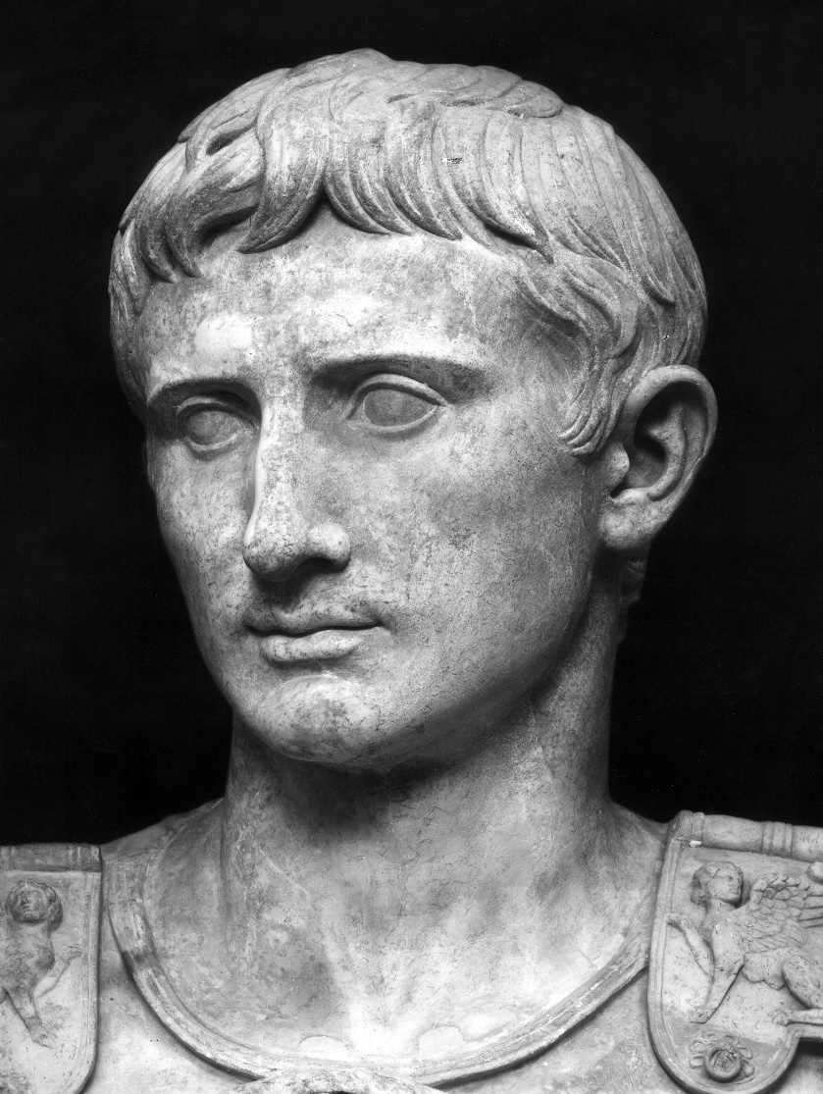**TOPIC 1: Augustus, 27 BC – AD 14**

**PART ONE**

***This booklet covers the following topics:***

* The presentation of Augustus’ victory at Actium in 31 BC
* Augustus’ military achievements
* The Constitutional Settlements of 27 and 23 BC
* The ‘restoration’ of the Republic and its values
* Augustus’ attitude towards religion
* Augustus’s reforms in Rome and in the provinces

**Suggested Reading**

**History Today Articles (go to** [www.historytoday.com](http://www.historytoday.com) **username= Godalming; password= history)**

# Augustus Down the Centuries

By [John M. Carter](http://www.historytoday.com/author/john-m-carter)

Published in [History Today](http://www.historytoday.com/archive/history-today/latest) [Volume 33 Issue 3 March 1983](http://www.historytoday.com/archive/history-today/volume-33-issue-3-march-1983)

# The Problem of Augustus

By [Michael Grant](http://www.historytoday.com/author/michael-grant)

Published in [History Today](http://www.historytoday.com/archive/history-today/latest) [Volume 3 Issue 11 November 1953](http://www.historytoday.com/archive/history-today/volume-3-issue-11-november-1953)

# The Many and the Few: Augustus, Tiberius and Roman Ideals

By [T.P. Wiseman](http://www.historytoday.com/author/tp-wiseman)

Published in [History Today](http://www.historytoday.com/archive/history-today/latest) [Volume 64 Issue 8 August 2014](http://www.historytoday.com/archive/history-today/volume-64-issue-8-august-2014)

# Augustus and Cleopatra

By [Christopher Smith](http://www.historytoday.com/author/christopher-smith)

Published in [History Today](http://www.historytoday.com/archive/history-today/latest) [Volume 64 Issue 2 February 2014](http://www.historytoday.com/archive/history-today/volume-64-issue-2-february-2014)

# The Praetorian Guard

By [Geoffrey Powell](http://www.historytoday.com/author/geoffrey-powell)

Published in [History Today](http://www.historytoday.com/archive/history-today/latest) [Volume 18 Issue 12 December 1968](http://www.historytoday.com/archive/history-today/volume-18-issue-12-december-1968)

# Women in Imperial Rome

By [J.P.V.D. Balsdon](http://www.historytoday.com/author/jpvd-balsdon)

Published in [History Today](http://www.historytoday.com/archive/history-today/latest) [Volume 9 Issue 8 August 1959](http://www.historytoday.com/archive/history-today/volume-9-issue-8-august-1959)

# The Roman Legions and their Officers

By [Geoffrey Powell](http://www.historytoday.com/author/geoffrey-powell)

Published in [History Today](http://www.historytoday.com/archive/history-today/latest) [Volume 17 Issue 11 November 1967](http://www.historytoday.com/archive/history-today/volume-17-issue-11-november-1967)

**Textbooks**

* R. Cromarty, J. Harrison & S. Matthews, *OCR Ancient History, Component 2: Rome*, Bloomsbury, 2018 (Due to be published February 2018)

**Books in the ILC**

* R. L. Fox, The Classical World: an Epic History of Greece and Rome, Penguin, 2006
* M. Beard, *S.P.Q.R.: A History of Rome*, Profile Books, 2015
* T. Holland, *Dynasty,* Abacus, 2016
* P. Mantin & R. Pulley, *The Roman World, From Republic to Empire,* Cambridge, 1993
* T. Martin, *Ancient Rome: From Romulus to Justinian,* Yale, 2013

**Useful Websites**

* <https://www.bloomsbury.com/cw/ocr-as-and-a-level-ancient-history/?pid=330294> (A companion website for the OCR Ancient History textbook – good selection of wider reading and revision quizzes)
* <http://www.ancient.eu/>
* <http://www.livius.org/>
* [www.ocr.org.uk](http://www.ocr.org.uk)

**Podcasts**

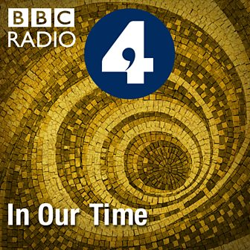Julius Caesar - [www.bbc.co.uk/programmes/b04jlygw](http://www.bbc.co.uk/programmes/b04jlygw)

The Augustan Age - <http://www.bbc.co.uk/programmes/b00ktfmw>

Rome and European Civilization **-** [www.bbc.co.uk/programmes/p00547ms](http://www.bbc.co.uk/programmes/p00547ms)

Tacitus and the Decadence of Rome - <http://www.bbc.co.uk/programmes/b00cdtxp>

Roman Satire - [www.bbc.co.uk/programmes/b00s0gwd](http://www.bbc.co.uk/programmes/b00s0gwd)

*For help in accessing the ebook catalogue on dawsonera, go to the ILC’s page on Godalming Online and read their guide to accessing ebooks.*

*Ebooks can be read using your college log on details whilst in college or at home.*

**ANCIENT HISTORY LUNCHTIME SUPPORT**

**If you need any help in Ancient History going over content, completing homework, attempting assessed questions or preparing for exams, there will be a lunchtime support session each Wednesday between 1 and 2 pm in room 211.**

**Augustus (Octavian); 27 BC – AD 14**

Following his victory at the battle of Actium in 31 BC, Octavian became the sole ruler of the Roman Empire and ended a period of intense civil war. In 27 BC his power was formalised and he was given the title ‘Augustus’. His reign from 27 BC to AD 14 would begin a new era in Roman history which some would call a ‘golden age’ and otherwise would criticise for dismantling the old Roman Republic. Augustus would also found the ‘Julio-Claudian’ dynasty consisting of his successors **Tiberius (AD 14-37), Gaius (Caligula) (37-41), Claudius (41-54) and Nero (54-68).**

*(The reigns of these emperors makes up the content of Component 2 of your AS/A level course)*

**Task:** Find and record definitions for the following terms (make sure you understand each by putting it in your own words):

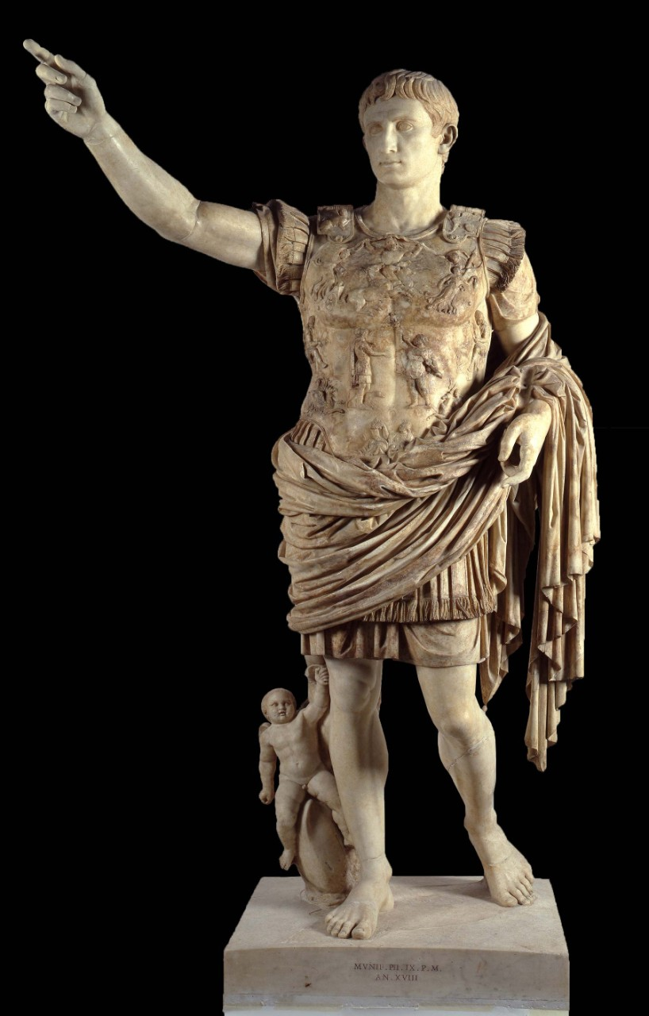***Principate:***

***Princeps:***

***Republic:***

***Magistrates:***

***Cursus Honorum:***

***Senate:***

**THE PRESENTATION OF AUGUSTUS’ VICTORY AT ACTIUM**

[***https://www.youtube.com/watch?v=Uk6tee8KBzs***](https://www.youtube.com/watch?v=Uk6tee8KBzs)

1. Which two figures competed for power after the death of Julius Caesar?
2. What surprise did Caesar’s will contain?
3. How did Mark Antony originally view Octavian and why?
4. What did Octavian manage to persuade the Senate of and what did he then do?
5. Why did Octavian and Mark Antony agree to work together?
6. Once Octavian and Antony had defeated Caesars’s assassins, what did they agree to do?
7. How did Cleopatra have her own claim to power in Rome and how did Antony want to take advantage of this?
8. How did Octavian turn the Roman people against Cleopatra and Antony?
9. What did Octavian need to confront Antony and Cleopatra?
10. What was the result of the Battle of Actium in 31 BC?
11. What was the name of Octavian’s admiral in the battle?
12. What did Mark Antony do rather than meet Octavian?
13. What did Cleopatra beg Octavian to do and why was this not possible?
14. What did Octavian go on to declare?
15. How was Augustus’ reign different to that of Julius Caesar?
16. What title was Octavian given by the Senate in 27 BC?

**THE PRESENTATION OF AUGUSTUS’ VICTORY AT ACTIUM**

[***https://www.youtube.com/watch?v=Uk6tee8KBzs***](https://www.youtube.com/watch?v=Uk6tee8KBzs)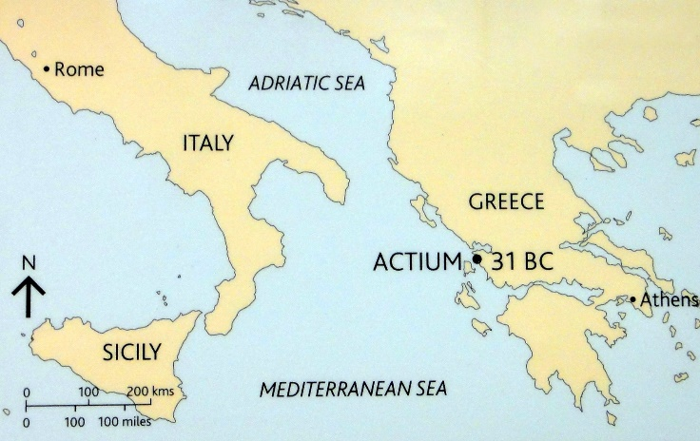

The Battle of Actium in 31 BC was the final battle of a conflict between Octavian and **Mark Antony** – a successful general and senator.

Octavian commanded the forces of the western Roman Empire, supported by his admiral **Agrippa**; Antony, allied with the Queen of Egypt, **Cleopatra**, commanded the forces of the eastern empire.

The battle was over quickly as Antony and Cleopatra’s forces fled the battle, both would go on to commit suicide the following year. Octavian was now left without any rivals and the undisputed leadership of Rome.

Although Actium was a relatively small battle, it would be hugely important for the rest of Octavian/Augustus’ reign. He would use the victory as propaganda to set his long reign in the most positive light possible.

The inscription below is from the temple to Apollo at the city he founded to celebrate his victory – **Nikopolis** (victory city).

**Prescribed Source – Victory monument celebrating Actium, 29 BC, Nikopolis in Epirus (NW Greece) (H10)**

[Imperator] Caesar, so of the deified [Julius, having won] a naval victory in the war which he waged on behalf of the state in this region, [dedicated] to Neptune [and] Mars the camp, decorated with spoils, [from] which he set out to pursue [the enemy], as consul for the fifth time and hailed *imperator* seven times, once peace had been achieved by land [and sea].

1. **How does Octavian present his victory at Actium and why do you think he did this?**

**Prescribed Source - Strabo, *Geography* 7.7.6 (H9)**

**Battle of Actium (31 BC): dedication to Apollo of Actium**

Here, too, near the mouth (of the Ambracian Gulf) is the sacred site of the temple of Apollo of Actium. There is a ridge of high ground, at the summit of which is set the temple itself; below it a plain with a sacred grove, and a dockyard where Caesar dedicated as the first fruits of his naval victory an offering of ten ships, a representative sample of each type from those with a single bank of oars right up to a ten-banker.

Octavian wanted to use the victory at Actium to send a number of messages throughout his reign:

* **It marked the start of a period of peace and stability for Rome, ending almost a century of civil war**
* **It was the triumph of the civilised Roman world over the corrupt east (here he focused on Cleopatra’s involvement)**
* **It was a victory for the Roman Senate and People whom Octavian claimed to have represented at Actium**

In addition to ceremonies and inscriptions, Octavian/Augustus would also use art and poetry to present his victory at Actium in the ‘right’ way.

Two poets and works in particular, glorified Octavian and his victory at Actium – **Horace and Virgil.**

**TASK:** in pairs do some quick research into these two figures taking one each. Try to find the dates they were writing, the form of their writing, any of their key works, their attitudes towards Augustus.

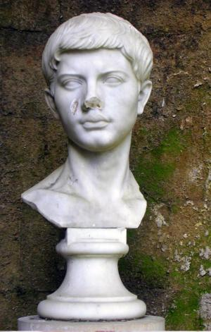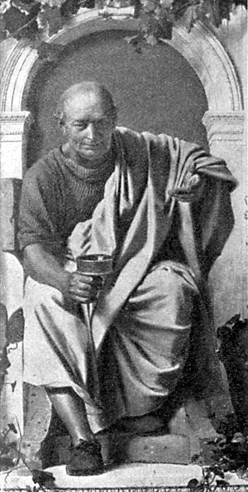

**Horace**

**Virgil**

**Prescribed Source - Horace, *Odes* 1.37 (G24)**

**How is Octavian’s victory at Actium presented in this poem?**

**Suicide of Cleopatra**

Come now, my boon companions, now’s the time

To drink, to dance, beating the earth with foot

Unfettered, and with feasts worthy of the Salii to deck

The couches of our gods – aye, now’s the time!

For it were sacrilege before to draw up Caecuban

From ancestral cellars, while the queen

Was plotting demented ruin for the Capito,

Planning our empire’s funeral rites

With her contaminated crew of men

Diseased by vice, herself without restraint

**How is Cleopatra presented in this poem?**

In hoping for what she fancied and drunk

With fortune’s sweetness. But she came to her senses

When scarcely one ship survived the fire,

And her mind crazed on Mareotic wine

Was brought back to real terrors, when Caesar

Pursued her as she flew from Italy,

Pressing on with oars, like a hawk

Against gentle doves or a swift hunter

Against a hare in the snowy plains

Of Thessaly, his aim to load with chains

The doom-laden monster. Seeking

**According to Horace, how did Cleopatra commit suicide?**

A nobler death, she did not in women’s fashion

Trembles at the sword, nor with her swift fleet

Reach secret coasts for safety.

She dared to gaze with face serene on her

Fallen palace, and bravely grasped

Savage serpents, to drain their dark

Venom through her body’s veins.

Determined on death, she grew fiercer yet,

Disdaining to be brought, a queen no more,

By harsh Liburnian galleys to be paraded,

No humble woman, in a proud triumph.

In this section of the ***Aeneid***the hero and mythical founder of Rome, Aeneas, has received new armour from the God Vulcan, which has pictures over showing, among other things, the victory at Actium

**Prescribes Source - Virgil, *Aeneid* 8.671–8.731 (G38)**

**The Shield of Aeneas**

Between these scenes was a depiction of a broad swelling sea,

Waves wrought in gold, all flecked with white foam. Circling

Around it in silver, bright dolphins were churning the waters

With tail-fins and cleaving a way through the surf.

At the centre you could see the fleets, wrought in bronze,

And the Actian war, there see the battle-lines drawn,

And the Leucate boiling with water, and the waves sparkling with gold.

On one side was Augustus Caesar, leading the Italians

To battle together with Senate and People, the Penates

And the great gods, standing on the high poop, while from his brow

Twin flames shot joyfully upward, and on his helmet his father’s star appeared.

On the other wing, Agrippa, with the winds and the gods on his side,

Stood aloft, leading his line, and – that proud badge of war –

His temples adorned the ships’ beaks of the naval crown.

On the other side, with barbarous arms and a motely array,

Antony, returned in conquest from the eastern peoples and the Red Sea,

Brought Egypt into the battle, the might of the Orient, far-away Bactria,

While (for shame!) an Egyptian wife followed behind.

The fleets charged into battle; the whole sea foamed,

Shattered with oak stokes and the bow-waves of three-toothed prows.

They made for open water. Now you would think that the isles of the Cyclades,

Torn loose, were sailing the seas or mountains colliding in battle

With towering mountains – so vast were the turreted decks of the ships,

On which men hastened to battle. Blazing tow and flying steel

Were scattered everywhere by hands and weapons, while with fresh

Slaughter Neptune’s fields grew red. In the midst the queen summoned

Her squadrons with the Egyptian rattle, but failed even yet

To see the twin snakes waiting at her back. Her gods, misbegotten,

Of every kind, even barking Anubis, ranged against Neptune,

Minerva, and Venus brandished their armaments. At the heart

Of the struggle, engraved in iron, Mars raged, and

From the skies the grim Furies, and Discord, delighting

In her garment divided, ran riot; behind her Bellona

Followed, bloodily flailing. Above and surveying it all,

Actian Apollo was drawing his bow. For terror of this, all,

Egyptian and Indian, Arab and Sabaean, were turning to flight.

The queen herself could be seen, having summoned the winds,

To be opening her sails and now, even now, to have loosened the ropes.

Amid carnage, and pale at the prospect of death, the fire-god

Had portrayed her carried along by the waves and the north-west wind.

Opposite, the Nile, grieving with his mighty body, was stretching out

His folds and with all his robes was calling back the defeated

To his watery bosom and the secret retreats of his streams.

But now Caesar was riding in triple triumph through the walls

Of Rome, and was making to Italy’s gods his vow everlasting,

Three hundred great shines, all through the city. Now resounding

With joy and games and applause were the streets. At each temple

Was a chorus of matrons, at each an altar; before the altars

They sacrificed bullocks lay strewn upon the ground.

He himself, seated on the snow – white threshold of shinning Apollo,

Told over the gifts of the nations, and high on the proud portals

He displayed them, while rank upon rank the vanquished nations passed by,

As varied in their tongues as in their garb and arms.

Here Mulciber had mouolded the Nomads and the Africans

In their lose-flowing robes; here the Lelegae, the Carians

And the Gelonian archers. The river Euphrates passed (now gentler

In its flow), and the Morini (most distant of men), the twin-horned Rhine,

The Dahae unconquered before, the Araxes outraged at his bridge.

All this on Vulcan’s shield, the gift of his mother, Aeneas wondered at.

Ignorant of what they portrayed, he rejoiced in the images,

Raising on his shoulders the fame and fate of his offspring.

**How is Octavian’s victory at Actium presented in this poem? (A developed paragraph needed)**

**Prescribed Source – Suetonius, *Augustus* 17–18**

17. Eventually Augustus broke his friendship with Mark Antony, which had always been a tenuous one and in continual need of patching, and proved that his rival had failed to conduct himself as befitted a Roman citizen by ordering the will he had deposited at Rome to be opened and publicly read. It listed among Antony’s heirs the illegitimate children fathered by him on Cleopatra. Nevertheless, when the Senate outlawed Antony, Augustus allowed all his relatives and friends to join him under safe conduct, including Gaius Sosius and Tuts Domitius, the consuls of the year. He also excused Bononia, a city traditionally dependent on the Antonii, from joining the rest of Italy in taking an oath to support him. Shortly thereafter he defeated Antony in a sea battle off Actium, where the fighting went on so long that he spent the whole night aboard his ship.

In winter quarters on Samos, after his victory, Augustus heard the alarming news of a mutiny at Brundisium among troops whom he had picked from every unit in the army; they were demanding the bounties due to them and an immediate discharge. He returned to Italy, but ran into two storms: the first between the headlands of the Peloponnese and Aetolia, and the second off the Ceraunian Mountains. Some of his galleys went down on both occasions; the rigging of his own vessel was carried away, and her rudder split. He stayed no more than twenty-seven days at Brundisium, just long enough to pacify the mutineers, then took a roundabout route to Egypt by way of Asia and Syria, besieged Alexandria, where Antony had fled with Cleopatra, and soon reduced it. At the last moment Antony sued for peace, but Augustus ordered him to commit suicide, and inspected the corpse. He was so anxious to save Cleopatra as an ornament for is triumph that he actually summoned Psylli to suck the poison from her wound, supposedly the bite of an asp. Though he allowed them honourable burial in the same tomb and gave orders that the mausoleum which they had begun to build should be completed, he had the elder of Antony’s sons by Fulvia dragged from the image of Divius Julius, to which he had fled with vain pleas for mercy, and executed. Augustus also sent cavalry in pursuit of Caesarion, whom Cleopatra claimed to be the son of Caesar, and killed him when captured. However, he spared Cleopatra’s children by Antony, brought them up no less tenderly than if they had been members of his own family, and gave them the education which their rank deserved.

18. About this time he had the sarcophagus containing Alexander the Great’s mummy removed from the mausoleum at Alexandria and, after a long look at its features, showed his veneration by crowing the head with a golden diadem and strewing flowers on the trunk. When asked, ‘Would you now like to visit the mausoleum of the Ptolemies?’ he replied, ‘I came to see a king, not a row of corpses.’ Augustus turned the kingdom of Egypt into a Roman province, and then, to increase its fertility and its yield of grain for the Roman market, set troops to clean out the irrigation canals of the Nile, which had silted up after many years’ neglect. To perpetuate the glory of his victory at Actium, he founded a city close to the scene of the battle and named it Nicopolis, and made arrangements for the celebration of games there every five years. He also enlarged an ancient local temple of Apollo and embellished his camp with trophies taken from Antony’s fleet, consecrating the site jointly to Neptune and Mars.

The official presentation of Octavian’s victory was significant as it helped to legitimise his takeover of power and his move away from the government of the Roman Republic. It also helps to explain why there would be relatively little opposition to Octavian’s takeover and his continued popularity:

**Prescribed Source – Velleius Paterculus, *History of Rome*, 2.89.1**

89.1 Caesar returned to Italy and Rome to be greeted by huge crowds and universal acclaim from young and old, rich and poor alike. The magnificence of his triumph and the public games he provided could hardly be adequately described within the scope of a full-scale work, let alone one as restricted as this.

**TRIUMPH: A public parade celebrating a successful military commander or an important victory**

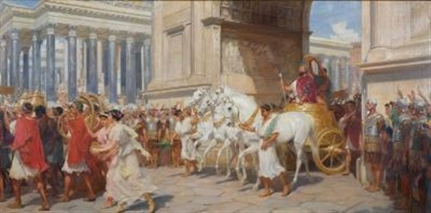**AUGUSTUS’ MILITARY ACHIEVEMENTS**

In addition to the image Augustus wanted to present about his victory at Actium, he also wanted to be viewed as a **supreme military commander**. In the past it was common for successful commanders to be awarded a **‘triumph’** celebrating their achievements. Octavian returned to Rome in 29 BC and held the **Triple Triumph** celebrating his victories in **Dalmatia**, **Actium** and **Alexandria** (see map at the back of the booklet).

**Prescribed Source – Suetonius, *Augustus* 22**

22. The gates of the Temple of Janus Quirinus, which had been closed no more than twice since the foundation of Rome, he closed three times during a far shorter period, as a sign that the empire was at peace on land and at sea. He enjoyed an ovation after Philippi, and again after his Sicilian success – and celebrated three full triumphs in a row for his victories won in Dalmatia, off Actium and at Alexandria.

**Prescribed Source - Dio, The Roman History: The Reign of Augustus 51:21; 29 BC**

21. These events took place during the winter, and during the same period the people of Pergamum were also granted permission to hold the sacred games, as they were named, in honour of Octavian’s temple. During the summer Octavian crossed over to Greece and from there returned to Italy.

When he finally entered Rome, not only did all the citizens offer sacrifice, as I have mentioned above, but even the consul, Valerius Potitus. Octavian, it is true, had been consul throughout the year, as he had been for the two years before, but Potitus had succeeded Sextus Appuleius. It was he who in pubic and in person sacrificed oxen upon Octavian’s arrival on behalf of the people of Rome and of the Senate, something which had not been done for any man before.

After this Octavian spoke in praise of his subordinates, and conferred honours upon them as was his custom. To Agrippa, among other distinctions, he also presented a dark blue flag to commemorate his naval victory, and to the soldiers he gave other gifts. The populace were granted four hundred sesterces each, first to the men of adult age and later to the children on account of his nephew Marcellus. Octavian refused to accept from the Italian cities the gold required to make the triumphal crowns they had voted for him, and meanwhile not only paid the debts which he himself owed, as has already been explained, but did not press others to pay their debts to him. Because of these concessions, the Romans forgot all the hardships they had suffered and accepted his triumph with pleasure, as though the enemies he had conquered had all been foreigners. Indeed the quantity of money which was circulating through all parts of the city alike was so huge that the price of goods increased, and loans for which the borrower had willingly paid twelve per cent could not be obtained for a third of that rate.

In his triumph celebrated on the first day his victory over the Pannonians and Dalmatians, the Iapydes and their neighbours, and a number of Germans and Gauls. I should explain that Gaius Carrinas had subdued the Morini and other tribes which had risen in rebellion with them, and had driven back the Suebi who had crossed the Rhine to attack the Romans. Accordingly this triumph was celebrated both by Carrinas – in spite of the fact that his father had been executed by Sulla, and that he himself together with others in like cases had been debarred from holding office – and by Octavian, who was duly entitled to the credit for the victory by virtue of his position as supreme commander. These were the achievements which were honoured on the first day. On the second the naval victory at Actium, and on the third the subjugation of Egypt were commemorated. All the processions presented a striking appearance on account of the spoils from Egypt – indeed the quantity of plunder from there was enough to decorate all the processions – but the Egyptian spectacle surpassed all the others in luxury and magnificence.

Among the items which were carried along was an effigy of the dead Cleopatra lying on a couch, so that in sense she too, together with the live captives, who included her children Alexander, named the Sun, and Cleopatra, named the Moon, formed a part of the pageant. After this came Octavian, who rode into the city behind the whole procession. He played his part in all respects according to the usual customs, except that he allowed his fellow consul and the other magistrates, contrary to precedent, to follow him, together with the senators who had taken part in the victory. The normal arrangement was for these officials to lead the procession, and for the senators only to follow it.

1. Highlight the three triumphs Augustus celebrated as part of the Triple Triumph in the text above
2. How did Augustus behave when returning to Rome and why do you think he did this?

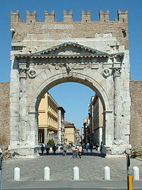Along with the ‘Triple Triumph’, Augustus also ensured his military reputation through the architecture of Rome. He had built a triumphal triple arch celebrating his military achievements. The original version no longer survives but replicas were built across the empire the arches carried the following inscription:

**Prescribed Source – Triumphal Arch, 29 BC, Roman Forum (H17)**

The Senate and People of Rome (set this up) in honour of Imperator Caesar, son of the Deified, consul five times, designated consul for a sixth time, *imperator* seven times, to commemorate the preservation of the state.

1. What in your own words, does the inscription credit Octavian with having done?

It was claimed that Augustus by ending the civil wars and pacifying the empire had created the **Pax Augusta.** This was the idea that Augustus had brought peace and stability to the Roman worldand was a very powerful idea after almost a century of civil war. The primary sources, many of which are pro-Augustan all seem to praise this side of Augustus’ reign. Suetonius repeated a claim made by Augustus that the doors of the Temple of Janus Quirinus were closed three times during his reign symbolising that peace existed across the empire – Augustus and Suetonius claimed that the gates had only be closed on two other occasions before in the history of the city. Further evidence of the importance of the Pax Augusta was the proposal of the Senate to construct a new altar – the Altar of Augustan Peace, which was built in 13 BC and celebrated the stability Augustus had brought to the empire.

A wide range of ancient sources support the idea that one of Augustus’ greatest achievements was the bringing of peace to the Roman world.

In this section of the Aeneid, Jupiter is delivering a prophecy explaining the two foundation stories of Rome – the first that it was founded by Aeneas and the second by Romulus.

**Prescribed Source - Virgil, *Aeneid* 1.257–1.296 (G36)**

**Jupiter’s Prophecy**

‘Come lay your fears aside, Cytherea, for yet unchanged

And fixed stands your people’s destiny. You shall see the city

And the promised walls of Lavinium; and high to the stars of heaven

You shall transport great-hearted Aeneas. My resolve does not change.

But no, since these fears gnaw at your hear, yet more shall I show you.

Unrolling the scroll of the fates to reveal their mysteries.

Aeneas shall wage a vast war in Italy, shall crush fearsome

Peoples, and shall establish for his men civil traditions

And city walls for their safeguard, until three summers

Have seen him reigning in Latium, and three winters have passed

Since he conquered the Rutulians. Thereafter, the boy,

Ascanius, bearing also the name Iulus (Ilus it was

While Ilium stood), shall complete in rule each circling

Month for thirty long years. From its seat at Lavinium

He shall transfer his kingdom, building with mighty ramparts

The city of Alba Longa. Here for three hundred years

Shall endure the rule of Hector’s race, till a priestess of royal blood

Named Ilia, pregnant by Mars, shall bring her twin sons to birth.

Then, prospering under the tawny cover of the wolf his nurse,

Romulus shall take over his nation, shall build city-walls

Of Mars, and from his own name shall call his people Romans.

No limits of space or time do I place upon them; to them I have given

An empire without bounds. Savage Juno, moreover,

Who now troubles with her terrors land, sea and heaven,

Shall alter her plans for the better, and with me shall nurture

The Romans, lords of the world, the race of the toga.

Such is my will. And, as centuries roll by, a time will come

When Assaracus’ house shall bring to servitude Phthia

And famous Mycenae and lord it in conquered Argos.

There shall be born a Trojan of noble stock, Caesar,

Who shall extend the empire to the Ocean and fame to the stars,

Julius his name, passed down from great Iulus.

One day, free from care, you shall welcome him, heaped

With the Orient’s spoils, and he too shall be called upon in prayer.

Then shall the savage centuries lay wars aside and turn

To gentleness. Grey-haired Faith and Vesta, and Quirinus

With his brother Remus shall give laws. Then shall be closed

The gates of War, grim with their close-bolted bars of iron;

Within, unholy Rage shall sit on cruel weaponry,

Wrists pinioned behind back by a hundred knots

Of brass, roaring hideously from bloody mouth.’

1. What does Virgil suggest will be the role of Augustus in this prophecy and is it significant that Jupiter is saying this?

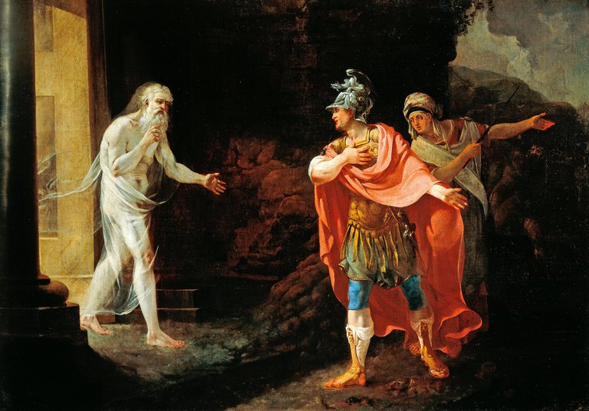

In this section, Aeneas is visiting the Underworld where he meets the soul of his father, Anchises. Anchises tries to inspire his son by showing him the souls of his great Roman descendants yet to be born.

**Prescribed Source - Virgil, *Aeneid* 6.752–6.806**

**Pageant of Roman heroes**

Anchises ceased speaking, and drew his son, and with him

The Sibyl, into the midst of that noisy throng of souls.

Climbing a hillock whence he could see them all spread

In a long line before him, and could thus pick out

And identify each face as it came, he began once again.

‘Come now, I shall speak of the glory due to fall to the Dardanian

Stock, and of the descendants from the Italian race

Which await, illustrious souls destined to enter

Our name. All this I’ll tell you, and your own fate.

Look, there, you see the young man who leans on his unmetalled spear

And by lot has drawn the next place in the light. He is the first

To share Italian blood and ascend to the breezes above:

Silvius, an Alban name, your son to be born after your death,

Whom, the late child of your old age, your wife Lavinia

Shall rear in the woods, a king and a father of kings.

Through his offspring our line shall rule in Alba Longa.

Next to him, there, is Procas, glory of Troy’s people, and Capys,

Numitor, too, and he whose name will renew yours,

Silvius Aeneas, your peer alike in piety and in arms

If ever he takes his place to reign in Alba.

What youths! Look at the strength they show and at

The civic crowns of oak which shade their brows!

These are the men to set citadels on the hilltops for you –

Nomentum and Gabii, Fidenae and Collatia’s fortress,

Pometia and the castle of Inuus, Bola, and Cora too –

These will be the names, but now are nameless places.

Moreover, in time, a child of Mars shall join his grandfather,

Romulus, whom his mother Ilia shall bear, of Assaracus’ line.

See how the twin crests stand so proudly over his helmet, and

How the father of the gods now marks him out with his own honour.

His, my son, his are the auspices under which that famous Rome

Shall match her empire to the bounds of the earth, her spirit to Olympus,

And enclose by a wall seven citadels as one city, blessed

In the abundance of her sons, like the Berecyntian mother,

Where she rides her chariot through Phrygia’s cities,

Wearing her turret-crown, happy to be mother of gods, and clasping

To her embrace her hundred grandsons, all divinities, and tenants all

Of the high halls of heaven. Hither now turn your twin eye-beams

And see this race, your Romans. Here is Caesar and all

Iulus’ offspring, destined to pass beneath the great vault of heaven.

This is the man, this is he whom so often you hear promised to you,

Augustus Caesar, son of a god, who shall bring back again

The age of gold to Latium, the very land where once

Old Saturn ruled, and shall spread our empire’s bounds

Beyond the Garamantes and the Indians, whose countries lie

Beyond the stars and the courses of time, and beyond

The highway of the sun, where Atlas, pillar of heaven, wheels

The firmament on his shoulders, studded with blazing stars.

Already now the Caspian kingdoms and the lands

Of Lake Maeotis tremble at oracles foretelling his coming,

And terror-struck the sevenfold estuaries of Nile are all astir.

Hercules, indeed, did not traverse the world so far, although he slew

The bronze-footed hind, and brought peace to the forests

Of Erymanthus, making all Lerna tremble at his bow. Nor did

Bacchus, who in triumph guides his chariot with vine-stem

Reins, driving his tigers down from Nysa’s lofty crest.

1. What two great things, according to this extract, was Augustus destined to do?

**Prescribed Source – Velleius Paterculus, *History of Rome*, 2.89.1-91.4**

89.1 Caesar returned to Italy and Rome to be greeted by huge crowds and universal acclaim from young and old, rich and poor alike. The magnificence of his triumph and the public games he provided could hardly be adequately described within the scope of a full-scale work, let alone one as restricted as this. 89.2 There was nothing, thereafter, which men could hope for from the gods, nor the gods provide to men, no blessings which in their wildest imaginings men could pray for nor good fortune bring to pass, which Augustus on his return to Rome did not restore to the republic, the Roman people, and the world at large. 89.3. Twenty years of civil strife were ended, foreign wars laid to rest, peace restored, and man’s crazed lust for warfare everywhere dead and buried. Force was restored to the laws, authority to the courts, majesty to the senate; the power of the magistrates was reduced to its former limits, except that two praetors were added to the eight; the ancient, traditional form of the republic was brought back. 89.4 Fields were cultivated once again, religious rites observed; men felt safe at last, with their property rights secured. Existing laws were revised and improved; new ones passed to the general advantage. The senatorial lists were revised strictly, but not unkindly; leading citizens who had earned triumphs and other civic distinctions were encouraged by the *princeps* to contribute to the adornment of the city. 89.5 Only the office of consul was Caesar prevailed upon to hold successively, despite his frequent protestations, until his eleventh election. Later he was to refuse it vigorously. His rejection of the dictatorship was as obstinate as the people’s determination to offer it to him. 89.6 As for the wars he waged as victorious commander, the universal peace his victories imposed upon the world, the innumerable achievements inside and outside Italy, these would tax the energies of a writer prepared to spend the whole of his life describing them alone. But mindful of the declared objective of my work, I have laid before the eyes and minds of my readers a broad overall picture of his principate.

90.1 As I have observed above, the civil wars were now dead and buried, and the limbs of the body politic torn apart by the wounds inflicted by so long a series of conflicts were healing back together. Dalmatia, after 220 years of armed rebellion, was brought to a firm acknowledgement of Roman rule; the Alps, teeming with wild and barbarous tribes, were subdued; the Spanish provinces were pacified after numerous campaigns, some successful, some less so, some conducted by Augustus himself, others by Agrippa, whom the friendship of the *princeps* had advanced to ta third consulship and then to a share of his tribunician power. 90.2. Roman armies had originally been sent to these provinces 250 years ago, during the consulship of Scipio and Sempronius Longus, in the first year of the second Punic War, under the command of Gnaeus Scipio, Africanus’ uncle. For the next 200 years warfare continued there, with such massive casualties on both sides that through the loss of generals and armies Rome suffered regular disgrace and sometimes even threats to her imperial power. 90.3. Those Spanish provinces cost both Scipios their lives; those provinces strained the resources of our ancestors in a humiliating 15-year campaign under Viriathus; they caused panic among the Roman populace during the war with Numantia; they were the scene of the disgraceful surrender of Quintus Pompeius and of Macinus’ even more despicable capitulation, which was repudiated by the senate when they handed over their disgraced general to the enemy.; Spain’s armies, too, destroyed so many of our commanders, both consular and praetorian, and in our fathers’ time made Sertorius so powerful, that for some five years it was impossible to decide whether the armies of Rome or Spain were more likely to prevail and which nation would yield obedience to the other. 90.4. These, then, were the provinces – so vast, so densely populated, so ferocious – that some 50 years ago Caesar Augustus pacified so effectively that, where previously there had been no respite from the most devastating wars, now under the legate Gaius Antistius, then under Publius Silius, and others after him, there was no room even for brigandage.

91.1. While peace was being imposed in the West, in the East the Parthian king handed back to Augustus the Roman standards lost to Orodes when Crassus was crushed, and those yielded to his son Phraates when Antony’s army was repelled. The *cognomen*, Augustus was conferred on him on the proposals of Plancus with the unanimous support of the senate and the people of Rome. 91.2. But to some the supreme felicity of the current order was intolderable. Two men of widely differing character launched a conspiracy to assassinate Caesar. Lucius Murena might have seemed a honourable man, had he not become involved in this crime; Fannius Caepio, his accomplice, had long since proved a villain. They were arrested by the authorities and suffered by law the same violent death which they had planned for Caesar. 91.3. Soon afterwards Egnatius Rufus, who was in every respect more a gangster than a senator, acquired such ever-increasing popularity as aedile by using his own slaves as a public fire-brigade that he was elected praetor for the following year. Soon after he even dared to stand for the consulship; but the widespread notoriety of his criminal activities and the fact that his finances were as impoverished as his character encouraged him to gather together a band of like-minded villains and plot Caesar’s assassination, doubtless with the intention that, since his own safety was incompatible with Caesar’s, he would eliminate him before his own death. 91.4. Certainly it seems to be characteristic of the outlook of such men that, rather than die alone, they prefer that their deaths should bring down the state as well. The result would be the same, but the publicity rather less. In this respect Egnatius proved no more successful a conspirator than the previous two. He was consigned to prison with his accomplices and met the death his life so richly deserved.

1. Highlight three phrases from this source that refer specifically to the idea of **Pax Augusta**
2. What is the tone of this source and does this effect its reliability?

**Augustus’ Military Achievements – the Pax Augusta**

One particularly clear way of seeing the way in which Augustus wanted to portray his reign and his role as the supreme military leader, is through the coinage he produced. Why do you think coins were such an important form of communication for Roman rulers?

**Aureus** = Gold coin equal to 100 sesterces

**Denarius** = Silver coin equal to 4 sesterces

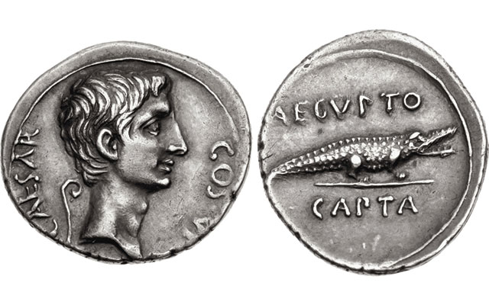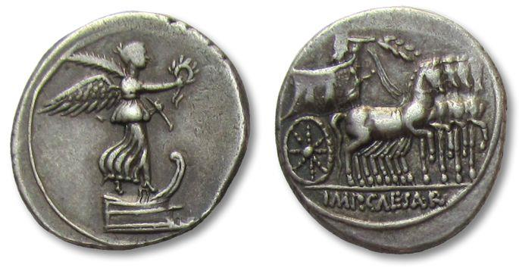

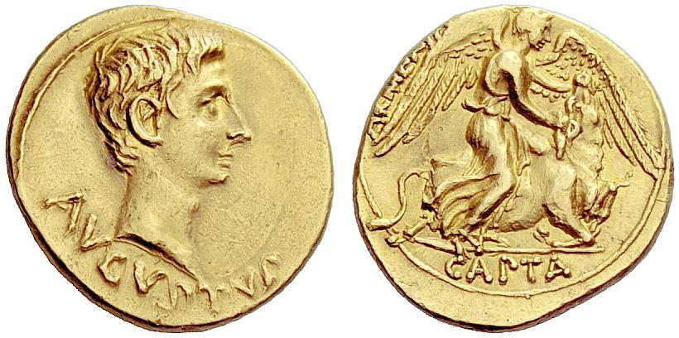

What kind of image of himself as ruler is Augustus trying to create through these coins?

**Prescribed Source – Capture of Armenia, *aureus*, 20 BC or 19-18 BC**

**Obv.:** Bare head of Augustus

**Rev.:** Victory cutting the throat of bull, “Armenia Captured”

**Prescribed Source – Capture of Egypt, *denarius*, 27 BC**

**Obv.:** Bare head of Augustus, “Caesar, Son of the Deified, Consul for the seventh time”

**Rev.:** crocodile, “Egypt captured”

**Prescribed Source – *Denarius* of Augustus 29-27 BC**

**Obv.:** Victory, standing right, on prow, holding wreath and palm

**Rev.:** Octavian standing in ornamented quadriga, holding branch “Victorious Caesar”

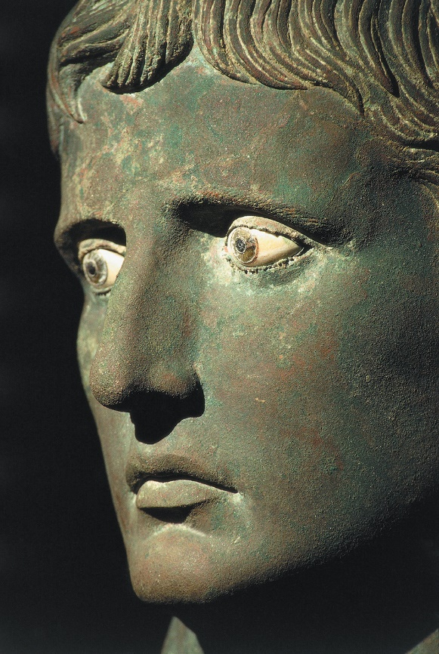**The establishment of Augustus as Emperor**

***Task: from what you have gained so far, summarise the character of Augustus and how he wanted his reign to be seen***

***Assess how the period 31-27 BC is characterised by the ancient sources.***

**THE CONSTITUTIONAL SETTLEMENTS OF 27 AND 23 BC**

**THE FIRST CONSTITUTIONAL SETTLEMENT 27 BC**

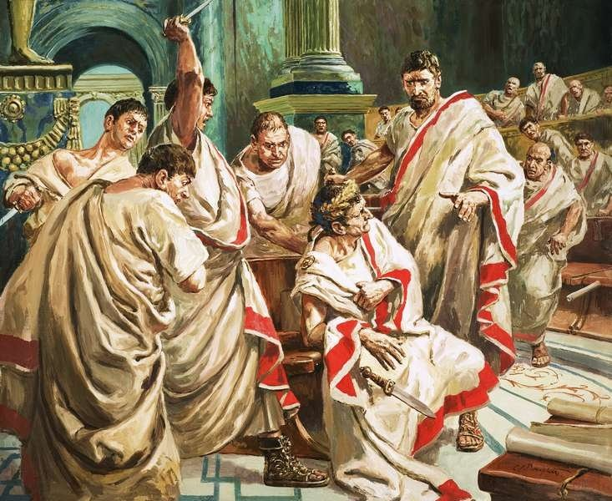When Octavian took power after 31 BC he was keen to stress his military achievements and how these had brought peace and stability to the empire after such a long period of civil war. Once his rule became more established, however, Octavian needed to alter his image away from a wartime leader and towards a legitimate, peacetime ruler. Octavian was also keen to avoid the mistake of his adopted father **Julius Caesar** who assumed the power of a **Dictator** and grew mistrusted leading to his assassination in 44 BC. Rome had a deep suspicion of overly powerful rulers going back to the overthrow of its kings in 510 BC meaning that Octavian had to be seen as the legitimate ruler whose power would be accepted by the people and elites of Rome.

Augustus seems to have been well aware of the need to strike this balance and of the dangers in appearing overly powerful:

**Prescribed Source - Dio, The Roman History: The Reign of Augustus 52:4; (29 BC) Octavian to Agrippa**

‘Equality before the law is an auspicious concept and works very justly in practice. Where we have men to whom heredity has allotted the same kind of nature, who belong to the same race as one another, have grown up under the same institutions, have been trained under similar laws, and contribute in equal degree with one another the service of their bodies and minds to their country, is it not just that they should share equally in all other respects as well, and is it not best that they should receive no distinctions save on account of merit? For equality of birth strives for an equal share of privilege, and if it obtains this it rejoices, while if it fails, it is incensed. Moreover the human race all over the world, since it originated from the gods and will return to the gods, turns its eye upwards and will not consent to be ruled for ever by the same person, nor will it submit to sharing the hardships, the dangers and the sacrifices, while at the same time it is excluded from sharing the advantages. Or if it is forced to accept such conditions, it will hate the regime which has imposed them, and if it can find the occasion, revenge itself upon what it hates.

‘Now all men, of course, claim the right to rule, and for this reason suffer themselves to be ruled in turn. They are unwilling for others to impose upon them, but on this account are themselves obliged not to impose upon other. They take pleasure in those honours which are paid them by their equals, and they approve of the penalties which are inflicted by the laws. If they live under a system of this kind, they regard its advantages as shared by all alike; they desire that no harm should befall any of its citizens, and they offer up their prayers that all its blessings should be enjoyed by the community at large. If any one of them is endowed with any particular excellence, he is most willing to make it public, practises it with enthusiasm and displays it with pleasure. Or if he sees such a quality on one of his fellows, he readily brings it forward, eagerly takes part in fostering it, and honours it most handsomely. On the other hand, if a fellow citizen commits a disgraceful action, he attracts the hatred of all, while if he suffers a misfortune, everyone takes pity on him. In short, each individual regards the resulting disgrace or loss as something experienced by the whole community.

**The Problem: *by 27 BC Octavian needs to establish and formalise his power, Rome and the empire needs strong leadership to recover from almost a century of civil war but the Senate and people are fearful of a new dictator or king – If you were Augustus what would you do?***

Octavian’s solution to this problem would be the **First Constitutional Settlement** in 27 BC. Octavian would get the Senate to offer him complete power, pretend to reject the offer only to then ‘reluctantly’ accept it later on. Octavian would argue that he would take on these powers at the request of the Senate and people and for the good of the state but when he addressed the Senate declared that he could not accept the power. The Senate in return demanded that he take them meaning that Octavian would gain absolute power without appearing to want to or to have aimed to.

**Prescribed Source - Dio, The Roman History: The Reign of Augustus: 53:11 (27 BC)**

11.While Octavian was reading this speech the senators were gripped by a variety of conflicting emotions. There were a few who knew his intention and so continued to applaud him enthusiastically throughout. Of the rest, some listened to his words with suspicion, while others believed them; both were equally astonished, the one at his astuteness and the other at his decision, and both displeased, the former at his scheming, and the latter at his change of mind.

There were already a number of senators who detested the republican constitution as a cause of internal dissension, who had been pleased at the change in government and who warmly supported Octavian. Thus, although his speech inspired different feelings in them, yet their conclusions were the same. Those who believed he had spoken the truth could not openly show their pleasure; those who were in favour of his decision were prevented by their fears, and the others by their disappointed hopes. On the other hand, those who were unconvinced did not dare to attack what he said or to challenge his sincerity, some because they were afraid and others because they had no wish to do so. And so this audience, taken as a whole, were compelled either to believe him or else pretend that they did. As for praising him, some lacked the courage and others the desire to do so. On the contrary, both while he was reading his speech and afterwards they frequently broke in with shouts, pleading for monarchical government and bringing forward every argument in his favour, until finally they compelled him, as it seemed, to accept autocratic powers. Then the first action he took was to have a decree passed granting to the members of his future bodyguard twice the rate of pay which was received by the rest of the army, to ensure that he was strictly guarded. So genuine was his desire to lay down absolute power.

1. What according to Dio was Augustus’ first act after being given autocratic power and why do you think he did this?
2. What do you think is Dio’s tone in the final sentence of this source?

The First constitutional Settlement was the beginning of the **principate** – the period of autocratic rule of Augustus. The power that it gave him, however, was largely honorific i.e. a collection of titles rather than any new power. Octavian gained the following:

* The title **Augustus** which meant ‘revered one’ (Octavian had wanted the name ‘Romulus’ after the legendary founder of Rome but according to Dio this was dropped as it sounded too much like a king.
* The right to decorate his doorposts with laurel
* The award of the Civic Crown (see the coin below where this was commemorated)
* The award and display of the Shield of Virtue
* Recognition of his **auctoritas** (his influence to affect Roman Society)

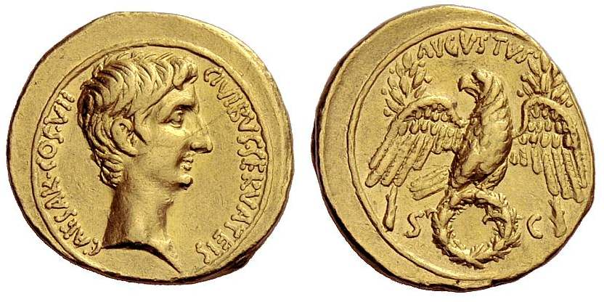

**Prescribed Source – *Aureus* 27 BC**

**Obv.:** Bare head of Augustus “Caesar, consul for the seventh time, for saving the citizens”

**Rev.:** eagle, wings spread, standing on oak-wreath; two laurel branches behind. “Augustus, by decree of the Senate”

One new and very real power that Augustus did gain from the First Constitutional Settlement was a greater control over parts of the empire. Augustus divided the empire into ‘Public’ provinces run by the Senate and ‘Imperial’ provinces run directly by him. He claimed that he took control of those provinces which were still rebellious or close to enemy territory to reduce the burden on the senate but what this meant in reality was that Augustus controlled key provinces in the empire and, most importantly, that he controlled the **army** as this was only needed in those ‘dangerous’ provinces under his control.

**Prescribed Source – Dio, The Roman History: The Reign of Augustus: 53:12 (27 BC)**

12. In this way Octavian’s leadership was confirmed both by the Senate and by the people. Even so, he still wished to be regarded as a representative of the people, and hence while he undertook the whole care and supervision of public business on the ground that it demanded a special degree of attention, he announced that he would not personally govern all the provinces, and that those which he did take on, he would not continue to govern permanently. In the event, he handed over the weaker provinces to the Senate, on the ground that they were at peace and free from war, but he kept the stronger under his authority, arguing that they were insecure and exposed to danger and either had enemies near their frontiers or were capable of starting a serious rebellion on their own initiative. The purpose of this decision, as he explained it, was that the Senate should enjoy without anxiety the fairest territories in the empire, while he should confront the hardships and dangers. But the real object of this arrangement was that the senators should be unarmed and unprepared for war, while he possessed arms and controlled the troops.

Thus it was held that Africa, Numidia, Asia, Greece (including Epirus), the regions of Dalmatia and Macedonia, Crete and the Cyrenaic portion of Libya, Bithynia and the adjoining territory of Pontus, Sardinia and the Spanish province of Baetica should be placed under the control of the Senate and the people. Octavian took charge of the rest of Iberia, that is the regions of Tarraco and Lusitania, and all the Gauls – Gallia Narbonensis, Gallia Lugdunensis, Aquitania and Belgica - both the native inhabitants and the foreign tribes which dwelt among them. I should explain that some of the Celts, whom we call Germans, had occupied all the Belgic territory which borders the Rhine and named it Germany. The southern portion of this region extends to the sources of the Rhine and the northern to the British Ocean. The above provinces, together with those of Coele Syria, Phoenicia, Cilicia, Cyprus and Egypt, were allotted at the same time to Octavian. At a later date he returned Cyprus and Gallia Narbonensis to the people and took Dalmatia for himself. A similar arrangement was adopted later for the other provinces in this way because at the present day each of them is governed separately, whereas originally and for many years they were administered in groups of two or three together. I have not mentioned the others, because some of these were acquired at a later date, and the rest, even if they had already been subdued, were not under the authority of a Roman governor but had either been left autonomous or entrusted to the rule of one kingdom or another. All those territories which came under the authority of the Romans after this period were added to the provinces administered by the emperor who was ruling at the time.

1. Select one quote from this source which sums up why Augustus divided the empire into provinces he ran and those the Senate ran

**Prescribed Source - Strabo, *Geography* 17.3.25**

**Imperial/Public Provinces**

Government of the provinces has been apportioned in different ways at different times. Current arrangements are those laid down by Caesar Augustus. For when his country entrusted him with the pre-eminent position in its governance and he became supreme ruler for life in war and in peace, he divided the whole empire into two parts. One he assigned to himself, the other to the people of Rome. For himself he took all those areas that still needed a military garrison – in effect those that were barbaric, or bordering on tribes not yet brought to heel, or infertile and difficult to cultivate and therefore inevitable prone to break lose and revolt, because whatever else they lack there is never a shortage of military strongholds. All the rest he assigned to the Roman people – all those that were peaceful or easily manageable without resource to arms. Each of the two parts he divided into a number of provinces, designated ‘Caesar’s’ or ‘the People’s’. To his own provinces Caesar dispatched legates and procurators, settling the provincial boundaries and organising their administration in different ways at different times according to circumstances; to their provinces the People send out either praetors or proconsuls, and these too are variously divided according to the requirements of the moment.

To begin with Caesar organised the People’s domain by creating two consular provinces; first, Libya, or as much of it as was under Roman control and outside the realm of Juba originally, and now of his son, Ptolemy; secondly, Asia, consisting of all the territory lying this side of the river Halys, and the Taurus mountains, apart from Galatia and the tribes formerly ruled by Amyntas, together with Bithynia and the Propontis. He then established ten praetorial provinces: in Europe and its neighbouring islands there were Further Spain (so called), the area around the rivers Baetis and Anas; Narbonitis, in Gallia Celtica; thirdly Sardo and Cyrnus (Sardinia and Corsica); then, fourth, Sicily; fifth, Illyria, as far as Epirus, and sixth, Macedonia; seventh, Achaea, as far as Thessaly, Aetolia, Acarnania, and some of the Epirote tribes along the borders of Macedonia; eighth, Crete, together with Cyrenaica; ninth, Cyprus; and tenth, Bithynia, together with the Propontis and certain parts of Pontus.

All the other provinces are Caesar’s. To some of them he sends out as governors men of consular rank, to others praetorians, and to some equestrians. Kings, dynasts, and decarchs are all part of Caesar’s portion – and always have been.

By the end of the First Constitutional Settlement Augustus was eager to say that he had not taken power but have been given it by the Senate and People. He could also claim that although he had been given lots of titles, none of these were new and that Augustus held no more power than any other public figure. In addition to this, the power given to Augustus in 27 BC was limited to ten years and limiting political power to a particular tenure was something done regularly in the republic. This allowed Augustus to deny any claims that he was becoming a king or dictator and even to claim that he was restoring the Roman Republic.

**Prescribed Source – Dio, The Roman History: The Reign of Augustus: 53:12 (27 BC)**

13. This was how the provinces were allotted. And since Octavian wished even then to impress upon the Romans that his mode of government was far removed from monarchical rule, he undertook to limit his administration of the provinces assigned to him to a period of ten years. He promised that he would establish order there within that period, and added with a touch of boasting that, if they were pacified more quickly, he would return them all the sooner to the Senate. Then he first appointed the senators themselves to govern both types of provinces, with the exception of Egypt. For this people alone he appointed a knight, whom I have already mentioned, for the reasons given at that point in my narrative.

In reality, however, this was a **façade**. Augustus controlled the **army** and the **public finances**, and the First Constitutional Settlement confirmed him as king in all but name.

**Prescribed Source - Dio, The Roman History: The Reign of Augustus 53: 16–17 (27 BC)**

16. This was how the regulations were laid down, more or less, at the time. As event turned out, Augustus was to exercise complete and permanent authority over all these matters. This was because he not only had control of the funds, but also commanded the army: nominally the public revenues had been separated from his own, but in practice the former, too, were spent as he saw fit. At any rate, when his ten-year period of office expired, another five years was voted to him, then another five, after that ten, and then ten for the fifth time. Thus through this succession of ten-year periods he remained sole ruler for life. It was for this reason that later emperors, although they were no longer appointed for a limited period but for their entire lives – once and for all – nevertheless always celebrated their reign every ten years, as if they were once more renewing their sovereignty, and the practice continues to the present day.

Octavian had even before received many honours when the questions of declining the sovereignty and of allotting the provinces were being discussed. At that time the privilege of placing the laurel trees on front of royal residence, and of hanging the wreath of oak leaves above them, was voted in his honour to recognize in perpetuity his status as victor over his enemies and the saviour of the citizens. The royal residence is known as the Palatine, not because it was ever decreed that it should be so called, but because Octavian lived on the Palatine hill and had his military headquarters there. The house also gained some measures of renown from the Palatine hill as a whole, because Romulus had once resided there. Accordingly, even if the emperor actually lives somewhere else, his residence keeps the name of Palatium.

When Octavian had finally put his plans into effect, the name Augustus was conferred on him by the Senate and the people. At the time when they wished to give him some title of special eminence, and some people were proposing one title and some another and pressing for its adoption, Octavian had set his heart strongly on being named Romulus. But when he understood that this aroused suspicions that he desired the kingship, he abandoned his efforts to obtain it and adopted the title of Augustus, as signifying that he was something more that human, since indeed all the most precious and sacred objects are referred to as *augusta.* For this reason when he was addressed in Greek he was named *Sebastos*, meaning as august individual: the word is derived from the passive form of the verb *sebazo*, I revere.

17. Through this process the power both of the people and of the Senate was wholly transferred into the hands of Augustus, and it was from this time that a monarchy, strictly speaking, was established. It would certainly be most truthful to describe it as a monarchy, even if at a later date two or three men held supreme power at the same time. It is true that the Romans hated the actual name of monarchs so vehemently that they did not refer to their emperors as either dictators or kings or anything similar. But since the final decision in the governing process is referred to them, it is impossible that they should be anything other than kings. Certainly the offices of state which in general owed their existence to the laws are, it is true, kept in being even now, except for that of censor, but the entire conduct and direction of affairs depend upon the wishes of the one man who holds power at the time. And yet in order to maintain the impression that this authority is derived from the laws and not from their own supremacy, the emperors have arrogated to themselves all the functions, together with their actual titles, attached to those offices in which power resided and which were held with the free consent of the people, with the single exception of the dictatorship.

Thus, for example, the emperors are very often created consuls, and they are referred to as proconsuls whenever they are outside the city limits. They adopt the style of Imperator for life – not only those who have won victories in the field, but all the others besides, to indicate their independent authority – and they use this title instead of those of king or dictator. The emperors have never used these last since they first fell out of use in the conduct of government, but they secure for themselves the prerogatives of these positions through the title of Imperator. This designation empowers them to raise troops, collect funds, declare war, conclude peace, rule foreigners and citizens alike, at all timed and in all places, and even to put to death both knights and senators within the city limits, and to act in all other capacities once entrusted to the consuls and the other officials who possessed *imperium*.

Similarly, by virtue of holding the censorship they scrutinize our lives and morals as well as conducting the census; they add some names to the orders of knights and senators and strike out others as they see fit. Then by virtue of being consecrated in all the priesthoods, and of being entitled to confer most of these offices upon others, and because of the fact that, even if two or three persons share the imperial power at the same time, one of them is Pontifex Maximus, they exercise supreme jurisdiction in all matters both profane and sacred.

The so-called tribunician power, which was once held only by men whose influence was rapidly beginning to climb, gives them the right to veto the consequences of any measures taken by any other official, should they disapprove of any such, and protects them against insult or abuse. Moreover, if they appear to have suffered, even to the most trivial extent, not only by deed, but even by word, they may destroy the perpetrator as one guilty of sacrilege, without a trial. The emperors, it should be explained, do not see fit to become tribunes, since they belong entirely to patrician class. But they assume tribunician power to the full as this existed when the office was at the height of its political influence, and they use it to number the years of their rule, the principle being that they receive the power each year together with those who are regularly appointed tribunes. These then are the offices which they have arrogated to themselves from the republic. They have preserved the form in which each of them was instituted, and retained the same titles for them. Their object has been to create the impression that they hold no power without a gift having been made of it to them.

1. How far do you agree with Dio’s view that “It would certainly be most truthful to describe it [Augustus’ power] as a monarchy”? (A developed and fully explained paragraph needed)
2. How does the following view of Velleius Paterculus on the Settlement of 27 BC compare to that of Dio?

**Prescribed Source – Velleius Paterculus, *History of Rome*, 2.89.3-4**

89.3. Twenty years of civil strife were ended, foreign wars laid to rest, peace restored, and man’s crazed lust for warfare everywhere dead and buried. Force was restored to the laws, authority to the courts, majesty to the senate; the power of the magistrates was reduced to its former limits, except that two praetors were added to the eight; the ancient, traditional form of the republic was brought back. 89.4 Fields were cultivated once again, religious rites observed; men felt safe at last, with their property rights secured. Existing laws were revised and improved; new ones passed to the general advantage. The senatorial lists were revised strictly, but not unkindly; leading citizens who had earned triumphs and other civic distinctions were encouraged by the *princeps* to contribute to the adornment of the city.

**THE SECOND CONSTITUTIONAL SETTLEMENT 23 BC**

The First Constitutional Settlement gave Augustus **absolute power** but contained problems that by 23 BC Augustus wished to correct.

* Firstly Augustus’ power came from a loose collection of prestigious titles and honours but was not yet fully formalised. This would make passing on this power to a successor difficult as it was not clear or precise what was being passed on. The power of the emperor needed to be formalised if it was going to be passed on.
* Secondly, the first settlement had given Augustus permanent control of one of the two consulships. This was a traditional power but it closed off a potential appointment and promotion for senators and could cause unrest from this group.

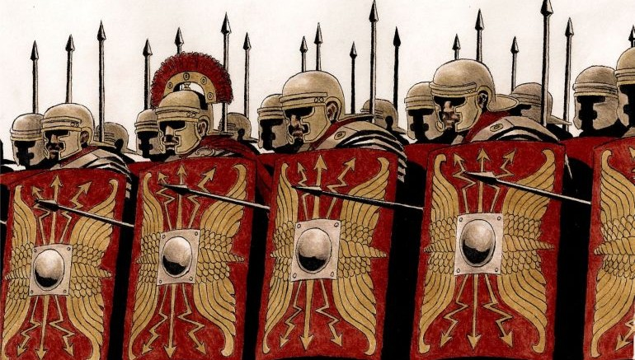The **Second Constitutional Settlement** of 23 BC would therefore formalise two specific positions and powers of Augustus:

1. Augustus was given ***imperium proconsulare maius*** (‘power greater than that of a proconsul’). This meant that the emperor had the power to overrule any provincial governor) or proconsul) and that he kept his power over the army. The consulship had given Augustus these powers before 23 BC but this was now unnecessary and he was free to give up the position of consul. Augustus’ control of the army was in fact enhanced. Previously as a consul he was required to give up this power once he entered the city of Rome (known as crossing the **pomerium** or sacred boundary), now he had permanent power over the army for life and was able to pass this on to his successor.
2. Augustus was also given ***tribunicia potestas*** (the power of one of the ten, annually elected tribunes – officials meant to represent the interests of the people of Rome, also known as tribunician power). This was the most important power Augustus gained in the Second Constitutional Settlement. It gave him the right to propose, pass or veto any legislation. Augustus would also use the position to indicate potential successors by appointing them co-tribunes. The significance of Augustus’ tribunician power is evident from the fact that he used it to date his reign e.g. “in the sixth year of his position as tribune…”

The Second Constitutional Settlement, therefore, codified the powers the emperor had and was these powers that would be passed on to each new emperor, signifying their absolute power. Significantly, though it was done through titles and positions that had existed under the Republic allowing Augustus to, falsely, claim that he had restored it.

**Prescribed Source - Tacitus, *Annals,* 3:56 (H26)**

**Tribunician Power (23 BC)**

The tribunician power was a term formulated by Augustus to express the supremacy of his own position. It allowed him to avoid the title of king or dictator, while giving a title to his predominant position in all the highest offices of state. He then selected Marcus Agrippa to share his title with him as colleague and, after his death, Tiberius Nero, thus ensuring that there could be no doubt about his intended successors. Since he had complete confidence in Tiberius; lack of ambition as well as his own pre-eminence, he hoped that this would prevent others from developing unhealthy ambitions for the throne.

1. List and explain three things tribunician power allowed Augustus to do











**Prescribed Source - Tacitus, *Annals,* 1: 2.1**

2.1 After the death of Brutus and Cassius, the republic no longer had an army. Pompey had been defeated in Sicily, Lepidus disposed of, and Anthony killed. As a result even the Julian faction had only Caesar left to lead them. He laid aside the title of triumvir and presented himself as a consul, content to defend the people by virtue of the tribunician power. Thereafter, once he had seduced the soldiery with gifts, the people with corn, and everyone with the delights of peace, he gradually increased his power, arrogating to himself the functions of the senate, the magistrates and the law. He faced no opposition, since the bravest souls had died in battle or fallen victim to prosecution, while the surviving nobles enjoyed a wealth and status which increased in proportion to their servility; and having profited by revolution, the preferred present safety to the insecurity of the past.

1. What, according to Tacitus, was the process by which Augustus gained his power in Rome? (How did he do it?)
2. **To what extent did Augustus restore the Roman Republic by 23 BC? When answering this question you must ensure that you develop a balanced answer and that you use at least once primary source on each side of your answer. (write separately)**

**The Constitutional Settlements**

**THE SECOND CONSTITUTIONAL SETTLEMENT**

**DATE:**

**WHAT POWERS DID AUGUSTUS GAIN?**

**KEY TERMS ASSOCIATED WITH THE SETTLEMENT:**

**THE FIRST CONSTITUTIONAL SETTLEMENT**

**DATE:**

**WHAT POWERS DID AUGUSTUS GAIN?**

**KEY TERMS ASSOCIATED WITH THE SETTLEMENT:**

**The Restoration of the Republic and of traditional Roman Values**

**Starter Question** – Can you think of any other times in history when a ruler or leader has campaigned to bring back traditional values?

For Augustus it was important to present an image of having restored the republic and this meant also restoring what were seen as ‘traditional’ morals and values. Augustus would argue that Rome had been corrupted by outside influences and Romans had become too concerned with luxury and decadence.

One way Augustus presented this image of restoration was through coinage:

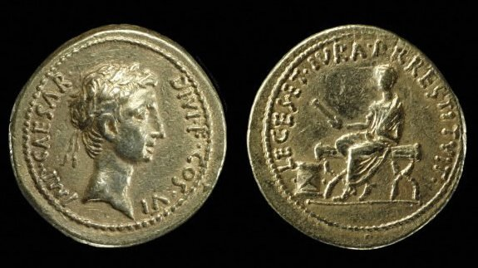**Prescribed Source – New *aureus* 28 BC**

**Obv.:** Head of Octavian, wearing laurel wreath “Commander Caesar, Son of the Deified, consul for the sixth time”

**Rev.:** Octavian seated on magistrate’s chair wearing toga, holding out scroll in right hand “He has restored to the Roman People their laws and rights”

**Prescribed Source – Lost *aureus* showing Augustus raising fallen *Res Publica* to her feet, 12 BC**

**Obv.:** Bare head of Augustus “Augustus””

**Rev.:** Augustus wearing toga extending his right hand to a personification of the Roman State (*Res Publica*) who kneels before him. “The State; Augustus”

Another way in which the idea of restoring old values and traditions was reinforced under Augustus was through poetry:

**Prescribed Source - Horace, Odes 3.6**

Ancestral crimes, though innocent, you’ll pay

The gods for, Roman, till you restore

Their temples, their crumbling shrines,

And images with black smoke besmirched.

What is Horace referring to by “the gods have visited many woes”?

Because you hold yourself less than the gods, you rule.

Hence your beginning: to this ascribe your end.

Neglected, the gods have visited many

Woes upon grief stricken Italy.

Already twice Monaeses’ and Pacorus’

Band have supressed our unhallowed

Onslaughts and grin at having added

Our booty to their scanty ornaments.

Almost pre-occupied with civil strife,

By Dacian and Ethiopian was our Rome

Destroyed – the latter fearsome with his fleet,

More skilled the Dacian with his arrow-flight.

What type of moral decline does Horace think has happened in Rome?

Fertile in sin our times stained first

The marriage-bed, the family, the home.

Sprung from this fount, disaster’s flood has rolled

Across our fatherland and populace.

The maiden ready for marriage delights

To learn Ionic dances and acquires

Accomplishments. To her very fingertips

Her thoughts run all on unchaste love.

Soon she’s hunting younger adulterers

At her husband’s parties, not choosing

Partners for forbidden pleasures

Snatched in haste with the lights away,

But going openly with whoever asks

With her husband in the know,

Whether it’s a salesman or a Spanish ship’s

Captain, big spender purchasing her shame.

Not from such parents sprang the youths

How does Horace view Rome in its past?

Who stained the sea with Punic blood,

Smote Pyrrhus, mighty Antiochus

And dread Hannibal. For these

Were manly offspring of a rustic stock,

The sons of soldiers, taught to turn the soil

With Sabellian mattocks, homeward then return

Obeying their strict mother’s call,

Bearing their load of timber for the fire,

While waning Sun shifts shadows on the hills,

Frees up the oxen’s yoke, and brings the happy hour

Behind his own departing chariot wheels.

What has destructive Time not rendered worse?

Our parents, more degenerate than their sires,

In us have fathered still more rotten stock –

And yet more prone to vice will be our heirs.

This idea of restoring traditional values is also seen in **Virgil’s *Aeneid****.* When Aeneas is seeing the pageant of Roman heroes (see earlier source) Augustus is described as “Augustus Caesar, son of a god, who shall bring back again the age of gold to Latium”

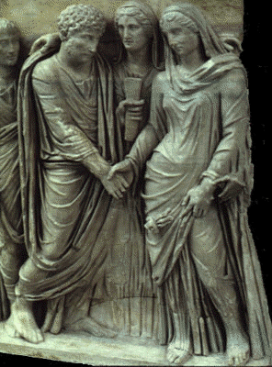

Augustus’ desire to restore traditional values and stop what he saw as the moral decline of Rome was most evident from two laws passed by him which tried to reduce adultery and create more ‘pure’ and legitimate children.

**Prescribed Source – Suetonius *Augustus,* 40**

Augustus thought it most important not to let the native Roman stock be tainted with foreign servile blood, and was therefore very unwilling to create new Roman citizens or permit the manumission of more than a limited number of slaves. Once, when Tiberius requested that a Greek dependent of his should be granted citizenship, Augustus wrote back that he could not assent unless the man put in a personal appearance and convinced him that he was worthy of the honour. When Livia made the same request for a Gaul from a tributary province, Augustus turned it down, saying that he would do no more than exempt the fellow from tribute – ‘I would far rather forfeit whatever he may owe the imperial exchequer than cheapen the value of the Roman citizenship.’ Not only did he make it extremely difficult for slaves to be freed, and still more difficult for them to attain full independence, by strictly regulating the number, condition and status of freedmen, but he ruled that no slave who had ever been born in irons or subjected to torture could become a citizen, even after the most honourable form of manumission.

1. Why according to Suetonius was Augustus concerned about Roman marriage and the birth of children?

The two laws Augustus introduced were the ‘**Julian Law on the duties of husbands’** and the **‘Julian Law on constraining adultery.’** Together they were known as Augustus’ moral reforms and were targeted primarily at the Roman upper classes (senators and knights) to try to create a more ‘pure’ future generation of Romans.

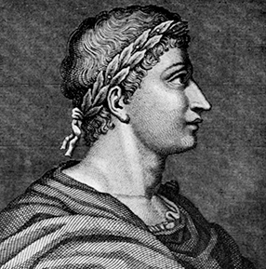**Prescribed Source - Ovid, *Fasti* 2.119–144**

**Augustus as *pater patriae***

O that I had a thousand voices, and such a spirit in my breast as that

By which you told the tale of great Achilles, Homer of Maeonia,

That I might sing with alternating lines the holy Nones:

This is the highest honour yet bestowed upon my Calendar.

My inspiration fails, my strength crumples beneath the load; for this

Above all other days is that which these songs must celebrate.

Madman I was. How could I think to lay such awesome weight upon

Frail elegiacs? This was a theme for high heroic verse.

*Pater Patriae*, your Country’s Holy Father, such is the name and title

Conferred upon you by People, Senate and my own Equestrians.

Events preceded us. Late though it was, your title merely matched

The achievement; for long since have you been Father of the World.

Yours is the title here on earth which high in heaven is that of Jupiter;

Father you are of men on earth, as of gods in heaven is Jupiter.

Romulus, yield pride of place: mighty the walls Augustus’ guardianship

Has given to Rome, while yours were such that Remus lightly leaped across.

Tatius and tiny Sabine Cures felt your power; Caenina too. But Roman

From furthest east to utmost west have Caesar’s conquests made

All that the sun beholds. You, Romulus, held some tiny stretch

Of conquered land. Caesar controls all that there is beneath the gaze

Of lofty Jupiter. You raped, where Caesar commanded sacrosanctity

For wives; your grove played host to wickedness, Caesar repulsed it.

Violence you ever loved; while Caesar cherishes the rule of law.

You were Rome’s lord and master – he simply *princeps*, our first citizen.

Remus denounced you; Caesar forgave his enemies. You to the heavens

Were by your father raised; Caesar raised his father.

1. What seems to be Ovid’s view on Augustus’ reforms – provide one brief quote from the poem in your answer.
2. How popular do you think Augustus’s moral reforms would have been more generally amongst the population of Rome?

Augustus’ revival of traditional Roman values went further than just these marriage reforms. He also restored the official census, carrying out the first census of the Roman people in 42 years. During his reign he would carry out three censuses: in 28 BC, 8 BC and 14 AD. Augustus’ choice of title was also designed to reinforce the image of him as a traditional leader and not one who had transformed Rome. For example, Augustus is meant to have repeatedly refused the title of **dictator** when it was offered to him by the Senate. The title was a legal position in Rome but one that had rarely been taken (most recently under Julius Caesar) and Augustus relied instead on his power as one of the two consuls originally and from 23 BC his tribunician power.

**Prescribed Source – Velleius Paterculus, *History of Rome*, 2.89.5**

89.5 Only the office of consul was Caesar prevailed upon to hold successively, despite his frequent protestations, until his eleventh election. Later he was to refuse it vigorously. His rejection of the dictatorship was as obstinate as the people’s determination to offer it to him.

**AUGUSTUS’ ATTITUDE TOWARDS RELIGION**

**Prescribed Source - Horace, *Odes* 1.2**

Enough for now has Father Jupiter poured out

Upon the earth in snow and biting hail, while with his red

Right hand he smote our holy citadels and brought

Dread to the city,

Dread to the nations, that the grim time might return

When Pyrrha bewailed portents not seen before,

When Proteus drove all his seals to visit

The high mountains,

Shoals of fishes stuck in the tops of elms,

Habitations formerly familiar to doves,

And panic-stricken deer swarm in the flood

That covered the land.

We have seen yellow Tiber, his waves

Repulsed with violence from his Tuscan shore,

Rush to hurl down the King’s memorial

And Vesta’s temple,

Boasting of vengeance won for his spouse,

Importunate Ilia, as his vagrant waters spread,

Against Jupiter’s will, beyond his left bank,

Wife-besotted river.

Of citizens sharpening swords against citizens,

By which grim Persians better would have perished,

And of their battles the youth shall learn, made few

By their parents’ vice

Which god shall the people call to aid the crumbling

Empire? With what prayers shall the holy virgins

Weary the ears of Vesta, now less inclined

To hear the hymns?

To whom shall Jupiter assign the task of sin’s

Atonement? Come at last, we pray you, adorned

With clouds to cloak your radiant shoulders,

Prophet Apollo.

Or, if you prefer, come Venus, smiling Queen

Of Eryx, round whom hover Laughter and Longing.

Or, if you care for your neglected race and offspring,

Come founder Mars,

Glutted, alas, with too long drawn-out sport,

Delighting in battle-cries and helmets polished smooth,

And in the fierce gaze of Marsian infantry

Against their bloodied foe.

Or Mercury, winged son of bountiful Maia,

If you have changed form and on earth

Are imitating a youth and willing to be called

Caesar’s avenger,

Return late to heaven and long be pleased

To dwell amongst the people off Quirinus,

And may no wind bear you off too soon,

Angry at our sins.

Remain here rather, delighting in great triumphs,

And being called Father and *Princeps*,

And do not permit the Medes to ride unpunished,

While you are leader Caesar.

1. Can you work out from this poem what Horace views Augustus as?
2. Why do you think religion would be so important to Augustus?

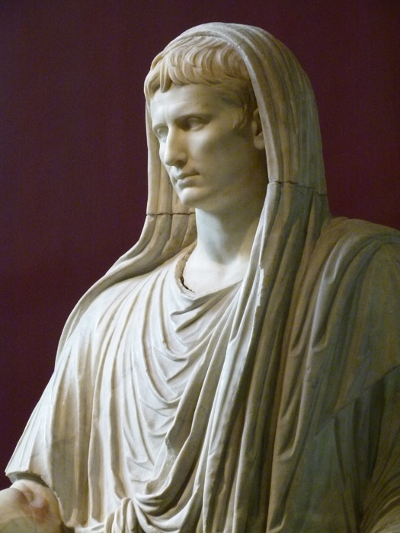

From the start of his reign Augustus was eager to be viewed as a devout figure but also someone who was carrying out the gods work on Earth. He held seven different priesthoods at once and was in 12 BC elected to the position of **Pontifex Maximus** – the chief priest of the Roman religion. For Augustus, religion was another traditional value that he wanted to revive, and he also wanted to present his reign a time when the gods protection of the Romans was restored after almost a century of civil war. To make this point, Augustus would restore temples and build new ones across Rome. He would also use coinage to stress his religious role:

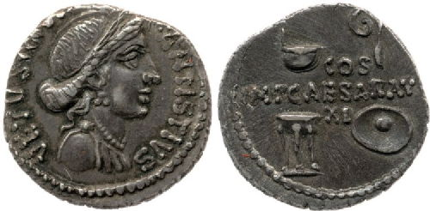

**Prescribed Source – Symbols of four priesthoods held by Augustus, *denarius*, 16 BC**

**Obv.:** Bust of Venus; “Caesar, Son of the Deified, Consul for the seventh time”

**Rev.:** ladle, augur’s wand, tripod and sacrificial bowl; “Imperator Caesar Augustus, consul for the eleventh time”

In the *Aeneid*, Virgil would claim that Augustus restored some 300 shrines whilst the poet Ovid also emphasised this:

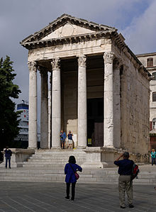**Prescribed Source - Ovid, *Fasti* 2.55–66**

**Augustus’ restoration of temples**

At February’s beginning, so they say, our Saviour Juno, neighbour

To Phrygia’s Mother Goddess, was honoured with new temples.

Where are they now, those temples which on Kalends long ago

Were consecrated to her? Fallen they lie, victims of time’s long march.

It was our blessed leader’s care and providence that all the rest should

Never be suffered likewise to decay crumbling into ruination.

Beneath his care our temples do not feel the searing touch of age; and so

He binds by ties of obligation not just mankind but all the gods as well.

O holy one, builder of temples and re-builder too, this is my prayer:

May all the gods repay your care by mutual benefaction, and grant

You years in heaven to match the years on earth you gave to them.

May they for ever at your doors take posts as guardian sentries.

In ancient Rome and in the case of Augustus, however, the emperor would go further than being the Pontifex Maximus. Upon his takeover of power, there were calls in the eastern pat of the Roman empire for the emperor to be worshipped as a **living god**. This would become known as the **imperial cult**.

The worship of Augustus as a living god began in the east but would eventually spread to the western parts of the empire too.

**Prescribed Source – Suetonius *Augustus* 93**

Augustus showed great respect towards all ancient and long-established foreign rites, but despised the rest. Once, for example, after becoming an initiate at Athens, he judged a case in which the privileges of the Attic Ceres’ priests were questioned. Since certain religious secrets had to be quoted in the evidence, he cleared the court, dismissed his legal advisers, and settled the dispute *in camera*. On the other hand, during his journey through Egypt he would not go out of his way, however slightly, to honour Apis, and he praised his grandson Gaius for not offering prayers at Jerusalem when he was travelling near Judaea.

1. Why do you think Augustus might be originally cautious about allowing the imperial cult to develop?

The first temple to Augustus to be sanctioned by the emperor would be at Pergamum in Asia Minor (modern day Turkey) in 29 BC:

**Prescribed Source - Tacitus, *Annals,* 4:37**

The Deified Augustus did not prevent the building of a temple at Pergamum to himself and the City of Rome.

The worship would then spread westwards and would also be seen in Rome itself. Romans believed that everyone carried an element of the divine in themselves called the **numen** along with their **genius**, or spirit. It was these that would be worshipped in Augustus and could be done so without Augustus claiming to be more than human. Evidence of the worship of Augustus in Rome comes from Ovid:

**Prescribed Source - Ovid, *Fasti* 5.140–158**

Do some quick research and record a definition for the term *lares*:

**Worship of the genius (divine spirit) of Augustus**

To the *Lares Compitales* cross-roads are dear; to dogs no less.

The *Lares* hunt down thieves; Diana’s hound-packs likewise.

Sleepless the *Lares* watch by night; sleepless too the dogs.

I sought the twin statues of those twin divinities and found

Nothing; perished they were by the power of time’s decay.

Rome has a thousand twin *Lares* now, and a leader’s *Genius*, whose gift

Bestowed them. Every district now pays honour to its three divinities.

I ramble. For to this theme Augustus’ month lays claim. My song

Must needs return to hymn the *Bona Dea*, our Good Goddess.

A pinnacle there is of natural rock from which derives its name,

The Crag, they call it. Of Mount Aventine it forms a goodly part.

Where according to Ovid is the ‘genius’ of Augustus being worshipped?

Here Remus took his futile stance while to his brother’s gaze

The birds of Palatine vouchsafed the earlier omens. There

On that gently sloping ridge the Senators established

A temple that abominates the gaze of men. An heiress

Of the ancient name of Clausus made the dedication, a maid

Whose body never had experienced sexual intercourse.

Livia restored that shrine, that she might never fail to imitate

Her husband and in all ways to follow him.

Ovid’s suggestion that Augustus was being worshipped as a protective spirit at crossroads is also confirmed by the following inscription from Rome, in which priests to the cult of the Augustan Lares were being appointed from freedmen:

**Prescribed Source – The introduction of the cult of the Augustan Lares at Rome, 7 BC**

To the Augustan *Lares*: the priestly attendants who on 1 August first took up post: Antigonus, the slave of Marcus Iunius Eros, Anteros, the slave of Decimus Poblicius Barna, Eros, the slave of Aulus Poblicius Dama, Iucundus, the slave of Marcus Plotius Anteros.

[Lares – protecting spirits]

**Summary Questions on Religion**

**Prescribed Source – Altar to the *numen* of Augustus, AD 12-13, Narbonne (in Gaul – modern-day France)**

[On the front]

During the consulship of Titus Statilius Taurus and Lucius Cassius Longinus on 22 September, a vow was undertaken by the commoners of Narbo in perpetuity:

May it be good, favourable and prosperous for Imperator Caesar Augustus, son of the Deified, Father of the Fatherland, chief priest, in his 34th year of tribunician power, for his wife, children and family, and for the senate and Roman people and for the colonists and inhabitants of the Julian Ancestral Colony of Narbo Martius, who have bound themselves to worship his divinity for ever. The people of Narbo have set up an altar at Narbo in the forum, at which, each year on 23 September, on which the good fortune of the age brought him forth as governor of the world, three Roman equestrians from the commoners and three freedmen are to sacrifice a victim each and are to supply at their own expense to colonists and inhabitants on this day incense and wine for worshipping his divinity; and on 24 September they are also to supply incense and wine to colonists and inhabitants; also on 1 January they are to supply incense and wine to colonists and inhabitants; also on 7 January, on which day he first entered upon his rule over the world, they are to worship with incense and wine and sacrifice a victim each and supply incense and wine to colonists and inhabitants on this day; and on 31 May, because on this day in the consulship of Titus Statilius Taurus and Manlius Aemilius Lepidus he brought the commoners’ judgements into harmony with the town councillors, they are to sacrifice a victim each and supply incense and wine to colonists and inhabitants for worshipping his divinity. And one of these three Roman equestrians [or three] freedmen…

[On the right side]

The commoners of Narbo have dedicated an altar to the divinity of Augustus (2 lines erased) according to the regulation which have been written below:

Divinity of Caesar Augustus, Father of the Fatherland, when I give and dedicate to you today this altar, I shall give and dedicate it by these regulations and in these regions, which here today I shall declare openly, as the lowest soil is of this altar and inscriptions: if anyone will wish to clean, decorate or restore it, let what may be done for its benefit , be permitted by both human and divine law; or if anyone will carry out a rite with a sacrificial victim, who does not hold up the entrails in front of him, nevertheless, as far as this is concerned let it be done validly; if anyone will wish to give a gift to this altar and to enrich it, let it be permitted, and let the same law exist for this gift as for the altar of Diana on the Aventine. By these laws and in these regions, just as I have declared, I give and dedicate this altar to you in the interests of Imperator Caesar Augustus, Father of the Fatherland, chief priest, in his 35th year of tribunician power, of his wife, children and family, of the senate and the Roman people, and of the colonists and inhabitants of the Julian Ancestral Colony of Narbo Martius, who have bound themselves to worship his divinity in perpetuity, so that you may willingly be propitious.

1. What does the inscription above reveal to you about the significance and extent of the imperial cult?
2. Why did Augustus need to be cautious about allowing the cult to establish?
3. Why nevertheless would the imperial cult be an advantage to Augustus (think carefully and try to include a minimum of three points in your answer)?
4. What tone do you detect in the following source from Tacitus and what does this tell you about the way some people viewed the imperial cult?

**Prescribed Source – Tacitus, *Annals,* 1.10.6**

10.6 There were no honours left for the gods, now that Augustus chose to be worshipped with temples and godlike images by *flamines* and priests.

**THE ADMINISTRATION OF ROME AND THE PROVINCES**

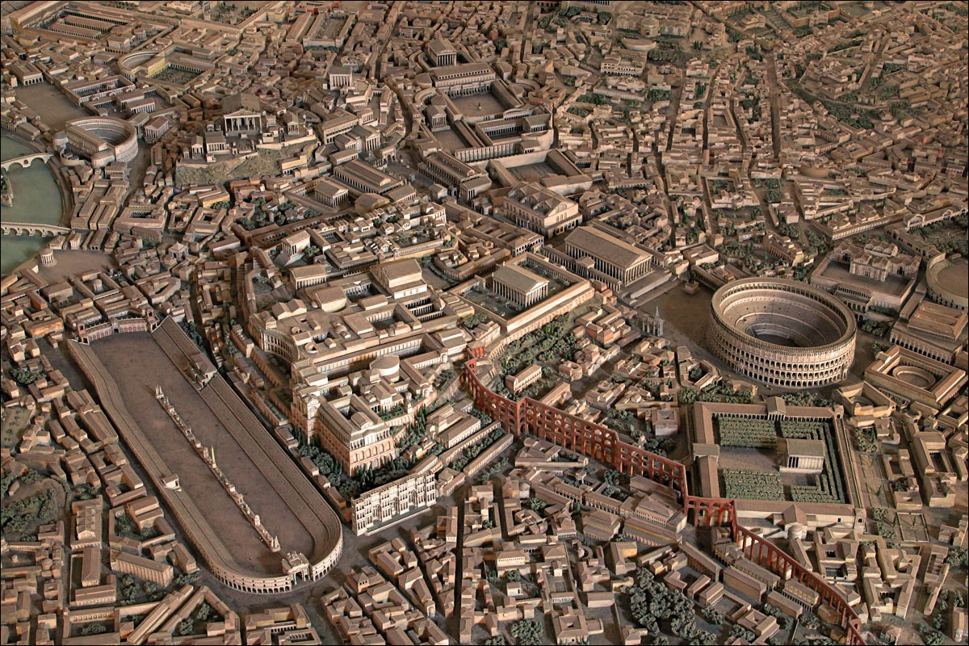

Augustus passed a series of reforms designed to improve the organisation and government of the city of Rome and the provinces of the empire.

**RECAP: How had Augustus divided up the Empire in the Fist Constitutional Settlement and why?**

1. Rome was divided in **thirteen** districts, each under the control of a magistrate chosen annually by lot. Each district was then divided in **wards** with locally elected officials
2. Augustus established a **fire brigade** for Rome and created regulations to reduce the risk of fire in the city

**Prescribed Source – Suetonius, *Augustus* 30**

30. Augustus divided the city into districts and wards, placing the districts under the control of magistrates annually chosen by lot and the wards under supervisors locally elected. He organized stations of nightwatchmen to watch for fires; as a precaution against floods, he cleared the Tiber channel, which had been choked by an accumulation of rubbish and narrowed by projecting houses. Also, he improved the approaches to the city, revamping the Via Flaminia as far as Ariminum at his own expense, and calling upon men who had won triumphs to spend their share of the plunder on putting the other main roads into good condition. Furthermore, he restored ruined or burned temples, beautifying these and others with the most lavish gifts – for instance, a single donation to Jupiter Capitolinus of 16,000 pounds of gold, besides pearls and precious stones to the value of 50 million sesterces.

**Prescribed Source - Strabo, *Geography* 5.3.7**

Caesar Augustus took a particular interest in the constant deterioration of the fabric of the city from fire, collapse and the fashion for renovation, mentioned above. To control the damage by fire he formed a fire brigade recruited from freedmen to bring help where needed; to reduce the danger of collapse he placed restrictions on the height of all new building, and a limit of seventy feet on the height of all buildings fronting onto the public streets.

1. Augustus extended the ‘sacred boundary’, known as Rome’s **pomerium**, enlarging the city. This was an act which would later on become a tradition for Roman emperors, as is clear from Tacitus when writing about the later emperor Claudius:

**Prescribed Source - Tacitus, *Annals,* 12:23**

Claudius also extended the *pomerium*, the sacred boundary of Rome, following ancient tradition whereby those who have expanded the empire are accorded the privilege of also extending the boundary of Rome. Yet no Roman general, with the exception of Lucius Sulla and the deified Augustus, had ever exercised this right, however great the nations they had conquered.

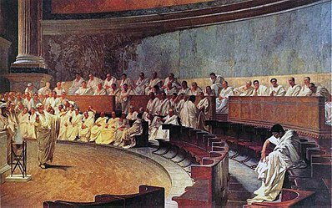In addition to changes to the organisation of the city of Rome, Augustus also made considerable changes to the **Senate** itself. Augustus’ aim was to reduce the overall size of the Senate and to ensure its loyalty (remember that his adopted father Julius Caesar had been assassinated by disloyal senators in the building itself). When Augustus took power there 1,000 senators and would revise this number in 29, 18 and 11 BC. The property qualification to become a senator was more than doubled from 400,000 sesterces to 1 million, and senatorial status was made hereditary meaning that there would be less change of its members. In 29 BC 190 senators were removed in this way and by 18 BC the total number of senators had fallen to 600.

Augustus realised, however, that he needed to be careful in his handling of the Senate; it was a potential source of opposition and Augustus was also claiming to be restoring the republic, at the heart of which had been the Senate. He therefore created a number of laws and reforms designed to appeal to the senate:

* Augustus banned the publication of the ‘**Proceedings of the Senate’** which was a record of what was discussed in the Senate. This gave senators much greater freedom and much less fear of public reaction to what they said
* He created new offices (jobs) for the upkeep of public buildings, roads and aqueducts, and for the distribution of grain. These were all new posts that could now be filled by ambitious senators

**TASK: highlight the reforms listed above in the source below from Suetonius**

**Prescribed Source – Suetonius, *Augustus* 36-37**

36. Among Augustus’ other innovations were a ban on the publication of the *Proceedings of the Senate*; a statutory interval between the conclusion of magistracies and their holders’ departure to provincial appointments; a fixed mule-and-tent allowance to provincial governors, replacing the system by which they contracted for these necessities and charged them to the public treasury; the transfer of the treasury from the control of city quaestors to that of praetors or men of praetorian status; and the ruling that a board of ten, instead of men of quaestorian status, should convoke the centumviral court.

37. To give more men some experience in the administration of public affairs, he created new offices dealing with the upkeep of public buildings, roads and aqueducts, the clearing of the Tiber channel, and the distribution of grain to the people. He also established the office of prefect of the city, a board of three for choosing new senators, and another for reviewing the troops of *equites*, whenever this was needed. He also revived the long obsolete custom of appointing censors, increased the number of praetors, and requested not one colleague but two whenever he held a consulship. The Senate, however, refused this last plea, everyone shouting that it was a sufficient detraction from his supreme dignity to acknowledge even a single colleague.

* Two new offices of **praetor** (annually elected magistrates responsible for justice) were created

**Prescribed Source – Velleius Paterculus, *History of Rome*, 2.89.3-4**

89.3. Twenty years of civil strife were ended, foreign wars laid to rest, peace restored, and man’s crazed lust for warfare everywhere dead and buried. Force was restored to the laws, authority to the courts, majesty to the senate; the power of the magistrates was reduced to its former limits, except that two praetors were added to the eight; the ancient, traditional form of the republic was brought back.

* Augustus created the position of **praefectus urbi** (Prefect of the City) who would run the city of Rome on a day-to-day basis and would be selected from the ranks of the senators

**Prescribed Source - Tacitus, *Annals,* 6:10-11**

**The post of city prefect (*praefectus urbi)***

10. But Piso’s particular distinction was that as city prefect he tactfully exercised the power of an office which had only recently been made permanent and which commanded only sullen obedience.

11. During the civil wars Augustus gave Cilnius Maecenas, a member of the equestrian order, total control over the administration of Rome and Italy. Later, when he became absolute ruler, the sheer size of the population and the ponderous inflexibility of legal remedies forced him to appoint a man of consular rank to control the slave population and the more disorderly elements of the populace, whose unruly tendencies yield only to the threat of force. Messala Corvinus was the first to hold this office, which he surrendered within a few days because he claimed that he did not know how to exercise its powers. Then Statilius Taurus had a distinguished tenure, despite his advance old age. Finally Calpurnius Piso held the post for some twenty years with no less distinction, which by senatorial decree earned him a state funeral.

Augustus’ desire to reform and to control the day-to-day decisions of Roman government extended beyond the city and out into the empire. The provinces would have most likely appreciated this change as rather than dealing with the complicated machinery of republican government, they now had one figure in Rome – the emperor – to appeal to. The level of Augustus involvement across the empire is made clear by the **Edicts of Cyrene**, a set of laws from Augustus that were created in 7 or 6 BC to improve the legal procedures in one particular city in North Africa.



**Prescribed Source –Edicts of Augustus 7-6 BC, Cyrene**

[Edict 1] Imperator Caesar Augustus, chief priest, in his 17th year of tribunician power, *imperator* 14 times, proclaims: since I find that 215 Romans in all from every age group in the province of Cyrene have a census rating of 2,500 *denarii* or more, from whom jurors are drawn, and that among them there are some cliques, and since embassies from the province’s cities have complained bitterly that these have been oppressing the Hellenes in lawsuits involving the death-penalty, with the same individuals prosecuting and bearing witness for each other in turn, and since I myself have learnt that some innocent people have been crushed in this way and have been carried off to the ultimate punishment, until the senate deliberates about this matter or I myself find some better solution, the governors of the province of Crete and Cyrene, in my opinion, will be acting honestly and appropriately if they appoint to the province of Cyrene the same number of Hellenic jurors as of Romans from the highest census ratings, nobody less than 25 years old, whether Roman or Hellene, and if indeed there is an abundance of such men, nobody with a census rating and property less than 7,500 *denarii*, or if the number of jurors who need to be appointed cannot be met in this way, let them appoint people with half, and not less, of this census rating as jurors in trials of Hellenes involving the death penalty. And a Hellene who is on trial, one day before the prosecutor begins to speak, is to be given the power over whether he wants all his jurors to be Roman or half to be Hellenes. If he has selected half Hellenes, then once the balls have been weighed and names written on them, let there be drawn from the one urn the names of the Romans and from the other those of Hellenes, until up to 25 of each race have been selected, of whom the prosecutor may reject up to one from each race if he wishes, and the defendant three in all, provided he rejects neither Romans nor Hellenes exclusively; then all the rest should depart for the voting and give their votes separately, the Romans casting their votes into one voting-urn, and the Hellenes separately into another. Then once the tallying of votes on both sides has been done separately, the governor is to declare publicly what is the judgement of the majority of all jurors. And since for the most part the relatives of the deceased do not leave unjust deaths unavenged, and since it is likely that Hellenic prosecutors on behalf of the dead who are kinsmen or fellow citizens will not be lacking who will exact punishment from the guilty, all who are the governors of Crete and Cyrene, in my opinion, will be acting justly and appropriately, if in the province of Cyrene they do not allow a Roman to prosecute a Hellene for the killing of a Hellenic man or woman, except if someone not honoured with Roman citizenship brings an action for the death of one of his relatives or fellow citizens.

[Edict 2]Imperator Caesar Augustus, chief priest, in his 17th year of tribunician power proclaims: there ought not to be ill-will and censure against Publius Sextius Scaeva, because he saw to Aulus Stlaccius Maximus son of Lucius and Lucius Stlaccius Macedo son of Lucius and Publius Lacutanius Phileros freedman of Publius, being sent bound to me from the province of Cyrene, when these men said that they knew and wanted to declare something that was connected with my safety and the public interest; for Sextus did this properly and carefully. Further, since they know nothing of matters connected with me and the public interest, but said that they had fabricated this in the province, and made it clear to me that they had lied, I am releasing them from custody with their freedom. But I am preventing from leaving without my command Aulus Stlaccus Maximus, whom the Cyrenians’ envoys accuse of having removed statues from public places, including one underneath which the city had inscribed my name, until I decide about this matter.

[Edict 3] Imperator Caesar Augustus, chief priest, in his 17th year of tribunician power proclaims: I command those from the province of Cyrene who have been honoured with Roman citizenship to perform their public duties in turn no less than the body of the Hellenes, except for those to whom exemption from tax together with citizenship has been given by law or by senatorial decree or by the decree of my father or myself. And as for those same men, to whom exemption from tax has been given, I wish that they be exempt for the property they possessed at that time, but that they pay dues for all property acquired after that point.

[Edict 4] Imperator Caesar Augustus, chief priest, in the 17th year of tribunician power proclaims: whatever disputes occur between Hellenes in the province of Cyrene, with the exception of those on trial for life, for whom whoever is in charge of the province ought himself to pass judgement and determine or to provide a panel of jurors, for all the other cases I wish that Hellenic jurors be given, unless someone being investigated or called to account wants to have jurors who are Roman citizens. But between those to whom as a result of this decree of mine Hellenic jurors will be given, I do not wish any juror to be given from the home city of the prosecutor or investigator or whoever is being investigated or called to account.

1. List as many different issues as you can find that the Edicts of Cyrene tried to improve or settle
2. What do the Edicts of Cyrene tell us about the type of emperor Augustus was?
3. What according to the following source from Strabo appears to have been the impact of Augustus’ style of management of the empire?

**Strabo, *Geography* 3.2.15**

**‘Romanisation’ of Baetica**

The Turdetanians, however, and especially those around the River Baetis, have changed over completely to the Roman way of life, and do not remember their own language any more. Most have become Latins and have received Roman colonists, so they are not far off all being Romans. The present jointly-founded cities Pax Augusta in the Celtic area, Emerita Augusta in the land of the Turdulians, and Caesaraugusta in the area of the Celtiberi as well as some other settlements show clearly the change in civic life.

The final area of reform under Augustus was a huge building programme in Rome.

**Prescribed Source – Suetonius, *Augustus,* 28**

Aware that the city was architecturally unworthy of its position as capital of the empire, besides being vulnerable to fire and river floods, Augustus so improved its appearance that he could justifiably boast, ‘I found Rome built of bricks, I leave it clothed in marble.’ He also used as much foresight as could have been expected in guarding against future disasters.

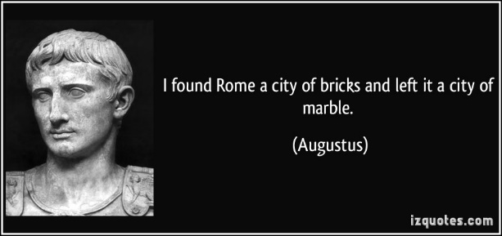

1. Can you think of any other reasons, not mentioned in this extract from Suetonius why Augustus would want to launch such an extensive building programme in Rome

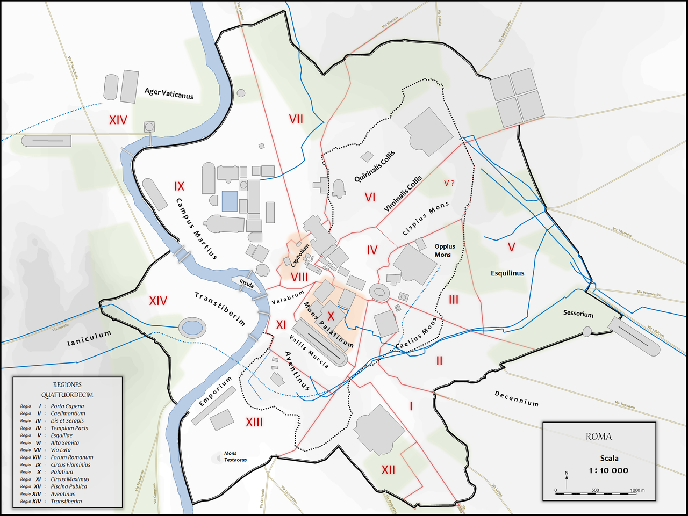

In addition to temples, baths and forums in Rome, Augustus also undertook new infrastructure projects, most importantly the building of a new **aqueduct** under the control of Marcus Agrippa.

**Strabo, *Geography* 5.3.8**

**Agrippa’s provision for Rome’s water-supply**

So great is the supply of water coming into the city through the aqueduct system that whole rivers may be said to flow through the city and its sewers; in fact almost every house has its own cisterns, pipes, and fountains in abundance. This was Marcus Agrippa’s primary concern, though he adorned the city with many other structures as well.

**Pliny, *Natural History* 36.121**

**Pliny on Agrippa’s water works of 33 BC**

During his aedileship Agrippa added to the existing aqueducts the *Aqua Virgo*, as well as combining or repairing the channels of the others. He also added some 700 reservoirs, 500 fountains, and 130 cisterns, a number of which were elaborately decorated. Upon these works, and all within the space of a single year, he set up 300 statues of bronze or marble and 400 marble columns. In his account of his own aedileship he himself adds that he held games lasting for 59 days and kept some 170 public baths open free of charge.

**How effective were Augustus’ Reforms?**

Try to include as many different reform as you can think of. For each place it on the grid below, explain why it was or was not effective, and where possible link it back to an ancient source where this is seen

|  |  |
| --- | --- |
| **Effective/Successful** | **Ineffective/Unsuccessful** |
|  |  |

**Key Question:** Do Augustus’s different reforms have anything in common either in their style or what they were trying to achieve?

**Primary Sources**

|  |  |  |  |  |
| --- | --- | --- | --- | --- |
| **Source** | **Date** | **Nature** | **Reliable** | **Unreliable** |
| **Suetonius** |  |  |  |  |
| **Tacitus** |  |  |  |  |
| **Dio** |  |  |  |  |
| **Horace** |  |  |  |  |
| **Virgil** |  |  |  |  |
| **Strabo** |  |  |  |  |
| **Ovid** |  |  |  |  |
| **Pliny** |  |  |  |  |
| **Macrobius** |  |  |  |  |
| **Velleius Paterculus** |  |  |  |  |
| **Younder Seneca** |  |  |  |  |
| ***Res Gestae Divi Augusti*** |  |  |  |  |

**KEY TERMS**

|  |  |
| --- | --- |
| **Term** | **Description** |
| **Republic** |  |
| **Principate** |  |
| ***Princeps*** |  |
| **Province** |  |
| **Consul** |  |
| **Triumph** |  |
| **Praetor** |  |
| **Numen** |  |
| **Pontifex Maximus** |  |
| **Pomerium** |  |
| **Pax Augusta** |  |
| **Praefectus Urbi** |  |
| **Tribunicia Potestas** |  |

**KEY FIGURES**

|  |  |
| --- | --- |
| **nAME** | **Description** |
| **Octavian** |  |
| **Julius Caesar** |  |
| **Marcus Agrippa** |  |
|  |  |
|  |  |
|  |  |
|  |  |

**The Roman Empire**

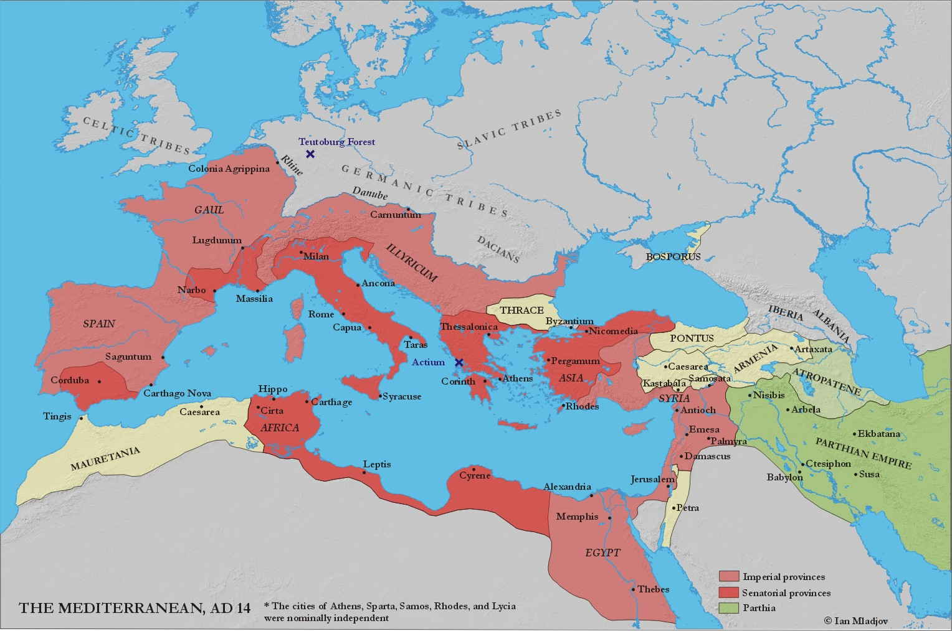



HOMEWORK RECORD

|  |  |  |  |
| --- | --- | --- | --- |
| ***Date set*** | ***Details*** | ***Date Due*** | ***Done?*** |
|  |  |  |  |
|  |  |  |  |
|  |  |  |  |
|  |  |  |  |
|  |  |  |  |
|  |  |  |  |
|  |  |  |  |
|  |  |  |  |
|  |  |  |  |
|  |  |  |  |