AS Music Technology Assessment Test: **Equalisation**

Mark Scheme

Total Marks

Put a cross in the correct box

1. What is equalisation(EQ)?

* A process of filtering, amplifying and attenuating, a range of frequencies(1)

2. Which is NOT a type of equaliser?

* Parabolic(1)

3. Amplifying a frequency band is called…

* Boosting(1)

4. Attenuating a frequency band is called…

* Cutting(1)

5. What is a filter?

* A circuit which alters the level of a limited range of frequencies(1)

6. Identify the following filters and describe what the filters do.

|  |  |  |
| --- | --- | --- |
|  | Filter | Describe what this filter does |
| Example:  Macintosh HD:Users:paul.clifford:Desktop:Hi-Pass Filter.tiff | High-Pass  Filter | Progressively reduces level of frequencies below a specified frequency(cutoff frequency) |
| Macintosh HD:Users:paul.clifford:Desktop:Low-Pass Filter.tiff | Low-Pass Filter/Hi-Cut  (1) | Reduces level(1) above (1)a specified frequency/ decreases high frequencies/removes hiss  Credit any valid example of use: e.g. usually around 20-  120Hz / remove rumble / remove hum / plosives /  reduce proximity effect / telephone effect / dynamic  swells / filter sweeps / thin voices / crossover /  multiband processing / remove sub-bass / overheads to  remove kick drum boom / remove bass from reverb /  remove LF / LM from acoustic guitars / make space for  the bass guitar in the mix / part of BPF (1) |
| Macintosh HD:Users:paul.clifford:Desktop:shelving.tiff | High  Shelf  Filter    (1) | Increase HF above a specified frequency  Credit any valid example of use: e.g. bring something  (vocal / reverb / acoustic guitar) forward in the mix /  clarity on overheads / correct lack of HF response from  dynamic mics / gentle high-shelf boost for mastering /  loudness curve / increases perceived (1) |
| Macintosh HD:Users:paul.clifford:Desktop:Peak.tiff | Peak Filter/  Notch Filter  (1) | Peak filters are used for more advanced application where it is necessary to target specific frequency bands with greater accuracy(1)  Q(also know as bandwidth or resonance) value allows more precision when dealing with localised frequency problems such as hum, noise, or vocal sibilance(1) |

7. An octave is the _______________of a frequency

* doubling(1)

8. What is frequency measured in?

* Hertz(1)

9. Name 4 applications (uses) for equalisers:

Remove Hiss(1)/Rumble(1)/Hum(1)/noise(1)

Instrument separation (1)/prevent masking (1)

Balancing the frequency spectrum

Adding definition/intelligibility to instruments/bringing it forward in a mix(1)

Shaping the timbre of instruments/Fat/Thin/honky/muddy/clean/dirty/bright dull(1)

Creative use(1)

10. Describe how you would eliminate low frequency noise/rumble on a vocal recording.

Use a diagram if necessary

Apply EQ to the Vocal/Use a High-Pass Filter/ Set cut-off frequency between 80-100Hz/Set a steep slope(48dB/octave)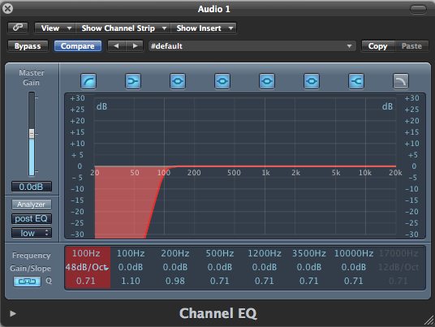(4)

11. List the differences between a graphic and a parametric equalizer.

|  |  |
| --- | --- |
| Graphic EQ | Parametric |
| More bands (1)  Amps/pedals 5-10 bands (1)  Studio / PA use 25-31 bands (1)  3 bands per octave / 1/3 octave equaliser (1)  Fader / Slider (instead of knob) (1) for each frequency  (1)  Positions of sliders resemble a graph of the frequency  response (1)  Bands have fixed Q / bandwidth (1)  Bands have fixed frequency (1)  Normally used for live use (1) to correct the frequency  response of a room / speaker system (1). Reduce feedback (1 | Assignable Frequencies(1)  More Flexible(1)  Studio use(1)  Different types of filters(1)  Adjustable Q/bandwidth(1)  Use for more specific and advanced functions(1)  Usually 4 filter types HPF/LPF/Shelf/Peak(1) |

12. Describe how you would reduce the hissing noise on an electric guitar recording.

Apply EQ to the guitar/Use a LPF/ Set the frequency around 3kHz/set a gentle slope(12dB/octave)

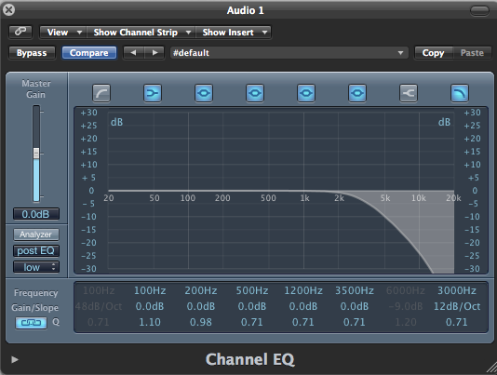(4)

13. Your electric guitar recording is too honky. Use the graph to explain how you would EQ the guitar.(6)

1) Vertical Axis-decibels/level (1) Horizontal Axis-Hertz/Frequency(1)

2) Center Frequency= 1kHz( acceptable ranges 900Hz-3kHz)(1)

Cut between -3dB to-6dB(1)

3) Peak filter with a wide bandwidth/Q(1)

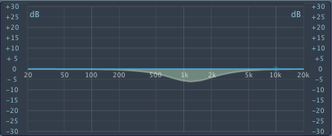

14. The pictures are examples of software and hardware equalisers. Describe the difference between hardware and software EQ (10)

|  |  |
| --- | --- |
| Software EQ | Hardware EQ |
| more flexible(1)  Parameters can be automated(1)  More memory for user presets(1)  Inexpensive(1)  Insert EQ on multiple tracks(1)  Multiple frequency bands(1)  Uses computer CPU or DSP card(1)  Hardware emulation(1)  No need for cables(1)  Marks are awarded for any examples of software EQ eg.  McDSP FilterBank  PSP Master Q  Digidesign Digirack 7-band EQ  Universal Audio Cambridge EQ  Logic Channel EQ/Fat EQ | Stand-alone units or built into mixing consoles(1)  Channel Strips(1)  Limited frequency bands(1)  Good quality units are expensive(1)  Not flexible(1)  Hardware units have their own sonic fingerprint(1)  Digital and Analogue(1)  Can only insert on 1 track at a time(1)  Needs setting up and patching into a mixing console/studio set up using cables(1)  Marks are awarded for any examples of software EQ eg.  Manley Massive Passive  Pultec EQP-1  SSL E-series(mixing console) EQ  API 550B/5500 EQ module |

Total Marks: 50